1. Identifying instances of financial excess in BPD spending

(1)To identify where there was financial excess in BPD spending we first looked at how the BPD budget had changed year over year. We looked at data from 2022-2025 as this was available to us from the City Of Boston. The overall budget was broken up into seven categories: Contractual Services, Current Charges & Obligation, Equipment, Fixed Expenses, Other Expenses, Personnel Services, and Supplies and Materials. To determine how the budget has changed between these categories, we looked at the percent each category made up of the total budget.From the graph, it is evident that Personnel Services consistently accounted for the largest portion of the total budget across all fiscal years from 2022 to 2025. This category highlights the significant costs associated with salaries and benefits, which dominate the overall spending. Year over year, while other categories such as Contractual Services, Current Charges & Obligations, and Supplies & Materials show relatively minimal changes in their share of the budget, the increasing trend in Other Expenses and Fixed Expenses suggests growing commitments or new initiatives that demanded additional funding. Notably, Equipment and Supplies & Materials remain the smallest contributors to the budget each year, indicating these areas are less prioritized. Despite these being essential for operations, their consistent low allocation reflects that BPD likely focuses resources on personnel-related and operational necessities rather than physical assets or materials. By 2025, the overall budget shows a consistent increase compared to previous years, with the largest growth occurring in Personnel Services and Other Expenses. This trend points to potential financial excess in staffing costs and operational overhead..

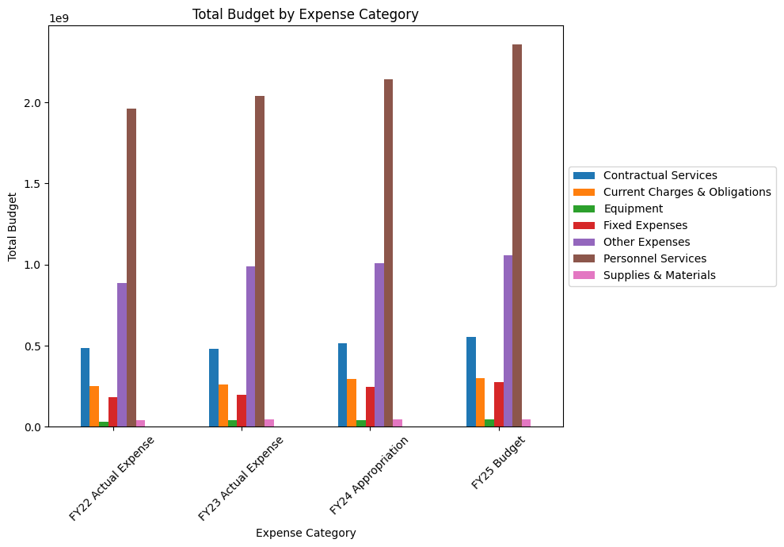

1. Where have funds grown or shrunk intra-departmentally?

Analyzing the top ten highest-earning police department occupations from 2020 to 2024 reveals that Policy Officer consistently holds the top spot in total income. This is unsurprising, given the large proportion of officers in this role. Almost all occupations experienced relatively stable earnings from 2020 to 2023, with an increase in 2024, likely reflecting the increased Total Budget shown in the figure above.

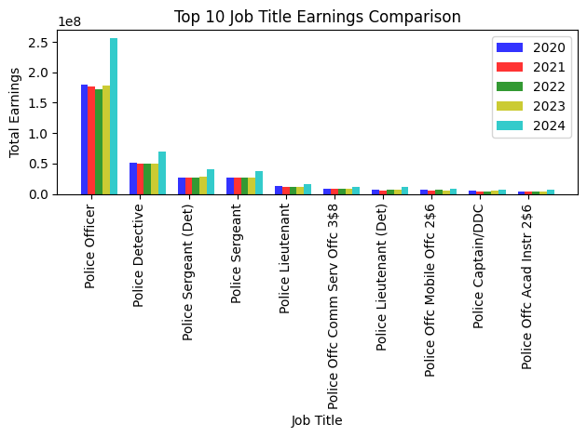

Lastly we looked at the changes in funding between departments. To do this we looked at earnings data from 2012-2022. From this we were able to see which departments received the highest salaries and therefore the most budget for that category, focusing on the top 10 departments.As the image shows, the police department has consistently been the highest-earning department between 2020 and 2024, with a significant increase in 2024. While other departments have remained relatively stable, this suggests a budget increase for the police department in 2024.

