ECONOMIC CONSEQUENCES OF THE PANDEMIC

-- A First Approach -

Gonçalo Fonseca

The economic situation brought about by coronavirus pandemic of 2020 is unprecedented and governments (US and otherwise) are a bit lost on how to respond.

News is moving quickly:

- $2 trillion stimulus bill was passed by Congress yesterday (March 25)
- This morning we got news of 3.3m unemployment claims - largest ever.
- Fed chairman Jerome Powell this morning announced we are likely in a recession already, and the downturn will continue to June.

Everyone anticipates an economic downturn of immense dimensions - unemployment exceeding (or soon to exceed) the numbers of the Great Depression - at least temporarily until the pandemic blows over. The question is what kind of downturn and how to handle it.

The term "Great Depression" has drawn many to think about the lessons of John Maynard Keynes and look to it for policy guidance. But it is important to understand the nature of this downturn in order not to make mistakes in the policy response.

It is my contention that the current pandemic is a supply shock, not a demand shock, and has set up an economic situation of incredible supply constraints and inflationary gaps that resembles more the economic situation of World War II rather than the preceding Great Depression. So it is perhaps not the Keynes of the General Theory (1936) but rather the Keynes of How to Pay for the War (1940) that is the most instructive for the current situation.

World War?

It may seem unusual to state it this way. After all, World War II was characterized by a boom and full employment, whereas we are here in a situation of mass unemployment.

But it is not a normal downturn. This is not normal unemployment brought about by economic conditions. It is forced unemployment - forced by the external circumstance of a pandemic. So we must really think in terms of conscription - instead of being conscripted into the army, the working population is being conscripted into quarantine.

This is not a crisis driven by lack of demand. It's lack of supply. People are not purchasing goods because they suddenly don't have money or are trying to save. People aren't purchasing because businesses aren't open. It may become a demand-driven down the line, as a second order effect, as people are laid off from closed businesses. But that is not the primary cause of the crisis.

And the response has to take that into consideration as well. It is not as if we want production to increase and people to be employed again. We want these businesses to stay closed.

This is unprecedented.

What it resembles most closely is the situation in WWII when a large part of resources in the economy were designated for the military, leaving little left over for consumer goods production. We had an economy where consumers and firms were forced to operate in a situation of constrained supply.

(1) Demand & Supply

First off, to be clear, let us start with some definitions. Economic downturns are characterized by declines in GDP.

GDP (Gross Domestic Product) means the total quantity of goods and services produced and sold in an economy over a period of time.

In the US it was around $21 trillion in 2019.

"Sold" means a transaction - there is a buyer and a seller, a demander and a supplier. It is a two-sided thing, not a one-sided thing.

So useful to remember basic definitions:

Demand = total quantity buyers (be they consumers, firms, or government) are willing and able to buy.

Supply = total quantity producers are willing and able to produce and sell.

The situation brought about by the pandemic potentially affects both sides. On the demand side, it affects the ability to buy (unemployed have lower income). On the supply side, it affects the ability to produce (firms closed) and ability to sell (shops closed).

But it is the supply side that is most affected by the pandemic shock. What is most deficient at this moment is not the willingness or ability to buy, but the ABILITY TO PRODUCE and the ABILITY TO SELL.

Firms cannot produce because workers aren't allowed to show up for work. Firms cannot sell because shops are not allowed to open. That is the immediate problem we are currently facing. It is not lack of demand, it is lack of supply.

(2) Demand & Supply Shocks

Let's take it to another level. Again, forgive the pedantry, but sit down for a moment with with a conventional S&D diagram - or rather Aggregate Supply (AS) and Aggregate Demand (AD) (by which we can reason simply, without getting into the weeds).

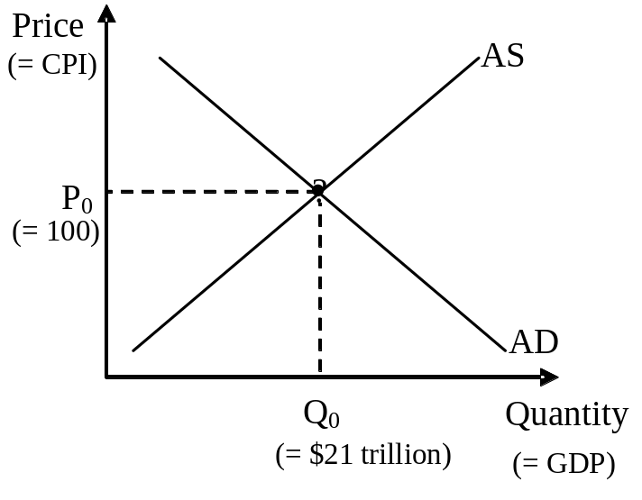

"Economic downturn" (some people call it a "recession") means GDP goes down - that's a decline in the amount of total quantity of goods produced and sold.

If less is being produced, then firms don't need as many workers as before and lay them off. So economic downturns are always accompanied by rising unemployment.

Diagrammatically, you measure quantity (GDP) on the horizontal axis. So if there is economic downturn, then GDP is less.

There are two ways quantity sold suddenly declines from your initial position - either (1) there is suddenly less demand (demand curve shifts left) or (2) there is suddenly less supply (supply curve shifts left). They have independent causes.

(1) Demand shock - this is the conventional case in many recessions (e.g. 1990, 2001 2007). Demand declines because of e.g. sudden lack of consumer confidence, wealth crash (people try to save more to make up for it), rising interest rates (firms shelve investment spending), tax increases, cuts in government spending, rising exchange rates (people prefer to import from abroad).

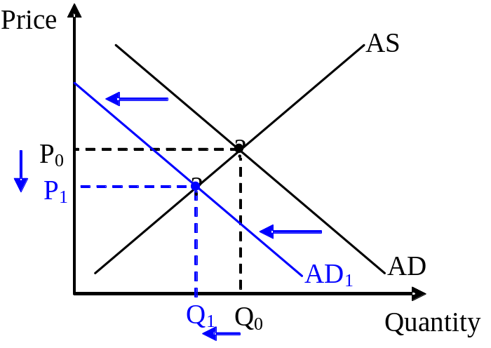

The 2001 & 2008 recessions were conventional demand shocks from evaporating wealth (stock market in 2001 & real estate market in 2008 going belly up) and (in 2008) rising interest rates (in a liquidity crunch), prompting people to suddenly try to save more and firms to cut back projects.

(2) Supply shock - this is the cause of both of the recessions of the 1970s (1973, 1979). Supply shocks are typically caused by suddenly rising costs, e.g. energy price spikes, bad harvests, unexpectedly high wage or profit demands, etc.

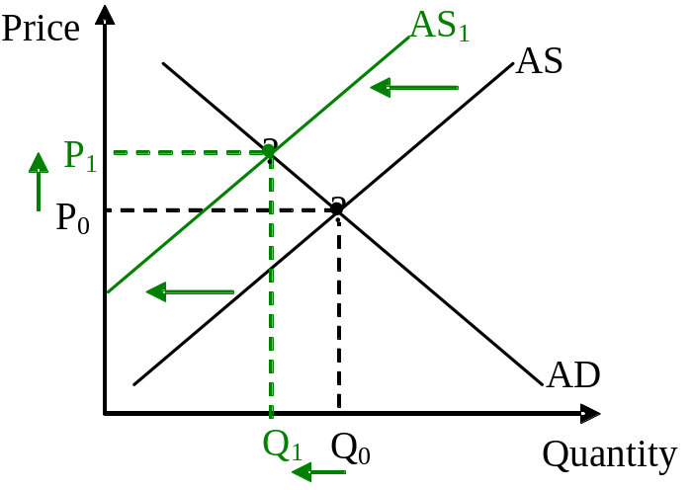

In sum, both a demand sock or a supply shock can produce an economic downturn (decline in GDP or Quantity). Since both types of shock lead to lower GDP, both types of shock will lead to higher unemployment. But the underlying cause is different.

What kind of situation do we have?

What we have here with this pandemic is a supply shock. Firms cannot stay open, they cannot produce, they cannot pay people enough to produce because people are forbidden from showing up at their job. This is a massive supply shock.

In a demand-driven downturn, goods would be piling unsold, and firms would have their warehouses filling up. That's not the case here. Goods aren't piling up unsold. Goods aren't being produced to begin with. It is not for lack of consumer orders - orders are there, but workers aren't showing up to work.

The importance of distinguishing between the type of shock is that you respond to demand-shock and supply-shocks differently. The number one lesson from the 1970s is that you don't respond to supply-driven recessions by increasing demand - you might end up just fueling "stagflation", i.e. inflation and unemployment.

How can you tell?

Now let's take this another step further. Granted that GDP downturns can be caused by either demand shocks or supply shocks. How do you, in practical terms, tell the difference?

If you only look at GDP (i.e. quantity), you can't. Both demand and supply shocks drive GDP down. But there is an additional clue: prices.

The general price level in the economy is measured by the Consumer Price Index (CPI). This is an index measure maintained by the Bureau of Labor Statistics which tracks the cost of a typical basket of consumer goods (typically set at "100" for a base year). Diagrammatically, prices (CPI) are shown on the vertical axis.

Do this diagrammatically. Let's go two steps:

(1) Suppose there is a demand-driven recession (like in say 2008). Demand curve shifts left - diagrammatically, both quantity and price goes down.

(2) Suppose there is a supply-driven recession (like in say 1979). Supply curve shifts left - diagrammatically, quantity goes down but price goes up.

So looking at GDP and CPI simultaneously should give us a clue to the situation we're in.

Are prices declining or rising? We don't know yet - as the BLS has not yet measured CPI yet

[BLS's website currently reports a mere 0.1% inflation for the CPI in February. We don't know yet for March. And it is going to be tough to measure, since the BLS uses real store shelf prices to measure CPI, but if stores are closed, not sure how they're going to adjust their methods.].

But anecdotally, it is at least seems that prices are not falling. In online stores, it is apparent firms are desperate to keep up with orders, and struggling with delivery. In mortar-and-brick supermarkets, the usual sales & coupons are much fewer than before. Evidently, they aren't trying to get rid of accumulating unsold items.

Now, anecdotal evidence can be mixed. While some sectors (e.g. online stores and supermarkets) are facing rising demand, demand is cratering in other sectors (e.g. take-away restaurants, airlines). So there is an element of changing composition of demand (e.g. switching from restaurants to supermarkets) while the aggregate level of demand may be unclear.

Granted, it is all very fuzzy in that we have yet to measure it. Moreover, there is panic buying, delivery problems, adjustment of habits, and most all length of uncertainty - there is still a lot of inventory and potential postponement of decisions - that will mar any formal measure.

But there is an immediate clue we see that we don't need to actually measure: factories are shut, shops are closed. That is by order of the authorities. If you're confused, I remind: supply is the producers willingness & ABILITY to produce & sell. We don't need to wait for CPI measures to see that firms are having a production & selling problem that is entirely due to artificial restrictions imposed by the pandemic and have nothing to do with the amount of consumer orders they're getting.

How should you respond?

As I averred to earlier, once you decipher the nature of the downturn, the government should respond according to it.

Typical macroeconomic tools governments have to fight recessions are heavily weighed on stimulating demand (i.e. more expenditure) in the economy. These include:
- cutting interest rates (induce firms to spend more on investment projects)
- lowering exchange rate (encouraging exports, i.e. inducing foreigners to import more of our goods)
- cutting taxes (induce consumers to spend more)
- increasing transfers (induce consumers to spend more)
- increasing government spending directly

and so on.

(1) Suppose you have a demand-driven recession. Demand curve shifts left (quantity & price declines). Suppose government responds to it by typical demand boosting (lowering interest rates, lowering taxes, increasing government spending, etc.) More expenditure means then the demand curve shifts right (quantity & price increases). The government's response counters the recession exactly, and we return quantity & price to where they were before. This is the right thing to do in this situation.

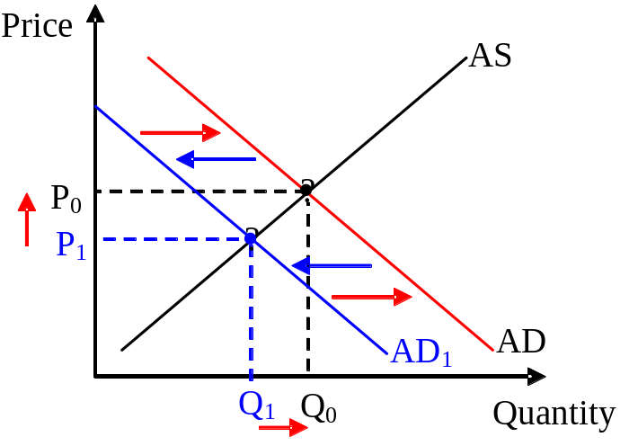

(2) Suppose you have a supply-driven recession. Supply curve shifts left (quantity declines & price increases). Suppose government responds to it the same way by demand boosting (lower interest rates, cutting taxes, etc.). So it is responding to a supply shift with a demand shift - quantity increases & prices increases again. So now quantity rises, but we are not countering the recession exactly, we are not returning to where the situation was before. That is, we might restore quantity to where it was before, but prices will be higher then before. We get the start of inflation. Or at least a one-time increase in prices. This response may be the wrong thing to do in this situation.

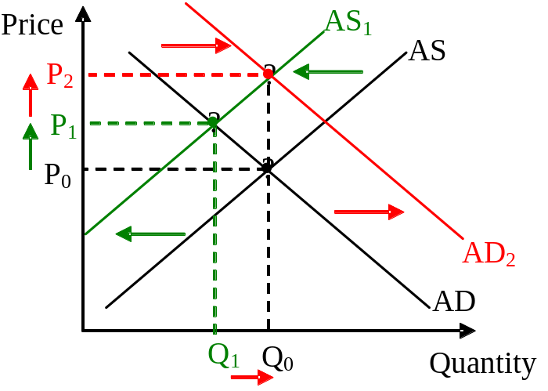

Why wrong? Ask yourself: in real terms are people better off? Quantity may be returned, but people's purchasing power is declining because of your attempt to respond to it via demand-boosting. For people on fixed incomes (e.g. pensioners) this is a definite worsening of their situation.

More importantly, an inflationary mechanism can set in motion. As real wages are lower, workers will demand a nominal wage increase to make up for higher prices. Those higher wages now cut into firm profits and constitute an additional supply shock to firms. Firms will respond to rising wage costs as they normally do - by lay-offs and curbing production. So once again, supply curve shifts left again and quantity declines again (& prices go up some more).

Government needs to respond again. If it responds again by raising demand once again, then that raises quantity again (& prices even more). But now real wages are lower than before, once more workers demand wages be adjusted for inflation, etc. The inflationary mechanism begins accelerating.

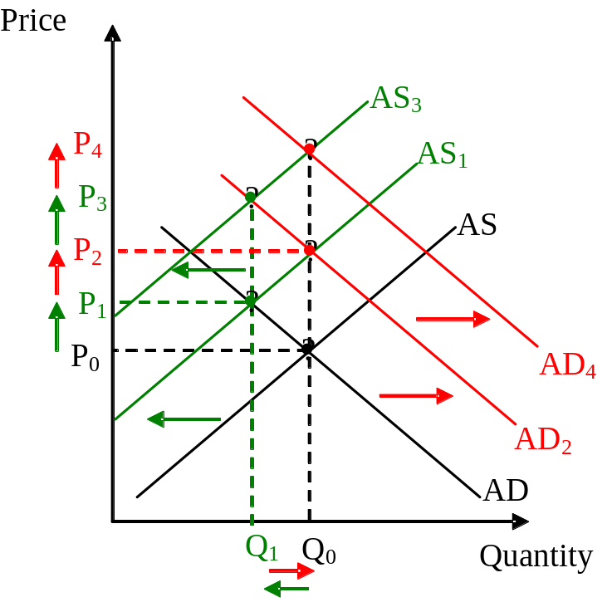

By responding to the initial supply shock by demand stimulus, the government may be setting inflation in motion, an acceleration mechanism when prices start climbing setting off a chain of additional supply shocks. And if the government responds in the same kind again, inflation just accelerates further while quantity just stagnates. You are forced to run twice or thrice as fast in a desperate attempt just to remain in the same place.

(diagrammatically, think of it as a series of supply curve shifts to the left followed by a series of demand curve shifts to the right. Q remains in place, but P rises continuously)

At some point, inflation expectations set in and begin to be written into wage contracts. At that point, the dance is over - you're not even having any effect on quantity anymore. Demand-boosting policy reactions are counteracted by supply shifts before they can even begin to have an effect. Quantity now falls permanently - you can't prevent unemployment from rising while inflation becomes permanent, i.e. stagflation.

That's the 1970s in a nutshell.

Lesson: Not all economic downturns should be responded the same way. Diagnose the problem correctly before you respond to it. A wrong response may make the situation worse. Be functional - tailor your response to the nature of the problem.

How has the government responded?

In response to the Coronavirus Pandemic of 2020, the government has undertaken a variety of responses.

- The Federal Reserve has cut interest rates to near zero.
- Federal and state governments have, to a variety of degrees where they could issued decrees to relieve particular burdens from consumers (e.g. suspend student debt repayments, freeze evictions, postpone tax day from April to July, etc.)

But more significantly Congress has stepped forth and passed the 2020 Stimulus bill yesterday [Act online]. Overall tag of over $2.2 trillion. To summarize its main components (not sure I got all details right):
- Direct payment transfers: rebate checks for all taxpayers: $1,200 rebate check for individuals (with income up to 75k, phased out until 99K) and $2,400 for married couples (with income up to $150k, phased out until $198k)
- Unemployment transfers: expand eligibility for unemployment benefits (e.g. you don't have to prove looking for job), extend benefits with $600 check to top-off of unemployment benefits up to four months (making up deficiency in State unemployment insurance to reach up to 100% in lost wages)
- Payroll tax cuts: businesses and self-employed get to defer FICA (still have to pay it, but over the next two years)
- Small business relief $350 bn, including tax credit to businesses who keep workers on payroll (refund half the wage bill, up to $5,000). To go this route, they have to prove 50% loss of business and forego access to SBA loans.
- Large corporations: nearly $500 bn pot of funds (loans, loan guarantees, etc.) for corporations, to be disbursed by the Treasury (with some conditions on buybacks, executive compensation, etc.)
- $150 bn for state & local governments budgets (make up for lost tax revenue & ease strain of greater welfare spending),
- Other designated funds to public sector - $25 bn for food stamps, $30 bn for schools, $11 bn for defence.
- Other designated funds to private sector - $100 bn for hospitals, $58 bn for airlines, $24 bn for farm relief, etc.

[How does the US response compare to elsewhere? In Denmark, the government responded by keeping all public workers on payroll and promising to pay up to 75% of payroll of private companies. Danish approach seeks to keep companies intact, shutting them down "temporarily", rather than forcing the procedure of going through layoffs so the quarantined unemployed can get income. So it will likely be easier for Danish companies to "reopen" on the day, with the same staff, whereas US companies will have to go through the rigamarole of re-hiring.

The US seems to focus their relief on unemployed. The bill did put a clause for wage takeover but to a more limited extent, and any company that adopts that foregoes access to other funds, so the incentives are low. That said, given that we got 3.3m claiming unemployment already, maybe it was too late for the US to rescue private wage bills on a grander scale.]

A pattern is worth noting - much of this has been tried before in 2008. Fed cutting interest rates to near-zero (as in 2008), Fed buying up paper (like in 2008-09), Congress passing something called a "Stimulus Act" (just like Obama's 2009 act), tax rebates checks are going to be mailed out to everybody (like the Bush rebates of 2008), corporate bailouts (like in 2008-09), etc.

It naturally brings forth the question: are we fighting the last recession or this one?

Inflationary consequences

Here is where the importance of diagnosis should step forward. The crisis of 2020 is fundamentally different in nature from 2008. And yet we are pulling out the same bag of solutions, as if it was the same kind of problem.

Particularly noteworthy are the rebate checks. When it was first proposed a week ago, it was hailed as UBI by the back door. But it is $1 trillion poorly spent - two-thirds will be given to the employed who already earning income and do not need it, whereas one-third will go to the unemployed without income, for which this one-time payment is insufficient.

Two-thirds of it is going to people like me - people who are employed and can work from home. I have enough money to spend, there's no reason to give me any more money. It does nothing for businesses in my neighborhood - I cannot buy more, because they cannot open.

Now, some hail these rebate checks as an attempt to increase aggregate demand in a situation of mass unemployment - the traditional "policy response" for recession. But do we want demand to increase?

This policy does not take into account the peculiarities of the Pandemic of 2020. Normally we think extra demand should induce firms to increase production, for which they will have to increase employment. But so long as they are facing supply constraints, firms cannot increase production and employment and we don't want them to. We want workers to stay in quarantine for the duration of the pandemic.

Moreover, it might have deleterious consequences. We are currently facing prospect of shortages, not excess supplies of unsold goods. Where does this extra demand go? If focused on demanding goods, that means firms will run down their inventories at a faster pace, and drive up the prices of goods, i.e. inflation.

The windfall of the extra rebate check just means I will bid up the price of toilet paper online, and set us down the road to inflation, when TP sells for $500 a roll and only millionaires can afford toiletries.

The only alternative outlet for that rebate windfall is to save, i.e. deposit the rebate check in a savings account, which goes on to buy assets like stocks, bonds, etc.

What I suspect is driving some supporters of this bill is a desire to prop up the stock market. It is because they hope people like me, people who don't need it and who cannot spend the money on goods and services because goods are services are not there to be had, will use it to buy stocks.

What else am I going to do with the money? It is either bidding for toilet paper (goods price inflation) or bidding for stocks (asset price inflation).

This is a poorly-thought response to the current crisis. Even if not its aim, its effect will be merely to boost the stock market and prop up the wealth of capitalists. Rising stock prices do nothing for most firms at the moment - under current conditions, when they are operating far under capacity (if at all), they are not going to suddenly start expanding capacity and hiring people that are not allowed show up for work (and we don't want them to!).

Now, it may be argued that this s preventive - in the sense, that falling stocks may make the middle class bourgeoisie timid sometime in the future, and so at least by using massive amounts of tax money to prop up their wealth portfolios means they won't (sometime in the future) get worried and start saving more (i.e. a real wealth effect which might lead to a real demand decline). In other words, it might serve to counter a potential demand decline sometime in the future. But we're not even close to that yet! And there are better options when that time arrives that doesn't involve trying to run up the Dow Jones.

What we have now, what we have immediately, is a serious supply shock, that needs to be addressed directly. And the policy response constitutes an erroneous demand-response that is not addressing what is going on, and indeed setting things in the wrong direction.

In summary, stimulating demand might not be right policy right now, and indeed might make situation worse if inflation takes hold.

What should be done?

There is no lack of aggregate demand at present - there may be in the future, but that is not the immediate problem. The immediate problem is lack of supply. And the supply constraints, under current circumstances, are insane and near impossible to overcome.

Online stores can't keep up with demand. And are themselves on the verge of being shut down (vide Amazon in Spain, Italy and France) and woe betide us when they do. Look around. Supermarkets are canceling all routine sales, and in several places prices are already going up as inventory depletes.

Increasing demand in this situation will be inflationary.

Many experts promoting large demand stimulus are analyzing the situation wrongly. The fact that few of them are differentiating between (a) people who can't work and (b) people who can work from home and whose income is not affected, should be a hint that they haven't thought this through yet.

There should be monetary relief for the first group. No doubt - immediately and completely, not merely a one-time rebate check, but a large part (up to the entire) wage bills should be footed, allowing workers to remain on the payroll and quarantined.

If funding is an issue, transfer the two-thirds allocated for the rebate checks to the employed to supporting the wages of the unemployed (or immobilized).

But there should be no handouts for the second group. No checks to people who are currently receiving income. That would be increasing demand more than it is now. On the contrary, if anything, the latter should be taxed, forced to save, or in some way rationed and prevented from demanding in order to relieve inflationary pressures.

Great Depression or World War II?

Let me return to where I started. The closest historical analogue we have to the current situation is not the stagnant economy of the Great Depression, but wartime economy of World War II. During the war, consumer goods industries were facing severe supply constraints due to the wartime requisitions of resources and redirected production for the military. This left few resources to produce consumer goods for the general public.
Which is more or less the situation we are facing now. Yes, the employment situation is very different between WWII and the Pandemic, but the production situation is similar. Firms are facing severe supply constraints similar to wartime constraints. And the goals should be similar. In short, we don't want firms to increase production, we want workers to stay home in quarantine.

The situation and policy response is consequently different:

- Great Depression - businesses piling up with unsold goods, need demand to increase.
- WWII - consumer goods industries deprived of resources, need demand to decrease.

For the duration of pandemic, we are facing a WWII-type situation: industries deprived of workers. You don't try to increase demand in this situation, you do the opposite - you try to curb demand, bringing demand back down to the level of production that you currently have (and want to have - again, increasing employment is not the current goal; you want workers to stay at home).

This is a perfectly Keynesian response to the current situation. Except not the Keynes you are thinking of. It is important to remember John Maynard Keynes wrote two books, addressing different policy responses to two different situations.

- J.M. Keynes General Theory (1936) - during Great Depression
- J.M. Keynes How to Pay for the War (1940) - during WWII

Policymakers and economists are only thinking of Keynes of 1936, and drawing upon his demand-stimulating policies outlined there. But it is Keynes of 1940, and the demand-curbing policies outlined there, which are more relevant to the current situation.

Keynes of 1940 addressed several policies which could be used to curb demand and relieve inflationary pressures in the wartime economy. Among the proposals he considered:

- higher taxation to curb incomes
- promoting savings (e.g. "victory bonds" drives, encourage or force savings during war, re-paid after war over)
- encouraging saving of resources & self-production (e.g. victory gardens)
- rationing of consumer goods
- set up Office of Price Administration to oversee & control wage & price increases.

A certain amount of all these measures was implemented, to a greater or lesser degree, by all governments during the war to relieve inflationary pressures.

Exaggeration?

Am I overestimating the inflationary pressure? Possibly. Inflationary pressures are certainly there. But many firms have a lot of inventory, and the duration of the pandemic could be mercifully short, so that the inventory outlasts it with room to spare. In which case, this document can be archived as an intellectual curiosity.

However, with so much production and delivery halted, inventories of consumer goods are being gradually depleted right now, so inflationary pressure is already mounting.

If the duration of the pandemic is long - and "long" is in the eye of the beholder, but let us say three months or so - then it likely that inflation will be unavoidable.

Now it may be said that inflation is a minor problem relative to mass unemployment. Isn't that what INET has always warned about? Obsessive fear of inflation provoked autarky during the Euro crisis, and created unnecessary unemployment. Faced with two choices, the unemployment is a greater evil than inflation.

That is generally true. But the difference this time, with a supply shock, is that we would have the rare combination of "stagflation" - both unemployment and inflation, at the same time. We are not choosing between one or the other, but are being served a cruel dish of both.

We can at least say this time unemployment is wanted. We would like people to have income to be able to live, but we don't want people to show up to workplaces. But the inflation is unwanted, and would be an immediate evil.

Inflation problem

How much of an evil is inflation?

You may have heard that inflation might be good for debtors (and bad for creditors). After all, inflation reduces the real value of nominal debts, thus eases the burden of debtors. With so many households already underwater in private debt, maybe some inflation wouldn't be a bad thing.

[To understand why: you contract and repay debts in nominal terms, i.e. in dollars, not in real purchasing power. So you borrow $100 tomorrow and pay back $100 next year (with some interest). But if there is inflation in the meantime, then the $100 you pay back is worth less in real purchasing power terms than the debt you contracted originally e.g. suppose price of bread is $5 a loaf, then when you borrow $100 today you are effectively borrowing enough to buy twenty loaves. If inflation doubles the price of bread over the course of the year to $10 a loaf, the when you pay back those $100 you are effectively paying back only ten loaves (less real stuff).]
.
Generally speaking this is true. And that might be a mitigating consideration.

But inflation has distributional impacts beyond debt.

- Inflation harms the real purchasing power of those on fixed dollar incomes or living off savings (like pensioners and many unemployed right now). Your savings account with $1,000 will be halved in real terms if price of goods double.

- Inflation complicates life for those who do not have the bargaining power to negotiate a compensatory rise their wages. This is especially true of those on the bottom rung of the wage ladder, whose power is weaker and opportunities to change employment are especially scarce in the current circumstances.

Inflation has differential impact and will likely have a severe distributional effect. Poor people on fixed incomes or without any income, will find what little savings they have depleting faster as the prices of consumer goods rise. Richer people, with large savings or lucky enough to be employed with good contracts will be less adversely affected.

Meeting basic needs

The priority we have, as a society, is ensuring that everybody can meet their needs - certainly in this time of crisis.

So the priority right now is to ensure two things for the duration of the pandemic:

- (1) ensuring everyone has some income.
- (2) ensuring everyone has access to consumer goods.

All attention has been focused on (1), and little or none at all on (2).

Most analysts seem to assume that (1) implies (2), that all they have to do is give income, and that automatically secures access to consumer goods.

But if shortages emerge and inflation rears its ugly head, that may no longer be the case.

The rich will be able to continue buying, but the poor will find it harder to afford basic consumer goods.

The pandemic is bad enough as it is in terms of harming incomes, it should also not lead to insecurity of consumption.

Food shortages?

Current food suppliers try to cover about three-four months in inventory. So we are not yet facing shortages. But if the pandemic draws out for long, shortages will arise and may become critical.

Yes, you may have already seen some shortages in some goods in the supermarkets - but much of that is temporary.

- Panic-buying by consumers is depleting supermarket shelves faster than normal.
- Closure of restaurants means that people are switching from restaurants to supermarkets, so the demand for supermarket food has sharply increased.

[e.g. a typical NYC neighborhood is served by dozens upon dozens of restaurants/fast-food places. They all shut down last week. So overnight the entire neighborhood became suddenly dependent on only a couple of local supermarkets. No wonder they ran out!]

I say temporary, because the closure of restaurants means that food suppliers no longer need to supply restaurants, and can be transferred to supply supermarkets (by some estimates as much of 50% of food supplies were destined for restaurants and other prepared foods before the pandemic, and that this has declined sharply to around 10-20%.)

So current shortages may be merely adjustment difficulties - as supermarkets adjust to increase their orders to meet increased wave of customers, and food suppliers adjust to redirect deliveries to supermarkets and away from restaurants.

So far.

. But adjustment f food supplies - in that the closure of so many restaurants and
That means shortages are not yet critical.

As the pandemic draws out, shortages will get serious and perhaps even critical. I am admittedly speculating, but not entirely thin air - That could be enough.

Moreover, given that the pandemic is global, it is not as if shortages here can be made up by importing food from some other part of the globe.

Every country is facing a supply shock.

Now it may be said that inflation is a minor problem relative to mass unemployment. Isn't that what INET has always warned about? Obsessive fear of inflation provoked autarky during the Euro crisis, and created unnecessary unemployment. Faced with two choices, the later is the greater evil.

But you can answer: isn't inflation good for debtors? Doesn't it wipe out their debts, etc.? So many households are underwater in debt, maybe some inflation wouldn't be a bad thing.

Some inflation isn't a bad thing. But under the current conditions, it would be a terrible thing. For the general well-being of society,

Yes it is terrible

J.M. Keynes How to Pay for the War (1940) - during WWII

Keynes (1940) - we need to bring demand down to level of production we want.
higher taxation
bond drives (forced saving)
rationing
encouraging saving of resources & self-production (e.g. victory gardens)
Office of Price Administration (OPA)

you force people to buy savings bonds or impose rationing. Which is what governments should be instituting right now.

I refer you to Keynes's "How to Pay for the War" for guidance of the current circumstances.

Am I overestimating the inflationary pressure? Possibly. Many firms certainly have a lot of inventory, and the duration of the pandemic could be short, so that the inventory outlasts it.

This way you prevent inflationary pressures

You want to prevent people from spending. Whether by taxation or forced savings bonds or rationing doesn't really matter - choose your favorite mix. But demand has to come down to meet the lower supply, at least until the pandemic is over.

What you don't want to do is increase demand right now. Or you'll soon be seeing TP at $500 a roll and only billionaires can wipe their butt.

.

UBI is what's in this bill. And should not be in the bill.

It is $1 trillion poorly spent - two-thirds completely wasted, one-third barely worth it. If you transferred that two-thirds to bulk up the one-third that need it, e.g. actually pay wages of the suddenly unemployed and to support small businesses that have been forced to shut down, you would at least give relief. This way it accomplishes nothing.

Two-thirds of that trillion is going to people like me. There's no reason to give me $1,000. I am employed, I can work from home, I have more than enough money to spend, there's no reason to give me any more money. It does nothing for businesses in my neighborhood - I cannot buy more, because they cannot open.

A windfall of an extra $1,000 just means I will bid up the price of toilet paper online, and set us down the road to inflation.

What I suspect is driving the supporters of the this bill - I mean the real supporters, not folks who are simply confused about economics - is a desire to prop up the stock market. It is because they hope people like me, people who don't need it and who cannot spend the money on goods and services because goods are services are not to be had, will use it to buy stocks. What else am I going to do with the money? It is either bidding for toilet paper or bidding for stocks.

This is a massive indirect way the government can undertake a large purchase of stocks.

This is a poorly-thought response to the current crisis. It's aim (and certainly its effect) will be merely to boost the stock market and prop up the wealth of capitalists. Rising stock prices do nothing for most firms at the moment - under current conditions, when they are operating far under capacity (if at all), they are not going to suddenly start expanding capacity and hiring people that are not allowed show up for work.

Now, you may argue it is preventive - in the sense, that falling stocks may make the upper middle class bourgeoisie (*grumble*) timid sometime in the future, and so at least by using massive amounts of tax money to prop up their wealth portfolios means they won't (sometime in the future) get worried about their savings and start saving more (i.e. a real demand decline). In other words, it is purely to nullify a potential wealth effect in the future. But we're not even close to that yet! And there are more options when that time arrives that doesn't involve trying to run up the Dow.

What we have now, what we have immediately, is a serious supply shock, that needs to be addressed directly. And this scheme constitutes an erroneous demand-response that is not addressing what is going on, and indeed setting things in the wrong direction.

What should be done?

There is no lack of demand at present. There is only lack of supply. And the supply constraints, under current circumstances, are insane and near impossible to overcome. Online stores can't keep up with demand. And are themselves on the verge of being shut down (vide Amazon in Spain, Italy and France) and woe betide us when they do.

Increasing demand in this situation will be highly inflationary.

Experts promoting this are analyzing the situation wrongly - this is the wrong policy response.

The fact that none of them is differentiating between (a) people who can't work and (b) people who can work from home and who's income is not affected, should be a hint that they haven't thought this through yet.

There should be monetary relief for the first group. No doubt - immediately and completely, not merely a one-time check, but the entire wage bills should be footed.

But there absolutely, under no circumstances, should be no handouts for the second group. No checks to people who are currently receiving income. That would be increasing demand more than it is now. On the contrary, if anything, the latter should be taxed up the wazoo, forced to save, or in some way rationed and prevented from demanding in order to relieve inflationary pressures.

The closest economic analogue we have is in wartime situations, where similar supply constraints impose themselves because much of production is redirected to the army. You DON'T increase demand in this siutation. You do the opposite - you curb it, you force people to buy savings bonds or impose rationing. Which is what governments should be instituting right now.

I refer you to Keynes's "How to Pay for the War" for guidance of the current circumstances.

You want to prevent people from spending. Whether by taxation or forced savings bonds or rationing doesn't really matter - choose your favorite mix. But demand has to come down to meet the lower supply, at least until the pandemic is over.

What you don't want to do is increase demand right now. Or you'll soon be seeing TP at $500 a roll and only billionaires can wipe their butt.

As you know, Congress is currently considering UBI-like proposals of income boosts. I was involved in a heated debate in the last couple of days with a promoter of the scheme, and engaged in a series of exchanges explaining to him why I thought it was a terrible idea in the current situation. I went through it rather pedantically, sorting through it through simple graphs to show that we are currently in an unprecedented supply shock situation which is highly inflationary, and what is needed is the opposite - to curb demand with some combination of higher taxation, forced saving and rationing.

Then I thought, why not discuss it with you guys? On Tuesday?

This is not a policy proposal I've seen anybody recommend so far, but it seems to me analytically the right one. And I'd like to have the opportunity to jaw-jaw with you guys about it on Tuesday (or with everybody on Thursday?) as maybe there's something I am missing.

Since it is in baby economics 101 form, it may be worth doing it on Thursday rather than Tuesday. But let me know what you think. Does this make sense? I know S&D isn't very heterodox, and maybe my policy answer is very disturbing - but it is very thoroughly Keynesian (as in Keynes of WWII, in his the "How to Pay for the War").

Let me know what you think. For the moment, it is for your eyes only. I can clean it up a bit.

Economic Consequences of the Pandemic

The economic situation brought about by coronavirus pandemic is unprecedented and governments (US and otherwise) are a bit lost on how to respond. Congress is considering a $1 trillion bill which would supposedly hand out $1,000 checks immediately to everyone. People are hailing at UBI-by-the-backdoor. This is the wrong response.

This is not a demand-driven crisis. It's lack of supply. People are not purchasing goods because they don't have money or are suddenly trying to save. People aren't purchasing because businesses aren't open.

The problem is with supply, not demand. I've tried to buy bread online. Demand is so high, and supply so constrained, they can't fulfill my order until next month.

Blowing $1 trillion this way wastes two-thirds of it, and does precious little for the remaining third.

A $1,000 check is not enough for someone without a job. Direct assistance to small businesses, taking over their entire wage bills, would be much better targeted, with much better results.

But giving people like me - who have a job - a $1,000 check does nothing at all for them. My barber was forced to close down this morning. What does giving me $1,000 change in terms of haircuts sold?

=====

[After some insistence that the crisis are demand driven and boosting demand via the $1,000 checks were worthwhile, I decided it was worth breaking it down in simple economic steps]

====

No.

I'm sorry to get all professorial on you, but maybe this needs baby steps to explain.

Demand & Supply

First off, to be clear, GDP means the quantity of total goods produced and sold in an economy. "Sold" means a transaction - there is a demander and there is a supplier. It is a two-sided thing, not a one-sided thing.

Remember definitions:

Demand = total quantity buyers (be they consumers, firms, or government) are willing and able to buy.
Supply = total quality producers are willing and able to produce and sell.

What is deficient at this moment is not the willingness or ability to buy, but the ABILITY TO PRODUCE and the ABILITY TO SELL.

Firms cannot produce because workers aren't allowed to show up for work. Firms cannot sell because shops are not allowed to open. THAT is the problem we have. It is not lack of demand, it is lack of supply.

Does that make sense?

Demand & Supply Shocks

Let's take it to another level. Again, forgive the pedantry, but sit down for a moment with with a conventional S&D diagram (or AS & AD, but we can reason simply by S&D).

Economic downturns means GDP goes down - that's a decline in the amount of total goods produced and sold. You measure that on the horizontal quantity axis.

There are two ways quantity sold suddenly declines from your initial position - either (1) there is less demand (demand curve shifts left) or (2) there is less supply (supply curve shifts left). They have independent causes.

(1) Demand shock - this is the conventional case in many recessions. Demand suddenly declines because of e.g. lack of consumer confidence, wealth declines (people try to save more to make up for it), rising interest rates (firms shelve investment spending), tax increases, cuts in government spending, or rising exchange rates (people prefer to import).

The 2001* & 2008 recessions were conventional demand shocks from evaporating wealth (stock market in 2001 & real estate market in 2008 going belly up) and (in 2008) rising interest rates (in a liquidity crunch), prompting people to suddenly try to save more and firms to cut back projects.

(* - the channel for the 2001 recession is actually trickier; in my estimation, the channel by which it hit was initially via supply. I can get into more details why, but essentially during the dot-com bubble a lot of workers and capitalists were underpaid, foregoing real wages and profits to ride on the stock market's rising value, until reality hit).

(2) Supply shock - this is the cause of both of the recessions of the 1970s. Supply shocks are typically caused by suddenly rising costs, e.g. energy price spikes, bad harvests, unexpectedly high wage or profit demands, etc.

What we have here is a supply shock. Firms cannot stay open, they cannot produce, they cannot pay people enough to produce because people are forbidden from showing up at their job. This is a massive supply shock.

In a demand-driven downturn, goods would be piling unsold, and firms would have their warehouses filling up. That's not the case here. Goods aren't piling up unsold. Goods aren't being produced to begin with. It is not for lack of consumer orders - orders are there, but workers aren't showing up to work.

You respond to demand-shock and supply-shocks differently. The number one lesson from the 1970s is that you don't respond to supply-driven recessions by increasing demand - you just end up with stagflation, i.e. inflation and unemployment.

How can you tell?

Now let's take this another step further. Granted that GDP downturns can be caused by either demand shocks or supply shocks, how do you, in practical terms, tell the difference?

If you only look at GDP (i.e. quantity), you can't. Both demand and supply shocks drive GDP down. But there is an additional clue: prices.

Do this diagramatically. Let's go two steps:

(1) Suppose there is a demand-driven recession (like in say 2008). Demand curve shifts left - diagramatically, both quantity and price goes down.

(2) Suppose there is a supply-driven recession (like in say 1978). Supply curve shifts left - diagramatically, quantity goes down but price goes up.

So looking at GDP and CPI simultaneously should give us a clue to the situation we're in. Are prices declining or rising? We don't know yet - as the BLS has not yet measured CPI yet (and it is going to be tough to measure, since the BLS uses real store shelf prices to measure CPI, but if stores are closed, not sure how they're going to adjust their methods. EDIT: just checked, BLS's website is down for maintenance for the day, LOL). But at least in online stores, it is apparent that prices are not falling. Firms are desperate to keep up with orders, they aren't trying to get rid of accumulating unsold items. This isn't a demand-driven crisis.

Granted, it is all very fuzzy in that we have yet to measure it, and there is panic buying, adjustment of habits, etc. But certainly demand is not the immediate problem.

But there is an immediate clue we see that we don't need to actually measure: factories are shut, shops are closed. That is by order of the authorities. If you're confused, I remind: supply is the producers willingness & ABILITY to produce & sell. We don't need to wait for CPI measures to see that firms are having a production & selling problem that is entirely due to artificial restrictions and have NOTHING to do with the amount of consumer orders they're getting.

How you should not respond

As I averred to earlier, once you decipher the nature of the downturn, you should respond according to it.

(1) Suppose you have a demand-driven recession. Demand curve shifts left (quantity & price declines). Suppose government responds to it by typical demand boosting - lowering interest rates, lowering taxes, increasing government spending, etc. Then demand curve shifts right (quantity & price increases). We compensate the recession exactly, and we return quantity & price to where they were before. This is the right thing to do in this situation.

(2) Suppose you have a supply-driven recession. Supply curve shifts left (quantity declines & price increases). Suppose government responds to it the same way (boosting demand, quantity increases & prices increases again). So it is responding to a supply shift with a demand shift. We are not compensating shifts exactly, we are not returning to where the situation was before - we might restore quantity, but prices will be twice as high as before. We get the start of inflation. Or at least a one-time increase in prices. This is the wrong thing to do in this situation.

Why wrong? Ask yourself: in real terms are people better off? Probably not. Quantity may be returned, but their purchasing power is declining because of your attempt to respond to it via demand-boosting. The usual inflationary mechanism goes into motion. Even if quantity is restored, my real wages are lower, so I will demand a wage increase to make up for higher prices.

Those higher wages now constitute an additional supply shock to firms - they will respond to rising wage costs as they normally do, by lay-offs and curbing production. So once again, supply curve goes down and quantity declines (& prices go up some more). Once again government needs to respond again. If it responds again by raising demand, that raises quantity again (& prices even more). My real wages are now lower than before, once more I demand my wages be adjusted for inflation, etc.

By responding to the initial supply shock wrongly, the government is setting inflation in motion, an acceleration mechanism when prices start climbing setting off a chain of additional supply shocks. And if the government responds in the same kind again, inflation just accelerates further while quantity just stagnates. You're forced run twice or thrice as fast in a desperate attempt just to remain in the same place. (diagramatically, think of it as a series of supply curve shifts to the left followed by a series of demand curve shifts to the right. Q remains in place, but P rises continuously)

At some point, inflation expectations set in and begin to be written into wage contracts. At that point, the dance is over - you're not even having any effect on quantity anymore. Demand-boosting policy reactions are counteracted by supply shifts before they can even begin. Quantity now falls permanently - you can't prevent unemployment from rising while inflation becomes permanent, i.e. stagflation.

That's the 1970s in a nutshell for you.

Lesson: don't make the initial mistake. Diagnose the problem correctly before you respond to it. Think before you act. Be functional - tailor your response to the nature of the problem.

Basic Econ 101. I hope this makes sense.

[more chat on UBI]

UBI is what's in this bill. And should not be in the bill.

It is $1 trillion poorly spent - two-thirds completely wasted, one-third barely worth it. If you transferred that two-thirds to bulk up the one-third that need it, e.g. actually pay wages of the suddenly unemployed and to support small businesses that have been forced to shut down, you would at least give relief. This way it accomplishes nothing.

Two-thirds of that trillion is going to people like me. There's no reason to give me $1,000. I am employed, I can work from home, I have more than enough money to spend, there's no reason to give me any more money. It does nothing for businesses in my neighborhood - I cannot buy more, because they cannot open.

A windfall of an extra $1,000 just means I will bid up the price of toilet paper online, and set us down the road to inflation.

What I suspect is driving the supporters of the this bill - I mean the real supporters, not folks who are simply confused about economics - is a desire to prop up the stock market. It is because they hope people like me, people who don't need it and who cannot spend the money on goods and services because goods are services are not to be had, will use it to buy stocks. What else am I going to do with the money? It is either bidding for toilet paper or bidding for stocks.

This is a massive indirect way the government can undertake a large purchase of stocks.

This is a poorly-thought response to the current crisis. It's aim (and certainly its effect) will be merely to boost the stock market and prop up the wealth of capitalists. Rising stock prices do nothing for most firms at the moment - under current conditions, when they are operating far under capacity (if at all), they are not going to suddenly start expanding capacity and hiring people that are not allowed show up for work.

Now, you may argue it is preventive - in the sense, that falling stocks may make the upper middle class bourgeoisie (*grumble*) timid sometime in the future, and so at least by using massive amounts of tax money to prop up their wealth portfolios means they won't (sometime in the future) get worried about their savings and start saving more (i.e. a real demand decline). In other words, it is purely to nullify a potential wealth effect in the future. But we're not even close to that yet! And there are more options when that time arrives that doesn't involve trying to run up the Dow.

What we have now, what we have immediately, is a serious supply shock, that needs to be addressed directly. And this scheme constitutes an erroneous demand-response that is not addressing what is going on, and indeed setting things in the wrong direction.

What should be done?

There is no lack of demand at present. There is only lack of supply. And the supply constraints, under current circumstances, are insane and near impossible to overcome. Online stores can't keep up with demand. And are themselves on the verge of being shut down (vide Amazon in Spain, Italy and France) and woe betide us when they do.

Increasing demand in this situation will be highly inflationary.

Experts promoting this are analyzing the situation wrongly - this is the wrong policy response.

The fact that none of them is differentiating between (a) people who can't work and (b) people who can work from home and who's income is not affected, should be a hint that they haven't thought this through yet.

There should be monetary relief for the first group. No doubt - immediately and completely, not merely a one-time check, but the entire wage bills should be footed.

But there absolutely, under no circumstances, should be no handouts for the second group. No checks to people who are currently receiving income. That would be increasing demand more than it is now. On the contrary, if anything, the latter should be taxed up the wazoo, forced to save, or in some way rationed and prevented from demanding in order to relieve inflationary pressures.

The closest economic analogue we have is in wartime situations, where similar supply constraints impose themselves because much of production is redirected to the army. You DON'T increase demand in this siutation. You do the opposite - you curb it, you force people to buy savings bonds or impose rationing. Which is what governments should be instituting right now.

I refer you to Keynes's "How to Pay for the War" for guidance of the current circumstances.

You want to prevent people from spending. Whether by taxation or forced savings bonds or rationing doesn't really matter - choose your favorite mix. But demand has to come down to meet the lower supply, at least until the pandemic is over.

What you don't want to do is increase demand right now. Or you'll soon be seeing TP at $500 a roll and only billionaires can wipe their butt.

The channel for the 2001 recession is actually trickier. In my estimation, both channels were hit simultaneously. I can get into more details why, but essentially during the dot-com bubble a lot of workers and capitalists were underpaid, foregoing real wages and profits to ride on the stock market's rising value, until reality hit. So the stock market crash had both a wealth effect on demand, but also a rise in real costs for firms (and thus impact on supply) as workers and capitalists began to require real compensation.

