**Online Rental Car**

By: Xai Vang, Sampson Abrahams,​

Samira Adam, & Sipxaysana Xayaxang

**Table of Contents**

1. Introduction
   1. Vision
   2. Scope
2. Business Case
3. Feasibility Studies
4. Software Development Methodology
5. Proposed System Functionalities
6. Hardware & Software Requirements

**Introduction:**

Our group will be creating a reservation application/system that can be used by small companies, such as a S&M Car Rental Company to keep take in reservations and honor those reservation.

**Vision:**

We envision a reservation application/system for small to medium size companies that can take in reservations. For example, a small Car Rental Company will be able to use this system for customers to reserve a car. This system should allow the company to be able to see things like, number of active rentals, pending rentals and view customer information.

**Scope:**

The system/application should have database integration technology to store information use as customer data, car data, reservation data and more. The system should be able to allow the company to view its past and upcoming reservations

**Business Value:**

Our belief is that small to medium size companies in the hostilely business such as a car rental company lack the technology know how to manage and create a reservation system/application for their business. The proposed system will allow general companies to simply use it rather than paper book keeping

**Feasibility Studies**:

We are planning cold call and in addition to surveying small to medium size companies about their reservation systems/processes. If the data show value in the idea, we will continue on to setup technical requirements.

**Software Development Methodology:**

In our limited introduction to SDLC processes, we believe that Agile methodology allows for the most flexibility as it relates to being able to shift in the moment and or fail and fail fast to understand quickly how we move forward. As Agile Methodology allows for ever changing requirements during development as the software is developed, key stakeholders must work together throughout the entire project, we believe it using Agile provides a competitive advantage

**Proposed System Functionalities**:

The functionality of the application is to provide the companies simply and easy to use car reservation system, this will allow customers place a reservations and companies a means to take said reservation and honor.

**Hardware and Software Requirements:**

As we’re still in the early stages we have yet to decide what the end resulting code and hardware will be. For now, as we see it, we believe we will need/use MySQL (database), Java Servlet Programming, JSP (code), Apache Tomcat (web server), hardware capable of running the webserver and any web browser with access to the internet.

**Use Case Diagram: Make Reservation**

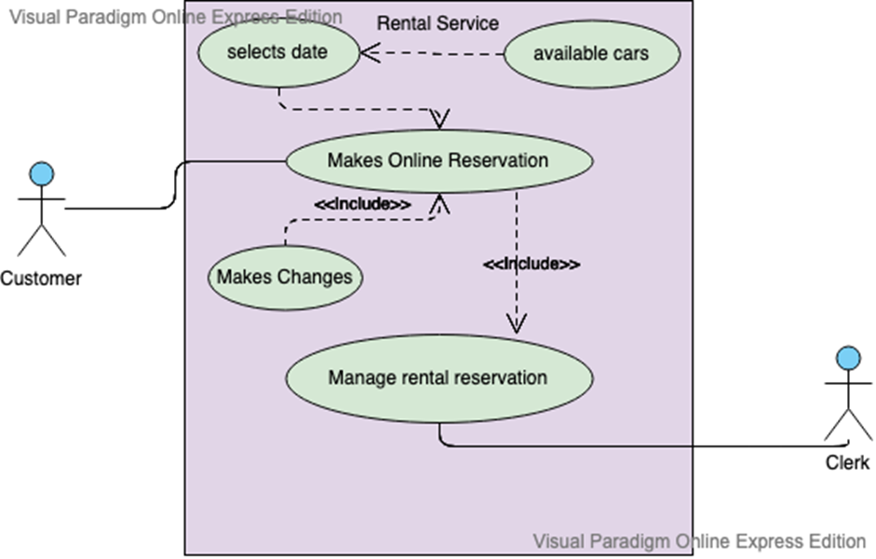

**Use Case Diagram: Pick up & Drop off**

