
FACULTY OF INFORMATION AND COMMUNICATION TECHNOLOGIES
SUMMER 2026
FINAL EXAMINATION
COURSE TITLE: | Relational Database and Web Integration
COURSE CODE: | SEN3102
CREDIT VALUE | 6
INSTRUCTOR: | Engr. Tanwi Nkiamboh
DEPARTMENT | Software Engineering
EXAMINATION HALL | B.S. Chumbow Hall
DATE: | Monday, September 28, 2026
TIME: | 8:00 - 10:30

STUDENT NAME: | BAYIGA BOGMIS IVAN
REGISTRATION NUMBER: | ICTU20241784
GITHUB : | https://github.com/ivan-14-dev/exam_data_base_2026.git
PROJECT REPORT
Design and Implementation of a Conference and Ticketing Management System for ICTU Events Ltd
Relational database, relational algebra, SQL, web integration, optimisation and security

Table of Contents
1. Introduction 4
1.1 Context 4
1.2 Objectives 4
1.3 Tools and environment 4
1.4 Organisation of the project files 4
2. Part 1 – Database Design and Enhancement 5
2.1 Analysis of the dataset 5
2.2 Conceptual ER diagram (Part 1 – Q1) 5
2.3 Relational schema and integrity constraints 6
2.4 Additional tables (Part 1 – Q2) 7
2.5 Physical implementation 8
3. Part 2 – Dataset 9
4. Part 3 – Relational Algebra Queries 10
4.1 Attendees who booked more than 2 seats for any single event 10
4.2 Events that are fully booked 11
4.3 Speakers presenting at more than one event 11
4.4 Attendees who have not booked any event 11
4.5 Events where total revenue is greater than 30 000 12
5. Part 4 – SQL Queries 12
5.1 Q1 – New booking for Alice Nzokou (Cybersecurity Workshop, 2 seats) 12
5.2 Q2 – Ticket price of the AI in Education Forum set to 12 000 13
5.3 Q3 – Total revenue per event in descending order 14
5.4 Q4 – Sessions with event name, speaker full name and session time 14
5.5 Q5 – Attendee who spent the most money 15
5.6 Q6 – Automatic update of the available seats 15
6. Part 5 – Web Application Integration 18
6.1 Architecture 18
6.2 Q1 – Responsive event listing page 19
6.3 Q2 – Ticket booking form linked to the database 20
6.4 Q3 – Secure user authentication 22
7. Part 6 – Optimization and Security 23
7.1 Q1 – Indexes on event names and booking dates 23
7.2 Q2 – Prepared statements against SQL injection 24
7.3 Q3 – Performance optimisation strategies applied 25
8. Testing 26
9. Installation Guide 27
10. Conclusion 27
References 27

1. Introduction

1.1 Context
ICTU Events Ltd organises conferences, workshops and forums and needs a single system to manage its attendees, speakers, events, bookings, sessions and payments. The company asked for a full-stack solution in which a relational database is integrated with a secure web application, with attention paid to both performance and security.
This report documents the complete work carried out for the examination: the design of the database, the loading of the dataset provided, the relational algebra and SQL answers, the web application and the optimisation and security measures. Every SQL script and every page of the application was executed on a real MariaDB server; the screenshots included in this report are the actual results obtained.

1.2 Objectives
- Part 1 – model the data with a complete ER diagram and propose two additional tables;
- Part 2 – create the database and load the dataset exactly as provided;
- Part 3 – answer five questions in relational algebra;
- Part 4 – write the SQL statements, including a stored procedure for the seat counter;
- Part 5 – build a responsive listing page, a booking form and a secure authentication module;
- Part 6 – optimise searches with indexes, protect against SQL injection and explain the optimisation strategies used.

1.3 Tools and environment
Table 1: Software environment used for the project
Component | Technology | Role
Database server | MariaDB 10.11.14 (InnoDB, utf8mb4) | Storage, constraints, trigger, procedure, indexes
Server-side language | PHP 8.3.6 with PDO (pdo_mysql) | Business logic and database access
Client side | HTML5, CSS3 (Grid, media queries), JavaScript | Responsive user interface
Operating system | Ubuntu 24.04 LTS | Development and test machine
Tools | Visual Studio Code, MariaDB client, Google Chrome, curl | Editing, execution and testing

1.4 Organisation of the project files
The deliverable is organised so that the database scripts can be executed in numerical order and the web server only exposes the public folder:

Part 1 Database Design and Enhancement

2.1 Analysis of the dataset
The dataset contains five tables. Attendees, Speakers and Events describe independent real-world objects and become strong entities. Bookings links an attendee to an event and carries its own data (number of seats, amount, date); Sessions links an event to a speaker and carries a title and a time slot.
Each of them therefore resolves a many-to-many relationship: Attendee–Event for Bookings and Event–Speaker for Sessions. The resulting relationships are summarised in Table 2.
Table 2: Relationships identified in the dataset
Relationship | Cardinality | Participation | Implemented by
ATTENDEE makes BOOKING | 1 : N | Booking total, attendee partial | bookings.attendee_id → attendees
BOOKING concerns EVENT | N : 1 | Booking total, event partial | bookings.event_id → events
EVENT includes SESSION | 1 : N | Session total | sessions.event_id → events
SPEAKER presents SESSION | 1 : N | Session total, speaker partial | sessions.speaker_id → speakers

2.2 Conceptual ER diagram (Part 1 – Q1)
Figure 1 gives the complete conceptual model in Chen notation. Entities are drawn as rectangles, relationships as diamonds and attributes as ellipses; primary keys are underlined. The double lines show total participation: a booking cannot exist without an attendee and an event, and a session cannot exist without an event and a speaker. The attribute available_seats is drawn with a dashed ellipse because it is derived (total seats minus the seats already booked); it was added to the Events table to support the booking procedure of Part 4.
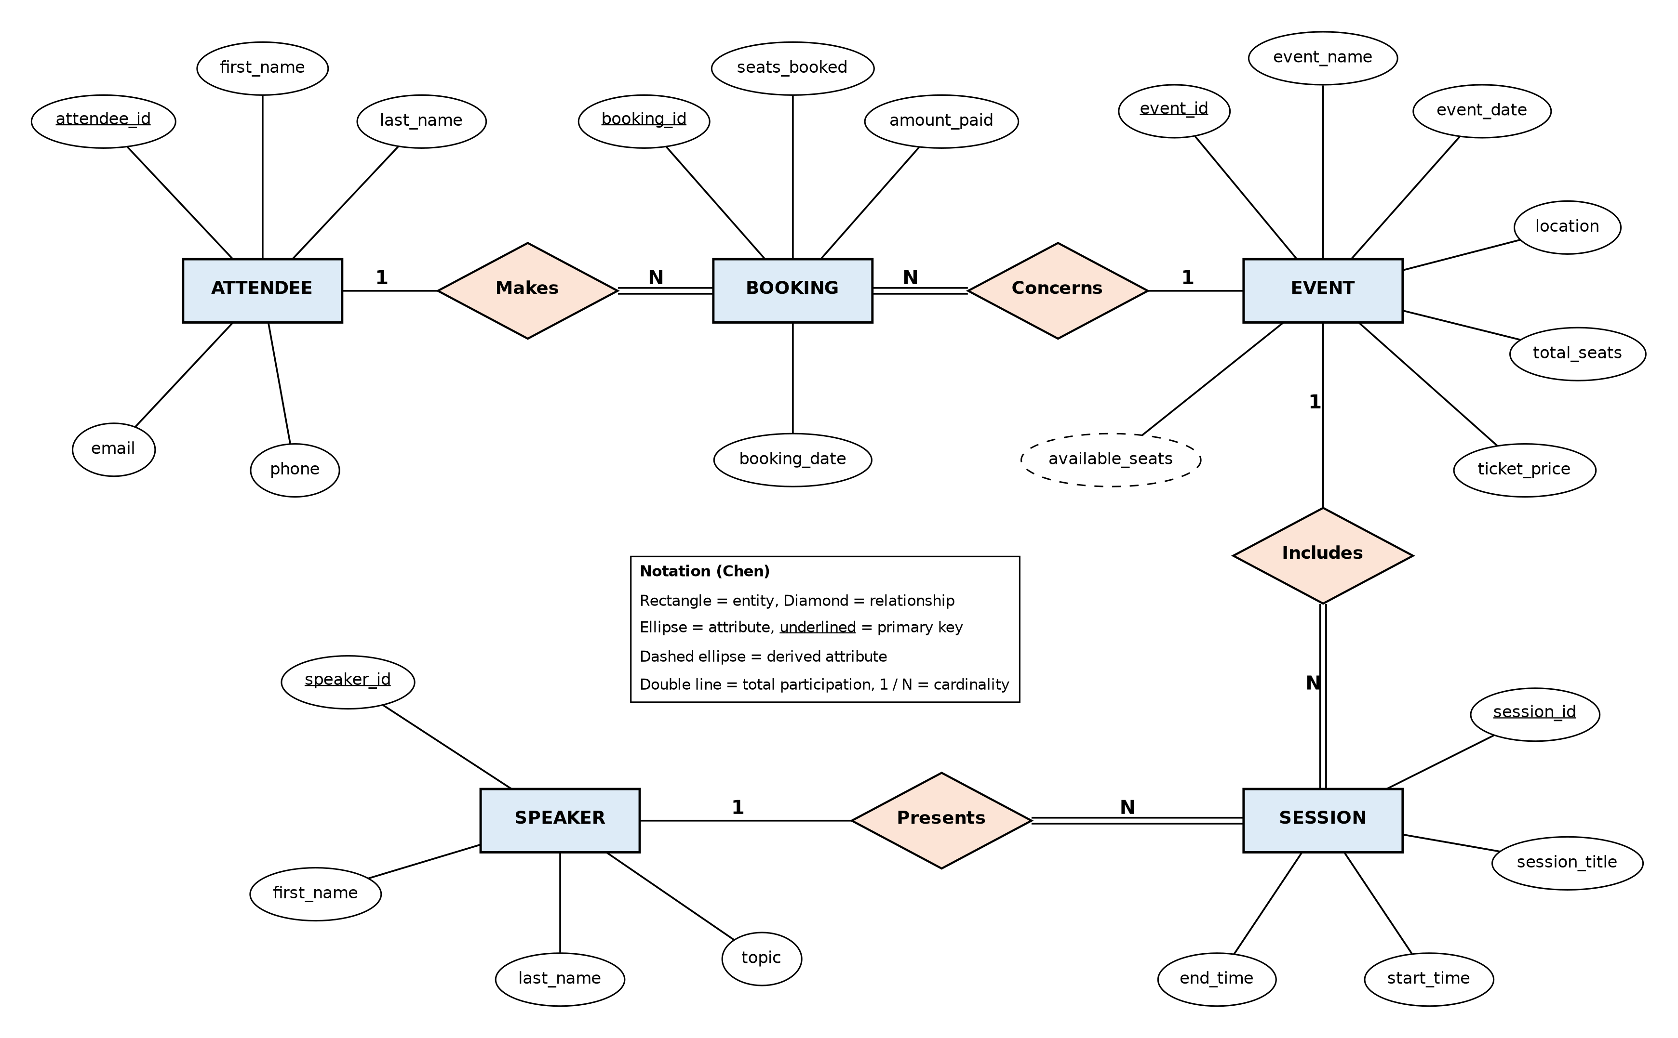
Figure 1: Conceptual ER diagram of the dataset tables (Chen notation)

2.3 Relational schema and integrity constraints
The conceptual model was mapped to relations following the usual rules: each entity becomes a table, and each 1:N relationship is represented by a foreign key on the N side. The schema is in third normal form: every non-key attribute depends only on the primary key of its table (the ticket price, for instance, is stored once in Events and never repeated elsewhere). The amount in Bookings is not a duplication of the price: it records what the attendee actually paid, which remains correct even if the price changes later.
Table 3: Keys and integrity constraints of the implemented tables
Table | Primary key | Foreign keys | Other constraints
attendees | attendee_id | – | UNIQUE(email)
speakers | speaker_id | – | NOT NULL on names and topic
events | event_id | – | CHECK total_seats > 0, CHECK available_seats ≤ total_seats, CHECK ticket_price ≥ 0, UNIQUE(event_date, event_name)
bookings | booking_id | attendee_id, event_id (ON DELETE RESTRICT) | CHECK seats_booked > 0, CHECK amount_paid ≥ 0
sessions | session_id | event_id (CASCADE), speaker_id (RESTRICT) | CHECK end_time > start_time

Monetary values use DECIMAL(10,2) to avoid rounding errors, and ON DELETE RESTRICT on the bookings protects the financial history: an event or an attendee that has bookings cannot be deleted by mistake.

2.4 Additional tables (Part 1 – Q2)

2.4.1 PAYMENTS
The scenario requires the system to manage payments, but the dataset only keeps a single amount_paid value per booking. A separate PAYMENTS table (one booking, zero or many payments) records how and when each booking was paid – MTN Mobile Money, Orange Money, card or cash – together with the operator's transaction reference, which is unique so the same payment cannot be recorded twice. It also supports a status (pending, completed, failed, refunded), payment in instalments and refunds when an event is cancelled, and it gives the accounting department an audit trail to reconcile the revenue of each event.
Additional table 1: every payment transaction of a booking
CREATE TABLE payments (
payment_id INT UNSIGNED AUTO_INCREMENT PRIMARY KEY,
booking_id INT UNSIGNED NOT NULL,
amount DECIMAL(10,2) NOT NULL,
payment_method ENUM('MTN_MOMO','ORANGE_MONEY','CARD','CASH') NOT NULL,
transaction_ref VARCHAR(64) NOT NULL,
status ENUM('PENDING','COMPLETED','FAILED','REFUNDED') NOT NULL DEFAULT 'PENDING',
paid_at DATETIME NOT NULL DEFAULT CURRENT_TIMESTAMP,
CONSTRAINT uq_payments_ref UNIQUE (transaction_ref), no double recording
CONSTRAINT fk_payments_booking FOREIGN KEY (booking_id)
REFERENCES bookings (booking_id) ON UPDATE CASCADE ON DELETE RESTRICT,
CONSTRAINT ck_payments_amount CHECK (amount > 0)
) ENGINE = InnoDB;

2.4.2 USERS
Part 5 requires secure authentication, which needs a place to store credentials. Keeping them in a USERS table separate from ATTENDEES isolates sensitive data (password hashes) from contact data, allows roles (attendee or administrator) and stores the counters used to lock an account after repeated failed logins. The link to ATTENDEES is one-to-zero-or-one, so a person registered at the desk can later open an online account.
Additional table 2: login accounts of the web application
CREATE TABLE users (
user_id INT UNSIGNED AUTO_INCREMENT PRIMARY KEY,
attendee_id INT UNSIGNED NULL,
email VARCHAR(120) NOT NULL,
password_hash VARCHAR(255) NOT NULL, bcrypt hash, never the password
role ENUM('ATTENDEE','ADMIN') NOT NULL DEFAULT 'ATTENDEE',
failed_attempts TINYINT UNSIGNED NOT NULL DEFAULT 0, brute-force protection
locked_until DATETIME NULL,
created_at DATETIME NOT NULL DEFAULT CURRENT_TIMESTAMP,
last_login_at DATETIME NULL,
CONSTRAINT uq_users_email UNIQUE (email),
CONSTRAINT uq_users_attendee UNIQUE (attendee_id), 1 : 0..1 with attendees
CONSTRAINT fk_users_attendee FOREIGN KEY (attendee_id)
REFERENCES attendees (attendee_id) ON UPDATE CASCADE ON DELETE CASCADE
) ENGINE = InnoDB;
Figure 2 shows the complete logical model with the seven tables in crow's foot notation, the dataset tables in blue and the two additional tables in orange.
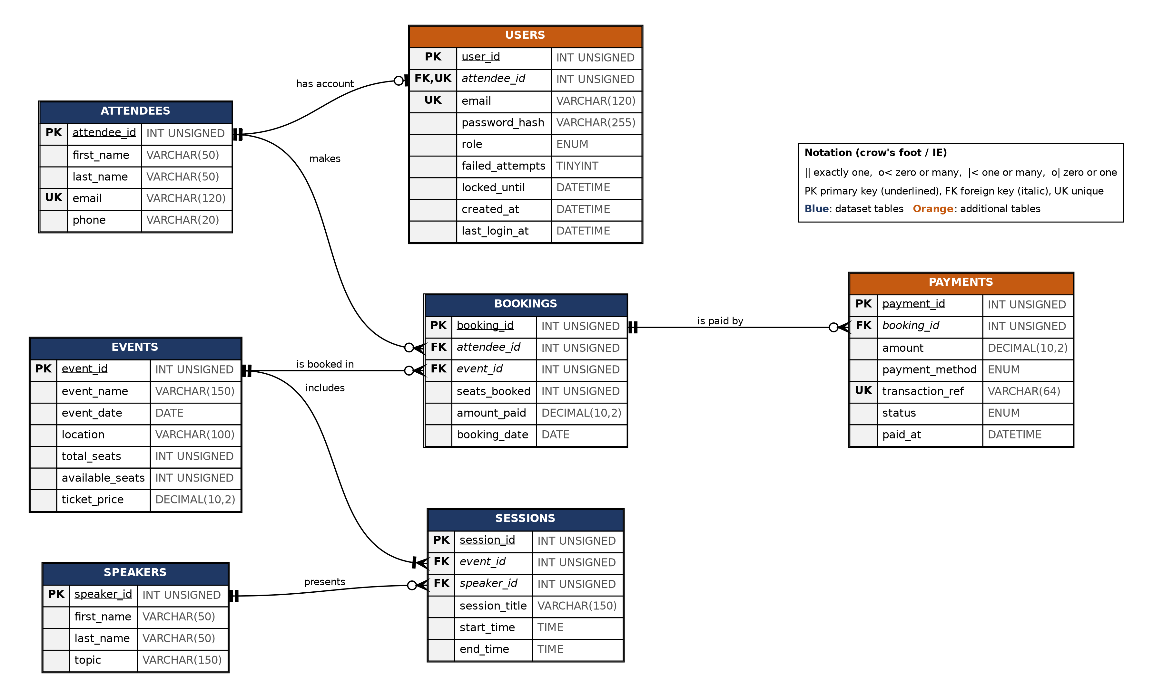
Figure 2: Logical ER diagram of the complete database (crow's foot notation)

2.5 Physical implementation
The schema is created by 01_schema.sql. Figure 3 shows the seven tables present on the server and the structure of the BOOKINGS table with its keys.
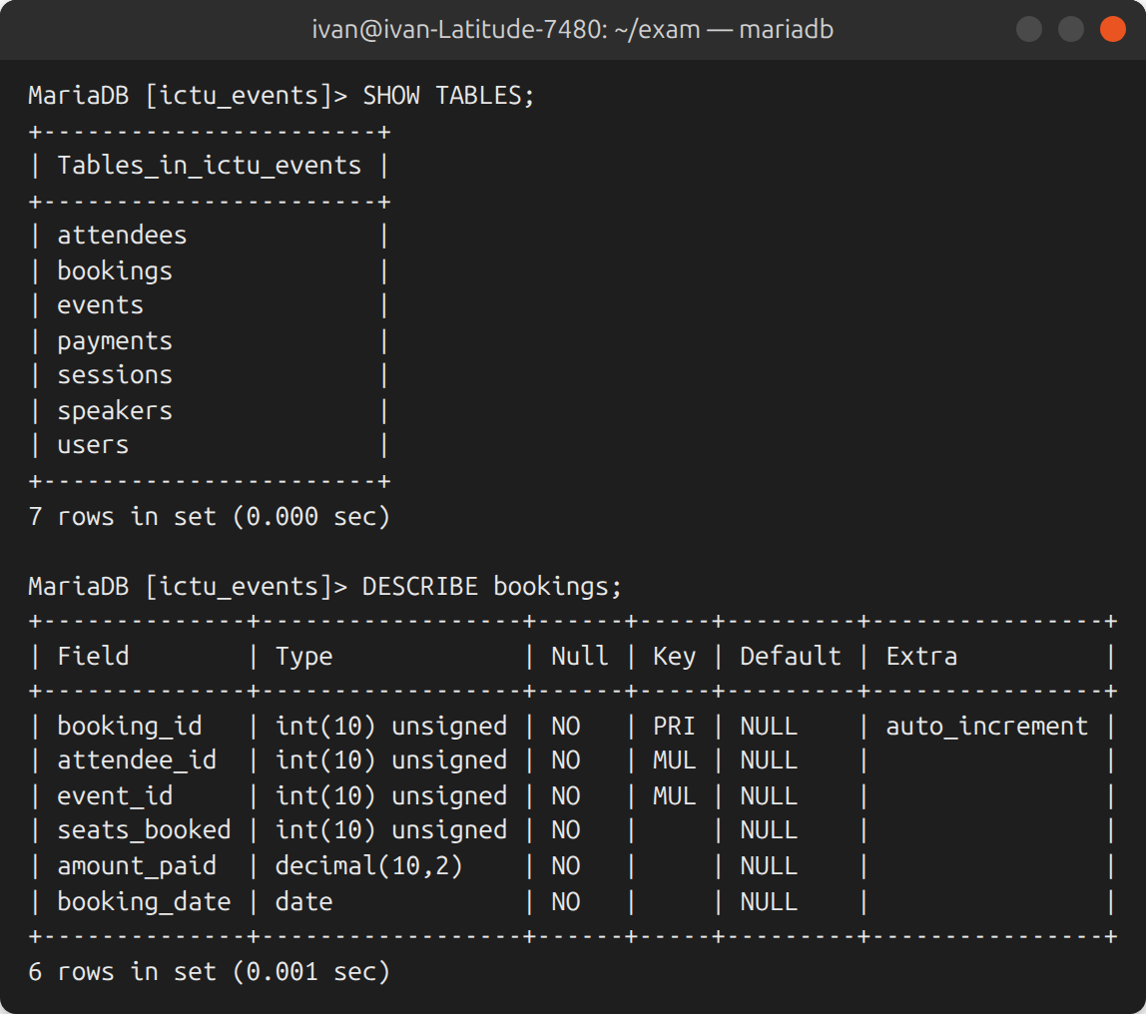
Figure 3: Tables of the ictu_events database and structure of BOOKINGS

3. Part 2 – Dataset
The data given in the examination paper was loaded without modification by 02_seed_data.sql (Table 4 to Table 8).
Table 4: Attendees
attendee_id | first_name | last_name | email | phone
1 | John | Nangu | nangu@ict.edu.cm | 678475601
2 | Pascal | Cho | cho@ict.edu.cm | 677710578
3 | Winnie | Onari | onari@ict.edu.cm | 690871033
4 | Grace | Tima | tima@ict.edu.cm | 655091237

Table 5: Speakers
speaker_id | first_name | last_name | topic
1 | Prof | Ngwa | AI in Education
2 | Dr | Cheikh | Cybersecurity Trends
3 | Engr | Nanga | Web App Optimization

Table 6: Events
event_id | event_name | event_date | location | total_seats | ticket_price
1 | Tech Conference 2025 | 2025-09-15 | Main Hall | 100 | 15000.0
2 | Cybersecurity Workshop | 2025-09-20 | Lab A | 50 | 20000.0
3 | AI in Education Forum | 2025-09-25 | Auditorium | 150 | 10000.0

Table 7: Bookings
booking_id | attendee_id | event_id | seats_booked | amount_paid | booking_date
1 | 1 | 1 | 2 | 30000.0 | 2025-08-01
2 | 2 | 1 | 1 | 15000.0 | 2025-08-03
3 | 3 | 2 | 1 | 20000.0 | 2025-08-05
4 | 4 | 3 | 3 | 30000.0 | 2025-08-06

Table 8: Sessions
session_id | event_id | speaker_id | session_title | start_time | end_time
1 | 1 | 1 | AI Overview | 09:00 | 10:30
2 | 1 | 3 | Optimizing Web Apps | 11:00 | 12:30
3 | 2 | 2 | Cyber Threats 2025 | 10:00 | 12:00
4 | 3 | 1 | AI in Classrooms | 14:00 | 15:30

Because the dataset does not contain the remaining seats, the derived column available_seats was initialised from the existing bookings with a single set-based statement:
available_seats = total_seats - SUM(seats_booked), for every event
UPDATE events e
LEFT JOIN (SELECT event_id, SUM(seats_booked) AS booked
FROM bookings GROUP BY event_id) b ON b.event_id = e.event_id
SET e.available_seats = e.total_seats - COALESCE(b.booked, 0);
This gives 97 seats for the Tech Conference (100 − 3), 49 for the Cybersecurity Workshop (50 − 1) and 147 for the AI in Education Forum (150 − 3), as visible in Figure 4. Four sample payments and one demo account (nangu@ict.edu.cm) were also inserted to test the additional tables.
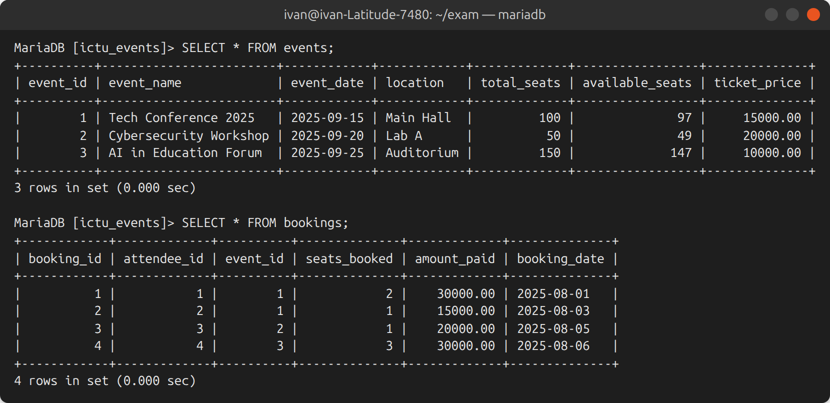
Figure 4: Events and Bookings after loading the dataset

4. Part 3 – Relational Algebra Queries
The following notation is used: σ selection, π projection, ⋈ natural join, × Cartesian product, ρ rename, set difference, ∧ logical AND and γ grouping with aggregation (extended relational algebra, needed as soon as a sum or a count is involved). Each expression was translated into SQL and executed on the original dataset (03_part3_relational_algebra_check.sql) to check the result.

4.1 Attendees who booked more than 2 seats for any single event
Step 1 adds up the seats per attendee and per event, in case the same person booked the same event several times. Step 2 keeps the groups above two seats and retrieves the names.
T ← γattendee_id, event_id ; SUM(seats_booked) → seats (Bookings)
R1 ← πattendee_id, first_name, last_name ( σ_{seats > 2} (T) ⋈ Attendees )
The totals are 2, 1, 1 and 3 seats; only Grace Tima (3 seats for the AI in Education Forum) satisfies the condition (Figure 5).
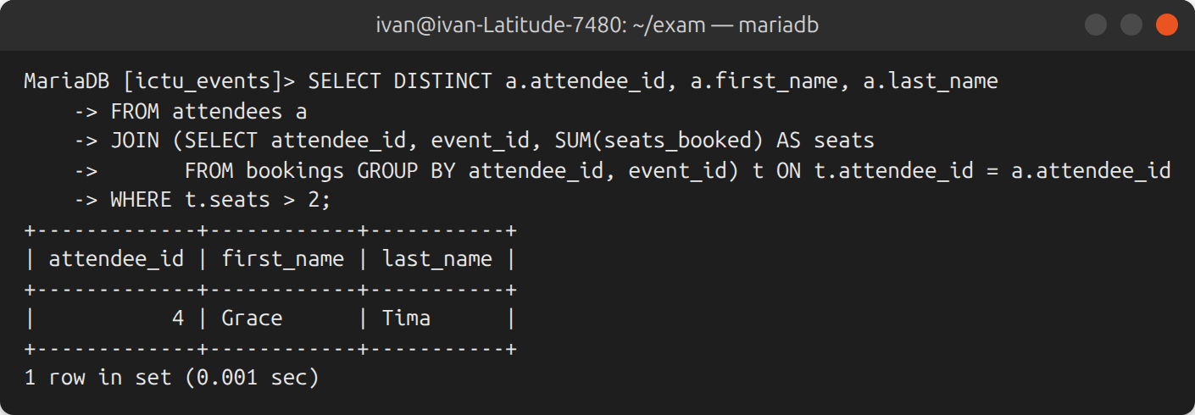
Figure 5: Verification of RA 1

4.2 Events that are fully booked
An event is full when the seats already booked reach its capacity.
B ← γevent_id ; SUM(seats_booked) → booked (Bookings)
R2 ← π_{event_id, event_name} ( σ_{booked ≥ total_seats} ( Events ⋈ B ) )
With the derived column the same result is obtained by π_{event_id, event_name}(σ_{available_seats = 0}(Events)). The events have 3/100, 1/50 and 3/150 seats booked, so the result is the empty relation (Figure 6): no event is fully booked.
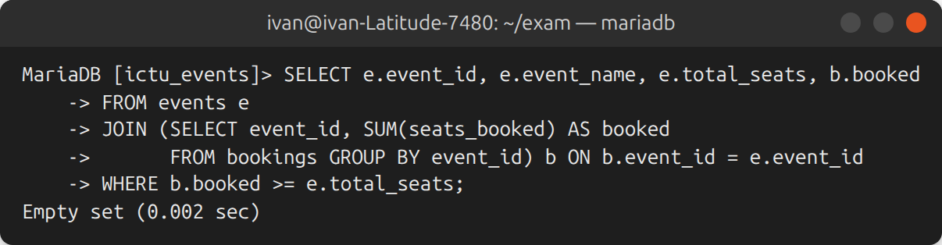
Figure 6: Verification of RA 2 (empty result)

4.3 Speakers presenting at more than one event
The Sessions relation is joined with a renamed copy of itself to find two sessions of the same speaker in different events. This version only uses basic operators.
S1 ← ρ_{S1}(Sessions) S2 ← ρ_{S2}(Sessions)
P ← π_{S1.speaker_id} ( σS1.speaker_id = S2.speaker_id ∧ S1.event_id ≠ S2.event_id ( S1 × S2 ) )
R3 ← πspeaker_id, first_name, last_name, topic ( P ⋈ Speakers )
An equivalent form with aggregation is σ_{n > 1}(γspeaker_id ; COUNT(DISTINCT event_id) → n(Sessions)) ⋈ Speakers. Prof Ngwa presents "AI Overview" (event 1) and "AI in Classrooms" (event 3) and is the only result (Figure 7).
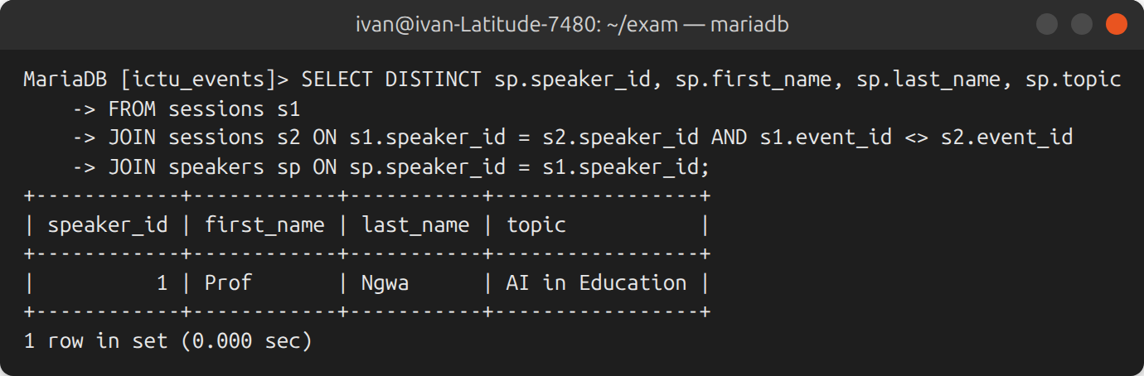
Figure 7: Verification of RA 3

4.4 Attendees who have not booked any event
The identifiers that appear in Bookings are removed from the set of all attendee identifiers, and the result is joined back to Attendees to obtain the names.
R4 ← ( π_{attendee_id}(Attendees) − π_{attendee_id}(Bookings) ) ⋈ Attendees
{1, 2, 3, 4} − {1, 2, 3, 4} = ∅: every attendee of the dataset has at least one booking (Figure 8). A new attendee who registers without booking would appear in this result.
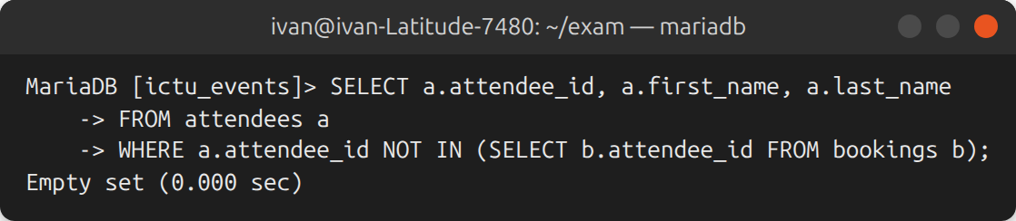
Figure 8: Verification of RA 4 (empty result)

4.5 Events where total revenue is greater than 30 000
R ← γevent_id ; SUM(amount_paid) → revenue (Bookings)
R5 ← π_{event_id, event_name, revenue} ( σ_{revenue > 30000} ( R ⋈ Events ) )
The revenues are 45 000 (30 000 + 15 000) for the Tech Conference, 20 000 for the Cybersecurity Workshop and 30 000 for the AI in Education Forum. Since the condition is strictly greater than 30 000, only the Tech Conference 2025 is returned (Figure 9).
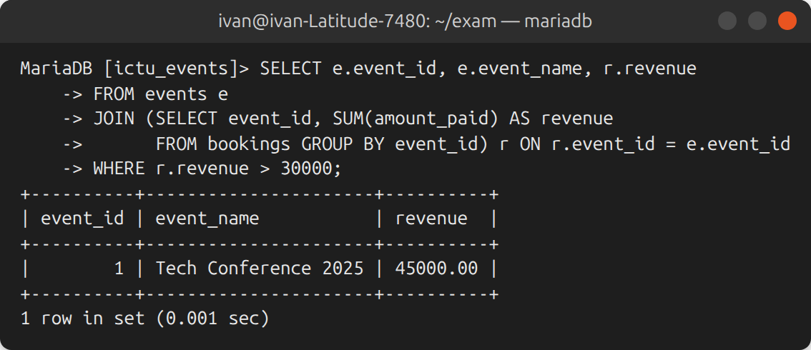
Figure 9: Verification of RA 5

5. Part 4 – SQL Queries
The objects of Q6 (trigger and stored procedure) are installed first by 04_part4_q6_trigger_and_procedure.sql, so that every booking, including the one of Q1, updates the seat counter automatically. The queries are then executed in the order of the questions by 05_part4_queries.sql; each result therefore takes into account the changes made by the previous questions.

5.1 Q1 – New booking for Alice Nzokou (Cybersecurity Workshop, 2 seats)
Alice Nzokou does not exist in the Attendees table, so she is registered first. Her e-mail address follows the pattern of the other attendees and her phone number, which is unknown, is left NULL. The identifiers and the price are looked up instead of being typed by hand, and the whole operation runs in one transaction.
START TRANSACTION;
Step 1: register Alice only if her e-mail does not exist yet
INSERT INTO attendees (first_name, last_name, email, phone)
SELECT 'Alice', 'Nzokou', 'nzokou@ict.edu.cm', NULL
FROM DUAL
WHERE NOT EXISTS (SELECT 1 FROM attendees WHERE email = 'nzokou@ict.edu.cm');
Step 2: look up Alice's id, the event id and its current price
SELECT attendee_id INTO @alice_id FROM attendees WHERE email = 'nzokou@ict.edu.cm';
SELECT event_id, ticket_price INTO @event_id, @price
FROM events WHERE event_name = 'Cybersecurity Workshop';
Step 3: insert the booking (amount = 2 x ticket price);
the trigger of Q6 decreases available_seats by 2
INSERT INTO bookings (attendee_id, event_id, seats_booked, amount_paid, booking_date)
VALUES (@alice_id, @event_id, 2, @price * 2, CURDATE());
COMMIT;
An INSERT … VALUES with variables is used instead of INSERT … SELECT … FROM events, because MariaDB does not allow a trigger to modify a table that is read by the statement which fired it (error 1442). Figure 10 shows the booking #5 of 40 000 FCFA and the counter going from 49 to 47 seats.
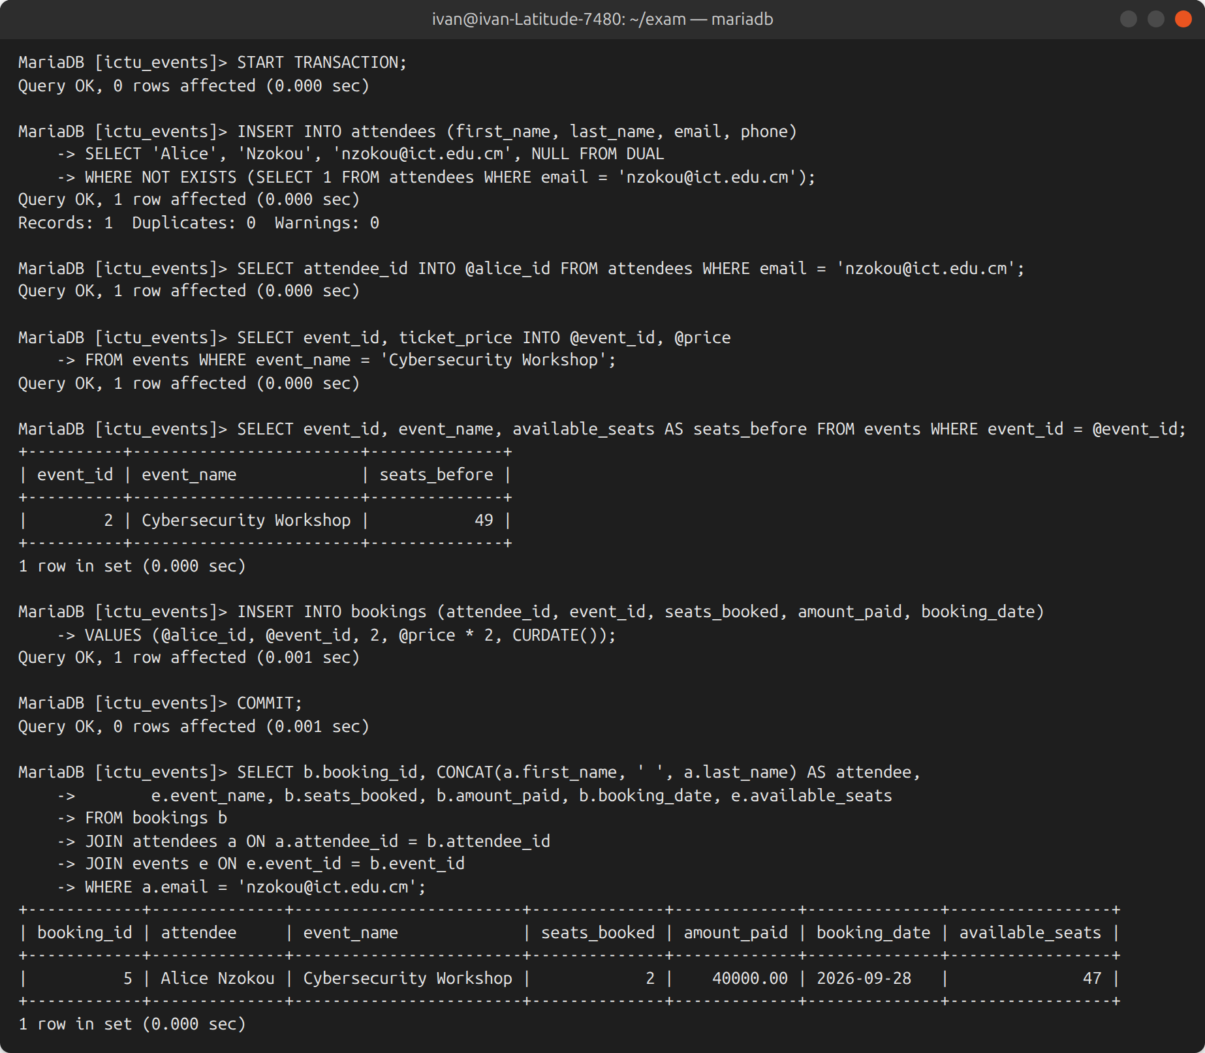
Figure 10: Execution of Q1

5.2 Q2 – Ticket price of the AI in Education Forum set to 12 000
Only future bookings are affected: amount_paid of past bookings is historical
UPDATE events
SET ticket_price = 12000.00
WHERE event_name = 'AI in Education Forum';
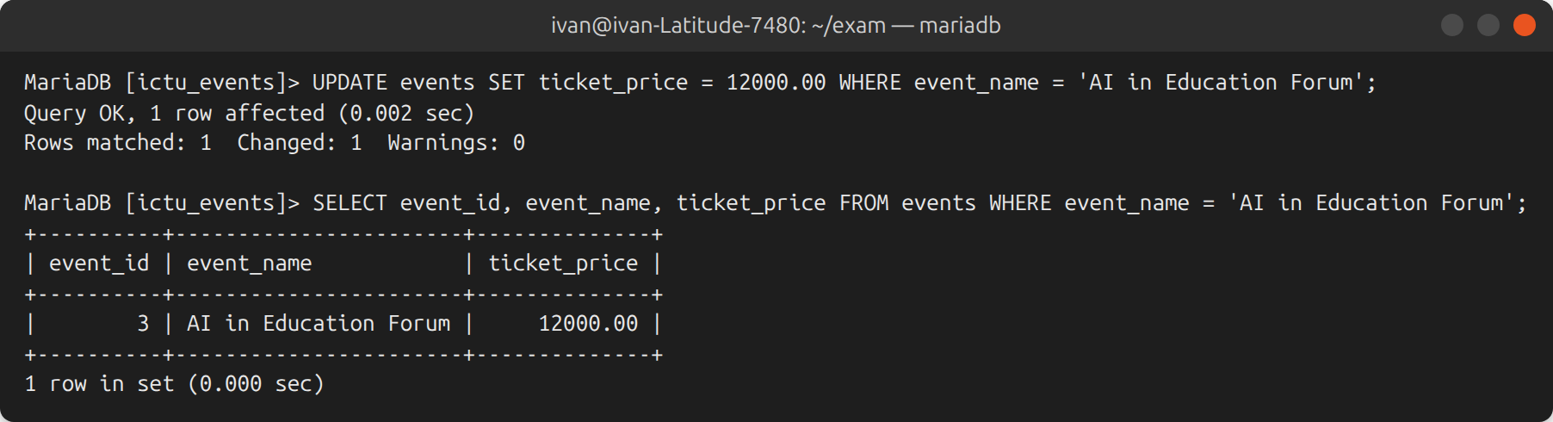
Figure 11: Execution of Q2

5.3 Q3 – Total revenue per event in descending order
SELECT e.event_id,
e.event_name,
COALESCE(SUM(b.amount_paid), 0) AS total_revenue 0 for an event without booking
FROM events e
LEFT JOIN bookings b ON b.event_id = e.event_id LEFT JOIN keeps every event
GROUP BY e.event_id, e.event_name
ORDER BY total_revenue DESC;
The Cybersecurity Workshop now comes first with 60 000 FCFA (20 000 + 40 000 from Alice's booking), followed by the Tech Conference (45 000) and the AI in Education Forum (30 000), as shown in Figure 12.
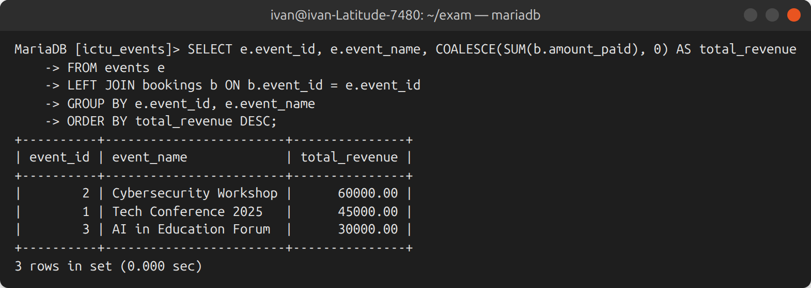
Figure 12: Execution of Q3

5.4 Q4 – Sessions with event name, speaker full name and session time
SELECT s.session_id,
e.event_name,
CONCAT(sp.first_name, ' ', sp.last_name) AS speaker_full_name,
s.session_title,
CONCAT(TIME_FORMAT(s.start_time, '%H:%i'), ' - ',
TIME_FORMAT(s.end_time, '%H:%i')) AS session_time
FROM sessions s
JOIN events e ON e.event_id = s.event_id name of the event
JOIN speakers sp ON sp.speaker_id = s.speaker_id name of the speaker
ORDER BY e.event_date, s.start_time; programme in chronological order
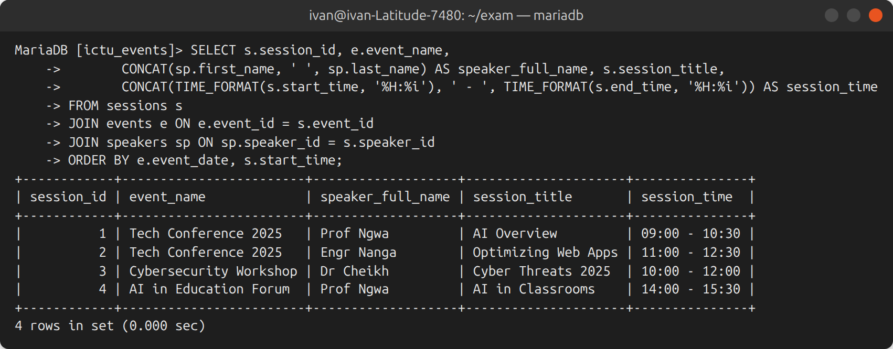
Figure 13: Execution of Q4

5.5 Q5 – Attendee who spent the most money
Step 1: total spent by each attendee
WITH spending AS (
SELECT a.attendee_id,
CONCAT(a.first_name, ' ', a.last_name) AS attendee_name,
SUM(b.amount_paid) AS total_spent
FROM attendees a
JOIN bookings b ON b.attendee_id = a.attendee_id
GROUP BY a.attendee_id, a.first_name, a.last_name
)
Step 2: keep every attendee whose total equals the maximum (handles ties)
SELECT attendee_id, attendee_name, total_spent
FROM spending
WHERE total_spent = (SELECT MAX(total_spent) FROM spending);
Comparing with MAX() was preferred to ORDER BY … LIMIT 1: in the original dataset John Nangu and Grace Tima are tied at 30 000 FCFA, and LIMIT 1 would have returned only one of them. After Q1, Alice Nzokou is the only top spender with 40 000 FCFA (Figure 14).
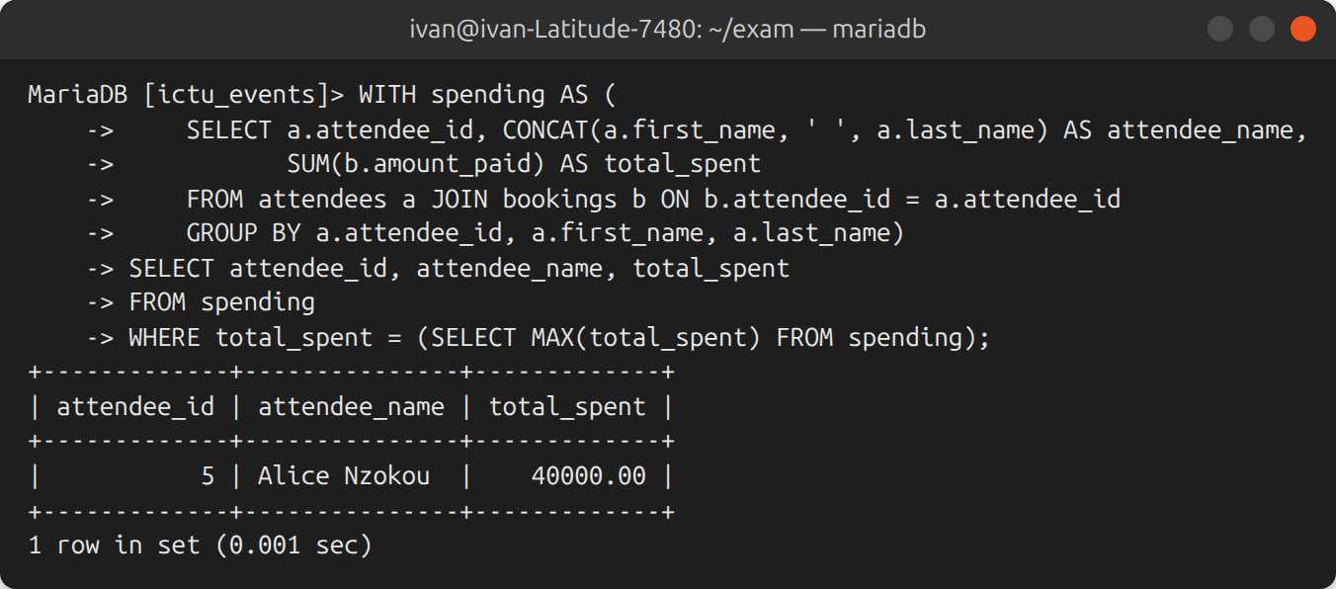
Figure 14: Execution of Q5

5.6 Q6 – Automatic update of the available seats
For the seats to be updated automatically whenever a booking is made, whatever the way the row is inserted, the logic was split between two database objects: an AFTER INSERT trigger on BOOKINGS, which decreases the counter, and the stored procedure sp_make_booking, which is the booking entry point used by the web application.

5.6.1 Trigger
DELIMITER $$
CREATE TRIGGER trg_bookings_after_insert
AFTER INSERT ON bookings
FOR EACH ROW
BEGIN
Step 1: decrease the seats only if enough of them remain
UPDATE events
SET available_seats = available_seats - NEW.seats_booked
WHERE event_id = NEW.event_id
AND available_seats >= NEW.seats_booked;
Step 2: no row updated = not enough seats -> the INSERT is cancelled
IF ROW_COUNT() = 0 THEN
SIGNAL SQLSTATE '45000' SET MESSAGE_TEXT = 'Not enough seats available for this event';
END IF;
END$$
The trigger runs inside the statement that inserted the booking. If it raises an error, InnoDB cancels the insertion as well, so the counter can never disagree with the bookings.

5.6.2 Stored procedure
CREATE PROCEDURE sp_make_booking(
IN p_attendee_id INT UNSIGNED,
IN p_event_id INT UNSIGNED,
IN p_seats INT,
OUT p_booking_id INT UNSIGNED)
MODIFIES SQL DATA
BEGIN
DECLARE v_available INT UNSIGNED DEFAULT NULL;
DECLARE v_price DECIMAL(10,2);
Step 1: on any error, undo the transaction and pass the error to the caller
DECLARE EXIT HANDLER FOR SQLEXCEPTION
BEGIN
ROLLBACK;
RESIGNAL;
END;
Step 2: validate the parameters
IF p_seats IS NULL OR p_seats <= 0 THEN
SIGNAL SQLSTATE '45000' SET MESSAGE_TEXT = 'Number of seats must be greater than zero';
END IF;
IF NOT EXISTS (SELECT 1 FROM attendees WHERE attendee_id = p_attendee_id) THEN
SIGNAL SQLSTATE '45000' SET MESSAGE_TEXT = 'Attendee not found';
END IF;
START TRANSACTION;
Step 3: read and lock the event row (prevents overselling under concurrency)
SELECT available_seats, ticket_price INTO v_available, v_price
FROM events WHERE event_id = p_event_id
FOR UPDATE;
IF v_available IS NULL THEN
SIGNAL SQLSTATE '45000' SET MESSAGE_TEXT = 'Event not found';
END IF;
IF v_available < p_seats THEN
SIGNAL SQLSTATE '45000' SET MESSAGE_TEXT = 'Not enough seats available for this event';
END IF;
Step 4: record the booking with the price computed by the server;
the trigger trg_bookings_after_insert then decreases the seats
INSERT INTO bookings (attendee_id, event_id, seats_booked, amount_paid, booking_date)
VALUES (p_attendee_id, p_event_id, p_seats, v_price * p_seats, CURDATE());
SET p_booking_id = LAST_INSERT_ID();
COMMIT;
END$$
DELIMITER ;
SELECT … FOR UPDATE locks the row of the event until the end of the transaction: if two customers try to buy the last seats at the same moment, the second one waits and then sees the updated counter. The procedure does not modify the seats itself, otherwise they would be counted twice. Figure 15 confirms that both objects exist on the server.
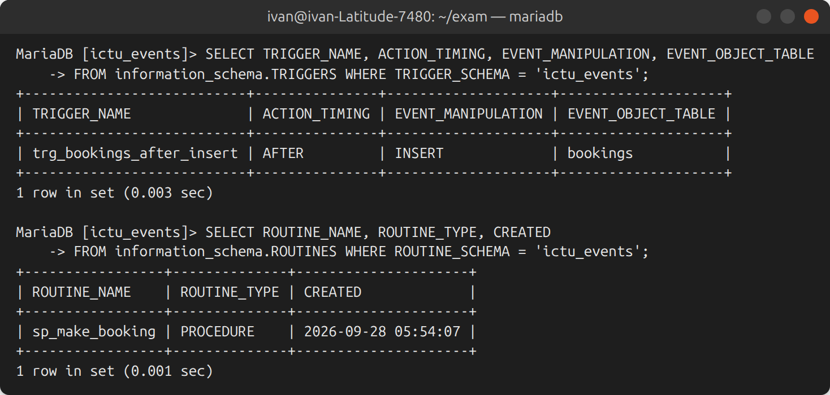
Figure 15: Trigger and stored procedure installed on the server
In Figure 16, Winnie Onari books 4 seats for the AI in Education Forum through the procedure. The amount (48 000 FCFA) is computed with the new price of Q2 and the seats go from 147 to 143.
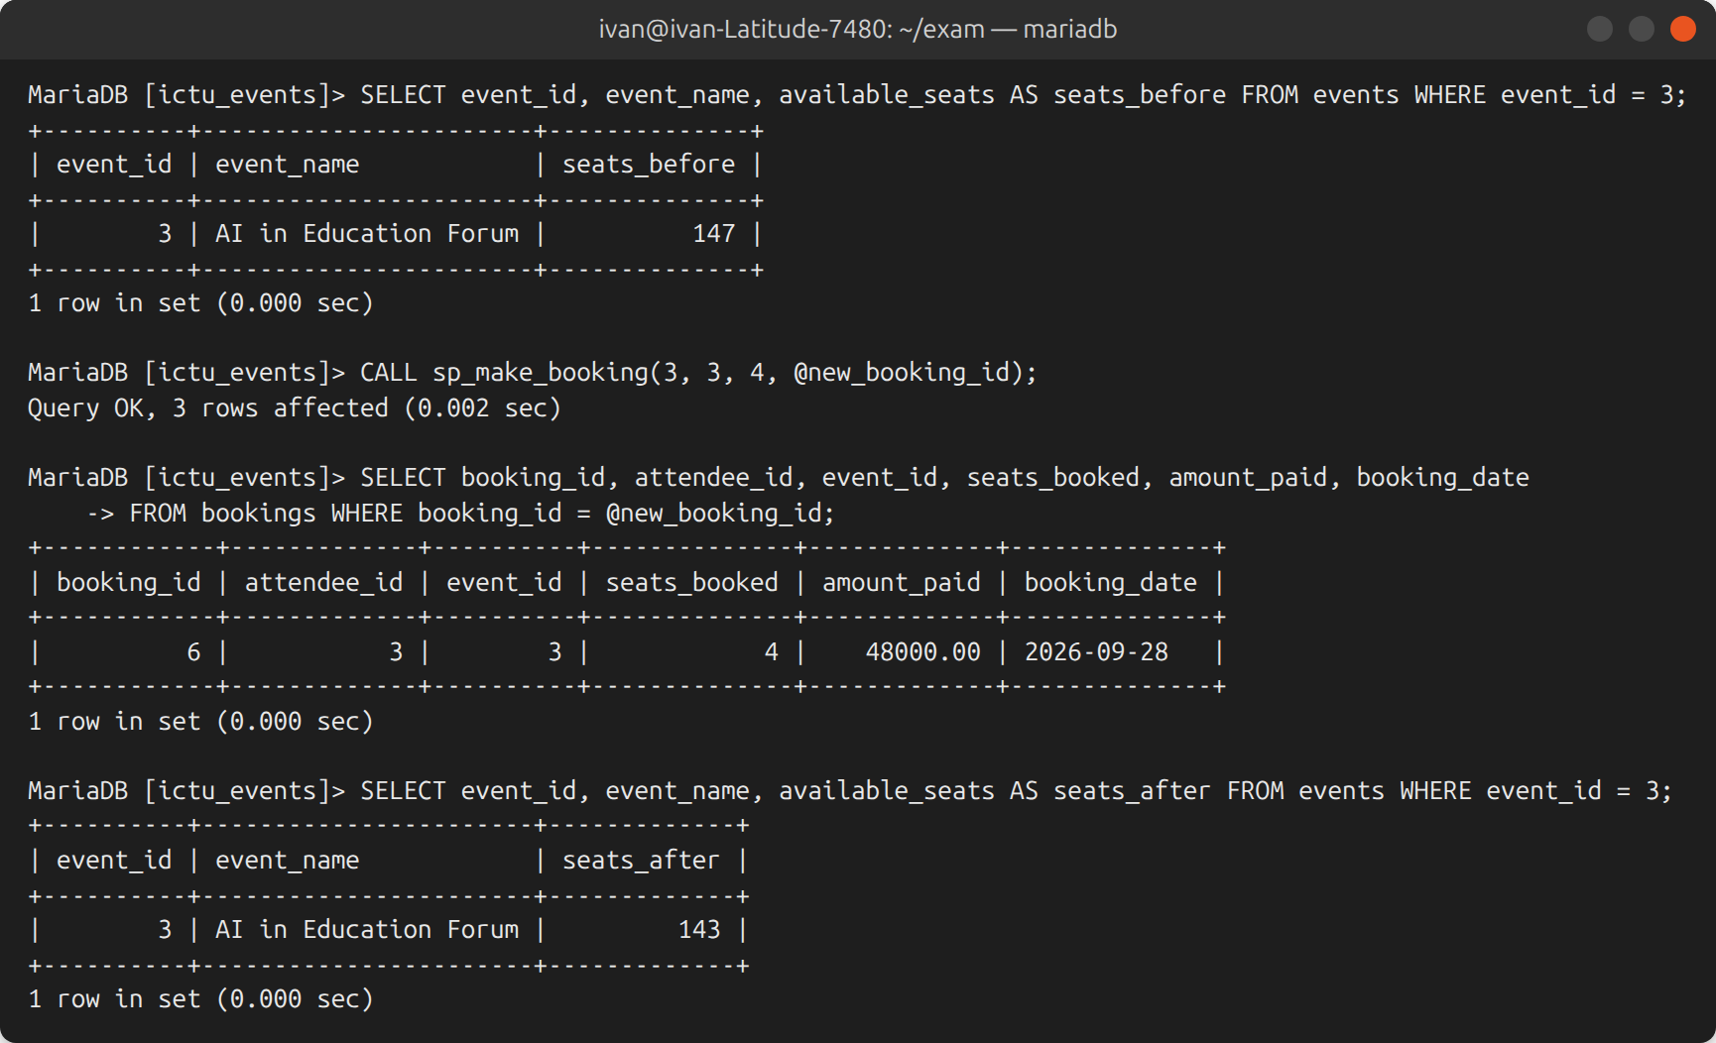
Figure 16: Booking through the stored procedure
Figure 17 shows that a direct INSERT into BOOKINGS, without the procedure, also updates the counter (97 → 94); the transaction was rolled back afterwards so as not to change the data. Figure 18 shows the error cases: too many seats, unknown event, zero seats and an oversized direct insertion refused by the trigger.
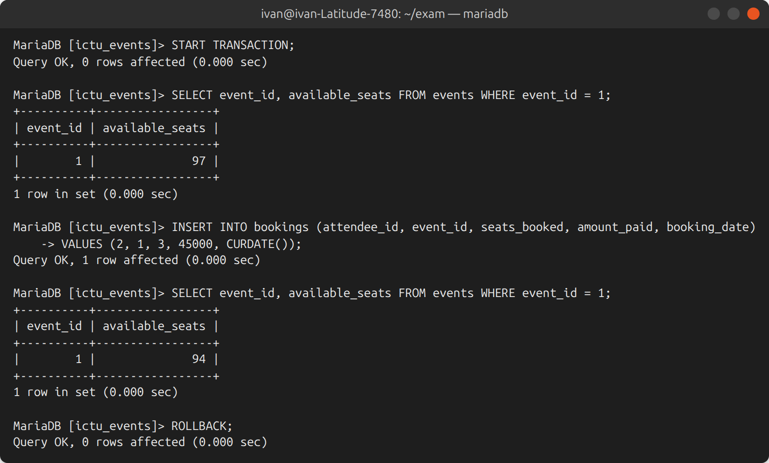
Figure 17: The trigger also fires on a direct INSERT
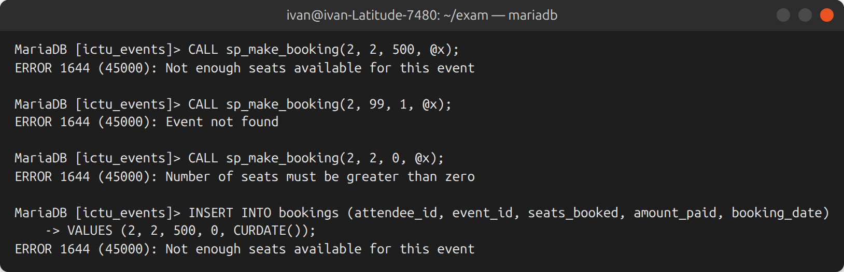
Figure 18: Bookings refused by the procedure and by the trigger

6. Part 5 – Web Application Integration

6.1 Architecture
The application follows a three-tier architecture (Figure 19). The browser only communicates with PHP scripts; PHP accesses MariaDB exclusively through PDO prepared statements with a restricted account (ictu_app) which can read the events, create attendees and accounts, and execute the booking procedure, but cannot drop, alter or delete anything. The database password is read from an environment variable and never appears in the source code.
Figure 19: Three-tier architecture of the application
// src/bootstrap.php - one PDO connection per request
$pdo = new PDO($dsn, $c['user'], $c['pass'], [
PDO::ATTR_ERRMODE => PDO::ERRMODE_EXCEPTION,
PDO::ATTR_DEFAULT_FETCH_MODE => PDO::FETCH_ASSOC,
PDO::ATTR_EMULATE_PREPARES => false, // real server-side prepared statements
]);

6.2 Q1 – Responsive event listing page
index.php displays every event as a card showing the date, location, price, the number of seats left out of the total and a filling bar. A badge turns red and the button is disabled when an event is sold out. The visitor can search an event by name and hide the events that no longer have seats.
// Build the query with placeholders only: user input never enters the SQL text
$sql = 'SELECT event_id, event_name, event_date, location,
total_seats, available_seats, ticket_price
FROM events WHERE 1 = 1';
$params = [];
if ($search !== '') {
$sql .= ' AND event_name LIKE :search'; // prefix search uses the index
$params[':search'] = addcslashes($search, '\\%_') . '%'; // escape % and _
}
if ($onlyAvail) {
$sql .= ' AND available_seats > 0';
}
$sql .= ' ORDER BY event_date, event_name';
$stmt = db()->prepare($sql);
$stmt->execute($params);
The layout is mobile-first and built with CSS Grid: one column on a phone, two columns from 640 px and three columns from 960 px (Figure 20 and Figure 21).
.grid { display: grid; grid-template-columns: 1fr; gap: 1rem; }
@media (min-width: 640px) { .grid { grid-template-columns: repeat(2, 1fr); } }
@media (min-width: 960px) { .grid { grid-template-columns: repeat(3, 1fr); } }
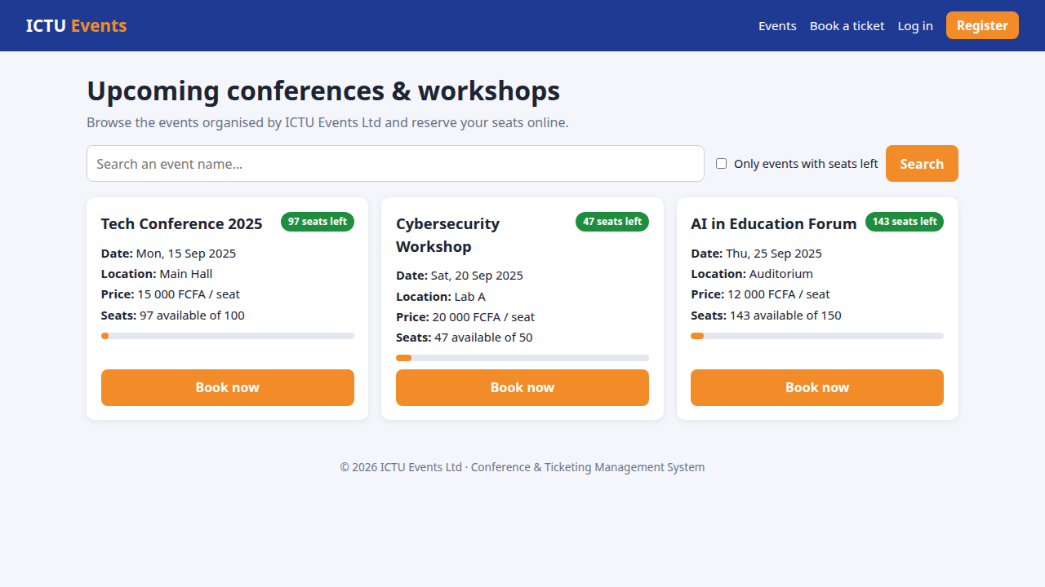
Figure 20: Event listing on a desktop screen
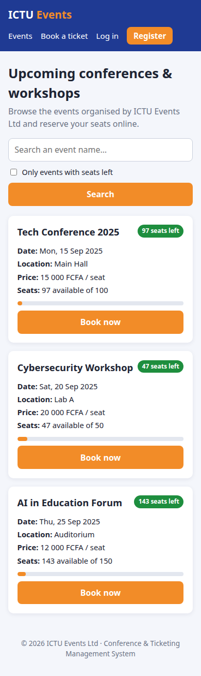 | 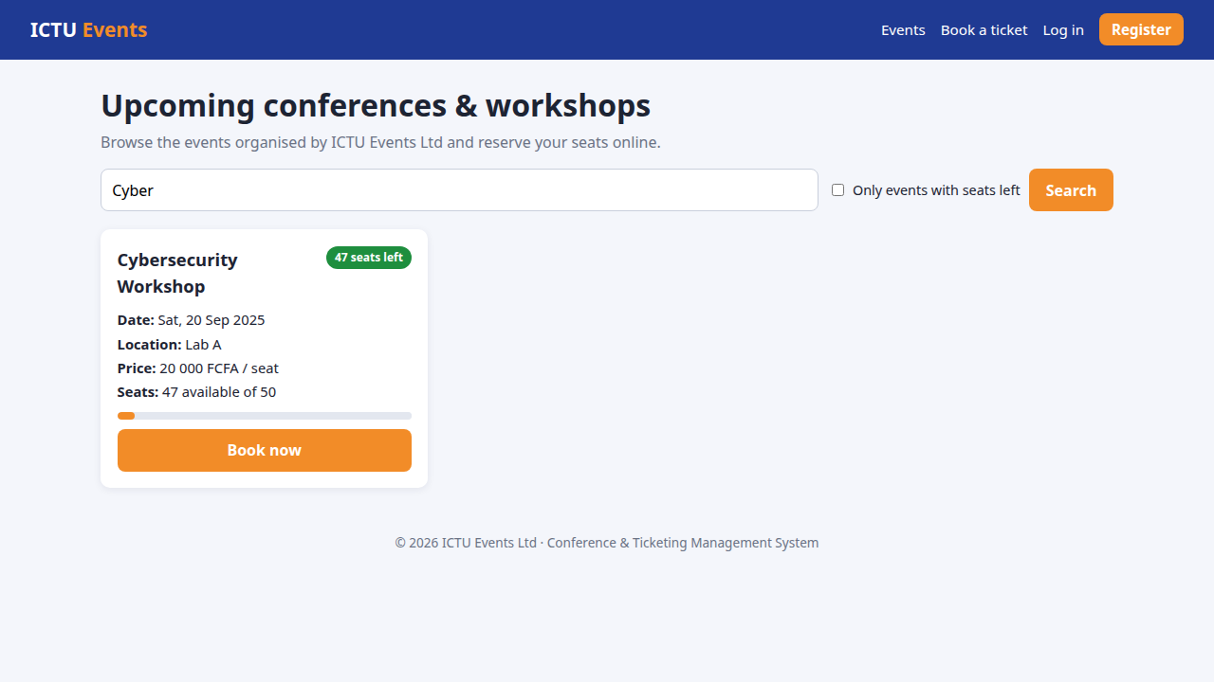
Figure 21: Left: the same page on a smartphone (390 px). Right: search for "Cyber"

6.3 Q2 – Ticket booking form linked to the database
book.php is only accessible after login. The list of events is read from the database and only contains events that still have seats; the total price is displayed while the user types, but the real amount is always recomputed by the database. On submission the script checks the CSRF token, validates the integers on the server side and calls the stored procedure. The attendee identifier comes from the session and never from the form, so nobody can book in someone else's name. After a successful booking the browser is redirected (Post/Redirect/Get), which prevents a duplicate booking if the page is refreshed.
$call = $pdo->prepare('CALL sp_make_booking(:attendee_id, :event_id, :seats, @booking_id)');
$call->bindValue(':attendee_id', (int) $user['attendee_id'], PDO::PARAM_INT); // session
$call->bindValue(':event_id', $eventId, PDO::PARAM_INT);
$call->bindValue(':seats', $seats, PDO::PARAM_INT);
$call->execute();
$call->closeCursor();
$bookingId = (int) $pdo->query('SELECT @booking_id')->fetchColumn();
flash("Booking #$bookingId confirmed. Thank you!");
redirect('book.php');
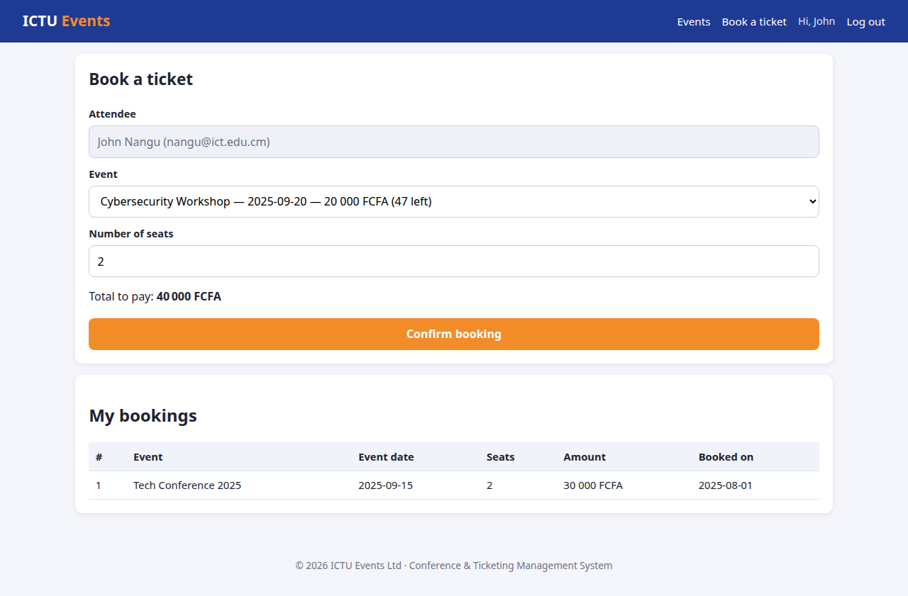
Figure 22: Booking form filled in (2 seats, total 40 000 FCFA)
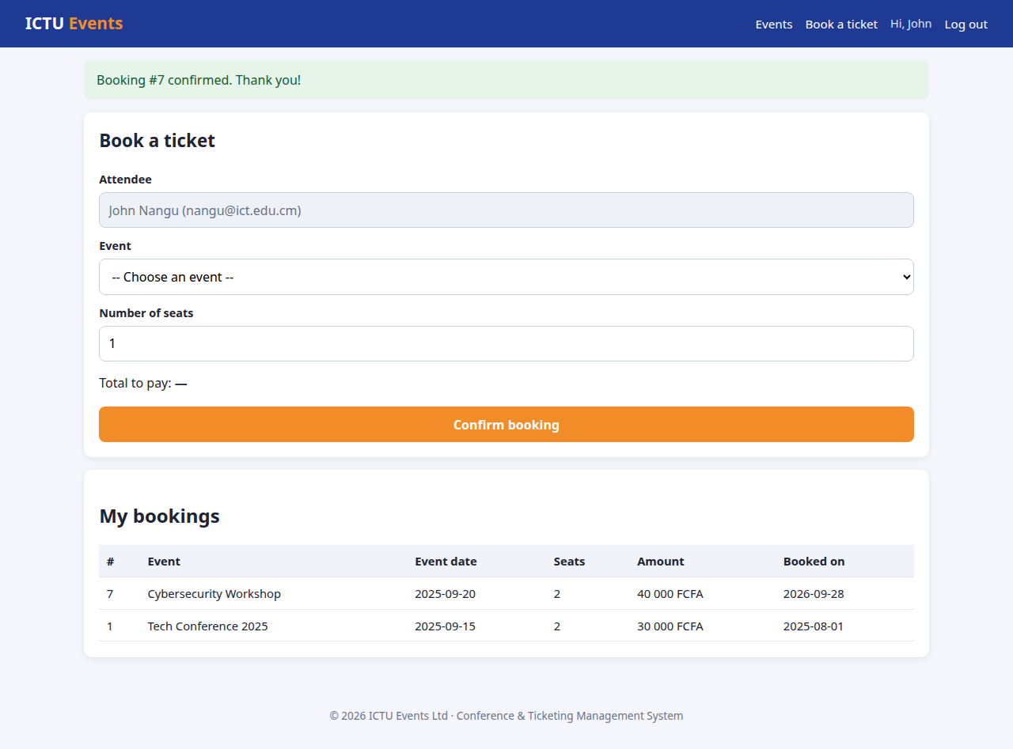
Figure 23: Confirmation and list of the user's bookings (the Cybersecurity Workshop drops from 47 to 45 seats)
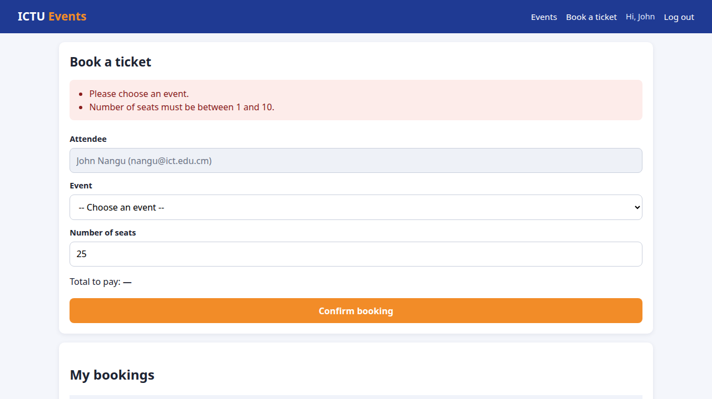
Figure 24: Server-side validation when 25 seats are requested

6.4 Q3 – Secure user authentication
Registration (register.php), login (login.php) and logout (logout.php) rely on the USERS table. Table 9 lists the threats considered and the measures implemented against each of them.
Table 9: Security measures of the authentication module
Threat | Measure implemented
Theft of the password database | Only a bcrypt hash is stored (password_hash, random salt); password_needs_rehash upgrades old hashes at login
Weak passwords | At least 8 characters with letters and digits, checked on the server, confirmation field
Brute force | failed_attempts counter; the account is locked for 15 minutes after 5 failures
Discovery of registered e-mails | Same message for a wrong e-mail or a wrong password; password_verify is also executed for an unknown e-mail so the response time is identical
Session fixation | session_regenerate_id(true) immediately after a successful login
Session hijacking | Cookie HttpOnly, SameSite=Strict, Secure under HTTPS, strict session mode, 30-minute inactivity timeout
Cross-site request forgery | 256-bit random token in every form, compared with hash_equals; logout by POST only
Cross-site scripting | All output escaped with htmlspecialchars; Content-Security-Policy default-src 'self'
Incomplete registration | Attendee and account created in one transaction; UNIQUE constraints on e-mail

// login.php - verification of the credentials (excerpt)
$hash = $account['password_hash']
?? password_hash(bin2hex(random_bytes(16)), PASSWORD_DEFAULT); // dummy hash
$valid = password_verify($password, $hash) && $account !== null;
if ($valid) {
session_regenerate_id(true); // new session id: no session fixation
$_SESSION['user'] = [/* user id, attendee id, name, role */];
} elseif ($account) {
// count the failure and lock the account for 15 minutes after 5 attempts
$fail = db()->prepare(
'UPDATE users
SET locked_until = IF(failed_attempts + 1 >= :max1,
NOW() + INTERVAL :mins MINUTE, locked_until),
failed_attempts = IF(failed_attempts + 1 >= :max2, 0, failed_attempts + 1)
WHERE user_id = :id');
$fail->execute([':max1' => 5, ':max2' => 5, ':mins' => 15,
':id' => $account['user_id']]);
}
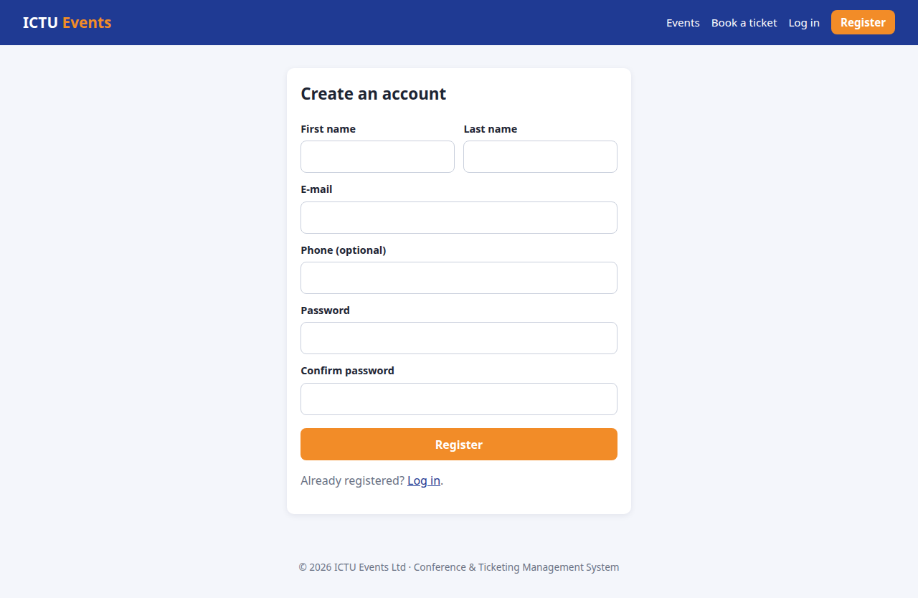 | 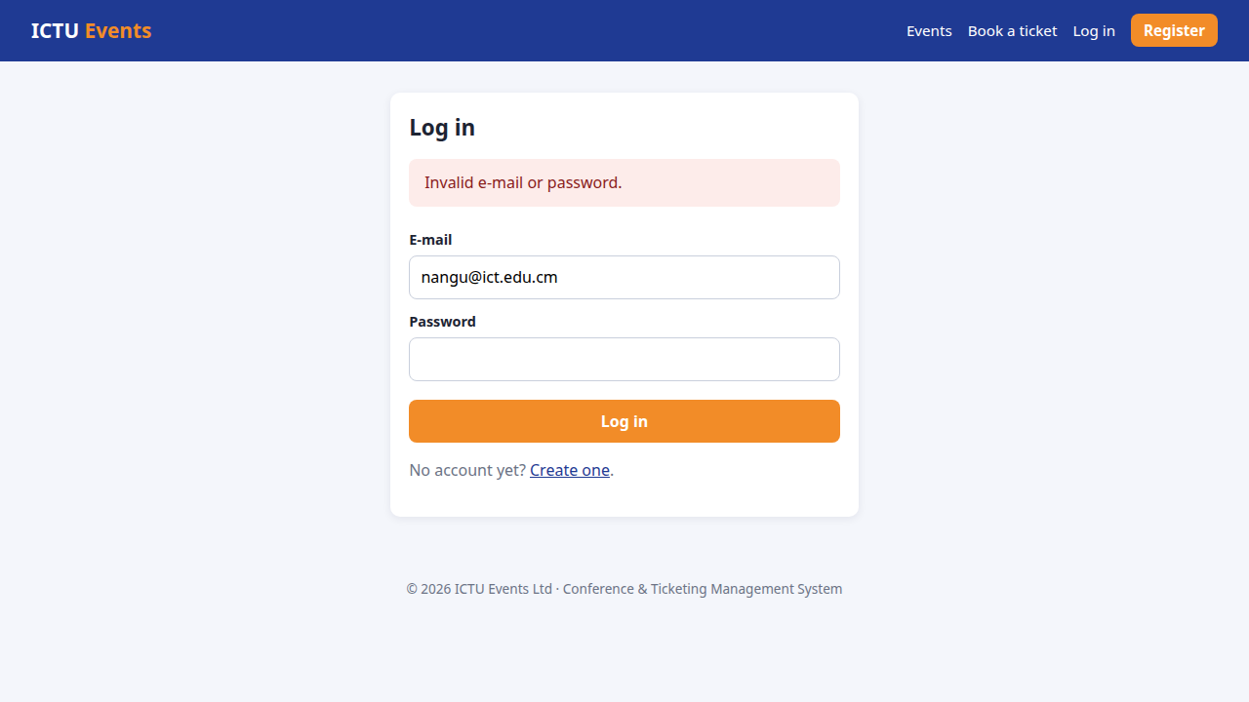
Figure 25: Registration form and generic message after a wrong password
In production the site must be served over HTTPS so that passwords and session cookies are encrypted in transit; an e-mail verification step before linking a new account to an existing attendee would be a useful improvement.

7. Part 6 – Optimization and Security

7.1 Q1 – Indexes on event names and booking dates
B-tree index on event_name: equality (= ?) and prefix searches (LIKE 'abc%')
CREATE INDEX idx_events_event_name ON events (event_name);
B-tree index on booking_date: equality, ranges (BETWEEN, >=, <) and ORDER BY
CREATE INDEX idx_bookings_booking_date ON bookings (booking_date);
Composite index for "bookings of an event over a period" (equality column first)
CREATE INDEX idx_bookings_event_date ON bookings (event_id, booking_date);
Before the indexes, MariaDB has no usable key: the search on the name reads the whole index of the table (type index, possible_keys NULL) and the search on the dates scans all the rows (type ALL), as shown in Figure 26. After the indexes the access type becomes range on the new index and fewer rows are examined (Figure 27). The demonstration tables are very small, so FORCE INDEX is used to display the plan the optimiser would choose on a real volume of data.
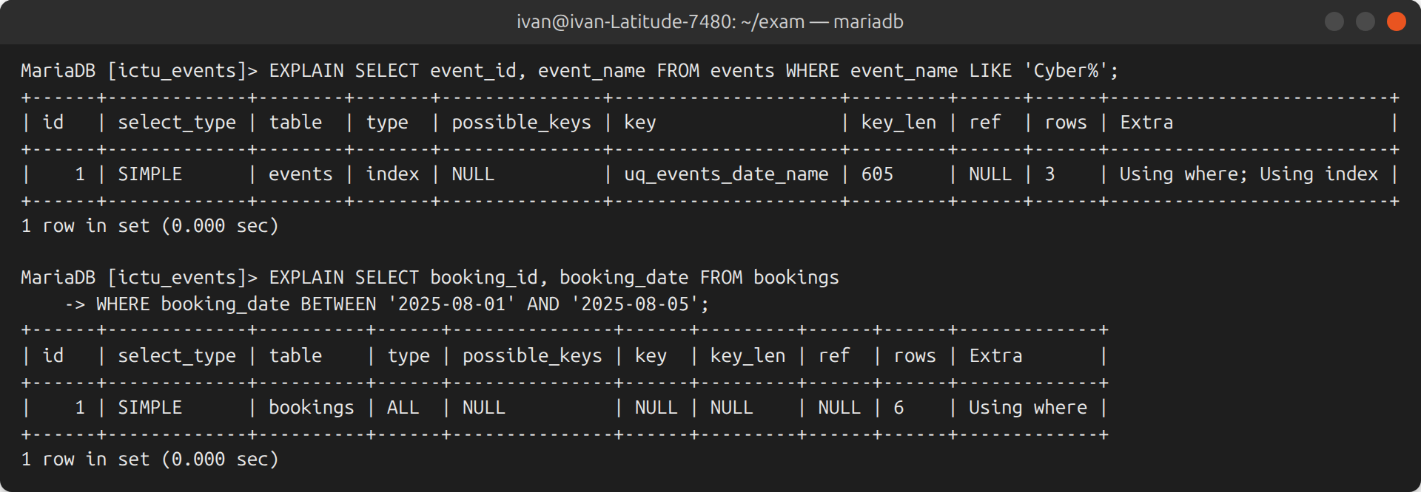
Figure 26: Execution plans before the indexes
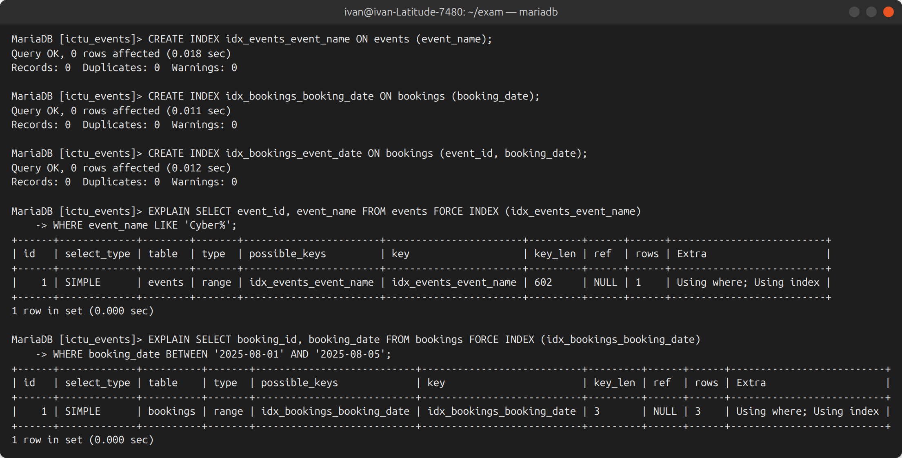
Figure 27: Creation of the indexes and execution plans afterwards

7.2 Q2 – Prepared statements against SQL injection
With a prepared statement the SQL text and the data are sent to the server separately: the query is first compiled with placeholders, then the values are bound. Whatever the user types is always treated as a value and can never change the structure of the query. The application never concatenates user input into SQL; all the queries follow this pattern:
// Vulnerable version (NOT used): "SELECT ... FROM users WHERE email = '$email'"
// Version used in login.php:
$stmt = db()->prepare(
'SELECT u.user_id, u.attendee_id, u.email, u.password_hash, u.role
FROM users u LEFT JOIN attendees a ON a.attendee_id = u.attendee_id
WHERE u.email = :email');
$stmt->execute([':email' => $email]);
The same principle is demonstrated directly on the server in Figure 28: the classic payload ' OR '1'='1 is compared as a plain string and returns an empty set instead of every account. In the web application the same payload typed in the login form or in the search box is rejected in the same way (tests 3 and 6 in Figure 29).
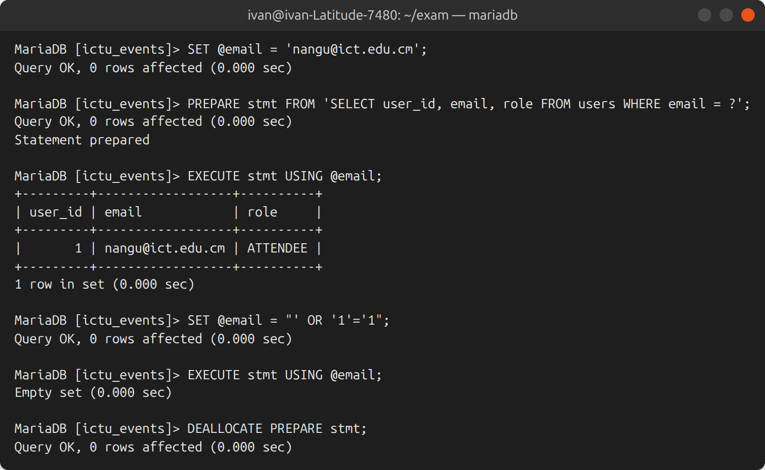
Figure 28: Prepared statement executed with a normal value and with an injection attempt

7.3 Q3 – Performance optimisation strategies applied

Strategy 1: indexing adapted to the search patterns
Indexes were created on the columns used for searching and filtering (event name, booking date and the pair event/date), in addition to the indexes that InnoDB creates for the primary keys, the UNIQUE constraints and the foreign keys used by all the joins of Part 4. With a B-tree the server goes directly to the matching rows (logarithmic cost) instead of reading the whole table (linear cost), which matters as the number of bookings grows. The queries were written so the indexes can actually be used: the search is a prefix search (LIKE 'term%') and no function is applied to an indexed column in a WHERE clause. Several plans show Using index, which means the answer is read from the index alone. Only useful indexes were created, since each index slightly slows down insertions.

Strategy 2: pre-computed seat counter maintained by the database
Computing the remaining seats as total_seats − SUM(seats_booked) on every display of the listing page would aggregate the whole BOOKINGS table each time, and this table keeps growing. Instead, the value is stored in events.available_seats and maintained by the trigger at the moment of each booking. The most visited page therefore reads a few rows only. In addition, a booking is performed in a single round trip (CALL sp_make_booking) instead of three or four separate queries from PHP, and the row lock only blocks bookings of the same event. The redundancy is safe because the trigger fires for every insertion and the CHECK constraints reject impossible values.
Other good practices were also applied: only the needed columns are selected (no SELECT *), one connection is reused during a request, and the Post/Redirect/Get pattern avoids re-executing a write when a page is refreshed.

8. Testing
Besides the database tests shown in the previous chapters, the web application was tested end to end with a script based on curl (tests/smoke_test.sh) which simulates a browser, including attacks. Figure 29 shows its output and Table 10 summarises the results.
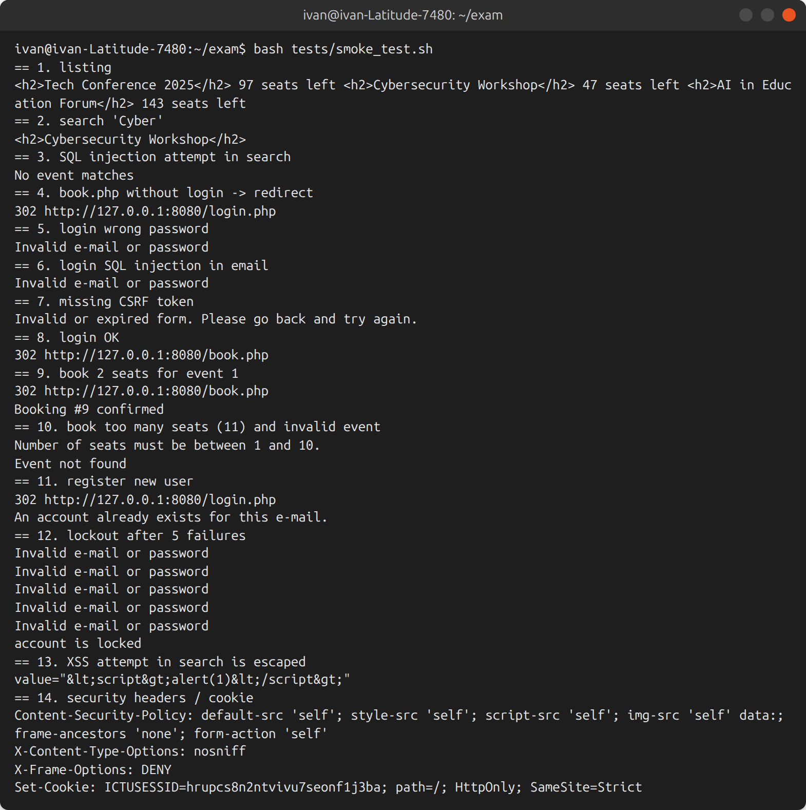
Figure 29: Output of the functional and security test script
Table 10: Summary of the web application tests
# | Test | Expected result | Result
1 | Event listing | All events with seats left | Passed
2 | Search "Cyber" | Cybersecurity Workshop only | Passed
3 | SQL injection in the search box | No data leak | Passed
4 | Booking page without login | Redirect to login | Passed
5–6 | Wrong password / SQL injection in login | Generic error, no bypass | Passed
7 | Form sent without CSRF token | Request refused (HTTP 400) | Passed
8–9 | Login then booking of 2 seats | Booking confirmed, seats decreased | Passed
10 | 11 seats / unknown event | Booking refused with a clear message | Passed
11 | Registration, then same e-mail again | Account created, then refused | Passed
12 | Six wrong passwords | Account locked after the fifth | Passed
13 | Script tag in the search box | Displayed as text (escaped) | Passed
14 | HTTP headers and session cookie | CSP, X-Frame-Options, HttpOnly, SameSite | Passed

9. Installation Guide
Requirements: MariaDB 10.6 or later (or MySQL 8.0.16 or later) and PHP 8.1 or later with the pdo_mysql extension.
# 1. Create the database and run every script in order
for f in database/0*.sql; do sudo mariadb < "$f"; done
# 2. Start the application (the password of ictu_app is defined in 07_app_user.sql)
DB_USER=ictu_app DB_PASS='ChangeMe_Ictu#2026' php -S 127.0.0.1:8080 -t webapp/public
# 3. Open http://127.0.0.1:8080 (demo account: nangu@ict.edu.cm / Ictu@2026)
On a production server (Apache or Nginx), the document root must point to webapp/public, the DB_* variables are defined in the virtual host, HTTPS is enabled and the password of ictu_app is changed.

10. Conclusion
The database is normalised, protected by keys and CHECK constraints, and extended with a PAYMENTS table and a USERS table. The relational algebra expressions were verified in SQL, and the six SQL tasks were executed on a real server, the seat counter being maintained automatically by a trigger and a transactional stored procedure. The web application provides a responsive listing, a booking form linked to the database and a secure authentication module, and all its queries use prepared statements. Indexes and a pre-computed seat counter keep the most frequent operations fast.
Possible extensions include an administration dashboard (management of events and sessions, revenue reports based on PAYMENTS), e-mail verification and password reset, integration of a Mobile Money payment API and e-tickets with QR codes.

