# Lens API Token

**API Token:** NpM55FbaJdFk3LsSKeV7qKW4opXOFyjJ94OztTLmVzAms4gx9Uwg

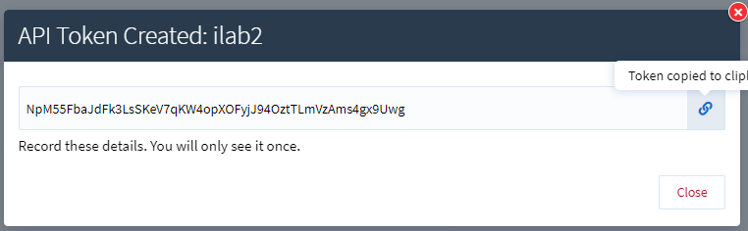

# IP Australia Secret:

**ID:** FTELrtrnxrq8JU3dCLp32Ov8VfzM7rrq

**Secret:** beh0nxtEh6zhTN-lbTAFkgBCkpHaxQl9dW9DhHxEtXRCCCAKmdt1fgyHPLD4vM4r