Impacts of Decarbonisation Policy on Heavy-Duty Trucking
Ivan Saundersª, Walter Mérida^{a*}
ªClean Energy Research Centre, The University of British Columbia, 2360 East Mall, Vancouver, British Columbia, V6T 1Z3, Canada
*Corresponding Author (walter.merida@ubc.ca)
Abstract
This paper presents a multinomial vehicle adoption model based on net present value, designed to evaluate how policies and technological progression impact the heavy-duty trucking sector. The sector is broken into three representative vehicle types – sleepers, day cabs, and straight trucks – and seven powertrains, including diesel, hybrids, battery-electric, fuel cell, and hydrogen internal combustion engines. Temporal evolution of physical component properties (e.g. battery density) is explicitly linked to the economic competitiveness of each powertrain over the modelling period. The model incorporates additional policy-relevant factors, including embodied emissions, autonomous vehicles, alternative hydrogen production pathways, and water and electricity consumption.
The model was applied to British Columbia (2025-2050) as an archetypal hard-to-abate jurisdiction, characterised by mountainous terrain, cold climates, and high gross vehicle weight limits. Results indicate that while the 2030 and 2040 emission targets will not be met under any modelled scenario, the 2050 target is achievable using a combination of policies, of which the low carbon fuel standard is the most effective. Zero-emission vehicle mandates can have a similar efficacy, but sufficient non-compliance fees are essential. Increasing gross vehicle weight limits for zero-emission vehicles is an effective, less-explored policy lever which reduces both emissions and total system costs.
In deep decarbonisation scenarios, hydrogen becomes the dominant fuel (58-71% of useful energy). While sectoral water consumption remains limited (1-1.4% of current provincial consumption), electricity demand becomes significant (24-28% of current production). Producing hydrogen through methane pyrolysis can mitigate these resource impacts but at the cost of reduced emission benefits.
Keywords: Heavy-duty trucks; Road freight; Emissions policy; Vehicle adoption modelling; Transport electrification; Hydrogen
Symbols and Abbreviations
Abbreviations can be found in Table 1. Symbols are provided in Table 2. Sets are presented in Table 3. Symbols may be subscripted to denote the sets they belong to and superscripted to provide context. For example, $M_{k,p,y}^{payload}$ represents the average payload mass for an HDT of type $k$, powertrain $p$, and model year $y$.
Abbreviation | Long form
B.C. | British Columbia
BE | Battery electric
CVS | Canadian Vehicle Survey
D | Diesel
DHICE | Diesel-hydrogen internal combustion engine
DHNP | Diesel hybrid (no plug)
DHP | Diesel hybrid (plug-in)
ESS | Energy storage system
FC | Fuel cell
FCET | Fuel cell electric truck
GVWL | Gross vehicle weight limit
HICE | Hydrogen internal combustion engine
HDT | Heavy-duty truck
LCFS | Low carbon fuel standard
LHV | Lower heating value
NPV | Net present value
O&M | Operation and maintenance
P | Pyrolysis
EP | Electrified pyrolysis
TCO | Total cost of ownership
WE | Water electrolysis
ZEV | Zero-emission vehicle
ZEVM | Zero-emission vehicle mandate
Table 1. List of abbreviations commonly used in the text.
Symbol | Description | Units
$$A$$ | Vehicle frontal area | [m²]
$$C$$ | Cost | [$]
$$E$$ | Energy | [J]
$$F$$ | Force | [N]
$$M$$ | Mass | [kg]
$$N$$ | Number of trucks | [-]
$$P$$ | Power | [W]
$$S$$ | Market share | [%]
$$T$$ | LCFS target reduction | [%]
$$X$$ | Fuel capacity | [varies]
$$a$$ | Acceleration | [m/s²]
$$d$$ | Distance | [km]
$$e$$ | Mass correction factor | [-]
$$g$$ | Gravity | [m/s²]
$$i$$ | Fuel emissions intensity | [kgCO₂e/unit]
$$r$$ | Refuel rate | [units/hr]
$$v$$ | Vehicle speed | [m/s]
$$x$$ | Fuel consumption | [unit/km]
$$z$$ | Maximum powertrain sales growth rate | [%]
$$Α$$ | Activity (multiple vehicles) | [t-km]
$$α$$ | Activity (per vehicle) | [t-km]
$$γ$$ | Key on/off | [-]
$$δ$$ | Discount rate | [%]
$$ε$$ | Energy per unit distance | [J/km]
$$η$$ | Efficiency | [%]
$$θ$$ | Battery degradation per cycle | [%/cycle]
$$κ$$ | Sector activity growth rate | [%]
$$λ$$ | Market sensitivity | [-]
$$μ$$ | Drag coefficient | [-]
$$ξ$$ | Battery degradation per year | [%/yr]
$$ρ$$ | Air density | [kg/m³]
$$σ$$ | Rolling coefficient | [-]
$$ς$$ | Revenue per unit activity | [$/t-km]
$$τ$$ | Time | [s]
$$φ$$ | Proportion of useful energy provided by a fuel | [%]
$$ϕ$$ | Slope angle | [°]
$$χ$$ | Vehicle survival rate | [%]
$$ψ$$ | Charger purchases per vehicle | [-]
$$ω$$ | Proportion of journeys that are weighed out | [%]
Table 2. Variables used in the model. Other variables may be introduced in the body of text.
Set | Description
$$t∈T$$ | Model time periods [2025-2050].
$$y∈Y$$ | Vehicle registration years [2000-2050]
$$a∈A$$ | Vehicle ages [0-24]
$$k∈K$$ | Vehicle type [sleeper-cab, day-cab, or straight truck]
$$p∈P$$ | Powertrain [diesel, DHP, DHNP, BE, FC, HICE, DHICE]
$$f∈F$$ | Fuels [diesel, hydrogen (electrolysis, pyrolysis, electrified pyrolysis), electricity (slow charge, fast charge)].
$$τ∈T$$ | Seconds of drive cycle.
Table 3. Sets used in the model.

Introduction
Road freight accounts for about 5.4% of global GHG emissions, mostly from heavy-duty trucks (HDTs) (IEA, 2023, 2024), and road freight activity is likely to continue to increase (Loo & Banister, 2016). In order to limit damage to communities and ecosystems, deep emission reductions are required from every sector (IPCC, 2023).
Emissions from existing HDTs can be reduced by mixing or replacing diesel with biofuels, but there are insufficient economically viable resources to supply the entire sector. Furthermore, emissions from biofuels may be insufficiently low when indirect land use is accounted for (Guest & Desjardins, 2017). Likewise, only modest emission reductions can be achieved through efficiency gains and hybridisation. Mass adoption of ZEVs is required to achieve deep emission reductions (Breed et al., 2021; Talebian et al., 2018).
Zero-emission vehicles (ZEVs) are typically powered by either electricity or hydrogen, through battery electric or fuel cell powertrains (Pihlatie et al., 2023). Hydrogen internal combustion engine trucks (HICETs) can achieve similar GHG emission reductions and are sometimes considered ZEVs (Wróbel et al., 2022), and are in this work. While battery-electric vehicles dominate the light-duty ZEV market, the low energy density of batteries can limit range and payload capacity in heavy-duty trucking, and the exact roles of BETs, FCETs, and HICETs within the sector remains to be seen.
Powertrain comparison studies provide insight into how different vehicle technologies perform and how this may change over time, often presenting results in terms of lifecycle emissions or total cost of ownership (TCO) (Hunter et al., 2021; Iyer et al., 2023). These can be used for system accounting models to identify potential pathways to achieve emission targets (Ahluwalia et al., 2025; Liu et al., 2021; Ren et al., 2022; Talebian et al., 2018), or optimisation models to identify cost-optimal fleet transitions (Aryanpur & Rogan, 2024; S. E. Franco et al., 2025; J. Wang et al., 2025). However, neither of these inform on how policies can be leveraged to achieve emission targets on a provincial or national scale.
The development of a policy framework to reduce emissions from HDTs requires an understanding of (i) how HDTs with alternative powertrains perform compared to diesel HDTs in different applications; (ii) how this is expected to change over time; (iii) how this impacts adoption; and (iv) how this can be influenced by policies.
In this study, we develop a multinomial logit vehicle adoption model (Train, 2009) based on net present value (NPV) to explore how changing costs and technology performance between 2025 and 2050 are likely to impact HDT adoption and usage, and how this will impact the HDT sector at large. We apply the model to British Columbia as a case study.
A review of literature (Table 4) reveals that existing modelling approaches are often limited in their representation of the diversity of HDT applications, the expected change in performance of technologies over time, and the mechanisms through which policies influence adoption. These limitations typically reflect different study aims, but are relevant to the modelling context of this paper.
Study | Model details | Region | Findings | Limitations
Hammond et al. (2020) | - CIMS.  - Adoption driven by TCO, with exogenously declining intangible costs. | Canada | - ZEV mandates most effective policy.  - Carbon tax, LCFS, and ZEV mandates together can meet 2050 emissions target.  - Hydrogen dominant low-carbon fuel, followed by electricity.  - Limited natural gas powertrain uptake. | - Homogeneous representation of HDT sector.  - Full compliance with ZEV mandates assumed.  - Technology performance improves only via fuel efficiency.  - No limits to non-incumbent sales growth.  - HICE not considered.  - Weather, terrain, and battery degradation not modelled.
Lajevardi et al. (2022) | - CIMS.  - Sector split into short/long haul.  - Drive cycle modelling.  - ESS sizing by application. | British Columbia | - Provided adequate infrastructure, BETs and FCETs dominate short haul, while FCETs and plug-in hybrids dominate long haul.  - Limited natural gas powertrain uptake. | - Full compliance with ZEV mandates assumed.  - LCFS met for diesel through biofuels substitution, despite potentially insufficient supply.  - Static physical technology performance.  - No limits to non-incumbent sales growth.  - HICE not considered.  - Weather and battery degradation not modelled.  - Limited vehicle-level policy insight.
Zhao et al. (2024) | - Probability-based dynamic discrete choice model with sixteen decision factors.  - Adoption driven by preference scores. | California | - BETs dominate short haul and FCETs dominate long haul in 2050.  - Refuelling convenience and cost are the most important factors for adoption. | - Vehicle attributes treated as decision factors rather than tied to performance or cost.  - No limits to non-incumbent sales growth.  - HICE not considered.  - Weather, terrain, and battery degradation not modelled.  - Limited policy insight.
Birky et al. (2025) | - Multinomial logit variation (heterogeneous consumer preferences)  - Drive cycle modelling with FASTSim. | USA | - Future sales dominated by hybrid diesel powertrains.  - FCETs outperform BETs in long-haul applications. | - Limited consideration of HDT subsectors.  - Full compliance with ZEV mandates assumed.  - Limited policy insight and implementation detail.  - No link between payload capacity and revenue.  - Weather, terrain, and battery degradation not modelled.
Raoofi et al. (2025) | - Systems approach (combined infrastructure and vehicle adoption). | Sweden | - BET uptake contingent on infrastructure.  - Investment in infrastructure and technology maturity more effective than vehicle subsidies.  - Unstable policies delay adoption. | - Different modelling focus: infrastructure-vehicle adoption dynamics rather than vehicle performance modelling.  - Homogeneous HDT sector.  - No consideration of hydrogen powertrains.
Table 4. Summary of relevant HDT adoption studies.
In particular, previous studies (i) consider a limited set of powertrains, often excluding hydrogen internal combustion engines (HICE); (ii) apply generic ‘intangible’ costs to alternative powertrains which decline exogenously, rather than linking costs to technologies; (iii) assume static technology characteristics across modelling years; (iv) do not consider certain policies (ZEV gross vehicle weight limit changes and driver break regulations) or inadequately consider others (e.g. assume full compliance with ZEV mandates); (v) neglect realistic limits on incumbent market shares due to production scaling; (vi) omit operating conditions that materially impact adoption (weather and terrain); and (vii) make no consideration of other factors which could significantly impact policy decisions, such as vehicle embodied emissions, autonomous vehicles, hydrogen production pathways, and water and electricity consumption.
Contributions that distinguish the present model and work from prior efforts include:
- Heterogeneous representation of the HDT sector: In order to better capture the diversity of the sector, HDTs are split into three different types, sleeper-cab, day-cab, and straight trucks, each with different usage patterns.
- Simulating competition amongst seven powertrains: The inclusion of diesel, hybrid (no plug), hybrid (plug-in), BE, FC, HICE, and diesel-HICE (DHICE) powertrains.
- NPV-based adoption informed by technology and policy: Instead of TCO, NPV (which also accounts for revenue) was determined directly using the underlying technological properties (e.g., battery density, fuel cell lifetime) of each powertrain, rather than through exogenous declining intangible costs. A suite of policies is integrated into the model in order to assess their impact on NPV and adoption.
- Consideration of wide array of policies: driver break mandates, ZEV mandates, ZEV gross vehicle weight limit (GVWL) changes, carbon tax, and a low carbon fuel standard (LCFS). ZEV GVWL changes and break mandates are often overlooked policy levers.
- Literature-informed uncertain temporal parameter progressions: Uncertainty in the progression of costs and technical performance is handled through Monte Carlo simulation. The temporal progressions of these technological properties (and costs) and their uncertainty are estimated based on extensive literature review.
- Modelling ZEV mandates through a credit market, rather than assumed compliance, making for more realistic policy analysis.
- Realistic limits to incumbent market shares: Adoption growth rates for alternative powertrains are limited based on global production constraints.
- Weather terrain, and battery degradation impacts are incorporated into the model.
- Additional considerations that could affect the sector and policy decisions are integrated into the model, including operator cost foresight, autonomous vehicles, hydrogen production pathways, embodied emissions, and water and electricity consumption.
The model was applied to British Columbia as a case study, which is characterised by its large area, low population density, limited rail infrastructure, mountainous terrain, cold conditions, high gross vehicle weight limits, and long vehicle lifetimes. These conditions add to the challenge of decarbonisation and make an interesting case study (COMT, 2019; Statistics Canada, 2020).
The purpose of this study is to examine the use of demand-side policies to incentivise ZEV uptake and reduce HDT sector emissions. That infrastructure is widely-acknowledged as a prerequisite for ZEV uptake is well established and not the focus of this work. The $900M H2 Gateway project and expansion of medium- and heavy-duty vehicle recharge infrastructure demonstrate B.C.’s commitment to ZEV infrastructure (BC Hydro, 2025a; Government of B.C., 2024a). Limitations to ZEV sales growth prevent unfeasible infrastructure scenarios from occurring in the model.

Methodology
In this section, we discuss the development of a multinomial logit model to estimate HDT adoption from 2025 to 2050. While the model is novel, it builds on previous work including Lajevardi et al. (2020), Hammond et al. (2020), and Birky et al. (2025). The model was applied to British Columbia to estimate emissions and costs under different policy scenarios. Policies assessed include a carbon tax, ZEV mandates, a low carbon fuel standard (LCFS), changes to gross vehicle weight limits (GVWLs) for ZEVs, and driver break mandates (see Section 2.7). Additional factors that could affect policy decision are considered, including embodied emissions, water and electricity consumption, alternative hydrogen production pathways, operator cost foresight on future fuel and component costs, and autonomous vehicles.
In B.C., HDTs consist of class-7 and class-8 vehicles with a gross vehicle weight limit (GVWL) greater than 11,793kg. They are mostly used for the transport of goods, and the majority run on diesel (Government of Canada, 1999; Muratori et al., 2023). More details on B.C.’s HDT fleet can be found in Section 3.
In order to capture the diversity of the sector, HDTs in this paper are divided into three representative vehicle types $k∈K$: sleeper-cab trucks, day-cab trucks, and straight trucks. Each of these has its own properties and usage patterns. For each vehicle type, seven powertrain types $p∈P$ were considered: diesel (D); diesel hybrid, no plug (DHNP); diesel hybrid, plug-in (DHP); battery electric (BE); fuel cell (FC); hydrogen internal combustion engine (HICE); and diesel-hydrogen internal combustion engine (DHICE).
The measurement of utility used to estimate the powertrain market share for each vehicle type is net present value (NPV) – the present value of all costs and revenues associated with a vehicle over its lifetime.
The uncertain progressions of costs and technical properties of vehicles and their components are expected to change over time and are quantified through review of literature, government, and industry resources. Monte Carlo analysis was employed to quantify uncertainty in results.

Vehicle Adoption Model
The model starts by estimating the surviving stock vehicles of type $k$ (e.g. sleeper, day cab, straight truck) in the start year. This is calculated assuming a constant activity growth rate $κ$ and that the current stock consists entirely of diesel powertrains using Eq. 1.
 | $$N_{k,y}^{0}=\frac{A_{t_{0},k}^{ }(1+κ)^{y-t_{0}}χ_{t_{0}-y}}{\sum_{a∈A}{ }α_{k,y,a}χ_{a}(1+κ)^{-a}}$$ | (1)
In subsequent years, rolling stock is calculated according to age-specific survival rates using Eq. 2.
 | $$N_{k,p,y,t}=N_{k,p,y,t-1}\frac{χ_{k,p,y,a}}{χ_{k,p,y,a-1}}, a=t-y$$ | (2)
The unconstrained market share of new sales for each vehicle of type $k$ and powertrain $p$ is calculated using a multinomial logit function (Train, 2009) where the measure of utility is net present value (NPV), given in Eq. 3.
 | $$S_{k,p,t}^{logit}=\frac{{\text{exp(λ⋅NPV}}_{k,p,t}\text{)}}{\sum_{p^{'}∈P}{ }{\text{exp(λ⋅NPV}}_{k,p^{'},t}\text{)}}$$ | (3)
To reflect production constraints, the growth rate for powertrains is limited (Eq. 4).
 | $$S_{k,p,t}=min⁡\left(S_{k,p,t}^{logit},S_{k,p,t-1} \frac{1+z_{p}\left(S_{k,p,t-1}\right)}{1+κ}\right)$$ | (4)
The residual market share is redistributed iteratively among unconstrained vehicles until all shares respect their production limits and the total market for each vehicle type $k$ sums to unity.
Total vehicle sales for type $k$ are determined through estimating the activity that cannot be achieved by pre-existing vehicles and dividing this by the average first-year activity of the newly purchased vehicles, which varies by powertrain (Eq. 19). This can then be used to estimate sales for each powertrain using Eq. 6.
 | $$N_{k,t}^{+}=\frac{A_{k,t}-\sum_{p∈P}{ }\sum_{a∈A∖\{0\}}{ }N_{k,p,y,t}α_{k,p,y,a}}{\sum_{p∈P}{ }\sum_{a∈A∖\{0\}}{ }S_{k,p,t}α_{k,p,y,a}}, y=t-a$$ | (5)
 | $$N_{k,p,t}^{+}=S_{k,p,t}N_{k,t}^{+}$$ | (6)

Net Present Value
An HDT’s NPV is estimated by discounting its expected revenue and subtracting the TCO, as shown in Eq. 7. All analysis is completed in constant dollars. For the case study, historical costs and forecasts were converted to CAD 2024 (Section 3).
 | $${\text{NPV}}_{k,p,y}=\sum_{a∈A}{\frac{ς_{k}α_{k,p,y,a}χ_{a}}{{\left(1+δ\right)}^{a}}}-{\text{TCO}}_{k,p,y}$$ | (7)
TCO comprises capital costs and the discounted costs of fuel, driver labour, and O&M. Additional costs associated with component replacements are described in Section 2.4, while policy-related costs and revenues are detailed in Section 2.7 – both directly impact NPV.
Similar to Lajevardi et al. (2022) and H. Zhao et al. (2018), capital costs are estimated as the sum of costs from major vehicle components using Eq. 8.
 | $$C_{k,p,y}^{capital}=C_{k}^{frame}+\sum_{f∈F_{p}}{\left(C_{k,p,y}^{engine}+c_{k,p,y}^{motor}P_{k,p}^{motor}+c_{k,p,y}^{fuel cell}P_{k,p}^{fuel cell}+C_{k,p,y}^{transmission}+C_{k,p}^{after treatment}+c_{k,p,f,y}^{ESS}X_{k,p,f}^{ESS}\right)}+γC^{charger}$$ | (8)
Discounted O&M and fuel costs are calculated using annual mileage and survival rates (Eqs. 9 & 10).
 | $$C_{k,p,y}^{O\&M}=\sum_{a∈A}{ }\frac{d_{k,p,y,a}χ_{a}c_{k,p}^{O\&M}}{\left(1 + δ)^{a}\right.}$$ | (9)
 | $$C_{k,p,y}^{fuel}=\sum_{f∈F}{\sum_{a∈A}{ }\frac{d_{k,p,y,a}χ_{a}x_{k,p,y,f,a}c_{f,k,p,y}^{fuel}}{\left(1 + δ)^{a}\right.}}$$ | (10)
Driver costs are calculated using an annual target distance (Eq. 11), reflecting the assumption that operators incur similar labour costs even if time spent charging or refuelling reduces mileage.
 | $$C_{k,p,y}^{driver}=\sum_{a∈A}{ }\frac{d_{k,p,y,a}^{target}χ_{a}c_{k,p,y}^{driver}}{\left(1 + δ)^{a}\right.}$$ | (11)

Vehicle Performance
NPV, system costs, and emissions are dependent on vehicle performance factors, such as payload capacity, range, and fuel consumption.

Payload
A vehicle’s mass is the sum of its unloaded mass components and payload (Eq. 12).
 | $$M_{k,p,y}=M_{k}^{frame}+M_{k,p}^{powertrain}+ρ_{k,p,y}^{ESS}X_{k,p}^{ESS}+M_{k}^{trailer}+M_{k,p,y}^{payload}$$ | (12)
As vehicles are subject to weight limits (GVWLs), payload capacity decreases as unloaded mass increases. The average payload is therefore estimated using payload capacity relative to an equivalent diesel truck and the proportion of trips that are weight-limited (Eq. 13).
 | $$M_{k,p,y}^{payload}=M_{k,diesel,t_{0}}^{payload}⋅\left[1-ω_{k}\left(1- \frac{{GVWL}_{k,p}-M_{k,p,y}^{unloaded}}{{GVWL}_{k,p}-M_{k,diesel,2025}^{unloaded}}\right)\right]$$ | (13)

Fuel Consumption and Range
Fuel consumption is calculated using representative drive-cycles for each vehicle type. Tractive power is calculated for each second of a drive-cycle using Eq. 14.
 | $$P^{trac}=F^{trac}v=v\left(\frac{1}{2}ρ^{air}μAv^{2}+σMgcos\left(ϕ\right)+Mgsin\left(ϕ\right)+M^{unloaded}(1+e)a\right)$$ |  |  | (14)
Tractive force is combined with accessory load and transmission efficiency to calculate the brake power using Eq. 15 (Lajevardi et al., 2019).
 | $$P^{brake}=\frac{P^{trac}}{η^{transmission}}+γP^{accessory}$$ | (15)
Total brake energy is estimated using Eq. 16, assuming that regenerative breaking is used when available, subject to motor power limits.
 | $$E=\sum_{τ∈T,P^{brake}≥0}{P^{brake}+\sum_{τ∈T,P^{brake}<0}{\left(η^{regen}⋅min⁡\left(P^{brake},P^{motor}\right)\right)}}$$ | (16)
The average brake energy per unit distance $ε=E/d$ can then be used to estimate fuel consumption (Eq. 17) and range (Eq. 18).
 | $$x_{k,p,y,a,f}=\frac{ε_{k,p,y,a,f}}{{LHV}_{f}η_{k,p,y,f}}φ_{k,p,f}$$ | (17)

 | $$d_{k,p,y,a}^{range}=\min_{f}{\frac{X_{k,p,y,a,f}}{x_{k,p,y,a,f}}}$$ | (18)
The model can optionally employ regression fits to input data to estimate fuel consumption more expeditiously during Monte Carlo simulation (see Sections 2.9 & 3.2).

Activity
The annual activity of an HDT is the product of its annual distance $d_{k,p,y,t}$ and average payload (Eq. 19).
 | $$α_{k,p,y,a}=d_{k,p,y,a}M_{k,p,y}^{payload}$$ | (19)
While average payload is affected by unloaded mass, annual distance is affected by range and refuel/recharge time; time spent refuelling during a journey reduces distance covered. To quantify this effect, a daily target distance is set based on the average daily distance of a diesel truck operating 5 days per week (Eq. 20).
 | $$d_{k,a}^{daily target}=\frac{d_{k,diesel,a}}{365×(5/7)}$$ | (20)
If a vehicle exceeds its range before reaching the target distance, it is assumed to travel as far as it can in the time remaining given that it has to find a station (during time $τ_{s}$) and refuel during time it would otherwise be driving (Eq. 21). The daily distance can thus be estimated using Eq. 22.
 | $$τ=\frac{d^{daily target}-d^{range}}{v}$$ | (21)
 | $$d^{daily}=d^{range}+\frac{\left(τ-τ_{s}\right)vr}{xv+r}$$ | (22)

Other Performance Considerations
Battery performance degrades with time and usage through calendar and cycle aging (Yarimca & Cetkin, 2024). For our system-level analysis, battery state-of-health (SOH), defined as capacity relative to initial capacity, was approximated using a simplified degradation model based on System Advisor Model (NREL, 2023) and is presented in Eq. 23.
 | $${SOH}_{a}=1-\sum_{a^{'}∈A, a^{'}≤a}{\left(θ\frac{d_{a}x_{a}}{X_{0}}+ξ\right)}$$ | (23)
When considering typical HDT usage patterns, BET range limitations only cause difficulties during the first few years of use. This is because mileage reduced significantly with age (Statistics Canada, 2009). For this reason, it is assumed that batteries would not be replaced during HDT lifetime.
Fuel cells are replaced once their lifetime (modelled in hours) is exceeded. The US Department of Energy has set the 2030 HDT fuel cell lifetime target to 25,000 hours (Marcinkoski et al., 2019).
Diesel and hydrogen powertrains are assumed to provide sufficient waste heat for cabin comfort, whereas BETs must provide energy for cabin heating from the battery. Further, the battery must be heated during cold conditions to avoid damage. The additional accessory load faced by BETs is estimated using a battery load model developed by Ramesh Babu et al. (2025).
To account for terrain, drive-cycles can be adjusted to have the maximum slopes typical of the region (NREL, 2026).

Greenhouse Gas Emissions
The annual fuel supply (FS) and fuel usage (FU) emissions of an HDT are calculated using Eq. 24 and Eq. 25, respectively.
 | $$E_{k,p,y,t}^{FS}=\sum_{f∈F_{p}}{d_{k,p,y,t}x_{k,p,y,t,f}i_{f}^{FS}}$$ | (24)
 | $$E_{k,p,y,t}^{FU}=\sum_{f∈F_{p}}{d_{k,p,y,t}x_{k,p,y,t,f}i_{f}^{FU}}$$ | (25)
The majority of embodied, or vehicle-cycle, emissions typically come from iron and steel production, the dominant materials of an HDT; however, Li-ion batteries are often the dominant source for BETs (M. Wang et al., 2024). Production emissions for iron, steel, and batteries are expected to decrease over time (IEA, 2020; World Steel Association, 2025; Xu et al., 2022).
When included in results, embodied emissions are calculated as the sum of non-ESS and ESS components, weighted by time-varying emission intensities (Eq. 26) and are assumed to occur in the year of purchase.
 | $$E_{k,p,y,t}^{embodied}=\left(M_{frame,k}+M_{powertrain,k,p}+βM_{trailer}\right)ε_{E,t}+X_{ESS,k,p,t}ε_{ESS,k,p,y,t}.$$ | (26)
System-wide emissions in year $t$ are obtained by summing the emission components for all vehicles in operation that year.

System Costs
System costs are calculated as the sum of annual capital, fuel, driver, O&M, part replacement, and policy costs incurred by operators. Policy costs calculations are discussed in the next section.

Policy Features
A carbon tax, low carbon fuel standard (LCFS), ZEV mandate, ZEV GVWL changes, and changes to driver break regulations can be specified within the model in order to create policy scenarios and assess their impact on the sector.
The carbon tax is applied to emissions from fuel supply and usage. The resulting increase to TCO is calculated using Eq. 27.
 | $$C_{k,p,y}^{carbon tax}=\sum_{f∈F}{\sum_{a∈A}{ }\frac{d_{k,p,y,a}χ_{a}x_{k,p,y,f,a}i_{f}c_{y+a}^{carbon tax}}{\left(1 + δ)^{a}\right.}}$$ | (27)
LCFS implementation depends on jurisdiction. In B.C., in addition to specifying minimum renewable content, the LCFS sets target carbon intensities for transportation fuels, which decrease over time. For HDTs, the initial carbon intensity was based on diesel (94.38 gCO2e/kg). Vendors of fuels above the target must purchase credits or pay a penalty, while fuels below the target generate credits. Credit calculations account for typical powertrain efficiency via an energy effectiveness ratio (EER); for example, BETs have an EER of 3.2 (Government of B.C., 2026a). EERs and vehicle-type granularity have developed over time. Credit value has fluctuated between C$100-500 (Government of B.C., 2026).
The model estimates LCFS credits using vehicle efficiency directly (Eq. 28), reflecting that future regulation will align with realised powertrain performances. While the price is dependent on the credit market, this involves many other sectors. A constant credit price is maintained in the model under the assumption that legislators will adjust targets to maintain the credit price.
 | $$C_{k,p,y}^{LCFS}=\sum_{a∈A}{\frac{χ_{a}d_{k,p,y,a}\left(\sum_{f∈F}{\left(x_{k,p,y,f,a}i_{f}\right)}-x_{k,diesel,y,a}i_{diesel}\left(1-T_{y+a}^{LCFS}\right)\right)c_{y+a}^{LCFS}}{{\left(1+δ\right)}^{a}}}$$ | (28)
A zero-emission vehicle mandate (ZEVM) sets an increasing target market share for ZEV sales. Vendors failing to meet the target must purchase credits from other vendors or pay a non-compliance fee (Government of B.C., 2024b). We assume that, through the credit market, this additional cost is distributed across all non-ZEV sales equally (Eq. 29). Because market share is dependent on price (Eq. 3), the additional cost and ZEV market share are solved jointly at each time step.
 | $$C^{ZEVM}=c_{{}_{penalty}}⋅\max\left(0,\frac{S^{target}-S^{ZEV}}{1-S^{ZEV}}\right)$$ | (29)
The model allows GVWL adjustment for all vehicle types and powertrains. FCETs, HICETs, and especially BETs, have a greater unloaded mass than diesel trucks, which can reduce payload and therefore revenue. Increasing GVWLs for ZEVs is one way to make them more competitive.
In high duty-cycle trucking applications, such as long-haul trucking, limited BET range and long recharge times can increase stoppage. Driver break regulations can provide opportunity for recharging without additional revenue loss. The model specifies maximum driving periods and break lengths. It is assumed that vehicles can recharge or refuel and that drivers are paid during breaks.

Other Features
The model integrates additional scenario features, including cost foresight, autonomous vehicle adoption, accelerated diesel truck retirement, and hydrogen production pathways. It also provides estimates of water and electricity consumption, based on fuel demand.
By default, operators are assumed not to have cost foresight; they assume fuel and component costs remain constant from the year of purchase. This can be changed to give operators full cost foresight to assess the impact on adoption.
If included in the model, autonomous vehicle adoption follows an S-curve (Eq. 30). Only eligible vehicles (e.g. ZEVs) may operate autonomously (Eq. 31). Driver costs are reduced in proportion to the share of vehicles operating autonomously.
 | $$S_{t}^{autonomous}=\frac{1}{1+\exp\left[b\left(t-t_{50}\right)\right]}$$ | (30)
 | $S_{k,p,t}^{autonomous}=ψ_{k,p,t} S_{t}^{autonomous}$. | (31)
The survival rate of diesel trucks can be altered to assess the potential impact on the sector.
By default, hydrogen is assumed to be produced through water electrolysis, which is low-carbon provided the electricity used to do this has a low carbon intensity. Water electrolysis is not the only way to produce low-carbon hydrogen. Another option is to produce hydrogen through methane pyrolysis, where methane is converted into hydrogen and solid carbon (Eq. 32) (Schneider et al., 2020).
 | $${CH}_{4}→C\left(s\right)+2H_{2} ΔH°=74.91 kJ/mol$$ | (32)
Although this reaction does not directly produce GHG emissions, emissions can still occur during methane supply and the combustion of natural gas to provide heat, although this heat can be provided using low-carbon electricity (Patlolla et al., 2023). Regular and electrified pyrolysis are both integrated into the model as hydrogen production options.

Uncertainty
The model employs a Monte Carlo approach (Metropolis & Ulam, 1949), randomly sampling input parameter distributions over multiple iterations in order to quantify output uncertainty. Uncertainty in results is visualised through box-and-whisker plots (5th, 25th, 50th, 75th, 95th percentiles) or shaded 5th-95th percentile regions around line plots.
For the case study, uncertainty was applied to a wide variety of input parameters and their temporal progressions, and each scenario was run for 10,000 iterations. Parameter distributions can be found in Appendix A.

Case Study: British Columbia
British Columbia presents a compelling region to examine heavy-duty trucking decarbonisation policy. Operations frequently traverse mountainous and remote terrain under extreme weather conditions, carrying high loads (GVWL > 60 t). Limited rail infrastructure leads to a high dependence for many communities on road freight.
This section details how the model introduced in Section 2 has been applied to B.C. The HDT sector is broken down into representative vehicle types (sleeper-cab, day-cab, and straight trucks), each with different populations, properties, and usage patterns. A range of powertrain options are available for each vehicle type.
In addition to fleet composition and technology choice, the analysis incorporates regional operating conditions and a number of policy scenarios.
Parameter values, probability distributions, and temporal progressions were derived from an extensive review of academic literature, government publications, and industry sources. A full parameter list can be found in Appendix A. Analysis was conducted in constant dollars (CAD 2024). All costs from external sources were converted accordingly.

The B.C. Fleet
In B.C., HDTs consist of class-7 (GVWL 11,794-14,969 kg) and class-8 (GVWL > 14,969 kg) vehicles (Government of Canada, 1999). In 2022, approximately 61,000 heavy-duty trucks were registered in the province (NRCan, 2025). Of these, an estimated 47% are straight trucks, with the remainder tractor-trailers (Statistics Canada, 2009). Of tractor-trailer units, around two-thirds are sleeper cabs and the rest are day cabs (National Research Council, 2010). We therefore represent the sector by three vehicle types: sleeper-cabs, day-cabs, and straight trucks.
Canadian Vehicle Survey (CVS) data imply that vehicle survival rates decline approximately linearly from 100% in their first year to near zero in their twenty-fifth. This implies an average lifetime of 15 years and an average fleet age of 7 years, assuming 2% annual sales growth (Statistics Canada, 2009). Almost all HDTs currently operate on diesel (Government of Canada, 2025), and all HDTs purchased prior to 2025 are assumed to have conventional diesel powertrains.
Following the approach of Redick et al. (2025), Eq. 33 was fit (least squares) to data from the CVS, yielding an average in-use annual distance of 66,510 km.
 | $$d=\frac{d_{max}-d_{min}}{a+exp⁡\left(-b\left(t-t_{50}\right)\right)}+d_{min}$$ | (33)
Mileage trajectories were assumed similar for each vehicle type, only scaled in magnitude. Truck activity, informed by the CVS and discussion with industry, is summarised in Table 4.
Truck type | Fleet | Average annual distance | Average payload | Distance | Activity
Sleeper-cab truck | 35% | 115,000 | 16,000 | 60% | 77%
Day-cab truck | 18% | 76,000 | 10,000 | 21% | 17%
Straight truck | 47% | 27,000 | 4,000 | 19% | 6%
Table 5. Truck fleet composition and typical usage in British Columbia.

Vehicle Performance and Cost
Drive-cycles from the NREL drive-cycle library (NREL, 2026) were used to estimate fuel consumption. Speed profiles were smoothed using a Savitsky–Golay filter of length 61. The Fleet DNA Long-Haul, Regional-Haul, and Local Delivery representative drive-cycles were applied by vehicle type. Sleeper cabs were modelled as long-haul for their first 7 years, then regional to reflect typical usage (Redick et al., 2025). The Long- and Regional-Haul cycles had their grade profiles scaled to achieve a maximum of 8% (Government of B.C., 2019). Day cabs were modelled using the Regional-Haul cycle and straight trucks Local-Delivery cycle. In order to speed up Monte Carlo simulation, a surrogate regression model capturing 99% of the sample variance was used instead of directly handling the drive cycles on each iteration to estimate fuel consumption.
Vehicle performance parameters which were expected to change over time include powertrain efficiency, regenerative breaking efficiency, drag coefficient, ESS specific mass, battery recharge rate, usable battery capacity, fuel cell lifetime, and embodied emissions. Time-varying cost parameters include the cost of fuel, batteries, hydrogen storage, fuel cells, HICE, and chargers. Emissions, water, and electricity consumption factors for fuels are expected to remain constant; however, vehicle and battery production emissions are expected to fall over time. Upstream methane emissions are included in pyrolysis pathways. Sleeper BETs are expected to refuel using public fast charge infrastructure while day cabs and straight trucks use their own recharge facilities.
BET heating load was estimated by calculating the load using climate data from B.C.’s 10 most populous cities (ECCC, 2025b) and weighting the results by population. Sales growth rates are limited by global production (Link et al., 2024; MarketsandMarkets, 2024).
Probabilistic parameter trajectories were based on literature, government, industrial data, and models like GREET and GHGenius (S&T Squared, 2025; M. Wang et al., 2024), and can be found in Appendix A.
To account for heterogeneity in fleet procurement decisions, the logit scaling parameter (market sensitivity, $λ$) was set to represent a diversified market response. While multinomial logit models can be subject to the independence of irrelevant alternatives (Train, 2009), the powertrains in this study are distinct in technology and operation. Given the lack of data to quantify the distinctiveness of the different powertrains, a standard multinomial model was used to avoid the introduction of unverified nesting parameters.

Policies and considerations
The details of the policies applied to the British Columbia case study are supplied in Table 5. In addition to exploring each policy individually, two additional scenarios were explored: the ‘Base’ scenario, in which no decarbonisation policies were employed, and the ‘Policy Package’ scenario, in which an LCFS, a ZEV Mandate, and ZEV GVWL increases are all employed.
Policy | Description | Notes
Carbon tax | Tax ($/tCO₂):  2025: 95  2030: 170  2050: 170 | Follows B.C.’s planned trajectory before the tax ended (BC Gov News, 2025).
LCFS | Credit value: $300/tCO₂  Target Reductions:  2025: 18.3%  2050: 76% | (Government of B.C., 2026c).
ZEV Mandates | Targets:  2025: 0%  2030: 30%  2040: 100%  Non-compliance fee: $30,000 | Non-compliance fee based on government consultation (Government of B.C., 2023a).
ZEV GVWL increases | Sleeper: 5 tonnes  Day cab: 3 tonnes  Straight truck: 2 tonnes | Approximate additional mass of unloaded BETs in 2025.
Break mandates | 45-minute break every 4.5 hours. | Mimics EU regulation (OJEU, 2006). In B.C., drivers can go for up to 13 hours without stopping (Government of B.C., 2006).
Table 6. Policy details for the British Columbia case study.
The Base and Policy Package scenarios were also considered under the following alterations:
- Foresight: operators have full foresight on future cost reductions to fuels and replacement components.
- Autonomous vehicles: autonomous HDTs penetrate the market, reaching 50% penetration in 2040 with a diffusion rate of 0.5; however, only ZEVs are permitted to operate autonomously.
- Accelerated retirement: from 2025, all vehicles of 15 years or older are retired – usual survival rates apply before this point.
- Alternative hydrogen pathways: hydrogen is produced via methane pyrolysis or electrified methane pyrolysis.

Results and Discussion
In this section, we first present the lifecycle emissions, TCO, and NPV for each HDT type (sleeper, day cab, straight truck) and powertrain technology. We then examine the results for each scenario to assess the impact of policies and other factors on the HDT sector. Costs are all presented in CAD 2024.

Lifecycle emissions
Figure 1 breaks down the lifecycle emissions for each vehicle type and powertrain into components for the years 2030 and 2050. For diesel powertrains, fuel supply and fuel use together dominate lifecycle emissions. Embodied emissions (frame, powertrain, ESS) are comparatively minor. Assuming 2% activity growth, to achieve the provincial target of 80% emissions reductions by 2050 relative to 2007, diesel powertrains would need to reduce their emissions by around 90% (Government of B.C., 2023b, 2025b). Efficiency gains, hybridisation, or a transition to DHICE can only achieve modest reductions in diesel consumption and therefore emissions. Therefore, a transition to ZEVs is required to meet provincial emission targets due to their relative elimination of fuel emissions.
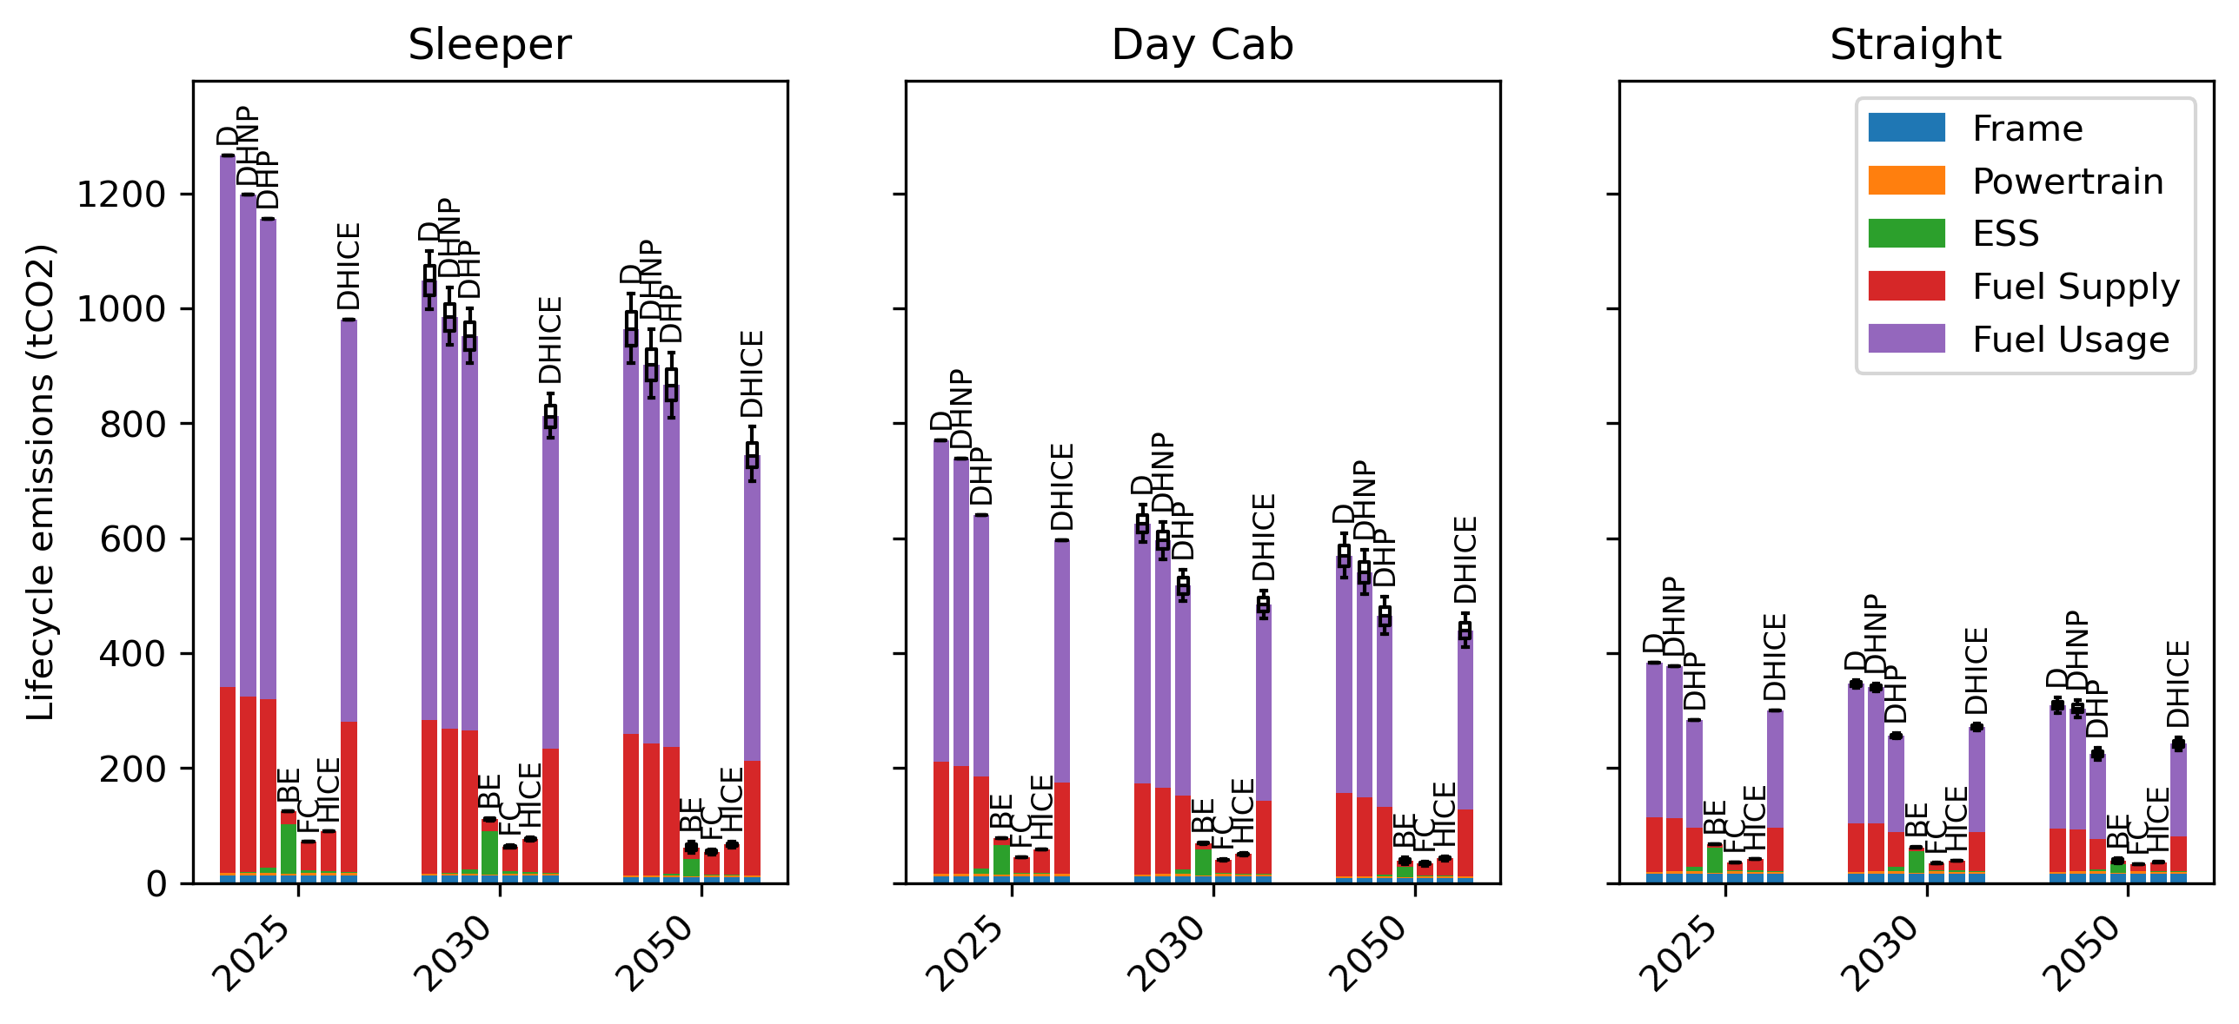
Figure 1. Lifecycle emissions for each powertrain and vehicle type in 2025, 2030, and 2050.
Sleepers enjoy the largest emissions reduction per vehicle for a transition to ZEVs as they cover the largest lifetime mileage, while straight trucks experience the smallest reduction.

Capital cost and NPV
Figure 2 presents estimated capital costs in 2025, 2030, and 2050, broken down into contribution by component. Diesel trucks have the lowest capital cost for all time periods. This is because they have a well-established supply chain and a simple energy storage system. Hybrids come with a modest increase in capital cost, due to additional battery and motor. HICE and DHICE are also moderately more expensive due to the hydrogen storage cost and increased engine cost, which decrease over time. BETs and FCETs are substantially more capital intensive, although their costs are expected to decline significantly.
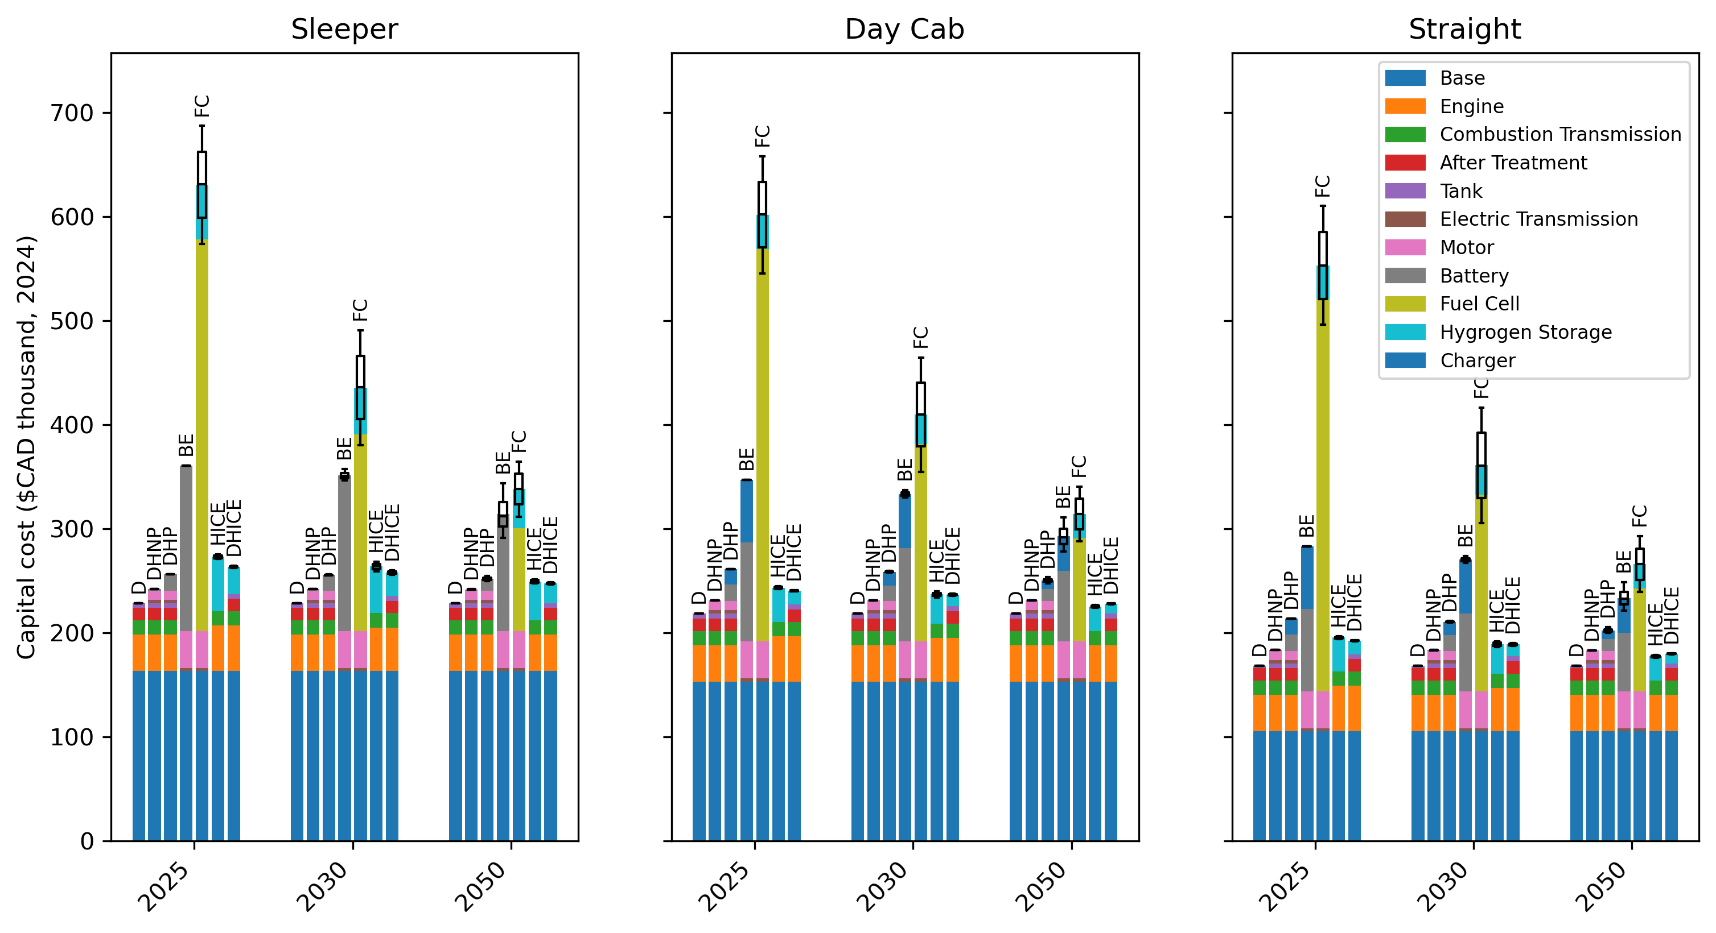
Figure 2. Capital cost by component for each powertrain and vehicle type in 2025, 2030, and 2050.
Figure 3 presents the NPV and its components for each vehicle type and powertrain in 2025, 2030, and 2050. Future fuel and component cost changes are accounted for, although in the model operators do not account for this unless specified.
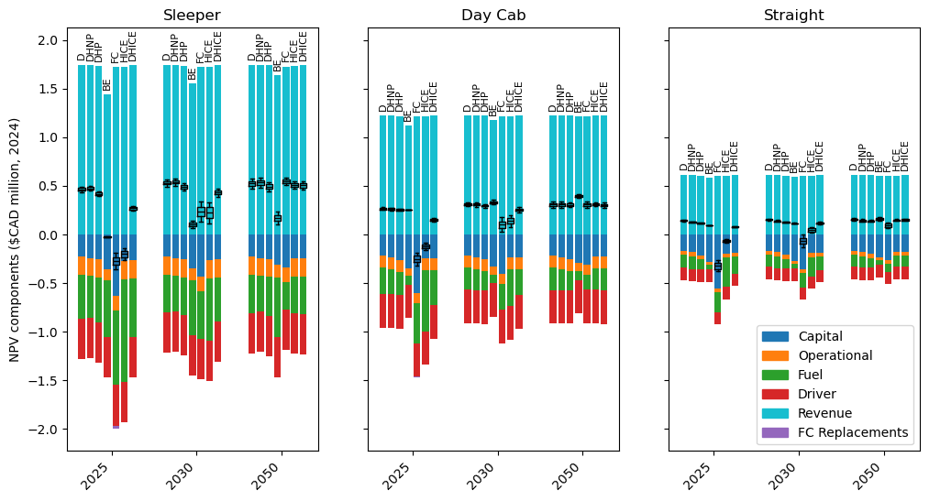
Figure 3. Net present value by component for each powertrain and vehicle type in 2025, 2030, and 2050.
DHNPs have the highest initial NPV for sleepers. For day cabs and straight trucks, fuel economy gains of DHNPs or DHPs are insufficient to offset capital costs due to their lower mileage.
BET sleepers are unlikely to become competitive with diesel because their reduced range and payload lead to revenue losses and because they are assumed to use more expensive fast charge facilities. However, BETs are likely the most competitive ZEV option for day cabs and straight trucks. This is because range and payload impacts are lower, and they are assumed to charge at their own facilities at lower cost. For day cabs, BETs have the highest NPV of all powertrains in 2050.
Hydrogen powertrains are lighter and don’t have the range limitations of BETs and so offer similar revenues to diesel HDTs. However, the high fuel and, for FCETs, fuel cell costs make them the least competitive option in 2025. As these costs decrease over time, the NPV of hydrogen powertrains increases, and by 2050, are competitive with diesel powertrains. FCETs have a higher NPV for sleepers, where fuel costs make a higher proportion of TCO, while HICETs have a higher NPV for straight trucks. FCETs and HICETs have a similar NPV for day cabs. The NPV of DHICETs sits between that of HICETs and diesel trucks for all vehicle types.
The results suggest that ZEVs are unlikely to be competitive in a free market until close to 2050; incentives are needed to achieve emission targets.

Policy scenarios
Figure 4 presents fuel supply and fuel use emissions from B.C.’s HDT fleet in 2050 under each policy scenario. The left axis shows absolute emissions (MtCO₂e), while the right axis indicates emissions relative to 2007 levels (%). While both forms of emissions have a similar response to decarbonisation policies, the effect on fuel use emissions is more pronounced. This is because ZEVs eliminate fuel use emissions but still have some associated fuel supply emissions.
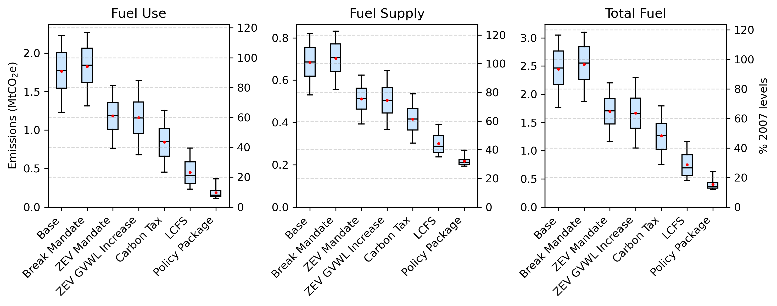
Figure 4. Fuel combustion, fuel supply, and total fuel emissions in 2050 in each policy scenario.
Figure 5 shows total fuel emissions under each policy scenario in 2030, 2040, and 2050. The dashed red lines indicate the provincial emission reduction targets of 40%, 60%, and 80%, respectively, relative to 2007 levels (Government of B.C., 2025b), assuming emissions have increased 34% since 2007 (Government of B.C., 2023b). The 2030 and 2040 targets are not met under any scenario, this is due to assumed diesel vehicle retirement rates and limits to ZEV sales growth and because of emissions growth since 2007. The 2050 target is likely only met in the Policy Package scenario, highlighting the need for multiple policy measures to achieve deep emission reductions.
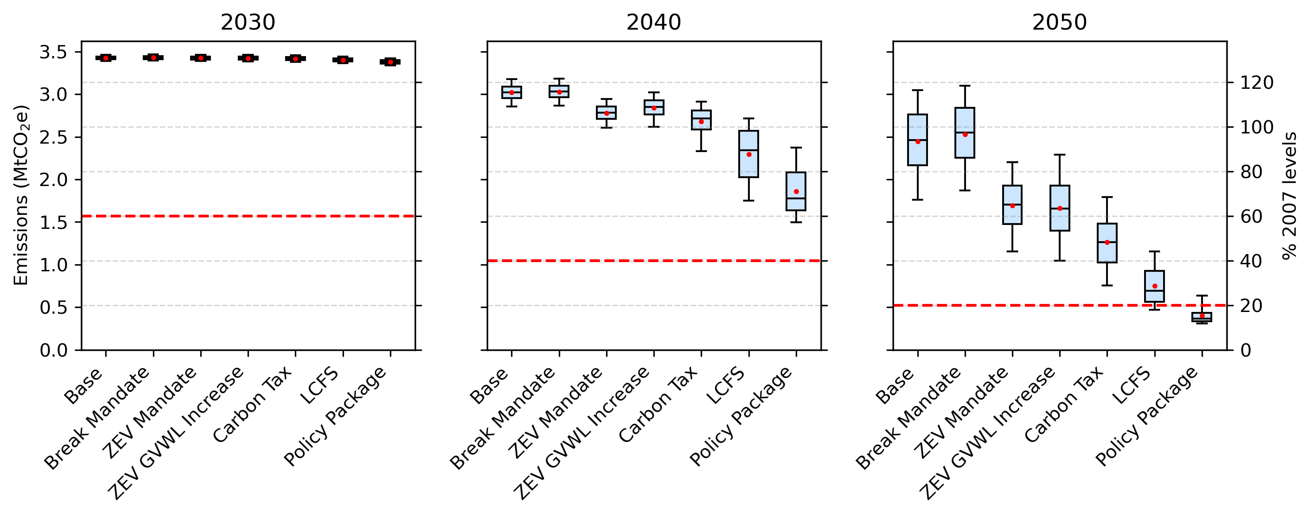
Figure 5. Total fuel emissions (supply and use) in 2030, 2040, and 2050 in each Policy Scenario. Red lines indicate provincial emission targets.
Figure 6 shows total fuel emissions in 2050, broken down by HDT type. Policy responses are broadly similar. Sleepers are the largest source of emissions in the sector due to their higher energy demand (they cover 60% of all HDT kilometres), and targeting them could have the highest impact. Sleepers are the least responsive to ZEV mandates as the non-compliance fee is smaller relative to NPV. More detail on individual policies is given in subsequent sections.
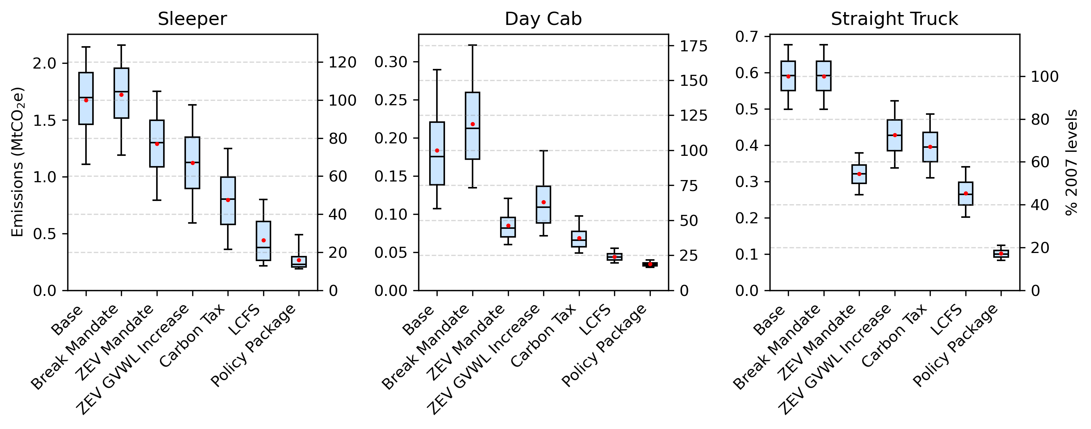
Figure 6. Total fuel emissions in 2050 by HDT type.
Figure 7 shows the average road freight activity cost (¢/t-km) for HDTs in B.C. in 2030, 2040, and 2050. The right-hand axis indicates activity costs relative to those in 2025. Where they differ, the activity cost excluding direct policy costs or revenues (such as LCFS credits) are also provided. Activity cost is generally expected to decrease over time. Stronger policies lead to lower system costs in the long-term due to reduced fuel costs. These cost reductions are not achieved in the base scenario due to lack of foresight on future costs and discounting, both of which reduce the consideration given by operators to fuel expenditure.
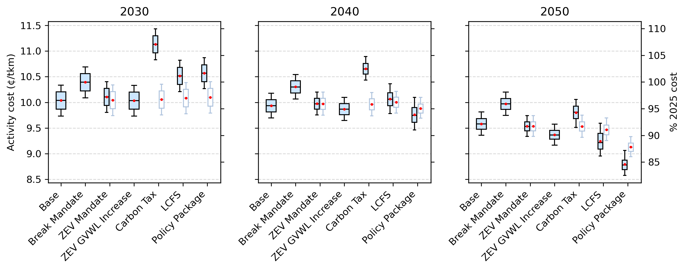
Figure 7. Average activity cost ($/t-km) in 2030, 2040, and 2050 for each policy scenario. Where different, activity costs including (left) and excluding (right) direct policy costs are provided side-by-side.
In Figure 8, the average activity cost (¢/t-km) from 2025 to 2050 is broken down by vehicle type for each policy scenario. It shows that the impact on cost is likely to vary by subsector. For example, while the carbon tax adds cost to all subsectors, break mandates only impact sleepers and day cabs. More detail on results from individual policies is given in the next sections.
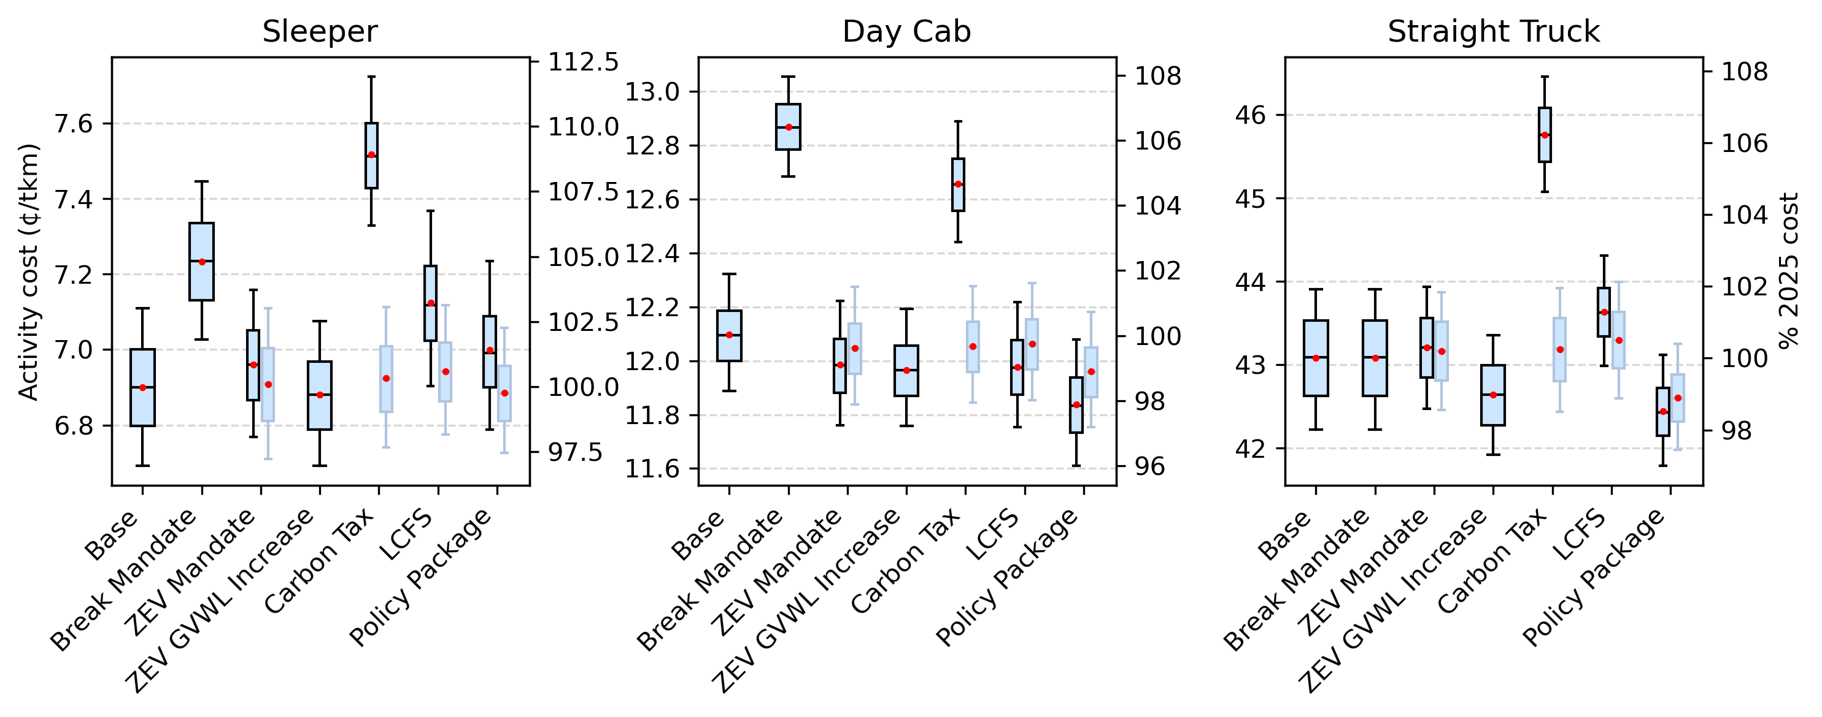
Figure 8. Road freight activity cost (average 2025-2050) for each policy scenario and vehicle type. Where different, activity costs including (left) and excluding (right) direct policy costs are provided side-by-side.

Base
Predicted sales and stock for sleeper-cab, day-cab, and straight heavy-duty trucks in B.C. from 2025 to 2050 are presented in Figure 9, respectively. Diesel-powered vehicles initially dominate sales for all vehicle types.
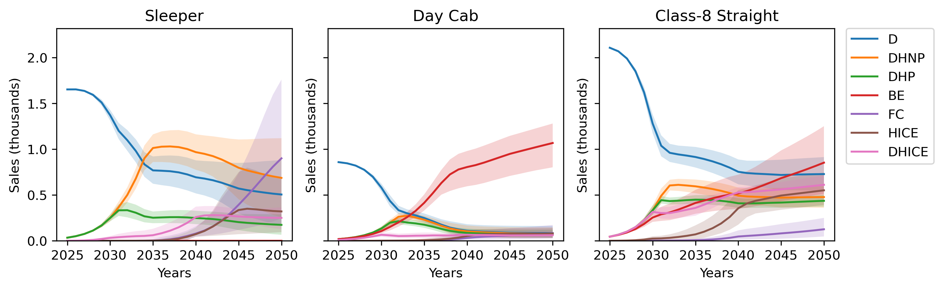
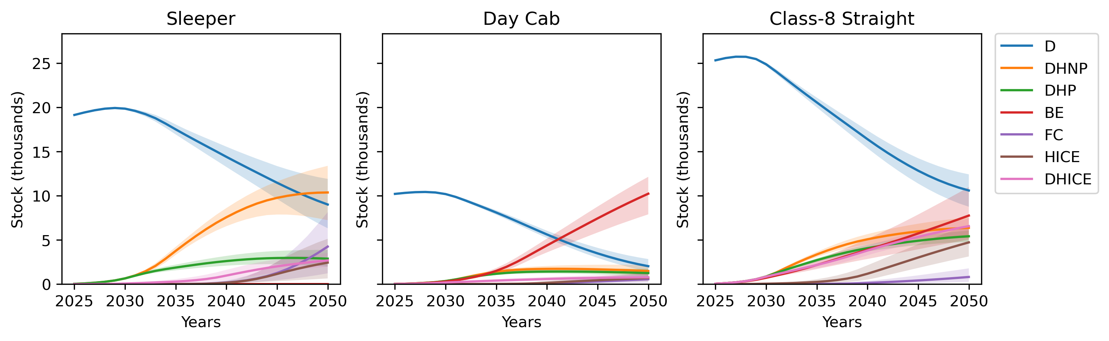
Figure 9. Sales (upper) and stock (lower) in the Base scenario (2025-2050) for each HDT type and powertrain.
Sleepers are predominantly diesel-powered throughout the modelling period with most vehicles either diesel or diesel-hybrids by 2050. Limited traction for DHICETs in the 2030s precedes FCETs and HICETS gaining market share in the 2040s, as hydrogen and fuel cell costs decrease. The BET market share remains low for sleepers due to range and payload capacity restrictions.
BETs are the dominant ZEV for day cabs, becoming the most cost-effective option in the 2030s. This is based on the assumption of day cab use for regional-haul applications; hydrogen powertrains may be more appropriate for day cabs in high load applications such as resource haulage.
Although straight trucks continue to be predominantly powered by diesel, the penetration of alternative powertrains is more complex. Hybrids, DHICETs, and BETs experience early sales growth before HICETs develop their own share of the market. The low capital cost of HICETs and the low cost of electricity in B.C. make them balanced competitors. The high capital cost of FCETs was found prohibitive for straight trucks, which have a lower mileage and therefore enjoy lower lifetime fuel savings.
Figure 10 shows useful energy delivered by fuel type in the Base scenario. The results indicate that, over the time horizon considered, diesel demand from the road freight sector is likely to decrease only modestly without policy incentives; diesel demand reductions from efficiency improvements and ZEV adoption are largely offset by sector growth. Consequently, emissions in 2050 remain at 67-116% of 2007 levels, highlighting that sufficient decarbonisation is not achievable without supporting policies.
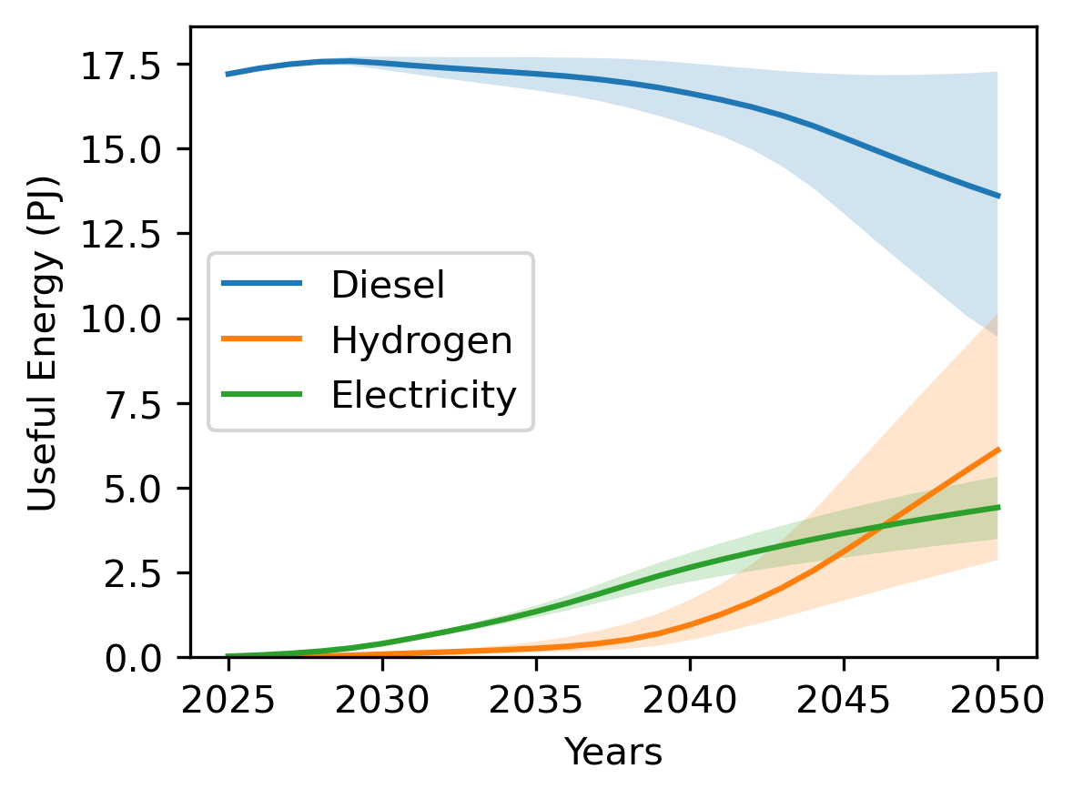
Figure 10. Useful energy supplied to HDTs in B.C. 2025-2050 by fuel in the Base scenario.

Break Mandates
Break mandates have no impact on straight truck sales emissions as the straight truck duty cycles are not impacted by the regulation. Emissions for sleepers and straight trucks are actually moderately increased due to elevated sales before the ZEV market share has risen. Sleepers don’t benefit from the policy since BETs remain uncompetitive and day cabs receive diminishing benefit from the policy as vehicle range increases. The policy leads to increased freight costs due to increased vehicle purchases and driver wage payments during breaks.

ZEV GVWL Increases
As a stand-alone policy, the simulated ZEV GVWL increases reduces 2050 HDT emissions by 24-42% relative to the Base scenario and lowers the total cost of activity from 2025 to 2050 by 0-2%. This is because it makes ZEV powertrains more competitive by increasing their payload capacity and therefore revenue. Its inclusion in the Policy Package leads adds emission reductions of 15-39%, compared to just an LCFS and ZEV mandate.

ZEV Mandate
In the ZEV Mandate scenario, 2050 emissions are 26-36% lower than the Base scenario. This is less than the impact that has been estimated by studies such as Hammond et al. (2020). In other studies, the ZEV mandates are assumed to be met, while in this study a credit market was modelled based on ZEV penetration and the non-compliance fee. The non-compliance fee ($30,000) was based on government consultation of industry and is low compared to the TCO of HDTs (particularly sleepers). The average additional cost and revenue to ZEV and non-ZEV HDTs, respectively, is presented in Figure 11. If the non-compliance fee is instead set to $100,000, emissions fall 52-68% below the Base scenario.
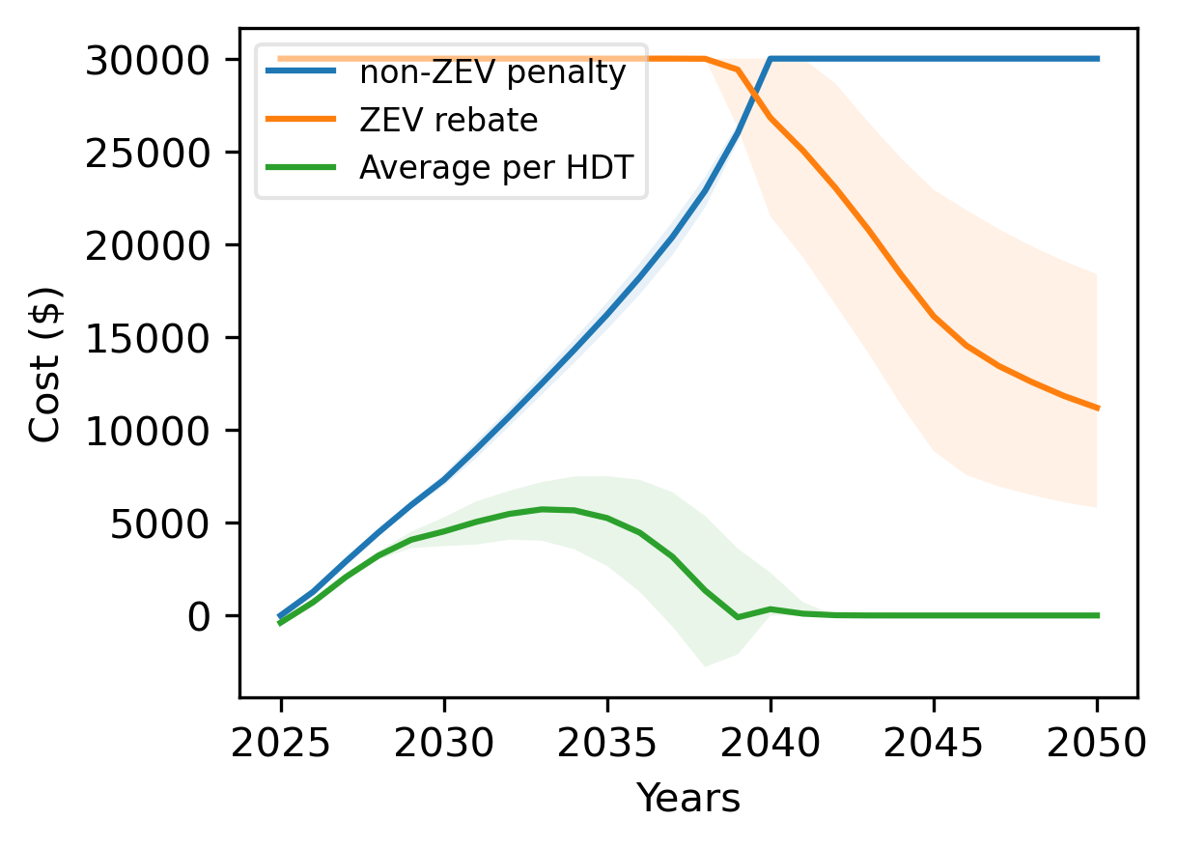
Figure 11. Additional cost per non-ZEV, rebate per ZEV, and average additional cost per any HDT sale in the ZEV Mandate scenario 2025-2050.
Currently, the B.C. government is considering a combined ZEV mandate for medium- and heavy-duty vehicles. A separate market for medium- and heavy-duty trucks would ensure that compliance is not achieved mostly through medium-duty adoption, which would yield lower emission reductions per ZEV substitution (Government of B.C., 2023b; Statistics Canada, 2009).

Carbon tax
The carbon tax was the second most effective single policy at reducing 2050 emissions after the LCFS, achieving 39-59% emission reductions relative to the Base scenario. This scenario experiences the highest trucking activity costs, increasing the total cost of activity 2025-2050 by 3-9%.

LCFS
The LCFS was found the most effective single policy at reducing emissions, achieving 59-77% emission reductions relative to the Base scenario in 2050. This is because the assumed credit value of $300/tCO₂ has a greater impact on NPV than the carbon tax, the second most effective policy. The credit value is dependent on the fuel market, which involves more than just HDTs; maintaining credit value in reality would take careful monitoring and setting of carbon intensity targets. Therefore, it is hard to reliably estimate the impact of the LCFS on system cost, and the results in Figure 7 and Figure 8 for the LCFS scenario activity costs present a hypothetical scenario.
However, assuming the credit value is maintained, the relative impact on NPV for each vehicle would be similar; as the target carbon intensity decreases, the NPV of every vehicle decreases – electricity or hydrogen use generates less credits, and diesel use requires more credit purchases. Therefore, the estimated impact on emissions and system cost excluding policy (LCFS credits) remain defensible.

Policy Package
Figure 12 shows B.C. sales and stock for each HDT type and powertrain from 2025 to 2050 in the Policy Package scenario (LCFS, ZEV mandates, ZEV GVWL increases). In this scenario, 2050 emissions are reduced 76-88% relative to 2007 levels.
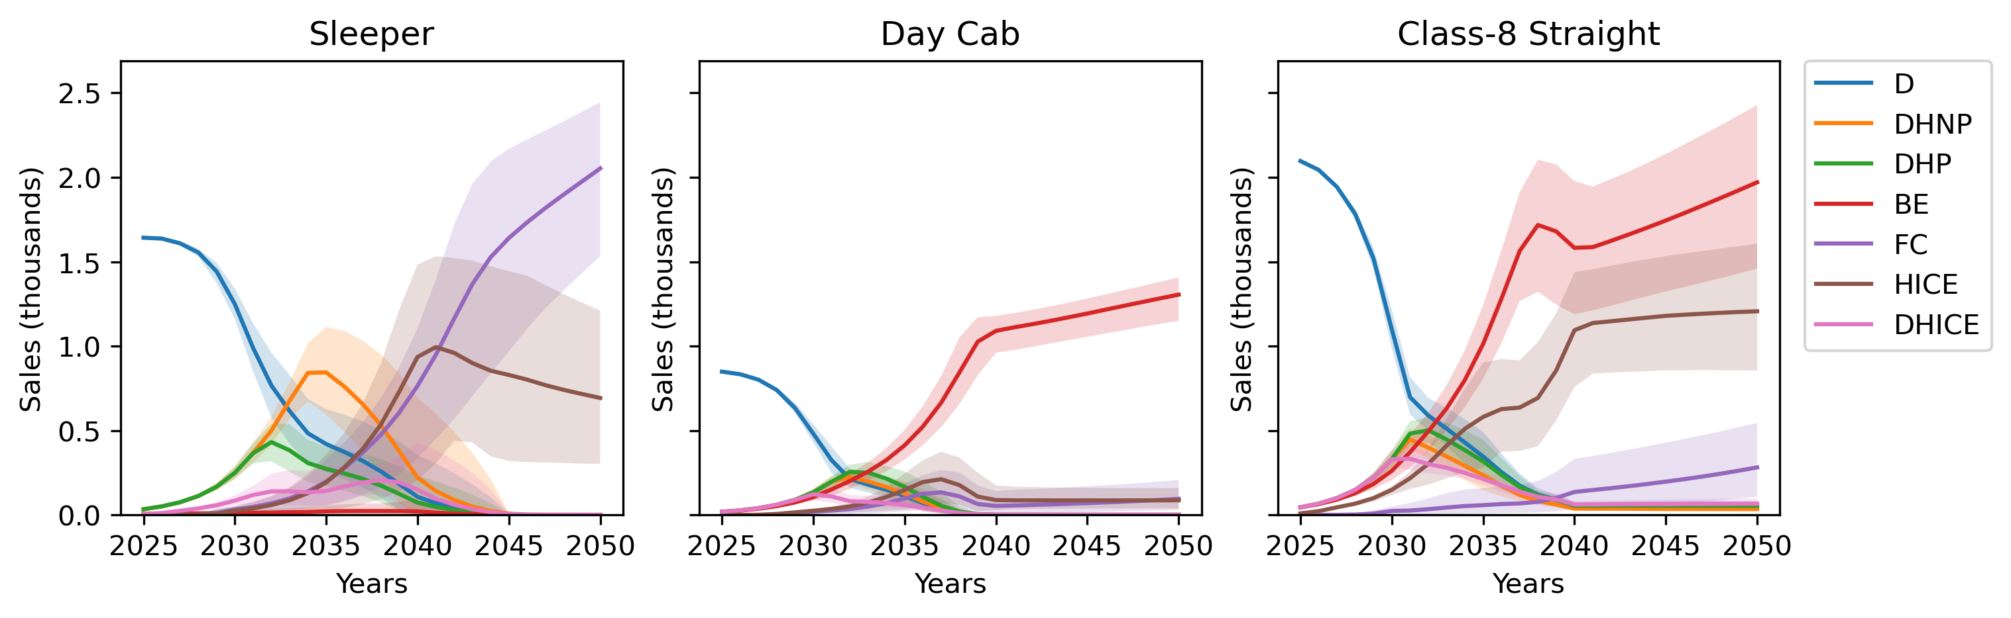
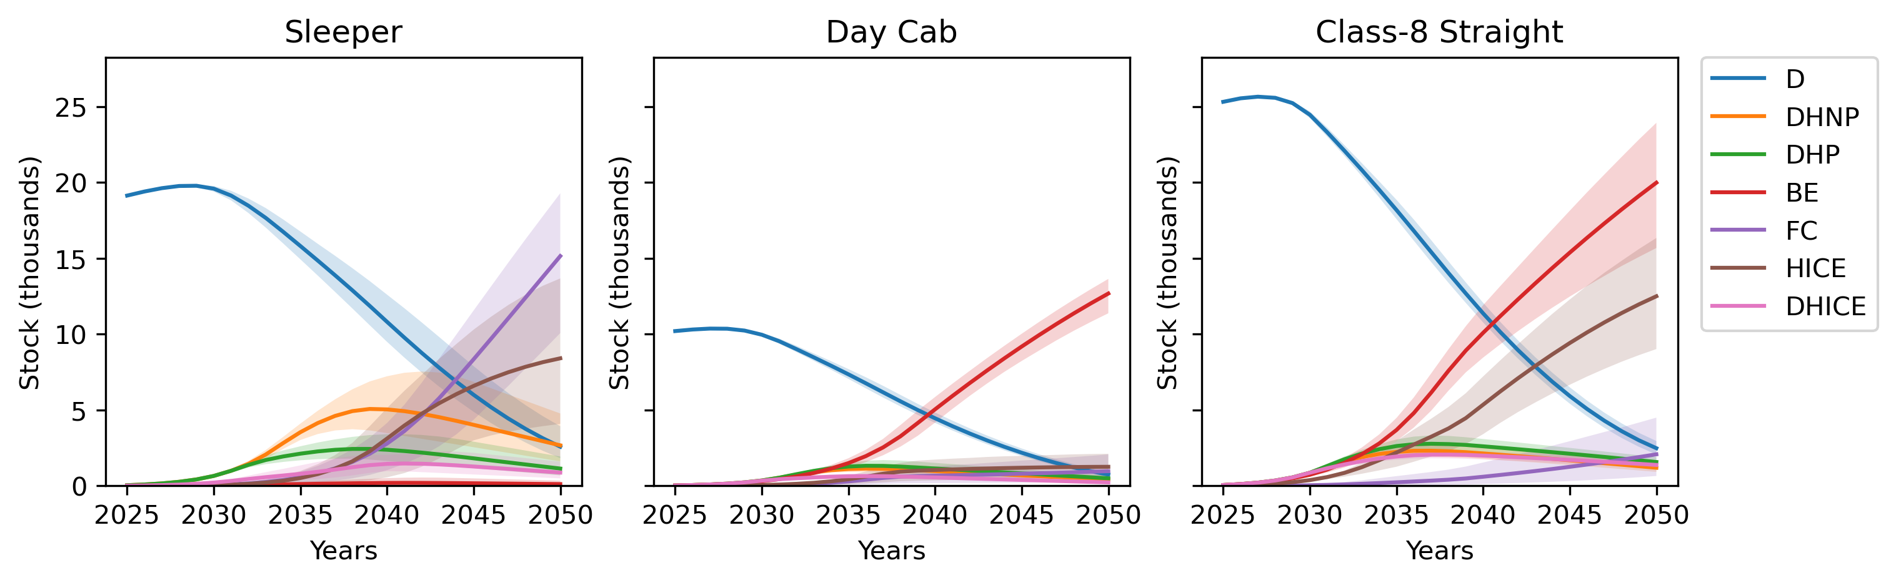
Figure 12. Sales (upper) and stock (lower) in the Policy Package scenario (2025-2050) for each HDT type and powertrain.
In this scenario, the sleeper-cab fleet becomes dominated by hydrogen powertrains, HICET powertrains initially grow slightly faster as it is assumed their production can scale at a faster rate. While the availability of HICE powertrains allows the market share of hydrogen powertrains to grow at a faster rate, FCETs ultimately have a higher NPV due to their superior fuel efficiency and are the most prevalent sleeper powertrain in 2050.
The day cab market share becomes dominated by BETs, as range and payload requirements are assumed less prohibitive. However, in applications where HDTs regularly operate at payload capacity, such as resource-sector haulage, HICE or FC powertrains may be preferable and take some of the day cab market share, leaving regional-haul day cab applications to BETs.
BETs and HICETs together dominate the straight truck market from the late 2030s. HICETs are preferred to FCETs due to their lower capital cost – mileage is lower than for sleepers and fuel economy is less important.
The amount of useful energy supplied to HDTs in B.C. in the policy package and consequent fuel emissions are presented in Figure 13. In 2050, diesel, electricity, and hydrogen supply 3-12%, 24-32%, and 58-71%, respectively, of the useful energy to the sector. The transition accelerates after 2035 as ZEVs come to dominate HDT sales. Hydrogen is the dominant fuel in the long term due to greater operational flexibility of hydrogen powertrains which causes them to dominate sleeper sales, which have the greatest energy demand.
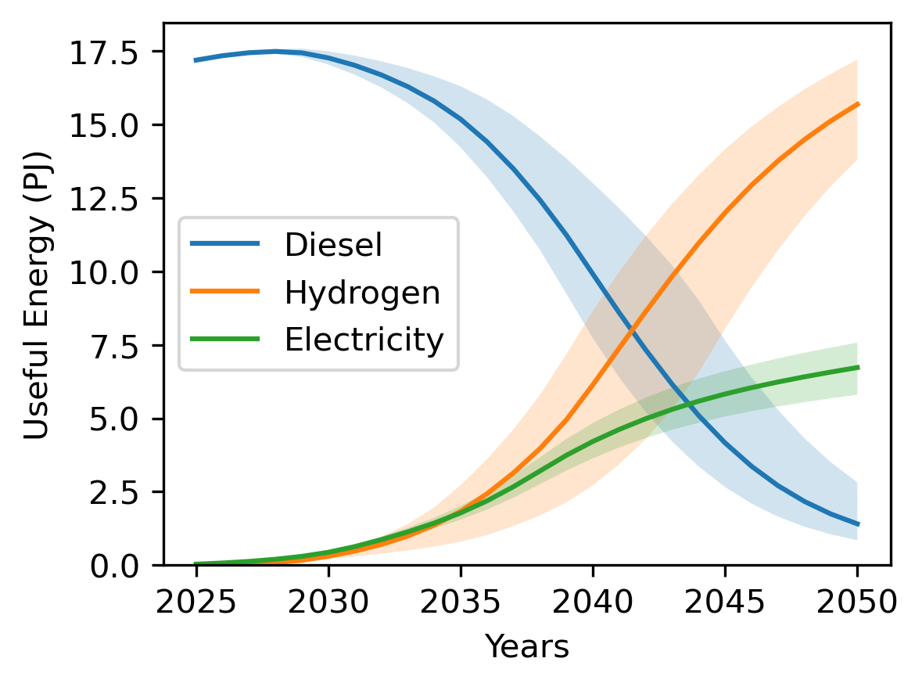
Figure 13. Useful energy supplied to HDTs in B.C. 2025-2050 by fuel in the Policy Package scenario.

Other considerations

Embodied emissions
Figure 14 shows embodied emissions for HDTs in B.C. in 2030, 2040, and 2050 under different policy scenarios. Although embodied emissions may double by 2050, deep emission reductions are still possible, because embodied emissions are small relative to current fuel emissions. Policy scenarios where BET uptake is higher result in greater embodied emissions, mostly due to the high emissions intensity of battery production. This effect is more pronounced in 2040 than 2050, as the carbon intensity of battery production is expected to decrease at a faster rate than that of iron and steel. Scenarios where activity per vehicle is lower (e.g. Break Mandates) also have higher embodied emissions as more vehicles are required to meet sector demand.
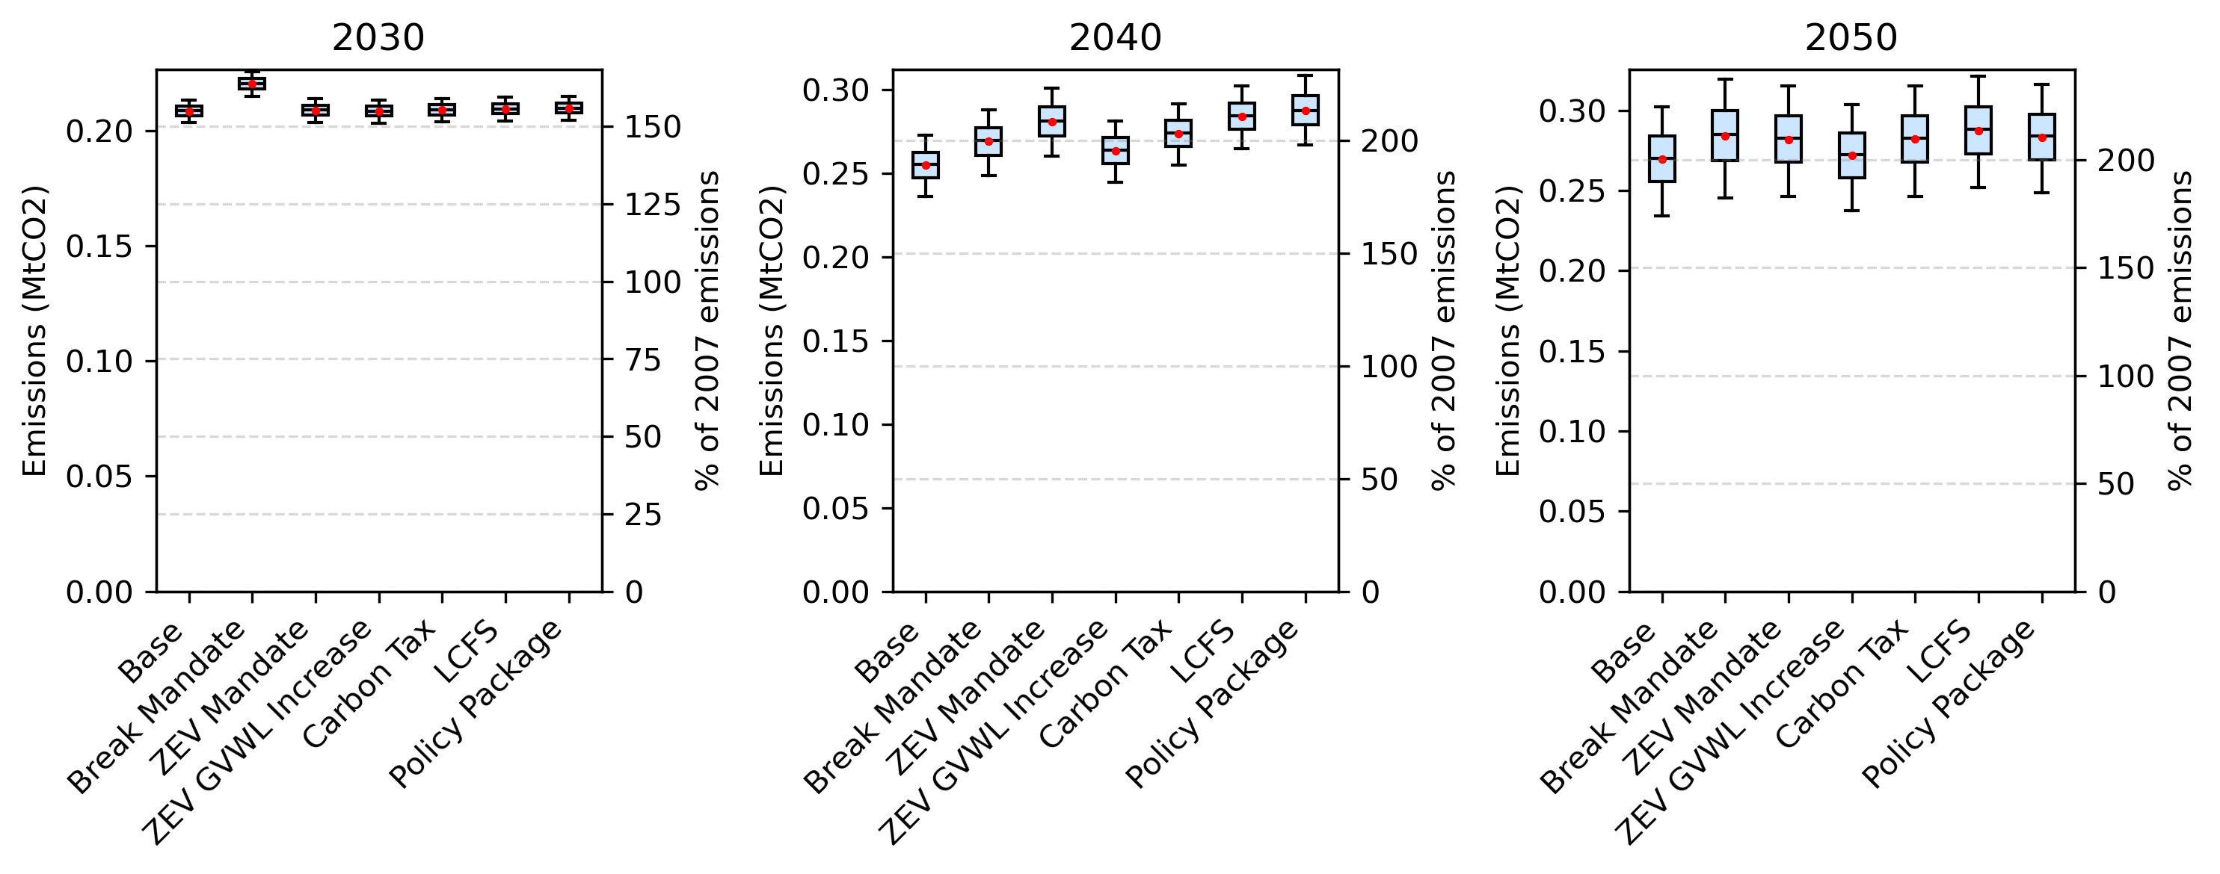
Figure 14. Embodied emissions from HDTs in B.C. in 2030, 2040, and 2050 in each policy scenario.

Accelerated Retirement
The mass retirement of diesel-powered HDTs of 15 years or older in the first-year leads to a spike in capital expenditure in the first model year due to the new vehicle purchases needing to meet activity requirements. However, activity from these vehicles is low as most vehicles have retired before this age and annual mileage is low for vehicles that are still in use. In the first year, capital expenditure increases 19% and freight activity cost by 3.6%. Overall, the impact on emissions is low (2-5%) when accelerated retirement is added to the Base scenario due to the assumption that activity from vehicles over 15 years of age is low and that lost activity is being recovered mostly through the purchase of additional diesel vehicles. However, adding accelerated retirement to the Policy Package scenario reduces its emissions in 2050 by 7-13%, as more of the lost activity is met by purchasing ZEVs. The impact on air quality was not assessed but could be significant.

Foresight
In the Base scenario, giving operators foresight on future cost changes led to emissions being 0-14% lower than they would otherwise be in 2050. Adding foresight to the Policy Package scenario reduced its emissions in 2050 by 11-41%. The effect on the Base scenario is weaker as hydrogen powertrain adoption is limited, with or without cost foresight. These results suggest that efforts to give confidence to operators that hydrogen costs will decrease in the future, such as through government infrastructure strategy and investment, could accelerate adoption of hydrogen powertrains and reduce emissions.

Autonomous vehicles
In the autonomous permits (AP) scenario, autonomous vehicles have 50% market penetration by 2040 for all ZEVs. Only ZEVs are permitted to operate autonomously, significantly decreasing their TCO. The results for this scenario are displayed in Figure 15. In the event of high autonomous vehicle penetration, limiting autonomous vehicles to ZEVs reduces emissions 54-67% relative to the Base scenario even with no other policy incentives in place. Adding autonomous permits to the Policy Package scenario reduces its emissions by 13-31%.
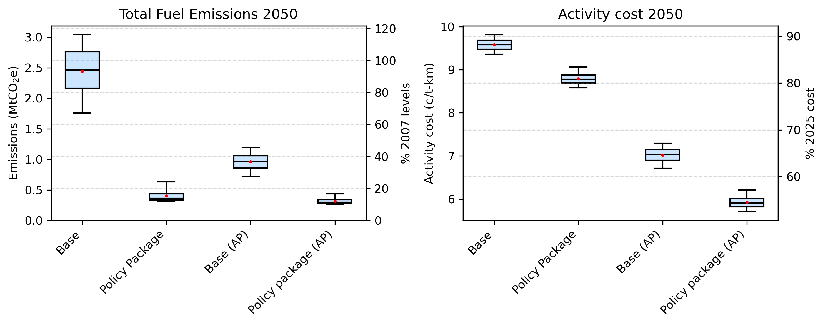
Figure 15. Emissions and activity cost in 2050 in the Base and Policy Package scenarios, with and without autonomous permits (AP) for ZEVs.
There are other considerations which are not made with respect to autonomous vehicles in this paper. On the one hand, issuing autonomous permits may also lead to an early retirement of existing vehicles, further accelerating the transition. On the other, activity cost reductions could lead to mode shifting from rail to road freight, increasing emissions, energy demand, and traffic. Autonomous vehicles could impact sector job security and affect perception of the energy transition.

Hydrogen pathways
Figure 16 shows estimated lifecycle emissions from FCETs and HICETs in 2030 under three different hydrogen production pathways: water electrolysis (WE), pyrolysis (P), and electrified pyrolysis (EP). Producing hydrogen from water electrolysis results in the lowest lifecycle emissions for all vehicle types and hydrogen powertrains, followed by electrified pyrolysis. It is possible that pyrolysis and electrified pyrolysis emissions could be reduced by tackling methane supply-chain emissions, although this was not considered.
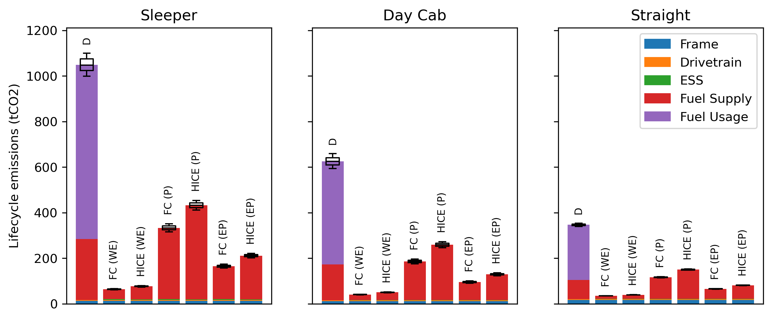
Figure 16. Lifecycle emissions from hydrogen-powered HDTs in 2030, with hydrogen sourced from water electrolysis (WE), pyrolysis (P), and electrified pyrolysis (EP). Diesel (D) trucks are included for comparison.
Figure 17 shows total fuel emissions in 2050 from HDTs in the Base and Policy Package scenarios for each hydrogen production pathway. In the Base scenario, the pyrolysis pathway leads to the lowest emissions, despite the higher emissions intensity relative to water electrolysis. This is because hydrogen produced via pyrolysis is cheaper than water electrolysis, and this accelerates adoption of hydrogen powertrains. In the Policy Package scenario, the water electrolysis pathway results in the least emissions. This is because mass adoption of hydrogen powertrains is achieved in either case and water electrolysis is a less carbon intensive production pathway.
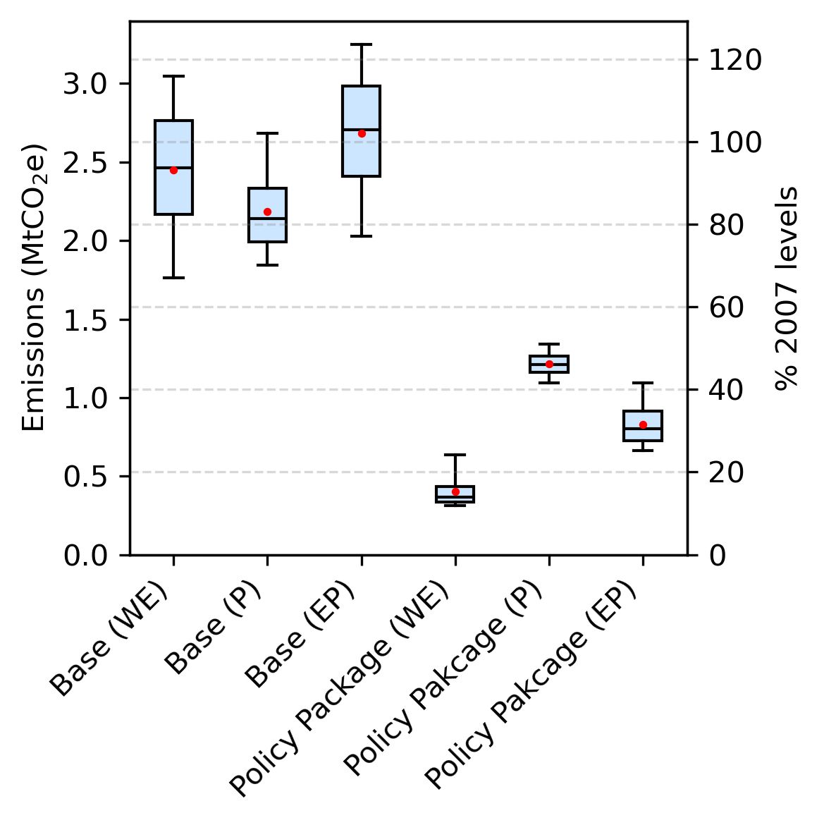
Figure 17. Emissions from HDTs in B.C. in 2050 in the Base and Policy Package scenarios under different hydrogen production pathways: water electrolysis (WE), pyrolysis (P), and electrified pyrolysis (EP).
Figure 18 shows electricity and water consumption in 2050 in the Base and Policy Package scenarios under different hydrogen production pathways. The Policy Package scenario increases water consumption due to increased hydrogen demand – with the water-electrolysis pathway, the sector consumes 25-33 million tonnes of water per year. While pyrolysis presents an opportunity to dramatically reduce water consumption, 25-33 million tonnes corresponds to just 1.0-1.4% of B.C.’s 2021 water consumption (ECCC, 2025a), and this is at the exchange of increased emissions (Figure 17).
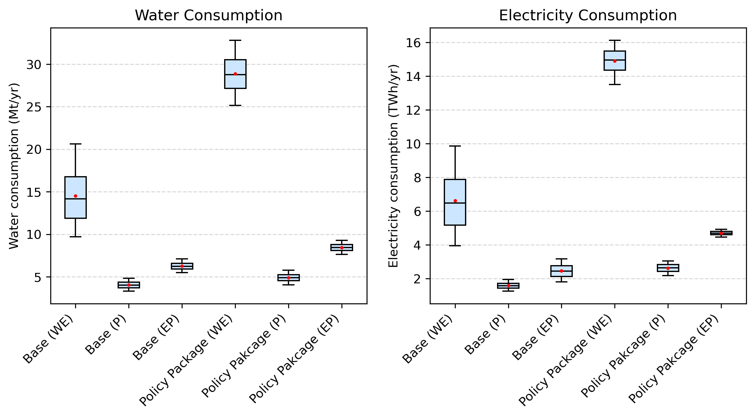
Figure 18. Annual water (left) and electricity (right) consumption in 2050 in the Base and Policy Package scenarios under different hydrogen production pathways: water electrolysis (WE), pyrolysis (P), and electrified pyrolysis (EP).
Electricity consumption and intensity may be a more important consideration: the electrification of the HDT sector could add around 13.5-16.1 TWh of electricity demand, i.e. 24-28% of the 56.1 TWh of electricity generated in B.C. in 2023 (CER, 2025). Pyrolysis does present an opportunity to reduce this demand significantly, although with higher emissions than the water electrolysis pathway.
While battery recharge could also add significantly to peak demand, according to our findings, most ZEV sleeper-cab trucks (which would likely require fast charging if battery-electric) are expected to use hydrogen powertrains in 2050 across the scenarios modelled.

Conclusion and Policy Implications
This paper discusses the development of a vehicle adoption model based on net present value (NPV) which can be used to predict future costs and emissions from the heavy-duty trucking sector and how these can be impacted by policies technological improvements. The model incorporates policy-relevant factors, such as embodied emissions, autonomous vehicles, alternative hydrogen production pathways, operator foresight on future costs, and water and electricity consumption.
The model was applied to British Columbia. The mountainous terrain, cold climates, high gross vehicle weight limits, and long vehicle lifetimes make for an interesting case study of a hard-to-abate region. The case study led to the following conclusions and policy implications:
- Deep decarbonisation of the HDT sector by 2050 will require mass adoption of ZEVs, which is unlikely to occur without policy incentives.
- Provincial emission reduction targets of 40% by 2030 and 60% by 2040 (relative to 2007 levels) are not achieved under any modelled scenario; however, the 2050 target is met through a combination of ZEV GVWL increases, a ZEV mandate, and an LCFS.
- The LCFS is the most effective of the policies considered for reducing emissions.
- The proposed penalty of $30,000 for B.C.’s MHDV ZEV mandates is too small in comparison to the costs and revenues associated with HDT operation. A dedicated ZEV mandate for HDTs with a non-compliance fee of $100,000 would have a similar efficacy to the LCFS.
- In deep decarbonisation scenarios, hydrogen is the dominant fuel, providing the majority of the useful energy to the sector. This is because sleeper cabs, which are responsible for 60% of sector mileage, find hydrogen powertrains more competitive due to superior range and payload capacity.
- While the impacts of decarbonisation policies on road freight activity costs are generally small, the carbon tax results in the highest cost increase. ZEV GVWL increases directly reduce activity costs. Activity costs in 2050 are generally smaller in deep decarbonisation scenarios.
- Driver break mandates did not result in reduced emissions, as they only provided significant benefit to BETs in the sleeper-cab market, where BETs remain uncompetitive regardless of this intervention.
Other findings include:
- Embodied emissions currently account for less than 10% of total sector emissions, but they may become the dominant emissions source under deep decarbonisation scenarios. Deep emission reductions remain achievable even when embodied emissions are considered.
- Operator foresight in regard to future fuel and component cost reductions can accelerate adoption of hydrogen powertrains, suggesting that efforts to build consumer confidence in hydrogen technology could support and earlier transition.
- Emissions reductions from accelerated retirement of diesel HDTs are limited unless a significant portion of new HDT sales are ZEVs.
- In the event that autonomous HDTs become readily available, limiting autonomous vehicles to ZEVs could provide an effective decarbonisation policy mechanism.
- Hydrogen production via electrolysis increases sectoral water consumption but remains modest relative to provincial use (approximately 1–1.4% of current provincial consumption in the Policy Package scenario).
- Electricity demand from HDTs could exceed 15 TWh/year by 2050, over one quarter of the current electricity demand in B.C. Methane pyrolysis and electrified methane pyrolysis can reduce the sector’s water and electricity consumption, but at the cost of increased fuel supply emissions.

Acknowledgement
The authors gratefully acknowledge the Canada First Research Excellence Fund – Accelerating Community Energy Transformation (CFREF-2022-00048) for financial support. The authors thank Dr. Gail Hochachka and Dr. Majid Gholami for their thoughts, insights, and interesting conversations.

Appendix A

General parameters
Parameter | Value
Growth rate (real) | 2%
Private discount rate (real) | 8%
Market sensitivity | 3e-5
Activity (year 0) | 48.9 Gt-km
Annual truck retirements | 4%
Gravity | 9.81 m/s²
Start year | 2025
End year | 2050
Max initial market share for alternate powertrains | 2%
Station access delay | 15 minutes
Table 7. Miscellaneous model parameters. Annual truck retirements as percentage of initial fleet for a given model year.

Vehicle activity
Truck type | Fleet | Average annual distance | Average payload | Distance | Activity
Sleeper-cab truck | 35% | 115,000 | 16,000 | 60% | 77%
Day-cab truck | 18% | 76,000 | 10,000 | 21% | 17%
Straight truck | 47% | 27,000 | 4,000 | 19% | 6%
Table 8. Truck fleet composition and activity (National Research Council, 2010; NRCan, 2025; Statistics Canada, 2009)
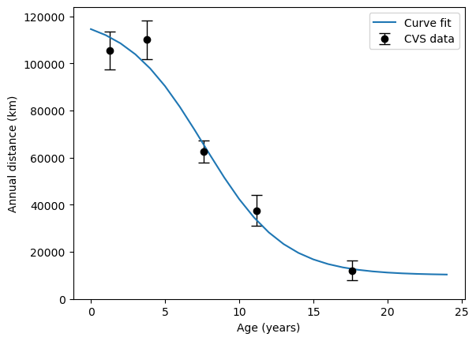
Figure 19. Annual distance vs age for class-8 trucks in Canada (Statistics Canada, 2009).

Fuel Properties
Fuel | Unit | LHV (MJ/unit) | Supply GHG intensity (kgCO2e/unit) | Use GHG intensity (kgCO2e/unit) | Refuelling efficiency | Water use (L/unit) | Electricity use (kWh/unit) | Sources
Diesel | L | 38.6 | 0.88 | 2.52 | 1.0 | 2.95 | 0.1 | (S&T Squared, 2025; M. Wang et al., 2024)
Electricity (slow charge) | kWh | 3.6 | 0.0099 | 0 | 0.95 | 1.43-1.88 | 1.0 | (Government of B.C., 2025a; M. Wang et al., 2024)
Electricity (fast charge) | kWh | 3.6 | 0.0099 | 0 | 0.86 | 1.43-1.88 | 1.0 | (Government of B.C., 2025a; M. Wang et al., 2024)
Hydrogen (electrolysis)¹ | kg | 120 | 0.57 | 0 | 1.0 | 95.6-121.4 | 55 | (A. Franco et al., 2023; IRENA and Bluerisk, 2023)
Hydrogen (pyrolysis)² | kg | 120 | 6.44 | 0 | 1.0 | 4.71-5.66 | 2.12 | (Serrato & Rowe, 2025; M. Wang et al., 2024)
Hydrogen (electrified pyrolysis)^{1,2} | kg | 120 | 1.92 | 0 | 1.0 | 16.3-20.9 | 10.23 | (Serrato & Rowe, 2025; Wang et al., 2024;Seymour et al., 2024)
- Water consumption includes water consumed to supply electricity.
- Methane supply emissions included.
Table 9. Physical fuel properties.

Vehicle performance
Parameter | Value(s) | Citations and notes
Frontal area | 9.2 m² | (National Academics, 2020)
Mass correction | 0.2 | (Gilleon et al., 2022)
Transmission efficiency | 95% | (Gilleon et al., 2022)
Embodied emissions (except Li-ion battery) | 2025: 2.2 kgCO₂/kg  2050: triangular (0.9, 1.7, 2.2) kgCO₂/kg | (World Steel Association, 2025)  (IEA, 2020)
Li-ion BESS specific mass | 2025: 6.0 kg/kWh  2035: 3.34-5.57 kg/kWh  2050: triangular (1.74, 3.34, 5.57) kg/kWh | 67% increase on cell level; solid state majority by 2035; advanced chemistries potential by 2050.  (Haghbin et al., 2025)  (Jose et al., 2025)  (Tiede et al., 2022)
Battery degradation | 1%/yr  0.002%/cycle | (NREL, 2023)
Autonomous $t_{50}$ | triangular (2035, 2040, 2070) | Purely for scenario analysis.
Table 10. Shared HDT technical parameters.
Parameter | Value(s) | Citations and notes
Drag coefficient* | 2000: 0.7  2010: 0.6  2025: 0.49  2030: 0.34-0.43  2050: 0.30-0.41 | (Marcinkoski et al., 2019)
Trailers per truck | 3 | (National Research Council, 2010)
GVWL | 53,500 kg | Category 7: Truck – Full Trailer  (COMT, 2019)
Frontal area | 9.2 m² | (National Academics, 2020)
Frame mass | 6,052 kg | (M. Wang et al., 2024)
Trailer mass | 5,029 kg | (M. Wang et al., 2024)
Weighed out journeys | 30% | (EPA, 2011)
Table 11. Technical parameters for class-8 sleeper-cab trucks.
Parameter | Value(s) | Citations and notes
Drag coefficient* | 2000: 0.7  2010: 0.6  2025: 0.49  2030: 0.34-0.43  2050: 0.30-0.41 | (Marcinkoski et al., 2019)
Trailers per truck | 3 | (National Research Council, 2010)
GVWL | 53,500 kg | Category 7: Truck – Full Trailer  (COMT, 2019)
Frame mass | 5,380 kg | (M. Wang et al., 2024)
Trailer mass | 5,029 kg | (M. Wang et al., 2024)
Weighed out journeys | 30% | (EPA, 2011)
Table 12. Technical parameters for class-8 day-cab trucks.
Parameter | Value(s) | Citations and notes
Drag coefficient* | 2000: 0.75  2025: 0.6  2050: 0.5-0.6 | Weight of aerodynamic fairings less worthwhile for short-haul applications (National Research Council, 2010).
Trailers per truck | 3 | (National Research Council, 2010)
GVWL | 24,250 kg | Category 5: Straight Truck  (COMT, 2019)
Frame mass | 8,600 kg | Day Cab * 1.46 for box and liftgate.  (M. Wang et al., 2024)
Trailer mass | 0 | No trailer
Weighed out journeys | 30% | (EPA, 2011)
Table 13. Technical parameters for class-8 straight trucks.
Parameter | Value(s) | Citations and notes
Powertrain mass | D: 1,857 kg  DHP: 1,974 kg  DHNP: 1,974 kg | Including transmission  (M. Wang et al., 2024)
Engine efficiency* | 2000: 40%  2010: 43%  2025: 46%  2030: 49-51%  2050: 0.51-0.54% | (National Research Council, 2012)  (Meszler et al., 2018)  (Marcinkoski et al., 2019)
Battery discharge efficiency | 87.5% | Including inverter and motor  (Lajevardi et al., 2019)
Transmission efficiency | 96% | (Lajevardi et al., 2019)
Diesel ESS specific mass | - | Included in powertrain mass
Regen efficiency (round-trip)† | 71% | Power-limited.
Motor size† | 220 kW | (Lajevardi et al., 2019)
Accessory load | Diesel: 4250 W  Hybrid: 3,400 W | (Ramesh Babu et al., 2025)  25% increase if not electrified (Lajunen, 2014).
Fuel capacity | Sleeper: 500 L
Battery size | DHP: 100 kWh  DHNP: 5 kWh
Usable capacity | Diesel: 95%  Battery: 95%
Refuel rate | Diesel: 6000 L/min  Charging:  2025: 250 kW  2050: triangular (250, 500, 750) kW | For en-route re-fuelling only.
Refuel efficiency | Diesel: 100%  Charging: 90% | (Franca et al., 2018)
* 5% (absolute) reduction in efficiency for day-cabs and straight trucks.
† Hybrids only
Table 14. Technical parameters specific to diesel DHP, and DHNP HDTs.
Parameter | Value(s) | Citations and notes
Powertrain mass | 1,115 kg | Including transmission. Not including battery.  (M. Wang et al., 2024)
Battery discharge efficiency | 87.5% | Including inverter and motor  (Lajevardi et al., 2019)
Battery size | Sleeper: 1000 kWh  Day-cab: 600 kWh  Straight truck: 500 kWh
Regen efficiency (round-trip) | 71% | Power-limited.
Motor size | 880 kW | (Lajevardi et al., 2022)
Accessory load | 6,900 W | (Ramesh Babu et al., 2025)
Usable capacity | 2025: 80%  2030: 85-90%  2050: 90-95%
Refuel rate | 2025: 250 kW  2050: triangular (250, 500, 750) kW | For re-fuelling en route only.
Refuel efficiency | Sleeper: 86%  Day-cab: 95% | (Franca et al., 2018)
Table 15. Technical parameters specific to BETs.
Parameter | Value(s) | Citations and notes
Powertrain mass | 1,999 kg | Including transmission.  (M. Wang et al., 2024)
Efficiency | 2025: 59%  2030: 59-63%  2050: 63-66% | (Marcinkoski et al., 2019)
HESS size | Sleeper: 80 kg  Day-cab: 50 kg  Straight truck: 50 kg
HESS specific mass | Sleeper:  2025: 18.5 kg/kgH2  2050: 15.1 kg/kgH2  Day-cab/straight truck:  2025: 16.0 kg/kgH2  2050: 13.0 kg/kgH2 | (Simmons et al., 2025)  (M. Wang et al., 2024)
Li-ion battery size | Sleeper: 5 kWh  Day-cab: 5 kWh  Straight truck: 5 kWh
Regen efficiency (round-trip) | 71% | Power-limited.
Motor size | 880 kW | (Lajevardi et al., 2022)
Fuel cell size | 880 kW
Fuel cell lifetime | 2025: 20,000 hours  2030: 22,500-27,500 hours  2050: 27,500-32,500 hours | (Marcinkoski et al., 2019)
Li-ion battery size | 5 kWh
Accessory load | 3,400 W | (Ramesh Babu et al., 2025)
Usable capacity | 90%
Refuel rate | 480 kg/hr | For re-fuelling en route only.
Table 16. Technical parameters specific to FCETs.
Parameter | Value(s) | Citations and notes
Powertrain mass | 1,857 kg | Including transmission.  (M. Wang et al., 2024)
Engine efficiency* | 2025: 46%  2030: 49-51%  2050: 51-54% | (Marcinkoski et al., 2019)
HESS size | Sleeper: 80 kg  Day-cab: 50 kg  Straight truck: 50 kg
HESS specific mass | Sleeper:  2025: 18.5 kg/kgH2  2050: 15.1 kg/kgH2  Day-cab/straight truck:  2025: 16.0 kg/kgH2  2050: 13.0 kg/kgH2 | (Simmons et al., 2025)  (M. Wang et al., 2024)
Accessory load | 4,250 W | (Ramesh Babu et al., 2025)  (Lajunen, 2014).
Usable capacity | 90%
Refuel rate | 480 kg/hr
Table 17. Technical parameters specific to HICETs.
Parameter | Value(s) | Citations and notes
Powertrain mass | 1,857 kg | Including transmission.  (M. Wang et al., 2024)
Engine efficiency* | 2025: 46%  2030: 49-51%  2050: 51-54% | (Marcinkoski et al., 2019)
Diesel ESS size | 500 L
Diesel ESS specific mass | - | Included in powertrain mass
Hydrogen ESS size | 20 kg
Hydrogen ESS specific mass | 2025: 16.0 kg/kgH2  2050: 13.0 kg/kgH2 | (Simmons et al., 2025)  (M. Wang et al., 2024)
Accessory load | 4,250 W | (Ramesh Babu et al., 2025)  (Lajunen, 2014).
Usable capacity | 90%
Refuel rate | Diesel: 6000 L/hr  Hydrogen: 480 kg/hr | For en route refuelling only.
Table 18. Technical parameters specific to DHICETs.
Powertrain | Maximum annual sales growth | Citation/notes
Diesel, DHNP, DHP, HICE, DHICE | Market share <15%: 44-54%  Market share >15%: 34-38% | (MarketsandMarkets, 2024)
BET, FCET | Market share <15%: 35-49%  Market share >15%: 25-29% | (Link et al., 2024)
Table 19. Maximum annual sales growth rates for different powertrain types.

Vehicle cost
Component | Cost ($CAD 2024) | Citation/notes
Frame | Sleeper: $163,000  Day-cab: $153,000  Straight truck: $105,000 | (H. Zhao et al., 2018)  (Transport Canada, 2018)
Diesel Engine | $35,000 | (H. Zhao et al., 2018)
Combustion transmission | $13,700 | (H. Zhao et al., 2018)
Electric transmission | $3,200 | (H. Zhao et al., 2018)
Diesel after treatment | $12,000 | (BCTA, 2019)
Diesel tank | $9.44/L | (Lajevardi et al., 2019)
BESS | 2025: $159/kWh  2050: triangular (81, 101, 157) $/kWh | (BloombergNEF, 2024)  (Mauler et al., 2021)
HESS | 2025: $625-686/kg  2030: $498-625/kg  2050: $442-498/kg | (Simmons et al., 2025)  (Marcinkoski et al., 2019)
Electric motor | $40/kW | (H. Zhao et al., 2018)
Fuel cell | 2025: $357-500/kW  2030: $146-285/kW  2040: $100-201/kW  2050: $79-146/kW | (Kleen & Gibbons, 2024)
HICE | 2025: $43,750  2050: $35,000 | (H. Zhao et al., 2018)  (DESNZ, 2024)
Charger cost¹ | 2025: $60,000  2030: $50,000-60,000  2040: $44,000-49,000  2050: $30,000-37,000 | (Perrault & Scholz, 2024; Recharged, 2025)
¹ Day cabs and straight trucks only; plug-in hybrids share one charger between four vehicles.
Table 20. Vehicle component costs used to estimate capital cost.
Vehicle Type | Revenue per t-km | Driver cost per km
Class-8 sleeper-cab | $0.10 | $0.38
Class-8 day-cab | $0.17 | $0.48
Class-8 straight truck | $0.60 | $0.50
Table 21. Revenue per t-km for each truck type. Driver costs informed by communication with BC Trucking Association. Revenue based on TCO for diesel trucks.
Powertrain | O&M cost per km
Diesel | $0.17
Diesel hybrid (no plug) | $0.17
Diesel hybrid (plug-in) | $0.17
BET | $0.12
FCET | $0.14
HICET | $0.17
DHICET | $0.17
Table 22. Operation and maintenance costs (truck maintenance and tyre replacements) (H. Zhao et al., 2018).
Fuel | Unit |  | 2025 | 2030 | 2035 | 2040 | 2045 | 2050 | Sources
Diesel¹ | L | Low | 1.67 | 1.46 | 1.65 | 1.74 | 1.71 | 1.67 | (CER, 2023)
 |  | High | 1.73 | 1.81 | 1.91 | 2.08 | 2.18 | 2.15
Electricity  (fast charge) | kWh | Low | 0.360 | 0.368 | 0.374 | 0.382 | 0.401 | 0.412 | (BC Hydro, 2025b; CER, 2023)
 |  | High | 0.361 | 0.372 | 0.385 | 0.397 | 0.407 | 0.418
Electricity  (slow charge) | kWh | Low | 0.102 | 0.105 | 0.106 | 0.109 | 0.114 | 0.117 | (BC Hydro, 2025;CER, 2023)
 |  | High | 0.103 | 0.106 | 0.110 | 0.113 | 0.116 | 0.119
Hydrogen  (electrolysis)² | kg | Low | 14.97 | 8.40 | 6.55 | 5.25 | 5.20 | 5.15 | (CICE, 2024)
 |  | High | 14.97 | 11.13 | 10.56 | 6.34 | 6.13 | 5.94
Hydrogen  (pyrolysis)^{2,3} | kg | Low | 11.05 | 7.24 | 5.41 | 4.18 | 2.91 | 2.80 | (CICE, 2024)
 |  | High | 11.05 | 7.38 | 6.96 | 5.21 | 5.02 | 4.85
Hydrogen  (electrified pyrolysis)^{2,3} | kg | Low | 15.85 | 9.90 | 7.86 | 5.60 | 4.75 | 4.55 | (CICE, 2024)
 |  | High | 15.85 | 11.81 | 11.05 | 7.48 | 7.12 | 6.81
- 5% GST.
- 5t/d with delivery progressing to 50 t/d with delivery or 300 t/d with delivery.
- Carbon black revenues in low scenario from 2045.
Table 23. Fuel cost. Uniformly distributed between low and high scenarios in Monte Carlo analysis.

References
Ahluwalia, R. K., Roh, H. S., Peng, J. K., Papadias, D., Baird, A. R., Hecht, E. S., Ehrhart, B. D., Muna, A., Ronevich, J. A., Houchins, C., Killingsworth, N. J., & Aceves, S. M. (2025). Net-zero transition model of Alberta’s heavy-duty trucking sector. Transportation Research Part D: Transport and Environment, 140(35), 104612. https://doi.org/10.1016/j.ijhydene.2022.12.152
Aryanpur, V., & Rogan, F. (2024). Decarbonising road freight transport: The role of zero-emission trucks and intangible costs. Scientific Reports 2024 14:1, 14(1), 2113-. https://doi.org/10.1038/s41598-024-52682-4
BC Gov News. (2025). B.C. eliminates carbon tax. British Columbia. https://news.gov.bc.ca/releases/2025FIN0014-000280
BC Hydro. (2025a). Driving forward: BC Hydro’s EV public charging progress report Report.
BC Hydro. (2025b, April 1). Charging rates and roaming. BC Hydro Power Smart. https://www.bchydro.com/powersmart/electric-vehicles/public-charging/charging-rates-roaming.html
BC Hydro. (2025c, April 1). General Service Business Rates. BC Hydro Power Smart. https://app.bchydro.com/accounts-billing/rates-energy-use/electricity-rates/business-rates.html
BCTA. (2019). Letter to MLA Bob D’Eith, Chair, Select Standing Committee on Finance and Government Services. Legislative Information Management System. https://lims.leg.bc.ca/pcms/file/8492/1031%E2%80%9109424.pdf
Birky, A., Sittler, L., Yip, A., Yang, F., & Polemis, K. (2025). HD ADOPT: Heavy-Duty Vehicle Choice Model Documentation. www.nrel.gov/publications.
BloombergNEF. (2024, December 10). Lithium-Ion Battery Pack Prices See Largest Drop Since 2017, Falling to $115 per Kilowatt-Hour: BloombergNEF | BloombergNEF. https://about.bnef.com/insights/commodities/lithium-ion-battery-pack-prices-see-largest-drop-since-2017-falling-to-115-per-kilowatt-hour-bloombergnef/
Breed, A. K., Speth, D., & Plötz, P. (2021). CO2 fleet regulation and the future market diffusion of zero-emission trucks in Europe. Energy Policy, 159, 112640. https://doi.org/10.1016/J.ENPOL.2021.112640
CER. (2023). Canada’s Energy Future 2023: End Use Prices. Canada Energy Regulator. https://apps.cer-rec.gc.ca/ftrppndc/dflt.aspx?GoCTemplateCulture=en-CA
CER. (2025). Renewable Energy in Canada. Canada Energy Regulator. https://www.cer-rec.gc.ca/en/data-analysis/energy-commodities/electricity/report/canadas-renewable-power/provinces/renewable-power-canada-british-columbia.html
CICE. (2024). The Potential for Methane Pyrolysis in B.C.
COMT. (2019). Heavy Truck Weight and Dimension Limits for Interprovincial Operations in Canada.
DESNZ. (2024). Powering Growth: The role of hydrogen internal combustion engines in non-road mobile machinery.
ECCC. (2025a). Canadian Environmental Sustainability Indicators: Water use in Canada. https://www.canada.ca/en/environment-climate-change/services/environmental-indicators/water-use.html
ECCC. (2025b, October 15). Canadian Climate Normals 1991-2020 Data. https://climate.weather.gc.ca/climate_normals/
EPA. (2011). Final Rulemaking to Establish Greenhouse Gas Emissions Standards and Fuel Efficiency Standards for Medium- and Heavy-Duty Engines and Vehicles: Regulatory Impact Analysis.
Franca, A., Zhao, Y., Duffy, G., Jami, A., & Petrunic, J. (2018). Techno-economic modelling of an electric bus demonstration project in London Ontario.
Franco, A., Giovannini, C., Franco, A., & Giovannini, C. (2023). Recent and Future Advances in Water Electrolysis for Green Hydrogen Generation: Critical Analysis and Perspectives. Sustainability 2023, Vol. 15, 15(24). https://doi.org/10.3390/SU152416917
Franco, S. E., Wang, J., Shirkoohi, M. G., Chen, Q., & Mérida, W. (2025). Public transit electrification planning with energy storage via second-life batteries – a stochastic programming approach. Applied Energy, 401, 126868. https://doi.org/10.1016/j.apenergy.2025.126868
Gilleon, S., Penev, M., & Hunter, C. (2022). Powertrain Performance and Total Cost of Ownership Analysis for Class 8 Yard Tractors and Refuse Trucks.
Government of B.C. (2006, March 28). Motor Vehicle Act Regulations: Division 37—Safety Code. https://www.bclaws.gov.bc.ca/civix/document/id/loo69/loo69/26_58_12#division37
Government of B.C. (2019, August 12). Elevations of Major Summits & Passes on B.C. Highways - Province of British Columbia. https://www2.gov.bc.ca/gov/content/transportation/driving-and-cycling/traveller-information/routes-and-driving-conditions/elevations
Government of B.C. (2023a). B.C. Medium- and Heavy-Duty Zero-Emission Vehicles: 2023 Consultation Paper .
Government of B.C. (2023b). Transportation Sector British Columbia and Territories Table 27: Truck Secondary Energy Use and GHG Emissions by Truck Type | Natural Resources Canada. https://oee.nrcan.gc.ca/corporate/statistics/neud/dpa/showTable.cfm?type=CP&sector=tran&juris=bct&year=2022&rn=27&page=0
Government of B.C. (2024a). BC Gov News. https://news.gov.bc.ca/releases/2024EMLI0028-000807
Government of B.C. (2024b). B.C. Zero-Emission Vehicles Act & Regulation - Guidance Document.
Government of B.C. (2025a, August 21). Electricity emission intensity factors for grid-connected entities. British Columbia. https://www2.gov.bc.ca/gov/content/environment/climate-change/data/electricity
Government of B.C. (2025b, December 3). Climate action and accountability - Province of British Columbia. https://www2.gov.bc.ca/gov/content/environment/climate-change/planning-and-action#targets
Government of B.C. (2026a, January 1). Low Carbon Fuels (Technical) Regulation. https://www.bclaws.gov.bc.ca/civix/document/id/complete/statreg/295_2023
Government of B.C. (2026b, February 5). Low Carbon Fuel Standard credit market - Province of British Columbia. https://www2.gov.bc.ca/gov/content/industry/electricity-alternative-energy/transportation-energies/renewable-low-carbon-fuels/credit-market#data
Government of B.C. (2026c, February 12). Low Carbon Fuel Standard requirements - Province of British Columbia. https://www2.gov.bc.ca/gov/content/industry/electricity-alternative-energy/transportation-energies/renewable-low-carbon-fuels/requirements?utm_source=chatgpt.com
Government of Canada. (1999). Guidance document for heavy-duty vehicle greenhouse gas emission: chapters A to E. Canada. https://www.canada.ca/en/environment-climate-change/services/canadian-environmental-protection-act-registry/publications/vehicle-emission-regulations-guidance-document/chapters-a-e.html
Government of Canada. (2025, October 17). Vehicle registrations, by type of vehicle and fuel type. Statistics Canada. https://open.canada.ca/data/en/dataset/a9e40f30-3229-4fb7-8105-83e751c848d4
Guest, G., & Desjardins, R. (2017). Impact of uncertainty in indirect land-use changes and life-cycle carbon intensity for biofuels under climate legislation: a case study of British Columbia. Biofuels, 8(5), 605–613. https://doi.org/10.1080/17597269.2016.1242691;REQUESTEDJOURNAL:JOURNAL:TBFU20;JOURNAL:JOURNAL:TBFU20;WGROUP:STRING:PUBLICATION
Haghbin, S., Rezaei Larijani, M., Zolghadri, M. R., & Hedayati Kia, S. (2025). Automotive battery pack standards and design characteristics: a review. Discover Applied Sciences 2025 7:7, 7(7), 731-. https://doi.org/10.1007/S42452-025-07339-W
Hammond, W., Axsen, J., & Kjeang, E. (2020). How to slash greenhouse gas emissions in the freight sector: Policy insights from a technology-adoption model of Canada. Energy Policy, 137, 111093. https://doi.org/10.1016/J.ENPOL.2019.111093
Hunter, C., Penev, M., Reznicek, E., Lustbader, J., Birky, A., & Zhang, C. (2021). Spatial and Temporal Analysis of the Total Cost of Ownership for Class 8 Tractors and Class 4 Parcel Delivery Trucks . https://doi.org/http://dx.doi.org/10.2172/1821615
IEA. (2020). Iron and Steel Technology Roadmap: Towards more sustainable steelmaking.
IEA. (2023). Trucks & buses - IEA. International Energy Agency. https://www.iea.org/energy-system/transport/trucks-and-buses
IEA. (2024). World - IEA. International Energy Agency. https://www.iea.org/world/emissions?utm_source=chatgpt.com#what-are-the-main-sources-of-global-co2-emissions
IPCC. (2023). AR6 Synthesis Report: Summary for Policymakers Headline Statements. In Intergovernmental Panel on Climate Change. https://www.ipcc.ch/report/ar6/syr/resources/spm-headline-statements/
IRENA and Bluerisk. (2023). Water for hydrogen production. https://www.irena.org/-/media/Files/IRENA/Agency/Publication/2023/Dec/IRENA_Bluerisk_Water_for_hydrogen_production_2023.pdf
Iyer, R. K., Kelly, J. C., & Elgowainy, A. (2023). Vehicle-cycle and life-cycle analysis of medium-duty and heavy-duty trucks in the United States. Science of The Total Environment, 891(2), 164093. https://doi.org/10.1016/j.scitotenv.2023.164093
Jose, S. A., Gallant, A., Gomez, P. L., Jaggers, Z., Johansson, E., LaPierre, Z., Menezes, P. L., Jose, S. A., Gallant, A., Gomez, P. L., Jaggers, Z., Johansson, E., LaPierre, Z., & Menezes, P. L. (2025). Solid-State Lithium Batteries: Advances, Challenges, and Future Perspectives. Batteries 2025, Vol. 11, 11(3). https://doi.org/10.3390/BATTERIES11030090
Kleen, G., & Gibbons, W. (2024). Heavy-Duty Fuel Cell System Cost – 2023.
Lajevardi, S. M., Axsen, J., & Crawford, C. (2019). Comparing alternative heavy-duty drivetrains based on GHG emissions, ownership and abatement costs: Simulations of freight routes in British Columbia. Transportation Research Part D: Transport and Environment, 76, 19–55. https://doi.org/10.1016/J.TRD.2019.08.031
Lajevardi, S. M., Axsen, J., & Crawford, C. (2020). An Examination of Heavy-duty Trucks Drivetrain Options to Reduce GHG Emissions in British Columbia. University of Victoria.
Lajevardi, S. M., Axsen, J., & Crawford, C. (2022). Simulating competition among heavy-duty zero-emissions vehicles under different infrastructure conditions. Transportation Research Part D: Transport and Environment, 106, 103254. https://doi.org/10.1016/J.TRD.2022.103254
Lajunen, A. (2014). Fuel economy analysis of conventional and hybrid heavy vehicle combinations over real-world operating routes. Transportation Research Part D: Transport and Environment, 31, 70–84. https://doi.org/10.1016/J.TRD.2014.05.023
Link, S., Stephan, A., Speth, D., & Plötz, P. (2024). Rapidly declining costs of truck batteries and fuel cells enable large-scale road freight electrification. Nature Energy 2024 9:8, 9(8), 1032–1039. https://doi.org/10.1038/s41560-024-01531-9
Liu, F., Mauzerall, D. L., Zhao, F., & Hao, H. (2021). Deployment of fuel cell vehicles in China: Greenhouse gas emission reductions from converting the heavy-duty truck fleet from diesel and natural gas to hydrogen. International Journal of Hydrogen Energy, 46(34), 17982–17997. https://doi.org/10.1016/j.ijhydene.2021.02.198
Loo, B. P. Y., & Banister, D. (2016). Decoupling transport from economic growth: Extending the debate to include environmental and social externalities. Journal of Transport Geography, 57, 134–144. https://doi.org/10.1016/J.JTRANGEO.2016.10.006
Marcinkoski, J., Vijayagopal, R., Adams, J., James, B., Kopasz, J., & Ahluwalia, R. (2019). Hydrogen Class 8 Long Haul Truck Targets.
MarketsandMarkets. (2024, November). Hydrogen Internal Combustion Engine (ICE) Market Size, Share, Growth, Analysis, Report [2035]. https://www.marketsandmarkets.com/Market-Reports/h2-ice-market-10872777.html
Mauler, L., Duffner, F., & Leker, J. (2021). Economies of scale in battery cell manufacturing: The impact of material and process innovations. Applied Energy, 286, 116499. https://doi.org/10.1016/J.APENERGY.2021.116499
Meszler, D., Delgado, O., Rodríguez, F., & Muncrief, R. (2018). EUROPEAN HEAVY-DUTY VEHICLES: COST-EFFECTIVENESS OF FUEL-EFFICIENCY TECHNOLOGIES FOR LONG-HAUL TRACTOR-TRAILERS IN THE 2025-2030 TIMEFRAME.
Metropolis, N., & Ulam, S. (1949). The Monte Carlo method. Journal of the American Statistical Association, 44(247), 335–341. https://doi.org/10.1080/01621459.1949.10483310
Muratori, M., Borlaug, B., Ledna, C., Jadun, P., & Kailas, A. (2023). Road to zero: Research and industry perspectives on zero-emission commercial vehicles. IScience, 26(5), 106751. https://doi.org/10.1016/j.isci.2023.106751
National Academics. (2020). Reducing Fuel Consumption and Greenhouse Gas Emissions of Medium- and Heavy-Duty Vehicles, Phase Two: Final Report. The National Academics Press. https://doi.org/10.17226/25542
National Research Council. (2010). Technologies and approaches to reducing the fuel consumption of medium- and heavy-duty vehicles. In Technologies and Approaches to Reducing the Fuel Consumption of Medium- and Heavy-Duty Vehicles. National Academies Press. https://doi.org/10.17226/12845
National Research Council. (2012). Review of the 21st century truck partnership, second report. Review of the 21st Century Truck Partnership, Second Report, 1–176. https://doi.org/10.17226/13288
NRCan. (2025). Transportation Sector British Columbia and Territories Table 37: Truck Explanatory Variables. Canada. https://oee.nrcan.gc.ca/corporate/statistics/neud/dpa/showTable.cfm?type=CP&sector=tran&juris=bct&year=2022&rn=37&page=0
NREL. (2023). System Advisor Model (SAM) (2023.12.17). National Renewable Energy Laboratory (NREL).
NREL. (2026). DriveCAT: Drive Cycle Analysis Tool. https://www.nrel.gov/transportation/drive-cycle-tool
Patlolla, S. R., Katsu, K., Sharafian, A., Wei, K., Herrera, O. E., & Mérida, W. (2023). A review of methane pyrolysis technologies for hydrogen production. Renewable and Sustainable Energy Reviews, 181, 113323. https://doi.org/10.1016/J.RSER.2023.113323
Perrault, L., & Scholz, T. (2024). Electric Vehicle Availability Standard: Potential Impacts on Ownership Costs and Charger Supply.
Pihlatie, M., Ranta, M., Rahkola, P., & Åman, R. (2023). Zero-Emission Truck Powertrains for Regional and Long-Haul Missions. World Electric Vehicle Journal 2023, Vol. 14, Page 253, 14(9), 253. https://doi.org/10.3390/WEVJ14090253
Ramesh Babu, A., Sebben, S., Chronéer, Z., & Etemad, S. (2025). Heating load reduction strategies for cabin and battery climatization in electric trucks operating in cold climates. Thermal Science and Engineering Progress, 60, 103417. https://doi.org/10.1016/J.TSEP.2025.103417
Raoofi, Z., Mahmoudi, M., & Pernestål, A. (2025). Electric truck adoption and charging development: Policy insights from a dynamic model. Transportation Research Part D: Transport and Environment, 139, 104515. https://doi.org/10.1016/J.TRD.2024.104515
Recharged. (2025). How Much Does a Commercial EV Charging Station Cost in 2025? Recharged. https://recharged.com/articles/how-much-does-a-commercial-ev-charging-station-cost
Redick, Z., Layzell, D., & de Barros, A. (2025). Net-zero transition model of Alberta’s heavy-duty trucking sector. Transportation Research Part D: Transport and Environment, 140, 104612. https://doi.org/10.1016/J.TRD.2025.104612
Ren, L., Zhou, S., Peng, T., & Ou, X. (2022). Greenhouse gas life cycle analysis of China’s fuel cell medium- and heavy-duty trucks under segmented usage scenarios and vehicle types. Energy, 249(7830), 123628. https://doi.org/10.1016/j.energy.2022.123628
Schneider, S., Bajohr, S., Graf, F., & Kolb, T. (2020). State of the Art of Hydrogen Production via Pyrolysis of Natural Gas. ChemBioEng Reviews, 7(5), 150–158. https://doi.org/10.1002/CBEN.202000014;JOURNAL:JOURNAL:21969744
Serrato, C., & Rowe, A. (2025). Cost and emissions intensity of hydrogen from thermal pyrolysis of natural gas in BC .
Seymour, S. P., Xie, D., & Kang, M. (2024). Highly Uncertain Methane Leakage from Oil and Gas Wells in Canada Despite Measurement and Reporting. Energy & Fuels, 38(14), 13078. https://doi.org/10.1021/ACS.ENERGYFUELS.4C00908
Simmons, K., Hulvey, Z., & Celestine, A.-D. (2025). Onboard Type IV Compressed Hydrogen Storage System - Cost and Performance Status.
S&T Squared. (2025). GHGenius 5.02c. GHGenius.
Statistics Canada. (2009). Canadian Vehicle Survey: Annual. Statistics Canada. https://www150.statcan.gc.ca/n1/en/catalogue/53-223-X
Statistics Canada. (2020). Commodity flows by mode in Canada: Canadian Freight Analysis Framework, 2017. Government of Canada. https://www150.statcan.gc.ca/n1/daily-quotidien/200514/dq200514c-eng.htm
Talebian, H., Herrera, O. E., Tran, M., & Mérida, W. (2018). Electrification of road freight transport: Policy implications in British Columbia. Energy Policy, 115, 109–118. https://doi.org/10.1016/J.ENPOL.2018.01.004
Tiede, B., O’Meara, C., & Jansen, R. (2022). Battery Key Performance Projections based on Historical Trends and Chemistries. 2022 IEEE Transportation Electrification Conference and Expo, ITEC 2022, 754–759. https://doi.org/10.1109/ITEC53557.2022.9814008
Train, K. E. (2009). Discrete Choice Methods with Simulation (2nd ed.). Cambridge University Press.
Transport Canada. (2018). Final study report : operating cost of trucking : 2017 update / prepared for Transport Canada, Economic Analysis Directorate by Logistics Solution Builders Inc. https://publications.gc.ca/site/eng/9.924767/publication.html
Wang, J., Gholami Shirkoohi, M., Akter, R., & Mérida, W. (2025). Urban transit decarbonization via stochastic programming and statistical inference under uncertainty. Transportation Research Part D: Transport and Environment, 142, 104711. https://doi.org/10.1016/j.trd.2025.104711
Wang, M., Cai, H., Ou, L., Elgowainy, A., Alam, M. R., Benavides, P., Benvenutti, L., Burnham, A., Do, T., Farhad, M., Gan, Y., Gracida-Alvarez, U., Hawkins, T., Iyer, R., Kar, S., Kelly, J., Kim, T., Kolodziej, C., Kwon, H., … Zhou, J. (2024). GREET. USDOE Office of Energy Efficiency and Renewable Energy (EERE).
World Steel Association. (2025). Sustainability Indicators Report 2025. https://worldsteel.org/wp-content/uploads/Sustainability-Indicators-2025.pdf
Wróbel, K., Wróbel, J., Tokarz, W., Lach, J., Podsadni, K., & Czerwiński, A. (2022). Hydrogen Internal Combustion Engine Vehicles: A Review. Energies 2022, Vol. 15, Page 8937, 15(23), 8937. https://doi.org/10.3390/EN15238937
Xu, C., Steubing, B., Hu, M., Harpprecht, C., van der Meide, M., & Tukker, A. (2022). Future greenhouse gas emissions of automotive lithium-ion battery cell production. Resources, Conservation and Recycling, 187, 106606. https://doi.org/10.1016/J.RESCONREC.2022.106606
Yarimca, G., & Cetkin, E. (2024). Review of Cell Level Battery (Calendar and Cycling) Aging Models: Electric Vehicles. Batteries 2024, Vol. 10, Page 374, 10(11), 374. https://doi.org/10.3390/batteries10110374
Zhao, H., Wang, Q., Fulton, L., Jaller, M., & Burke, A. (2018). A Comparison of Zero-Emission Highway Trucking Technologies. https://doi.org/10.7922/G2FQ9TS7
Zhao, J., Burke, A. F., Miller, M. R., & Fulton, L. M. (2024). Vehicle choice modeling for emerging zero-emission medium- and heavy-duty vehicle markets in California. Transportation Research Interdisciplinary Perspectives, 26, 101169. https://doi.org/10.1016/J.TRIP.2024.101169

