Let's describe the AABB P by its center and vector of half-sizes s. Then

Cases of Cutting Planes

Constraint h_i >= 0
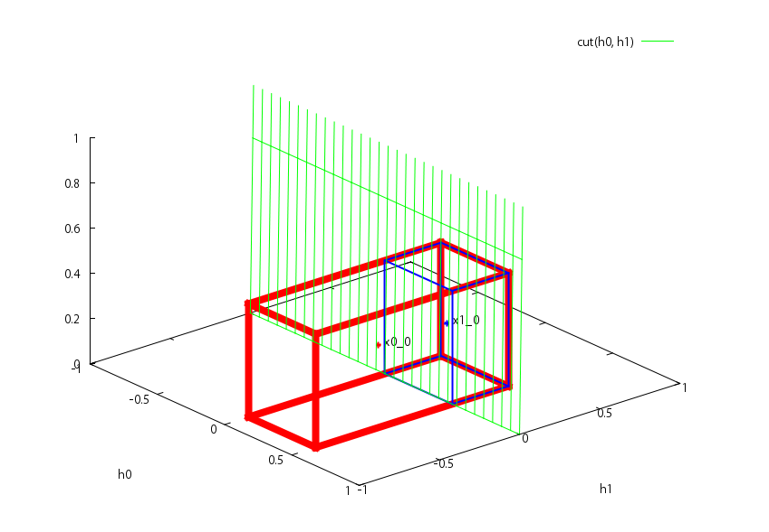

Constraint h_parent >= sum(h_child)
If parent is free, this constraint has the form:

If parent is dependent, we have to express it using free variables. This expression contains the parent of the parent. It it in turn is dependent, we have to continue the substitution until we reach a free parent or 1. It results in the following expression:

So, the constraint in both cases has the following form:

The bad case when the cutting plane passes trough the and cuts exactly diagonally is not possible, because in this case satisfies the constraint.

Point strictly above Convex

Cut by active hyperplane
The bad case when the cutting plane passes trough the and cuts exactly diagonally is not possible, because in this case is in the convex.

Cut by horizontal plane
We can do first an additional cut by horizontal plane. This cut alone is not enough, because it can pass exactly through the bottom of or below it and will not reduce its shape and volume.

Point in Convex

Cut by horizontal plane
Do a cut by a horizontal hyperplane passing through the point . This plane cannot be above , because it contains the maximum, and .

Additionally we can cut by an active plane here as well. This is an optimization step, because the algorimth will do this in the next iteration anyway: has the same coordinates as except the last one, and therefor satisfies all the constraints, but lies above convex.

