Problem 1
A simple problem with 1 variable and 2 constraints, this allows to show the problem on a 3-d chart.
x1 → max
x1 <= 3
x1 <= 5
x1 >= 0

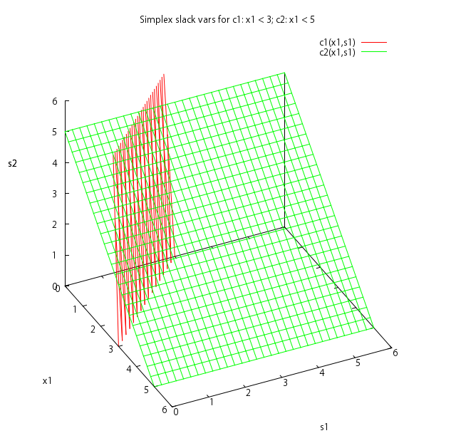

Tableau:
x1 | s1 | s2 | b
1 | 1 | 0 | 3
1 | 0 | 1 | 5
-1 | 0 | 0 | 0

Step 1.
Select pivot:
x1 | s1 | s2 | b | R
1 | 1 | 0 | 3 | 3/1
1 | 0 | 1 | 5 | 5/1
-1 | 0 | 0 | 0

Entering variable x1, leaving variable s1.
Transform:

x1 | s1 | s2 | b
1 | 1 | 0 | 3
0 | -1 | 1 | 2
0 | 1 | 0 | 3
Optimal solution found.

Problem 2
A problem 2 variables and one constraint, that allows to show the problem as a 3d chart. There is also an interesting point, x2 "contributes" more to the constraint, on the other hand, it contributes even more to the function, therefore it must be maximized.
x1 + 100x2→ max
x1 + 2x2 <= 2
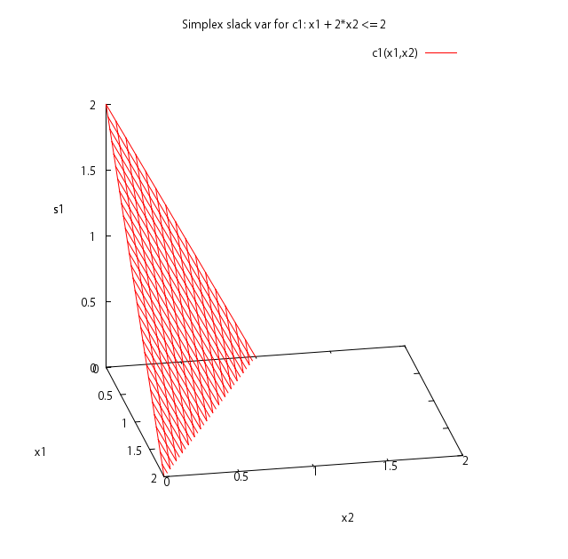

Tableau:
x1 | x2 | s1 | b
1 | 2 | 1 | 2
-1 | -100 | 0 | 0

Step1

x1 | x2 | s1 | b | R
1 | 2 | 1 | 2
-1 | -100 | 0 | 0

Transform:
x1 | x2 | s1 | b
0.5 | 1 | 1 | 1
49 | 0 | 50 | 100

Optimal solution found

Problem 3
Similar to the previous problem, but not x2 contributes more to the constraint than to the function.
x1 + 1.5x2→ max
x1 + 2x2 <= 2

Tableau:
x1 | x2 | s1 | b
1 | 2 | 1 | 2
-1 | -1.5 | 0 | 0

Step1

x1 | x2 | s1 | b | R
1 | 2 | 1 | 2 | 1
-1 | -1.5 | 0 | 0

Transform:
x1 | x2 | s1 | b
0.5 | 1 | 0.5 | 1
-0.25 | 0 | 0.75 | 1.5

Step2

x1 | x2 | s1 | b | R
0.5 | 1 | 0.5 | 1 | 2
-0.25 | 0 | 0.75 | 1.5

Transform:
x1 | x2 | s1 | b
1 | 2 | 1 | 2
0 | 0.25 | 1 | 2
Optimal solution x1 = 1, x2 = 0
Notice that the constraint (2nd row) is the same as in the original tableau (also after step 1 if multiply by 2).

Problem 4
A problem with 2 variables and 2 constrants, demonstrate the case where the local maximum of both x1 and x2 in not the same as global maximum.

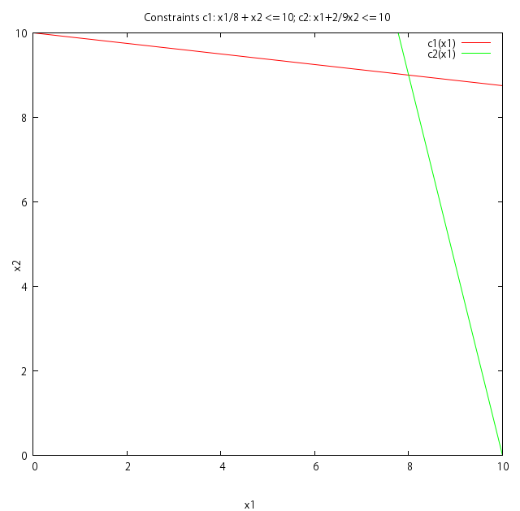
x1 + x2→ max
x1/8 + x2 <= 10
x1 + 2/9x2 <= 10
Tableau:
x1 | x2 | s1 | s2 | b
1/8 | 1 | 1 | 0 | 10
1 | 2/9 | 0 | 1 | 10
-1 | -1 | 0 | 0 | 0

Step1

x1 | x2 | s1 | s2 | b | R
1/8 | 1 | 1 | 0 | 10 | 80
1 | 2/9 | 0 | 1 | 10 | 10
-1 | -1 | 0 | 0 | 0

Transform

x1 | x2 | s1 | s2 | b
0 | 35/36 | 1 | -1/8 | 8 3/4
1 | 2/9 | 0 | 1 | 10
0 | -7/9 | 0 | 1 | 10

Step 2

x1 | x2 | s1 | s2 | b | R
0 | 35/36 | 1 | -1/8 | 8 3/4 | 9
1 | 2/9 | 0 | 1 | 10 | 45
0 | -7/9 | 0 | 1 | 10

Transform

x1 | x2 | s1 | s2 | b
0 | 1 | 36/35 | -9/70 | 9
1 | 0 | -8/35 | 36/35 | 8
0 | 0 | 4/5 | 9/10 | 17
Optimal solution found.

