|  |  |
| --- | --- |
|  |  |
|  |  |
|  |  |
|  |  |
|  |  |
|  |  |

# My picture title

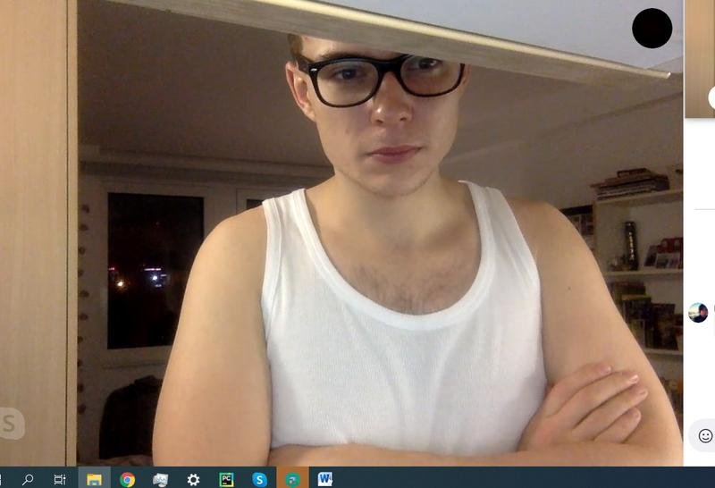

* Picture bullet section

# My picture title

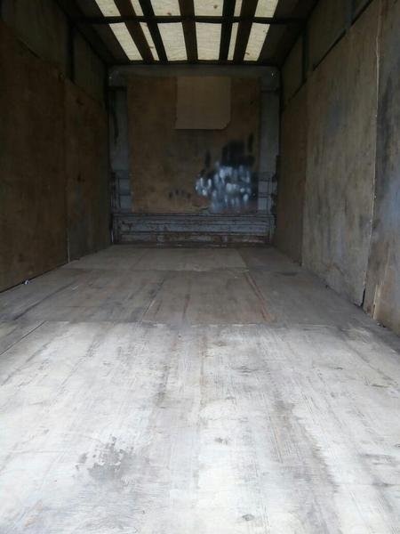

* Picture bullet section

# My picture title

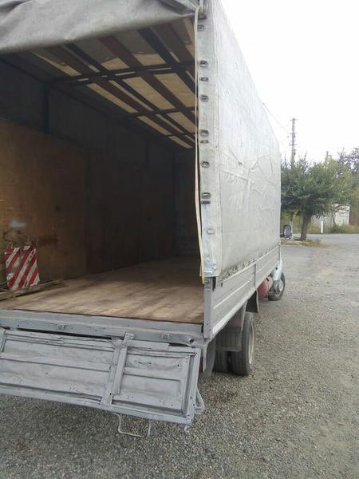

* Picture bullet section

# My picture title

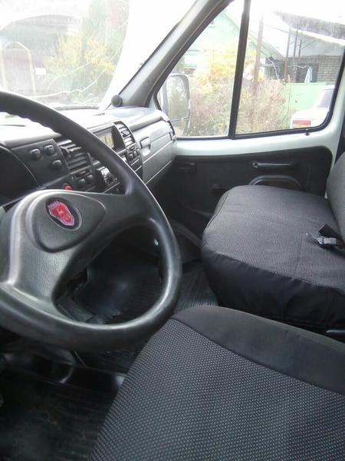

* Picture bullet section