**Project to ABW 2022 session**

**Ivan Dias Soares**

**The Ocean Cleanup**

# Introduction

The Ocean Cleanup is a non-profit organization developing and scaling technologies to rid the oceans of plastic. To achieve this objective, our engineers and scientists are working on a combination of closing the sources of plastic pollution and cleaning up what has already accumulated in the ocean and doesn’t go away by itself. That's why we have two fronts of action: the group acting in the oceans and the group acting in the rivers.

The rivers are the main source of ocean plastic pollution. They are the arteries that carry waste from land to the ocean. According to our research, [1000 rivers](https://theoceancleanup.com/sources/) are responsible for roughly 80% of riverine pollution. Our main action in the rivers is to intercept the plastic before it reaches the ocean. Our engineers have developed “The Interceptor”, a high-tech solution with solar-powered mechanics, smart processing, and connectivity for easy performance tracking. It is designed for series production, and in December 2020, we entered a partnership with Konecranes was signed to begin manufacturing for more locations. Due to its autonomous and large cleaning capacity, this is the primary technology we evaluate for feasibility in any new river we plan to tackle.

We currently have deployed this technology in four locations: Indonesia, Malaysia, the Dominican Republic, and Vietnam.

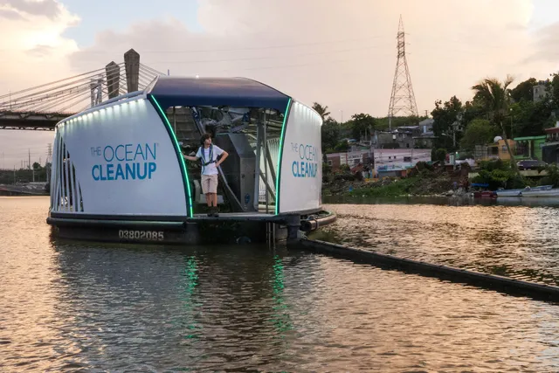Figure 1: The Interceptor

For the oceans we have developed another solution. Trash in the oceans accumulates in five ocean garbage patches, which stay in the middle of immense gyres. A gyre is a large-scale circular system of wind-driven surface currents in the ocean. There are five main gyres, located in the North and South Pacific, the North and South Atlantic, and the Indian Ocean (figure 2). The largest one being the [Great Pacific Garbage Patch](https://theoceancleanup.com/great-pacific-garbage-patch/), located between Hawaii and California. To solve it, we not only need to stop more plastic from flowing into the ocean, but also clean up what is already out there. Floating plastics trapped in the patches will keep circulating until they break down into smaller and smaller pieces, becoming harder to clean up and increasingly easier to mistake for food by sealife. If left to circulate, the plastic will impact our ecosystems, health, and economies for decades or even centuries.

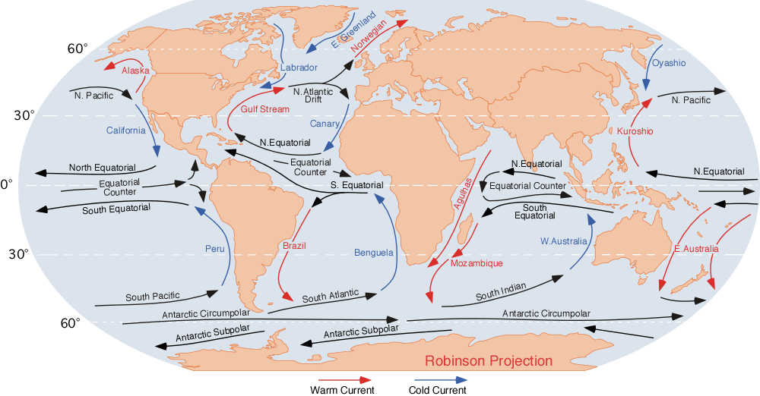 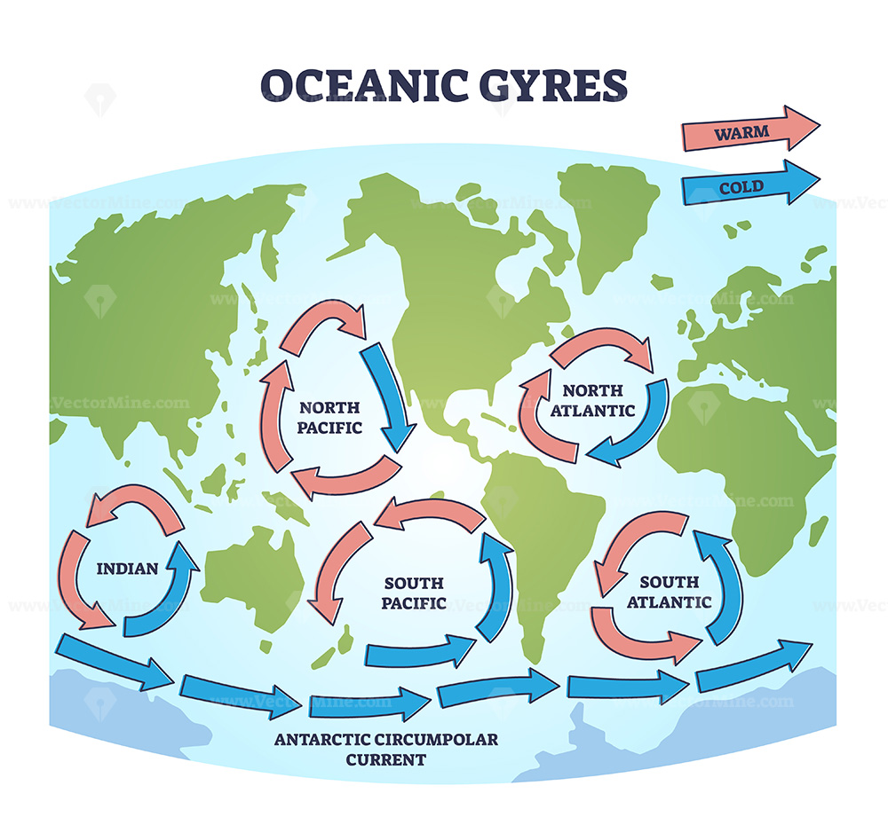

*Figure 2: Large scale surface ocean currents and the 5 main oceanic gyres.*

The fundamental challenge of cleaning up the ocean garbage patches is that the plastic pollution is highly diluted, spanning millions of square kilometers. Our cleanup solution is designed to first concentrate the plastic, allowing us to effectively collect and remove vast quantities.

This is how it works: With a relative speed difference maintained between the cleanup system and the plastic, we create artificial coastlines, where there are none, to concentrate the plastic. The system is comprised of a long U-shaped barrier that guides the plastic into a retention zone at its far end. Through active propulsion, we maintain a slow forward speed with the system.

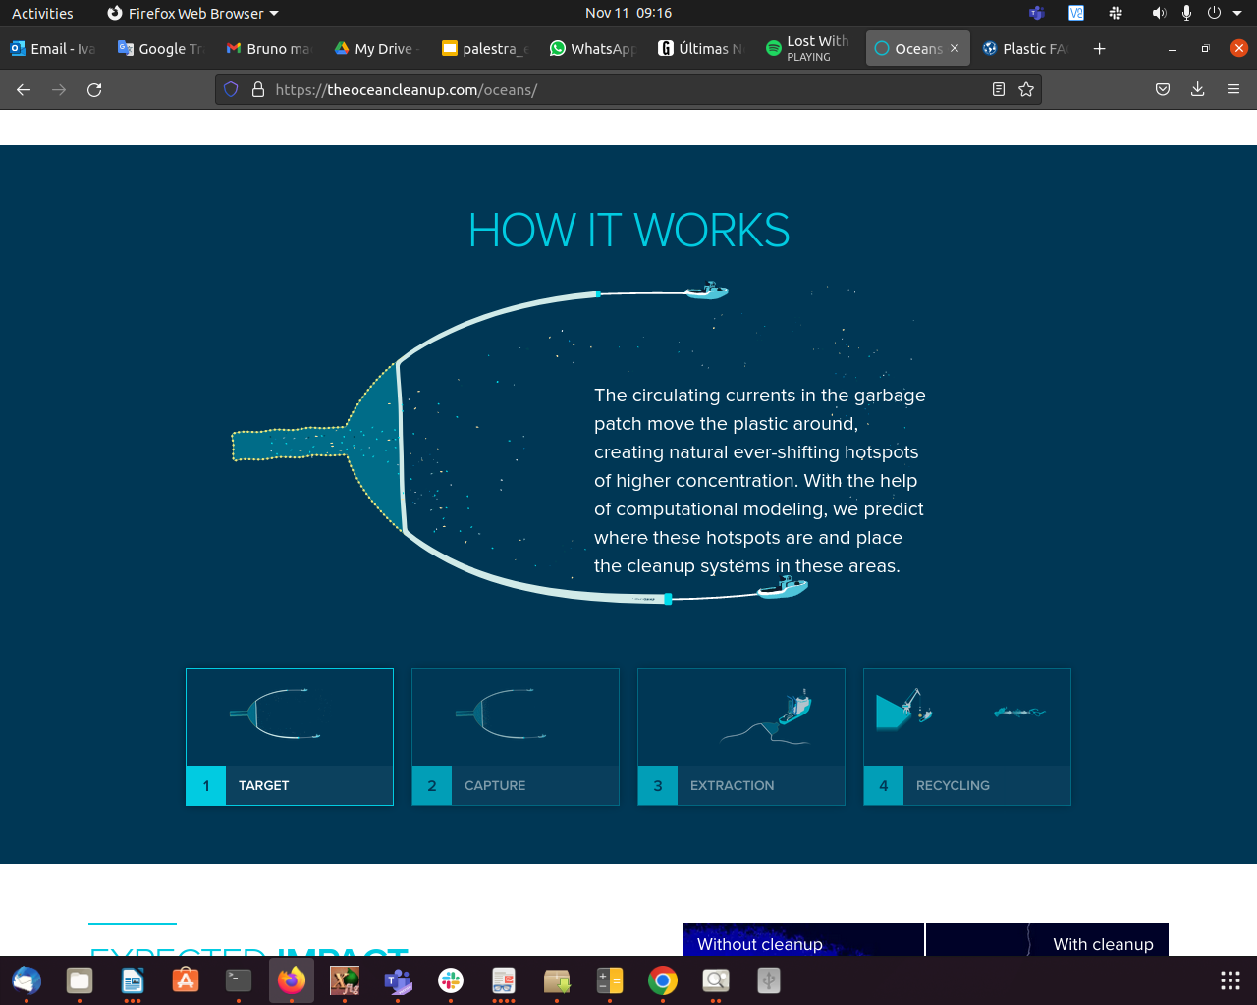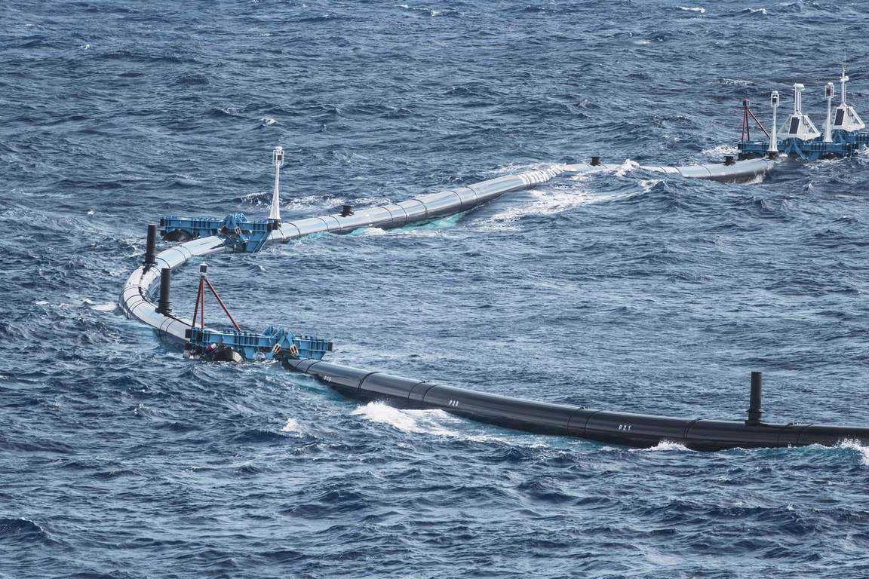 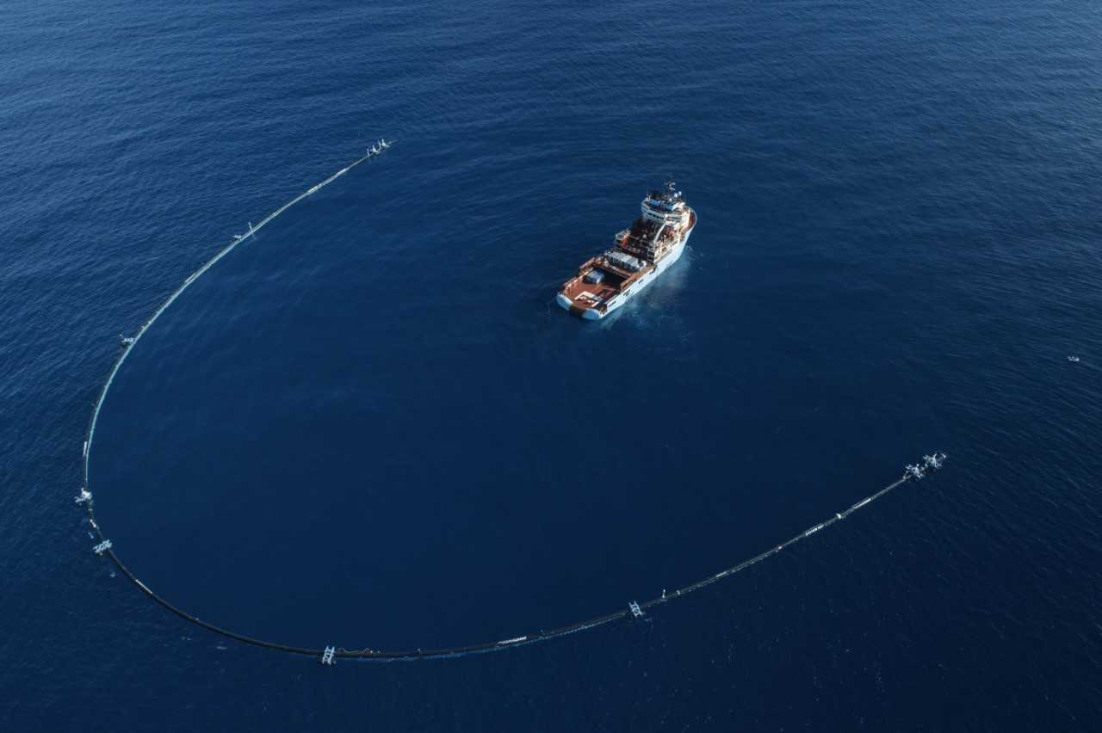

*Figure 3: Oceanic cleanup system*

Our work in The Ocean Cleanup is guided by the studies conducted by a few research groups, including the **Pacific Ocean Team,** the **Rivers Team** and the **Computational Modeling Team (CM Team)**, which I am part of. In the CM Team we run numerical models to simulate the behavior of the cleanup systems in the water, to understand how they interact with the winds, the ocean currents and the waves. My job in the CM team is to run the numerical models that simulate the ocean currents and the waves in the North Pacific Ocean.

## Objective of this Project

Use a neural network that can be trained on the existing numerical wave model to reproduce the wave spectra observed at scattered locations to a larger domain.

## Stakeholders and Users

The main users of the oceanic forecasting are the engineers of the group who develop and deploy the cleanup system in the Great Pacific Garbage Patch.

## Product

The product of the wave model is a report containing maps of wave height every 3 hours for 10 days.

## My Ideas for the projects

The kind of Neural Network that I want to use is **Physics-informed neural network** (**PINN**) (figure 4), a type of universal function approximators that can embed the knowledge of any physical laws that govern a given data-set in the learning process, and can be described by [partial differential equations](https://en.wikipedia.org/wiki/Partial_differential_equation) (PDEs) (Raissi et al., 2017).

The numerical model that is already implemented use a PDE which describes the physical law governing the space-time evolution of wave spectra. The model solves the PDE in a limited two-dimensional numerical domain. To compute the solution in this domain, the model needs a Initial Condition (IC), Open Bounday Conditions (OBCs) and a forcing (the physical agent that creates the waves, in our case, the wind). Having as input the wind data, and wave spectra in the open boundaries, the model is able to compute space-time evolution of wave spectra in the domain.

I want to use a neural network that can be trained on the existing numerical model to reproduce the wave spectra observed at scattered locations to a larger domain. The neural network will be a surrogate of the numerical model that it was trained on.

**Numerical model:**

Inputs

* Time dependent 2D wave spectra at points located at the boundaries of the domain
* Wind at the surface

Model

* Spectral wave model

Outputs

* Time dependent 2D wave spectra in the whole domain

**Surrogate model:**

Inputs

* Time dependent 2D wave spectra at points located at the boundaries of the domain
* Wind at the surface
* Time dependent 2D wave spectra at scattered locations inside the domain

Model

* PINN (where the “Physics” could well be energy conservation)

Outputs

* Time dependent 2D wave spectra in the whole domain (or at scattered locations in the domain for the model to be lighter)

The training of the surrogate should use the same inputs and outputs as the **Surrogate** (with the Time dependent 2D wave spectra at scattered locations -> which should mimic the “measurements” in our case being generated by the **Numerical model**).

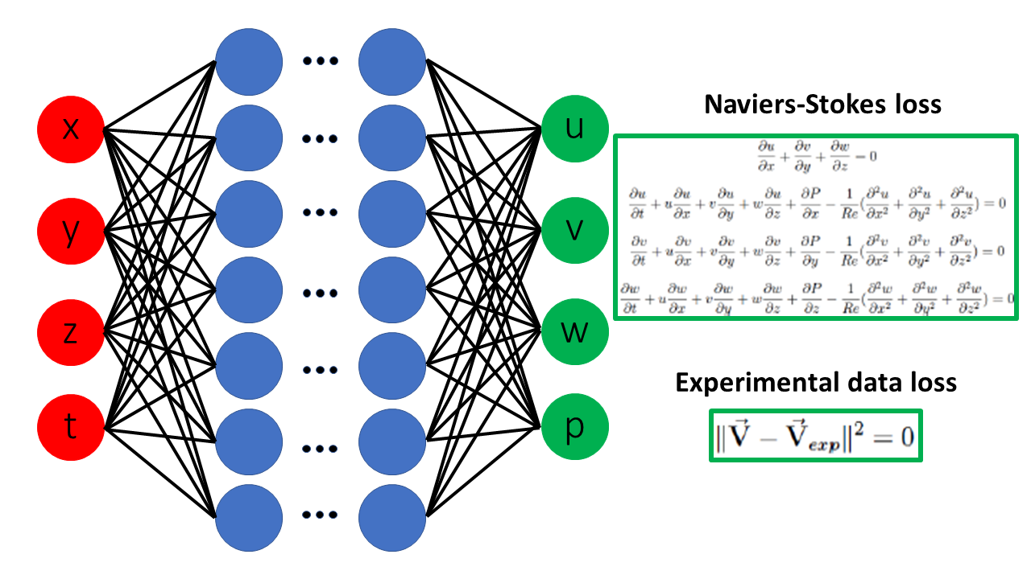Figure 4: Schematic drawing of a PINN based on the Navier-Stokes equations.

## The Wave Model

The Wave Watch III (WW3) model runs in The Ocean Cleanup (TOC) in two nested numerical domains (see figure 5). The larger grids has resolution of 1 o x 1 o, and the smaller 0.25 o x 0.25 o.

Simulations in the larger grid are forced with Global Forecast System (GFS) winds with time interval of 3 hours and horizontal resolution of 0.25 degrees.

Simulations in the smaller grid receive the open boundary values from the larger grid and are also forced with the same GFS winds.

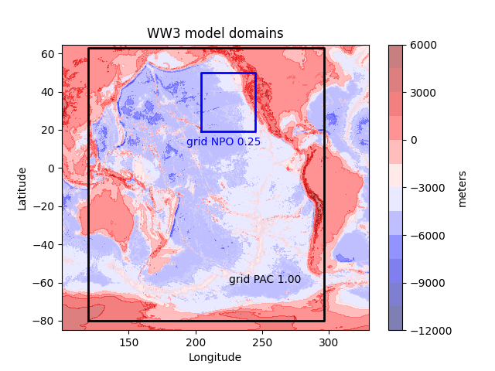

Figure 5: The Pacific Ocean topography and the WW3 numerical domains: the larger domain in black and the smaller domain in blue

The model results are validated by comparing wave significant height (Hs) and spectral density versus NOAA Buoys Hs and spectral density (see figure 6 for location of buoys). In this report we have used buoys 46002, 46006, 46059 and 51000.

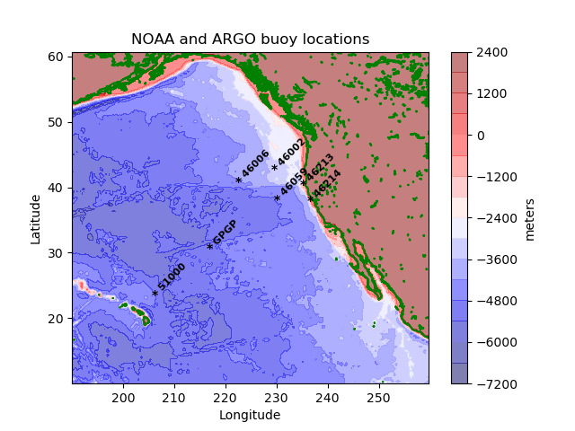

Figure 6: Locations of NOAA buoys.

# References

Raissi, Maziar; Perdikaris, Paris; Karniadakis, George Em (2017-11-28). "Physics Informed Deep Learning (Part I): Data-driven Solutions of Nonlinear Partial Differential Equations". [*arXiv*](https://en.wikipedia.org/wiki/ArXiv_(identifier)):[*1711.10561*](https://arxiv.org/abs/1711.10561) [[*cs.AI*](https://arxiv.org/archive/cs.AI)].