**JIRA Report Helper**

1. **What JIRA Report Helper do?**

JIRA Report Helper it is plugin for Google Chrome which allow quickly paste information about current issue into comment (while logging work or just adding comment to issue). It adding issue number and summary including info of every issue’s parent issues.

1. **How to install chrome extension for reporting in JIRA?**

* Download and unpack Jira.Extension:

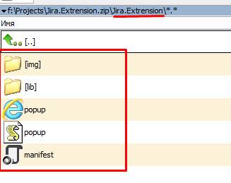

* Open Chrome settings, go to extension tab and select ‘Developer mode’ checkbox

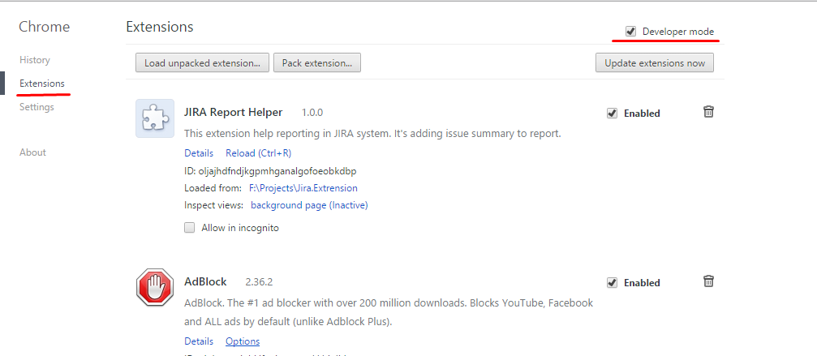

* Click ‘Load unpacked extension..’ and select Jira.Extension folder:

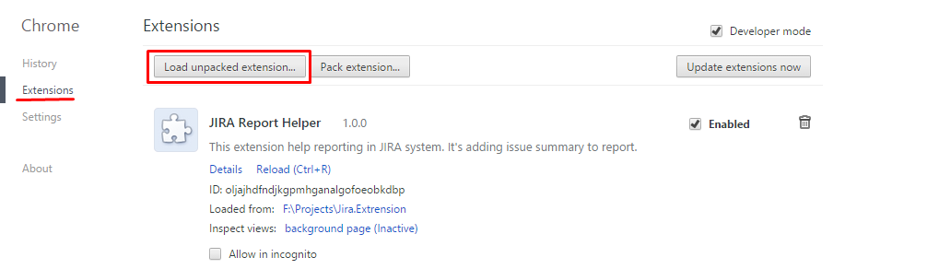

* After that extension will be added to Chrome browser. Make sure that extension enabled and turn off developer mode:

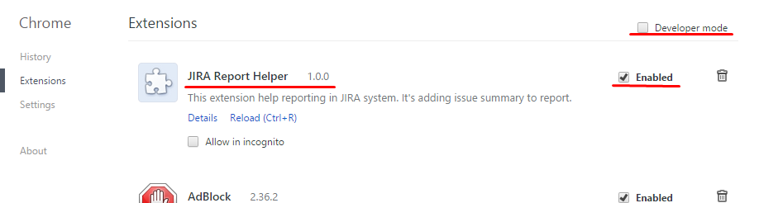

NOTE: it could be request from browser to disable developer mode extension. Don’t disable those extension to made JIRA Report Helper turned on.

1. **How to use JIRA Report Helper.**

* Open any issue details or select issue on board.
* Right click in any textarea field such as comment, work log description:
* In context menu click on ‘JIRA add issue summary’

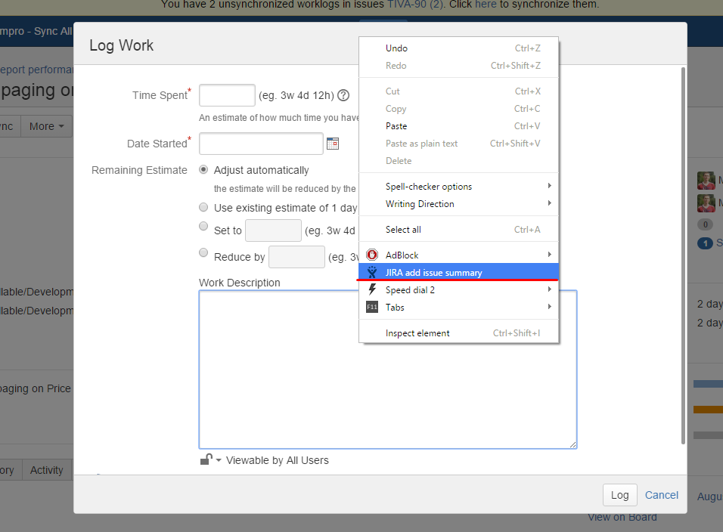

* It’s done – summary added into text fields:

