Lab: Associative Arrays
Problems for exercise and homework for the "JS Fundamentals" Course @ SoftUni.
Submit your solutions in the SoftUni judge system at: https://judge.softuni.org/Contests/1231

Phone Book
Write a function that stores information about a person’s name and phone number. The input is an array of strings with space-separated name and number. Replace duplicate names. Print the result as shown.

Example
Input | Output
['Tim 0834212554',  'Peter 0877547887',  'Bill 0896543112',  'Tim 0876566344'] | Tim -> 0876566344  Peter -> 0877547887  Bill -> 0896543112
['George 0552554',  'Peter 087587',  'George 0453112',  'Bill 0845344'] | George -> 0453112  Peter -> 087587  Bill -> 0845344

Meetings
Write a function that manages meeting appointments. The input comes as an array of strings. Each string contains a weekday and person’s name. For each successful meeting, print a message. If you receive the same weekday twice, the meeting cannot be scheduled so print a conflicting message. In the end, print a list of all successful meetings.

Example
Input | Output
['Monday Peter',  'Wednesday Bill',  'Monday Tim',  'Friday Tim'] | Scheduled for Monday  Scheduled for Wednesday  Conflict on Monday!  Scheduled for Friday  Monday -> Peter  Wednesday -> Bill  Friday -> Tim
['Friday Bob',  'Saturday Ted',  'Monday Bill',  'Monday John',  'Wednesday George'] | Scheduled for Friday  Scheduled for Saturday  Scheduled for Monday  Conflict on Monday!  Scheduled for Wednesday  Friday -> Bob  Saturday -> Ted  Monday -> Bill  Wednesday -> George

Address Book
Write a function that stores information about a person’s name and his address. The input comes as an array of strings. Each string contains the name and the address separated by a colon. If you receive the same name twice just replace the address. In the end, print the full list, sorted alphabetically by the person’s name.

Example
Input | Output
['Tim:Doe Crossing',  'Bill:Nelson Place',  'Peter:Carlyle Ave',  'Bill:Ornery Rd'] | Bill -> Ornery Rd  Peter -> Carlyle Ave  Tim -> Doe Crossing
['Bob:Huxley Rd',  'John:Milwaukee Crossing',  'Peter:Fordem Ave',  'Bob:Redwing Ave',  'George:Mesta Crossing',  'Ted:Gateway Way',  'Bill:Gateway Way',  'John:Grover Rd',  'Peter:Huxley Rd',  'Jeff:Gateway Way',  'Jeff:Huxley Rd'] | Bill -> Gateway Way  Bob -> Redwing Ave  George -> Mesta Crossing  Jeff -> Huxley Rd  John -> Grover Rd  Peter -> Huxley Rd  Ted -> Gateway Way

Storage
Write a function that takes a certain number of items and their quantity. If the same item appears more than once, add the new amount to the existing one. In the end, print all the items and their amount without sorting them. The input comes as an array of strings. Try using a Map().

Example
Input | Output
['tomatoes 10',  'coffee 5',  'olives 100',  'coffee 40'] | tomatoes -> 10  coffee -> 45  olives -> 100
['apple 50',  'apple 61',  'coffee 115',  'coffee 40'] | apple -> 111  coffee -> 155

Hints
Create the solve() function and create a new Map():
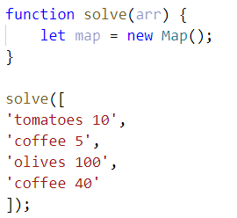
Loop through the array, split into tokens, and create variables for each one:
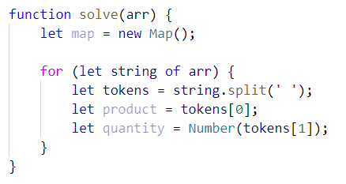
- This time for the quantity we need a number because if we see the same product again, we must add the new quantity
Now let us make the checks for the keys on the map:
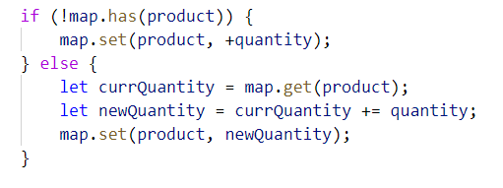
- First, we check if the map does NOT have the product we are currently at and if so, we set it to the given quantity
- Otherwise, we get the existing quantity, we add the new quantity, and set the product’s quantity to the new one
Now we just have to print the result:
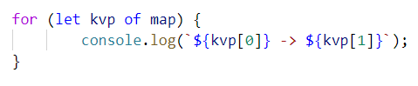
- Each key-value pair is and an array of 2 elements (the key and the value), so we use a for-of loop and print the key and the value

School Grades
Write a function that stores students and their grades throughout the year. If a student appears more than once, add the new grades to existing ones. Finally, print the students and their average grades, sorted alphabetically by student name. The input comes as an array of strings.
Note: The average grades must be fixed to the second decimal place.

Example
Input | Output
['Lilly 4 6 6 5',  'Tim 5 6',  'Tammy 2 4 3',  'Tim 6 6'] | Lilly: 5.25  Tammy: 3.00  Tim: 5.75
['Steven 3 5 6 4',  'George 4 6',  'Tammy 2 5 3',  'Steven 6 3'] | George: 5.00  Steven: 4.50  Tammy: 3.33

Word Occurrences
Write a function that counts the times each word occurs in a text. Print the words sorted by count in descending order. The input comes as an array of strings.

Example
Input | Output
["Here", "is", "the", "first", "sentence", "Here", "is", "another", "sentence", "And", "finally", "the", "third", "sentence"] | sentence -> 3 times  Here -> 2 times  is -> 2 times  the -> 2 times  first -> 1 times  another -> 1 times  And -> 1 times  finally -> 1 times  third -> 1 times
["dog", "bye", "city", "dog", "dad", "boys", "ginger"] | dog -> 2 times  bye -> 1 times  city -> 1 times  dad -> 1 times  boys -> 1 times  ginger -> 1 times

Hint
- Create a map
- Loop through the elements of the array of words
- Update the map
- Sort the map by value in descending:
- Finally, print the result in the format as the example above

