Lab: Functions
Problems for in-class lab for the Python Fundamentals Course @SoftUni.
Submit your solutions in the SoftUni judge system at https://judge.softuni.org/Contests/1727.

Absolute Values
Write a program that receives a sequence of numbers, separated by a single space, and prints their absolute value as a list. Use abs().

Example
Input | Output
1 2.5 -3 -4.5 | [1.0, 2.5, 3.0, 4.5]
-0 1 10 -6.66 | [0.0, 1.0, 10.0, 6.66]

Grades
Write a function that receives a grade between 2.00 and 6.00 and prints the corresponding grade in words.
- 2.00 – 2.99 - "Fail"
- 3.00 – 3.49 - "Poor"
- 3.50 – 4.49 - "Good"
- 4.50 – 5.49 - "Very Good"
- 5.50 – 6.00 - "Excellent"

Examples
Input | Output
3.33 | Poor
4.50 | Very Good
2.99 | Fail

Hints
- Read the grade from the console:
- Then, create a function and make an if statement for each case:
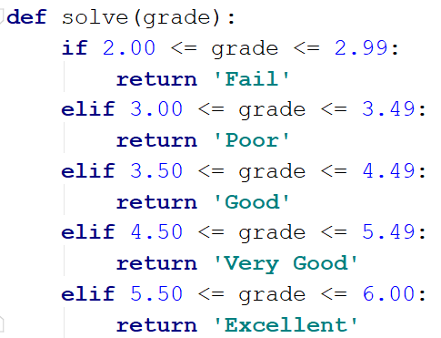
- Pass the input grade to the function:

Calculations
Create a function that receives three parameters, calculates a result depending on the given operator, and returns it. Print the result of the function.
The input comes as three parameters – an operator as a string and two integer numbers. The operator can be one of the following: "multiply", "divide", "add", "subtract".

Example
Input | Output
subtract  5  4 | 1
divide  8  4 | 2

Hints
- Read the input data from the console:
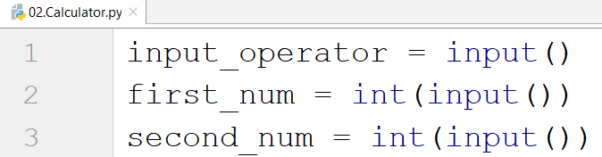
- Then, create the function and make an if statements for each case:
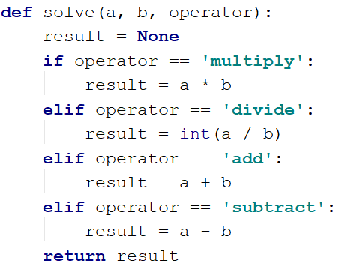
- Print the result by calling the function and passing the given parameters.

Repeat String
Write a function that receives a string and a counter n. The function should return a new string – the result of repeating the old string n times. Print the result of the function. Try using lambda.

Examples
Input | Output
abc  3 | abcabcabc
String  2 | StringString

Hints
- Read the input data:
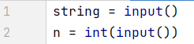
- Create the function:
- Print the result:
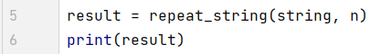

Orders
Write a function that calculates the total price of an order and returns it. The function should receive one of the following products: "coffee", "coke", "water", or "snacks", and a quantity of the product. The prices for a single piece of each product are:
- coffee - 1.50
- water - 1.00
- coke - 1.40
- snacks - 2.00

Print the result formatted to the second decimal place.

Example
Input | Output
water  5 | 5.00
coffee  2 | 3.00

Calculate Rectangle Area
Create a function that calculates and returns the area of a rectangle by given width and height. Print the result on the console.

Examples
Input | Output
3  4 | 12
6  2 | 12

Rounding
Write a program that rounds all the given numbers, separated by a single space, and prints the result as a list. Use round().

Example
Input | Output
1.0 2.5 3.0 4.5 | [1, 2, 3, 4]
2.56 1.9 -3.4 8.1 | [3, 2, -3, 8]

