Lab: Classes and Objects
Problems for in-class lab for the Python Fundamentals Course @SoftUni.
Submit your solutions in the SoftUni judge system at https://judge.softuni.org/Contests/1733.

Comment
Create a class with the name "Comment". The __init__ method should accept 3 parameters:
- username
- content
- likes (optional, 0 by default)
Use the exact names for your variables
Note: there is no input/output for this problem. Test the class yourself and submit only the class

Example
Test Code | Output
comment = Comment("user1", "I like this book")  print(comment.username)  print(comment.content)  print(comment.likes) | user1  I like this book  0

Hint
Create a class named "Comment". Create the __init__ method and pass it the three parameters:
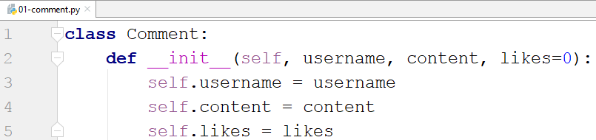
- we set the initial value of the likes to be 0
Test the class with the provided test code:
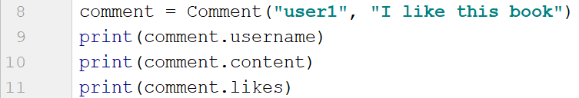

Party
Create a class Party that only has an attribute people – empty list. The __init__ method should not accept any parameters. You will be given names of people (on separate lines) until you receive the command "End". Use the created class to solve this problem. After you receive the "End" command, print 2 lines:
- "Going: {people}" - the people should be separated by comma and space ", ".
- "Total: {total_people_going}"
Note: submit all of your code, including the class

Example
Input | Output
Peter  John  Katy  End | Going: Peter, John, Katy  Total: 3
Sam  Eddy  Edd  Kris  End | Going: Sam, Eddy, Edd, Kris  Total: 4

Hint
Start by creating the class Party:
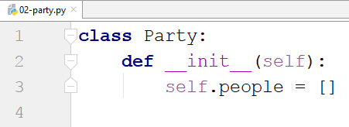
Create an instance of the class:
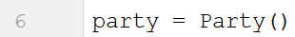
Create a loop that reads input and adds it to the people until you receive "End":
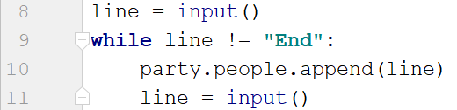
Finally, print the result:

Email
Create class Email. The __init__ method should receive sender, receiver and a content. It should also have a default set to False attribute called is_sent. The class should have two additional methods:
- send() - sets the is_sent attribute to True
- get_info() - returns the following string: "{sender} says to {receiver}: {content}. Sent: {is_sent}"
You will receive some information (separated by a single space) until you receive the command "Stop". The first element will be the sender, the second one – the receiver, and the third one – the content. On the final line, you will be given the indices of the sent emails separated by comma and space ", ".
Call the send() method for the given indices of emails. For each email, call the get_info() method.
Note: submit all of your code, including the class

Example
Input | Output
Peter John Hi,John  John Peter Hi,Peter!  Katy Lilly Hello,Lilly  Stop  0, 2 | Peter says to John: Hi,John. Sent: True  John says to Peter: Hi,Peter!. Sent: False  Katy says to Lilly: Hello,Lilly. Sent: True
Anna, Bella, Hi  Sam, Dany, Okey  Felix, Mery, Bye  Stop  0 | Anna, says to Bella,: Hi. Sent: True  Sam, says to Dany,: Okey. Sent: False  Felix, says to Mery,: Bye. Sent: False

Hint
First, we create the Email class with the __init__ method and the 2 other methods:
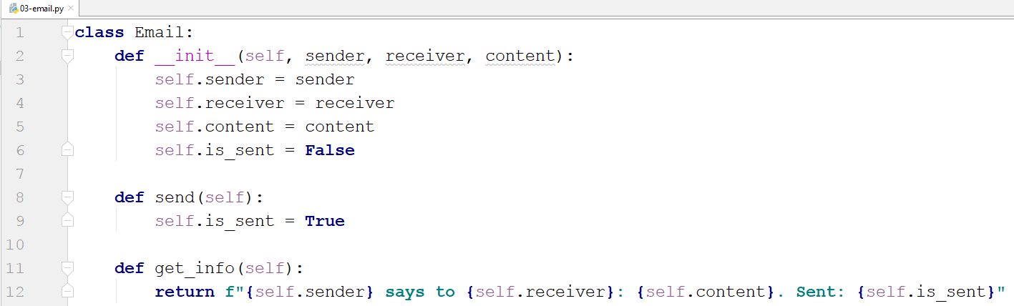
- The is_sent attribute is not passed to the function. It is set automatically to False
- The send() method does not accept parameters since it always sets the is_sent attribute to True
- The get_info() method also does not accept parameters. It just returns a string representation of the object
We read the input until we receive "Stop". Then, for each input, we create an Email and add it to the emails' list:
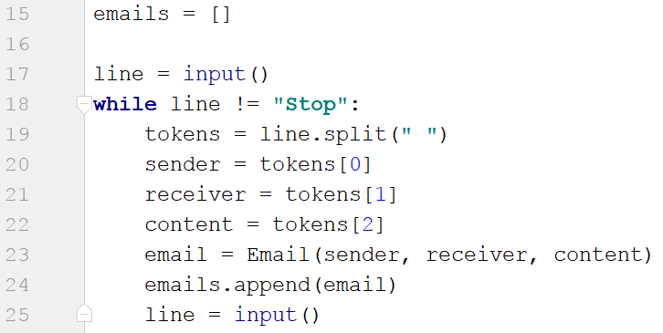
We read the indices of the sent emails, loop through them, and call the send() method for each of the emails at those indices:
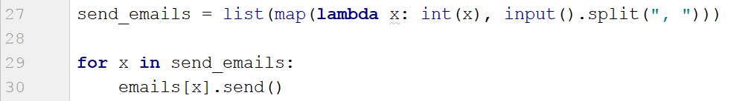
Finally, we print each of the emails:
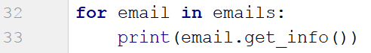

Zoo
Create a class Zoo. It should have a class attribute called __animals that stores the total count of the animals in the zoo. The __init__ method should only receive the name of the zoo. There you should also create 3 empty lists (mammals, fishes, birds). The class should also have 2 more methods:
- add_animal(species, name) - based on the species, adds the name to the corresponding list
- get_info(species) - based on the species returns a string in the following format:
"{Species} in {zoo_name}: {names}
Total animals: {total_animals}"
On the first line, you will receive the name of the zoo. On the second line, you will receive number n. On the following n lines you will receive animal info in the format: "{species} {name}". Add the animal to the zoo to the corresponding list. The species could be "mammal", "fish", or "bird".
On the final line, you will receive a species.
At the end, print the info for that species and the total count of animals in the zoo.

Example
Input | Output
Great Zoo  5  mammal lion  mammal bear  fish salmon  bird owl  mammal tiger  mammal | Mammals in Great Zoo: lion, bear, tiger  Total animals: 5
Blah  1  mammal bear  mammal | Mammals in Blah: bear  Total animals: 1

Hint
Start by creating the class and the __init__ method:
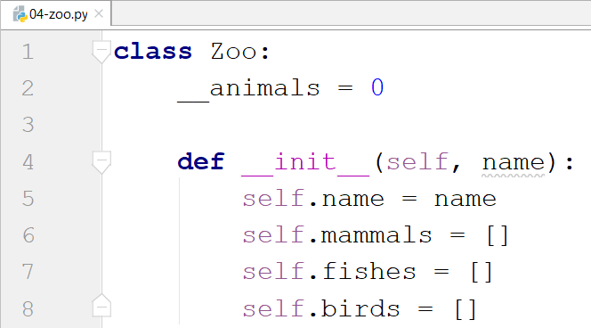
- The underscores in front of the animal's attribute is used to express that it is private. It is not meant to be used outside the class.
Then, create the other two methods for adding and getting the info:
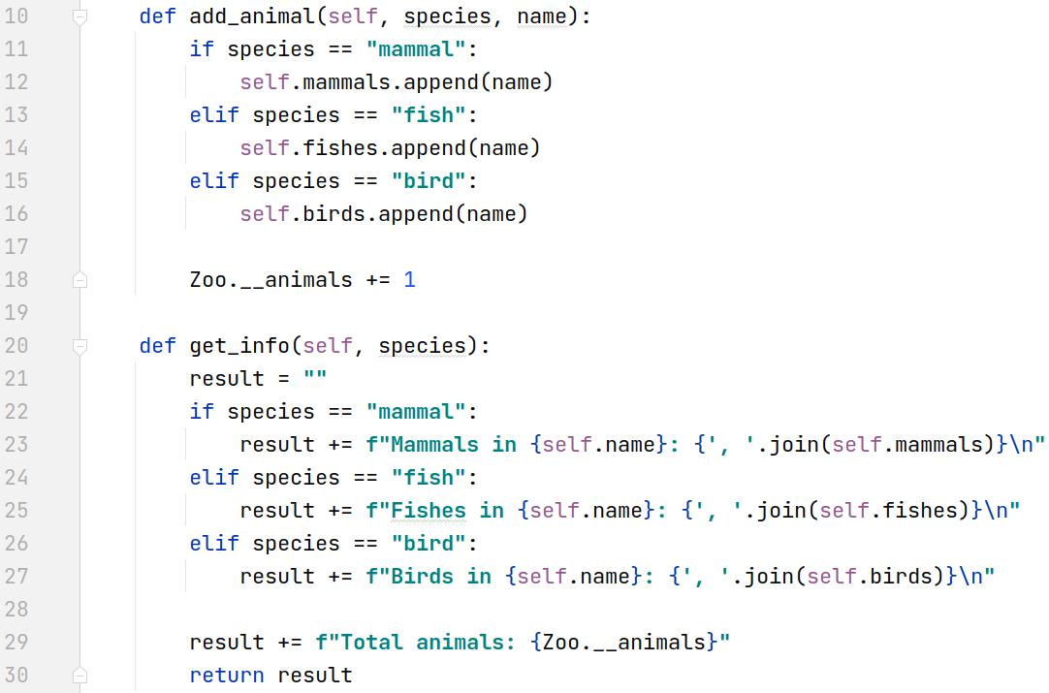
- We check the species type inside the methods.
Finally, implement the logic for reading the input and printing the result:
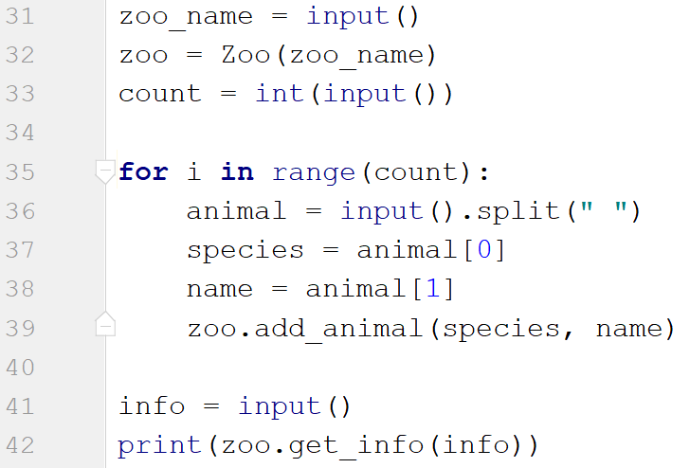

Circle
Create a class Circle. In the __init__ method, the circle should only receive one parameter - its diameter. Create a class attribute called __pi that is equal to 3.14. The class should also have the following methods:
- calculate_circumference() - returns the circumference of the circle
- calculate_area() - returns the area of the circle
- calculate_area_of_sector(angle) - gives the central angle in degrees, returns the area that fills the sector
Notes: Search the formulas on the internet. Name your methods and variables exactly as in the description! Submit only the class. Test your class before submitting it!

Example
Test Code | Output
circle = Circle(10)  angle = 5  print(f"{circle.calculate_circumference():.2f}")  print(f"{circle.calculate_area():.2f}")  print(f"{circle.calculate_area_of_sector(angle):.2f}") | 31.40  78.50  1.09

Hint
First, create the Circle class, set the attribute __pi, and create the __init__ method:
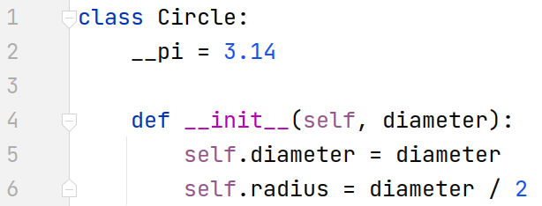
- We will be given the diameter so that the radius will be the diameter divided by 2
Create the first method that calculates the circumference:
After that, create the method that calculates and returns the area of the circle:
Finally, create the method that calculates the area of a particular sector:
Write some code to test your class before you submit it.

