Lab: Lists Advanced
Problems for in-class lab for the Python Fundamentals Course @SoftUni.
Submit your solutions in the SoftUni judge system at https://judge.softuni.org/Contests/1730.

No Vowels
Using comprehension, write a program that receives a text and removes all its vowels, case insensitive. Print the new text string after removing the vowels. The vowels that should be considered are 'a', 'o', 'u', 'e', 'i'.

Examples
Input | Output
Python | Pythn
ILovePython | LvPythn

Trains
You will receive a number representing the number of wagons a train has. Create a list (train) with the given length containing only zeros. Until you receive the command "End", you will receive some of the following commands:
- "add {people}" – you should add the number of people in the last wagon
- "insert {index} {people}" - you should add the number of people at the given wagon
- "leave {index} {people}" - you should remove the number of people from the wagon. There will be no case in which the people will be more than the count in the wagon.
There will be no case in which the index is invalid!
After you receive the "End" command print the train.

Example
Input | Output
3  add 20  insert 0 15  leave 0 5  End | [10, 0, 20]
5  add 10  add 20  insert 0 16  insert 1 44  leave 1 12  insert 2 100  insert 4 61  leave 4 1  add 15  End | [16, 32, 100, 0, 105]

To-do List
You will be receiving to-do notes until you get the command "End". The notes will be in the format: "{importance}-{note}".
Return a list containing all to-do notes sorted by importance in ascending order.
The importance value will always be an integer between 1 and 10 (inclusive).

Hint
- Use the pop() and insert() methods.

Example
Input | Output
2-Walk the dog  1-Drink coffee  6-Dinner  5-Work  End | ['Drink coffee', 'Walk the dog', 'Work', 'Dinner']
3-C  2-A  1-B  6-V  End | ['B', 'A', 'C', 'V']

Hints
Start by and creating an empty list:
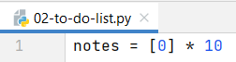
Create a while loop that reads the command and splits it if it is not "End". Then, remove the zero from the list by index (priority) and insert the note in its place:
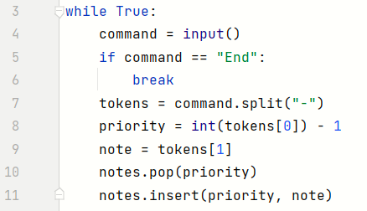
Finally, filter only the nonzero elements from the notes list and print the result:

Palindrome Strings
On the first line, you will receive words separated by a single space. On the second line, you will receive a palindrome. First, you should print a list containing all the found palindromes in the sequence. Then, you should print the number of occurrences of the given palindrome in the format: "Found palindrome {number} times".

Example
Input | Output
wow father mom wow shirt stats  wow | ['wow', 'mom', 'wow', 'stats']  Found palindrome 2 times
hey how you doin? lol  mom | ['lol']  Found palindrome 0 times

Hints
First, read all the strings and the searched palindrome, and we create an empty list for the found palindromes:
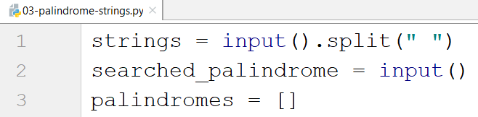
Then, we create a loop that checks if each word is a palindrome:
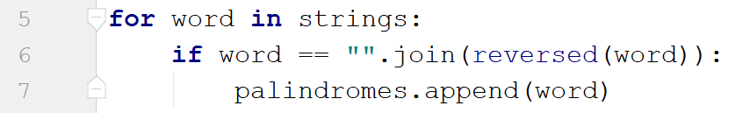
- We use the join() method with the reversed() method because reversed() returns an iterator, not a string, so we should make it into one.
Finally, we print the result:

Sorting Names
Write a program that reads a single string with names separated by comma and space ", ". Sort the names by their length in descending order. If 2 or more names have the same length, sort them in ascending order (alphabetically). Print the resulting list.

Example
Input | Output
Ali, Marry, Kim, Teddy, Monika, John | ["Monika", "Marry", "Teddy", "John", "Ali", "Kim"]
Lilly, Tim, Kate, Tom, Alex | ['Lilly', 'Alex', 'Kate', 'Tim', 'Tom']

Hints
Read the string and split it:
Use a sorted() function to sort the names by their length first, and then - alphabetically:
Print the final result:
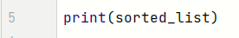

Even Numbers
Write a program that reads a single string with numbers separated by comma and space ", ". Print the indices of all even numbers.

Example
Input | Output
3, 2, 1, 5, 8 | [1, 4]
2, 4, 6, 9, 10 | [0, 1, 2, 4]

Hints
Read the string, split it, and convert the list of strings into a list of numbers using map function:
Use a map function to iterate over the list to find all the even numbers, and add their indices:
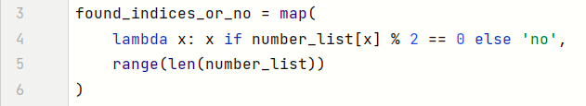
Use the filter function to filter only the indices and print the result:

The Office
You will receive two lines of input:
- a list of employees' happiness as a string of numbers separated by a single space
- a happiness improvement factor (single number).
Your task is to find out if the employees are generally happy in their office.
First, multiply each employee's happiness by the factor.
Then, print one of the following lines:
- If half or more of the employees have happiness greater than or equal to the average:
"Score: {happy_count}/{total_count}. Employees are happy!"
- Otherwise:
"Score: {happy_count}/{total_count}. Employees are not happy!"

Example
Input | Output | Comment
1 2 3 4 2 1  3 | Score: 2/6. Employees are not happy! | After the mapping:  3 6 9 12 6 3  After the filtration:  9 12  2/6 people are happy, so the overall happiness is bad
2 3 2 1 3 3  4 | Score: 3/6. Employees are happy! | Half of the people are happy, so the overall happiness is good

Hints
First, read the input:
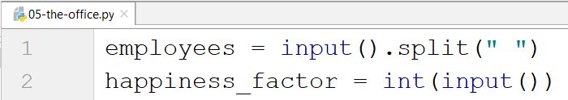
Then, use the map() function to multiply each element with the factor:
- Since all the elements in the employees' list are strings, we parse them to integers before multiplying them.
- Do not forget that the map function returns a map object, so we must cast it to a list.
Now, it is time to filter the elements that are greater than the average:
- We find the average by summing the elements and divide the result by its length
Finally, we print the result:
