目錄結構
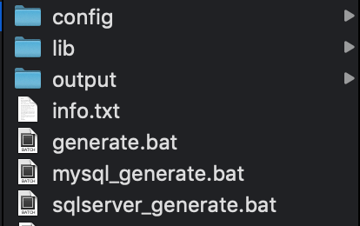

*_generate.bat
D:\java64\jdk1.8.0_121\bin\java -jar 執行java程式
lib/mybatis-generator-core-1.3.5.jar 執行目標
-configfile config/mysql.xml 設定檔
-overwrite 檔案覆蓋

/config/*.xml
指定jdbc driver位置
<classPathEntry location="C:\Users\carter\.m2\repository\mysql\mysql-connector-java\5.1.48\mysql-connector-java-5.1.48.jar" />
DB連線設定
<jdbcConnection driverClass="com.mysql.jdbc.Driver"
connectionURL="jdbc:mysql://192.168.14.203:3306/wwunion?useUnicode=true"
userId="wwunion"
password="wwunion123">
</jdbcConnection>
產生 model object
<javaModelGenerator
targetPackage="com.wwunion.backend.entity" 輸出的package
targetProject="output" 輸出的目錄
>
</javaModelGenerator>

產生 sqlMap檔(MyBatis Mapper XML設定檔)
<sqlMapGenerator
targetPackage="com.wwunion.backend.dao"
targetProject="output">
</sqlMapGenerator>

產生mapper interface檔
<javaClientGenerator type="XMLMAPPER"
targetPackage="com.wwunion.backend.dao"
targetProject="output">
</javaClientGenerator>

Table--JAVA Object mapping
<table tableName="MPCLM_B_SYS_HIERARCHY" DB TABLE名稱
domainObjectName="BSysHierarchy" TABLE對應的JAVA物件
>
</table>

執行*.bat檔，產生目標檔案置於output資料夾

