## Create Gradle Project：SpringCloud-Service01-Config

SpringCloudRoot/settings.gradle新增include 'SpringCloud-Service01-Config'  
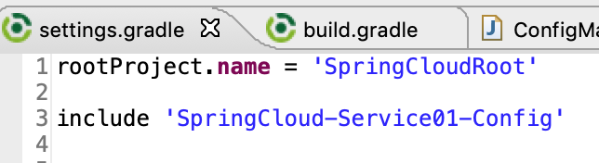

專案按右鍵 -> Gradle -> Refresh Gradle Project