sjcl-index.html (html format)

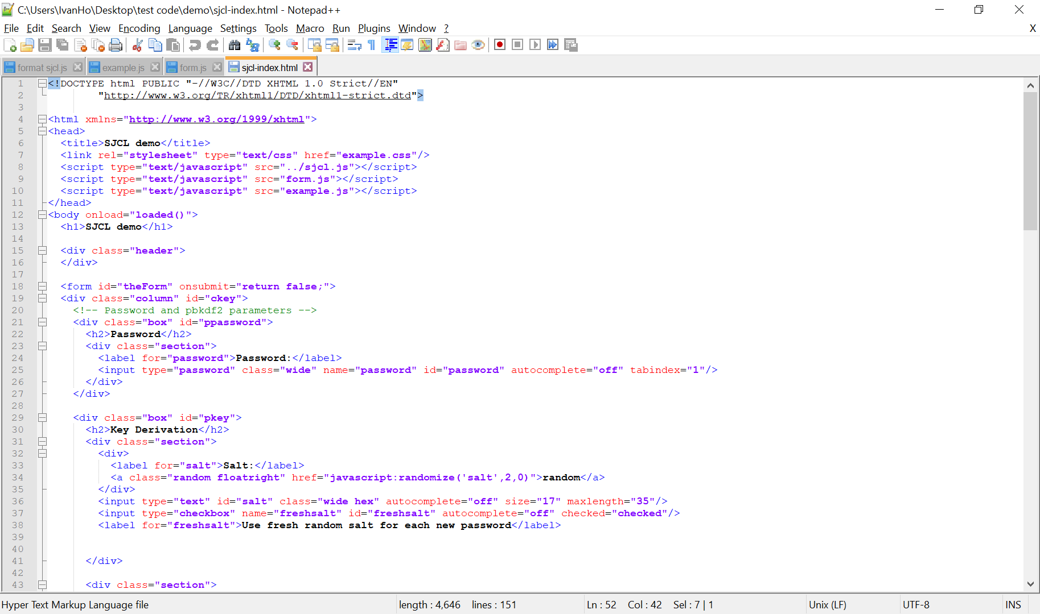

form.js -> (get/ set function)

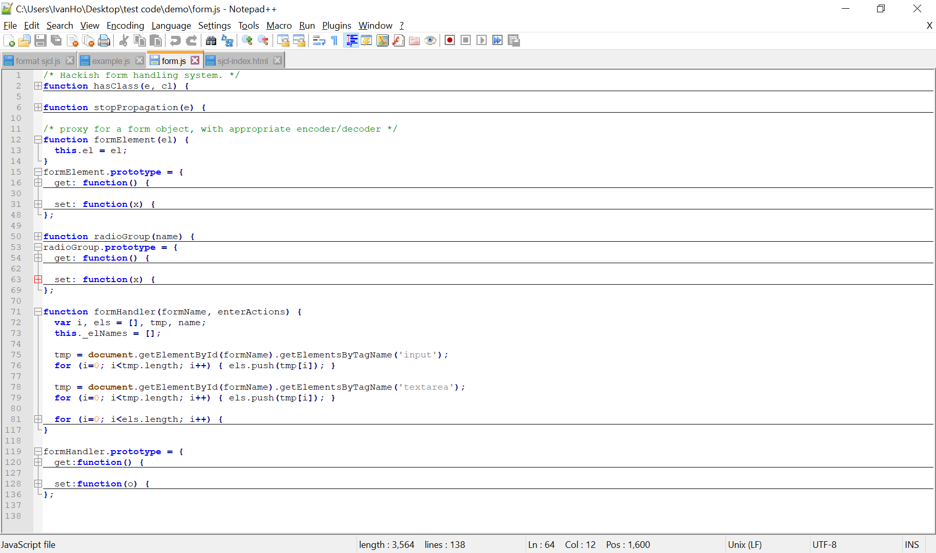

example.js -> (function -> doEncrypt(), doDecrypt() etc…)

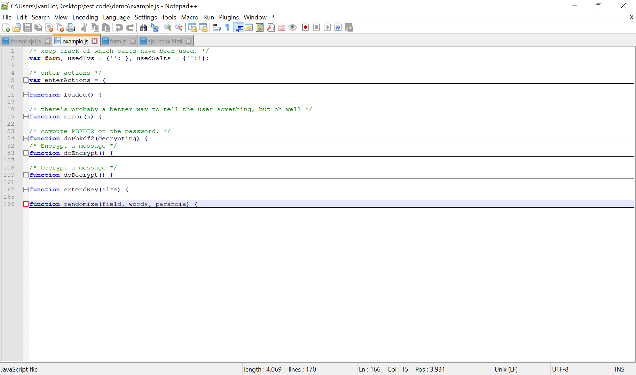

sjcl.js (format sjcl.js) -> sjcl library

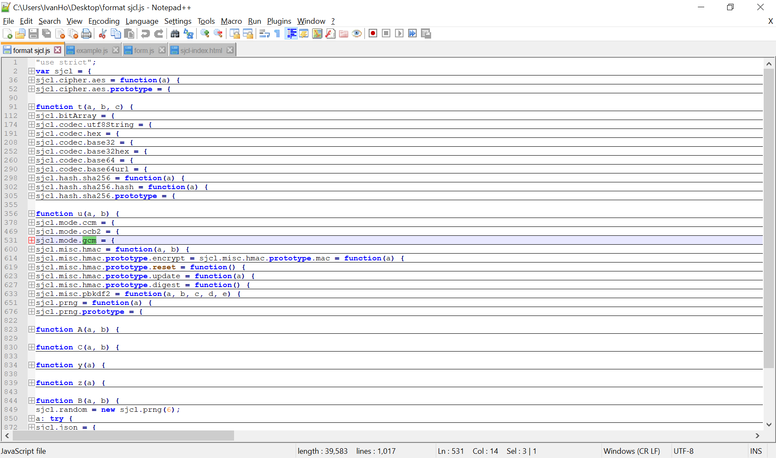

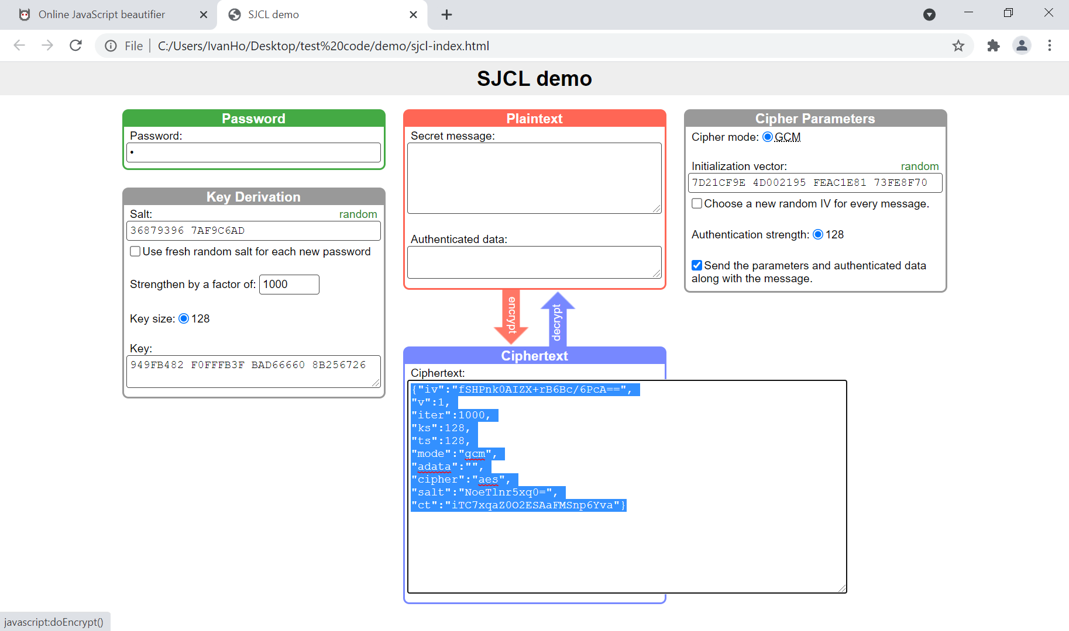

Key = Password + Key (Random/ Hard Code)

IV = IV (Random/ Hard Code)

sjcl-index.html



example.js -> doEncrypt()

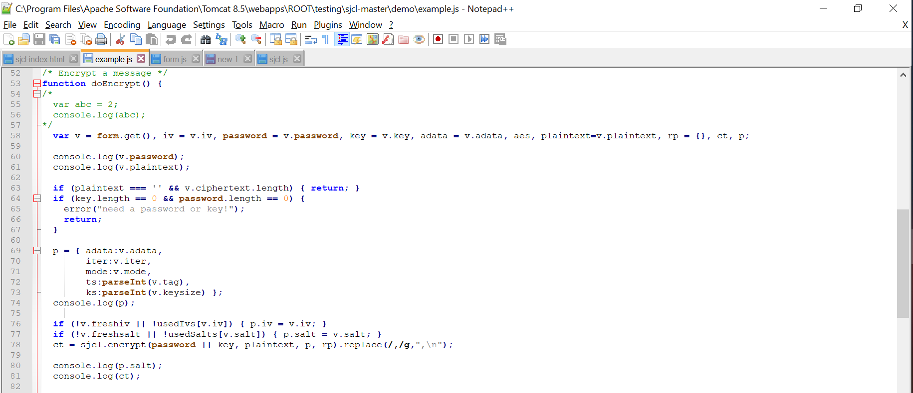

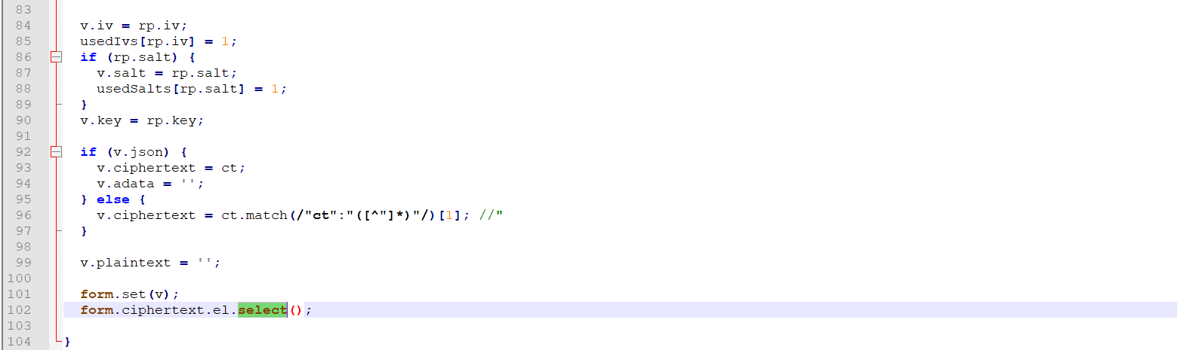

form.js

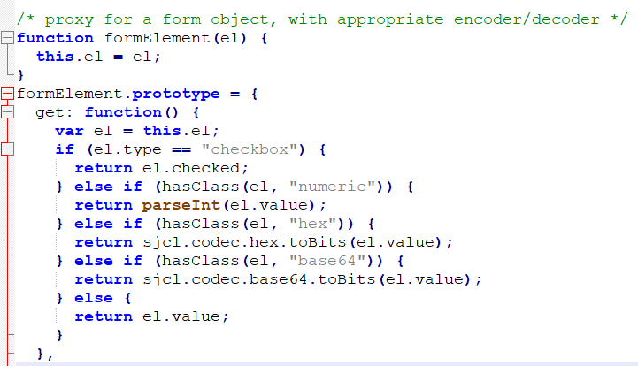

Strengthen by a factor of: 1000

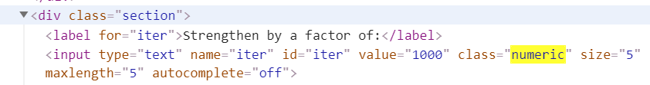

Key:

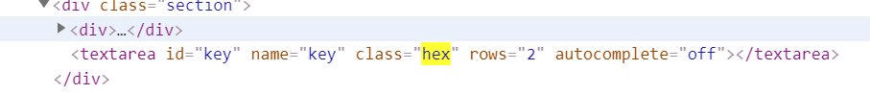

Salt:

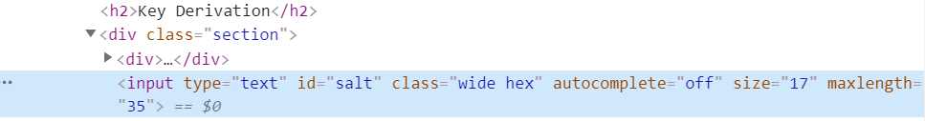

IV:



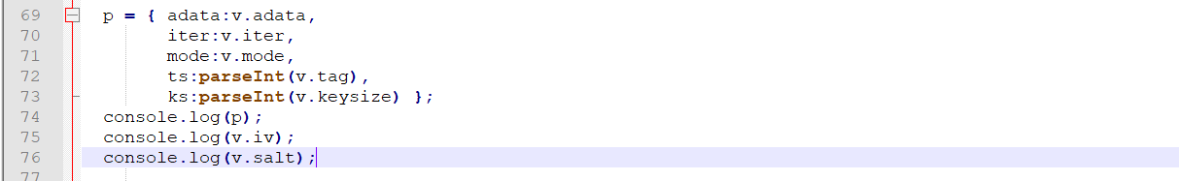

ts:parseInt(v.tag)

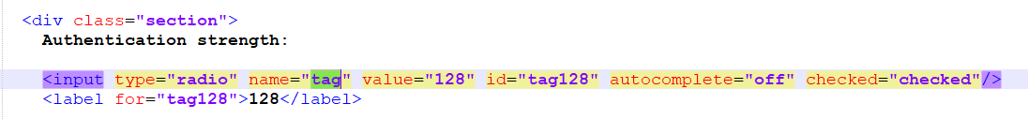

ks:parseInt(v.keysize)



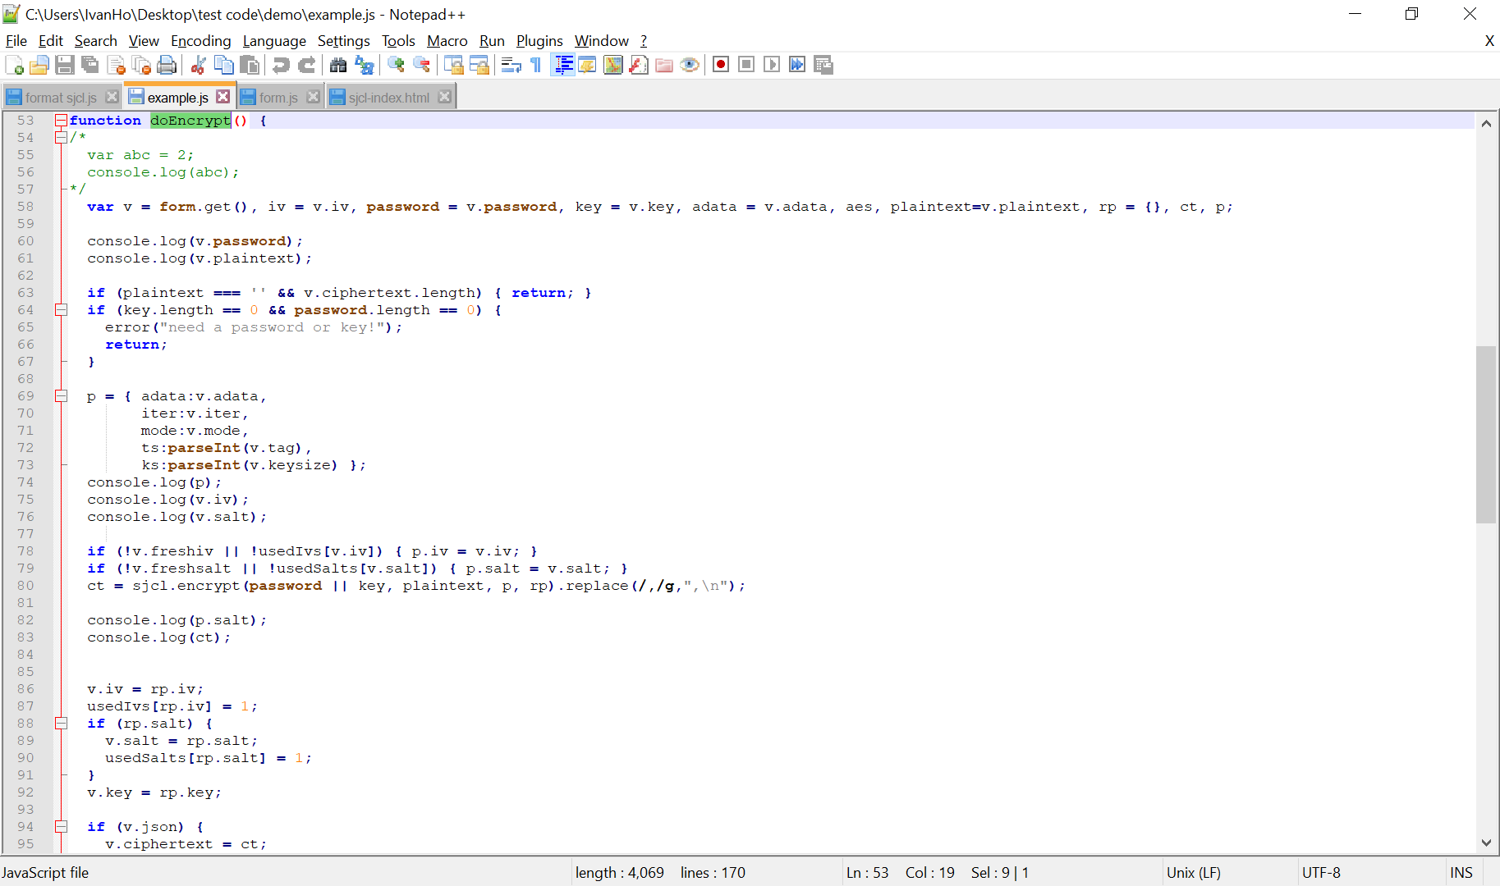

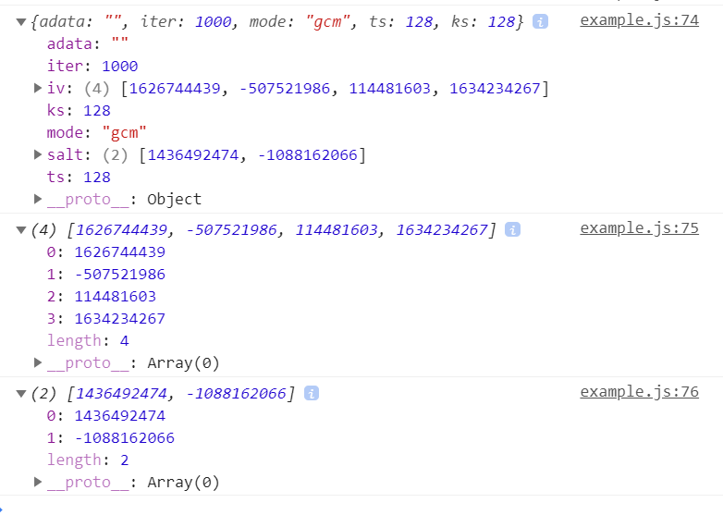

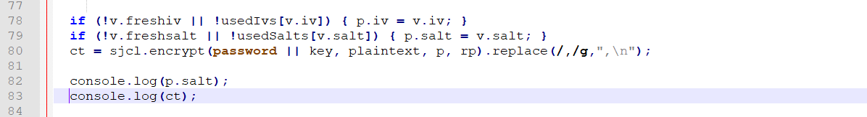

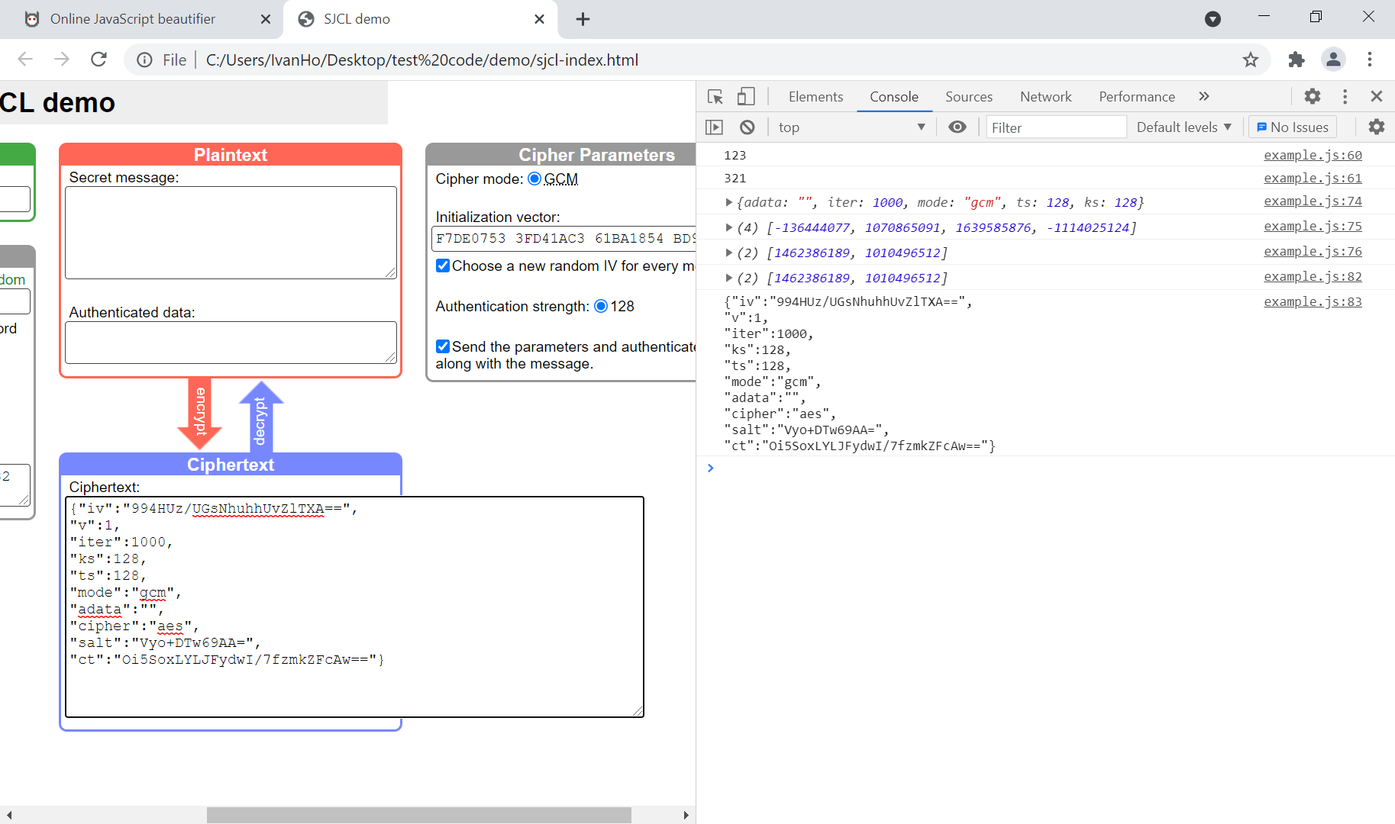



sjcl.js -> encrypt method

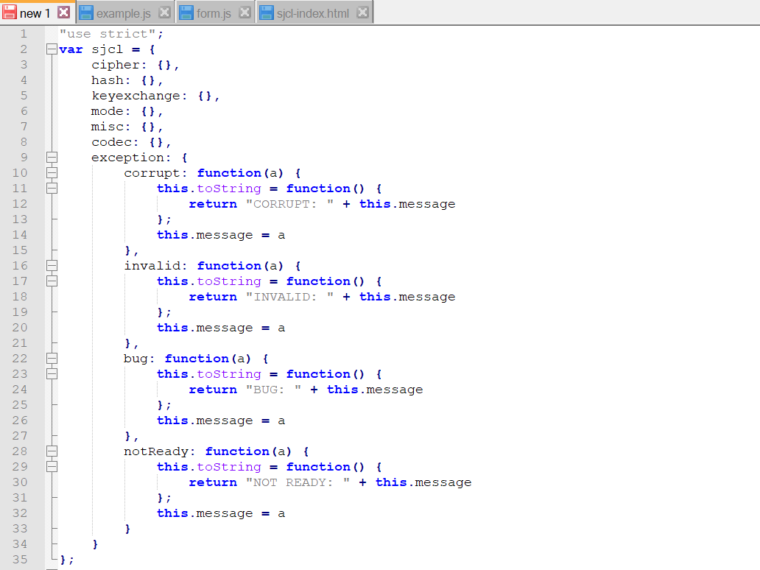

encrypt Function:

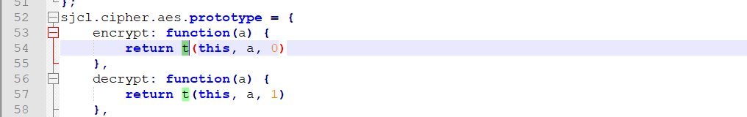

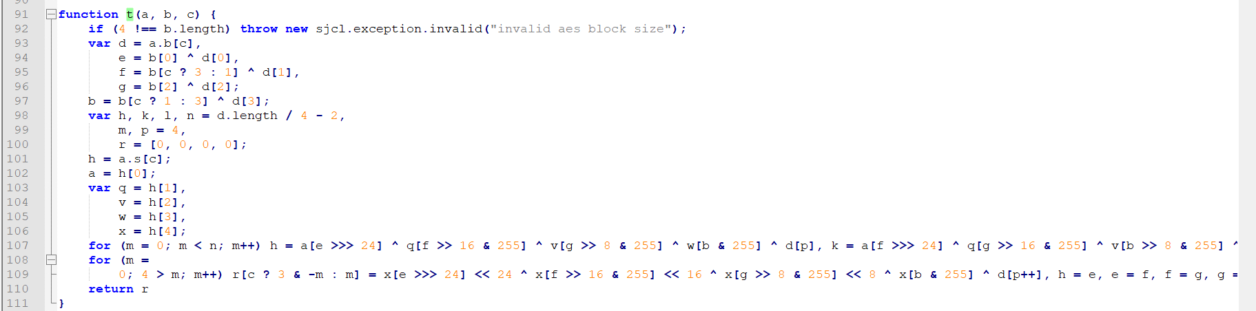

GCM encrypt Function:

