AI-Powered Web-Based Air Conditioning Recommendation, Service Request Management, and Technician Scheduling System for DVTech

A Capstone Project by

Flores, Francis C.
Ibon, Jenard A.
Mendoza, Jomar D.
Tinga, Princess Emilia T.
Villaro, Jerrelle A.

Submitted to the Faculty of Information Technology
Bulacan State University-Sarmiento Campus

In Partial Fulfillment
of the Requirements for the Degree
Bachelor of Science in Information Technology

March 26, 2026

CHAPTER I

INTRODUCTION

This chapter provides an overview of the study, highlighting the context, problem, objectives, significance, and scope of the project. It establishes the foundation for understanding the purpose and direction of the capstone project.

Background of the Study
Air conditioning systems have become an essential part of modern living due to the effects of climate change and rising global temperatures. Globally, households, offices, and commercial establishments increasingly rely on air conditioning to maintain indoor comfort, improve productivity, and support health (International Energy Agency (IEA), 2023; Muller & King, 2025) . Studies have shown that properly sized HVAC systems not only enhance occupant comfort but also reduce energy consumption and environmental impact (Jeong et al., 2025). As global urbanization continues, the need for reliable and energy-efficient air conditioning systems is steadily increasing (K. Johnson, 2020).
In tropical countries such as the Philippines, where high temperatures and humidity are experienced year-round, air conditioning has shifted from a luxury to a basic necessity (Nakai et al., 2025). Urbanized areas in Luzon, including the province of Bulacan, have experienced rapid residential and commercial development, further increasing the demand for efficient air conditioning systems (Zhu & Li, 2025). Local service providers such as DVTech play a critical role in supplying, installing, and maintaining air conditioning units for these growing communities.
DVTech is a local air conditioning service provider composed of approximately 30 technicians who handle installation, maintenance, and repair services. In addition to offering technical services, the company also sells various types of air conditioning units, including split-type air conditioners, window-type units, and floor-standing air conditioning systems, catering to both residential and commercial customers.
Despite the availability of technical guidelines for proper HVAC sizing, many service providers, including DVTech, continue to rely heavily on technicians’ experience and manual estimation to recommend air conditioning units (Board & Cooksey, 2025). This practice often results in oversized or undersized units, leading to inefficient cooling, higher electricity consumption, and frequent maintenance issues (Importance & Posts, 2025). Moreover, customer data collection and service scheduling are typically conducted manually, which can cause delays, errors, and lower customer satisfaction. Manual processes are time-consuming and prone to human error, which leads to inaccurate customer records and efficient service delivery (Kumar & Darreddy, 2025).
To address these challenges, this study proposes the development of an AI-Powered Web-Based Air Conditioning Recommendation, Service Request Management, and Technician Scheduling System for DVTech. The system will integrate multiple intelligent and user-centered features to enhance efficiency and service quality. It will include an AI-based image analyzer capable of assessing room layout and environmental factors to provide accurate air conditioning unit recommendations. Additionally, the AI feature is capable of providing simple troubleshooting suggestions based on the analyzed image, particularly for minor and common air conditioning issues, allowing users to identify and possibly resolve basic problems without immediately requiring technician assistance. Furthermore, a chatbot interface will be incorporated to collect customer inputs in an interactive and user-friendly manner, improving communication and data gathering. A technician scheduling module will also be developed to enable administrators to assign service tasks effectively based on technician availability and service priorities, ensuring timely and organized service operations.
The proposed system is designed to improve accuracy in unit selection, streamline operations, enhance customer experience, and support energy-efficient practices. By combining AI technology, interactive input collection, and administrator-controlled scheduling, the solution addresses current gaps and enhances the operational capability of DVTech.

Objectives of the Study
General Objective:
The general objective of this study is to design, develop, and evaluate an AI-Powered Web-Based Air Conditioning Recommendation, Service Request Management, and Technician Scheduling System for DVTech that improves accuracy in unit recommendation, streamlines technician scheduling, enhances customer experience, and provides management reports.
Specific Objectives:
The study aims to achieve the following specific objectives:
a. To design and develop the AI-Powered Web-Based Air Conditioning Recommendation, Service Request Management, and Technician Scheduling System for DVTech.
b. To implement key system features, including an AI-based recommendation and chatbot system to assist customers in selecting suitable air conditioning units and provide quick support, a technician scheduling module to efficiently organize and manage service tasks, and a report generation module to summarize customer requests, technician assignments, and system recommendations for effective monitoring and decision-making.
c. To evaluate the system’s performance and usability using established assessment frameworks to ensure its effectiveness and reliability. The ISO/IEC 25010 standards will be utilized to assess the overall system quality, particularly focusing on reliability and suitability for professional or administrator use. In addition, the Technology Acceptance Model (TAM) will be applied to measure client or user acceptance. This includes evaluating Perceived Usefulness (PU), which determines the system’s effectiveness in assisting users in their tasks; Perceived Ease of Use (PEOU), which examines how easy the system is to operate; and Attitude Towards Using (ATU), which reflects the users’ overall satisfaction and their willingness to adopt and continuously use the system.
Significance of the Study
This study aims to improve the efficiency and quality of air conditioning services through the use of an AI-powered web-based system. The findings of the study are expected to be beneficial to the following:
For DVTech (Admin/Management), the system improves operational efficiency by automating air conditioning unit recommendations, technician scheduling, and report generation. This reduces manual workload, minimizes estimation errors, and provides organized data for better decision-making. As a result, the company delivers faster and more reliable services to its customers.
For Technicians, the system provides a more organized way of handling service assignments through the scheduling module. This enables technicians to clearly view their assigned tasks, avoid scheduling conflicts, and manage their time more efficiently, leading to improved productivity and service performance.
For Customers, the system provides a more convenient and user-friendly experience by providing accurate air conditioning unit recommendations based on room conditions. Through the chatbot and AI-based assessment, customers easily input their needs and receive suitable suggestions, resulting in better satisfaction and informed decision-making.
For the Institution/Industry, this study supports the adoption of modern technologies in service-based businesses. By integrating artificial intelligence, automation, and web-based systems, it promotes improved service management, energy efficiency, and digital transformation within the HVAC industry.
For Future Researchers, this study serves as a foundation for further research related to artificial intelligence, web-based systems, and service automation. Future researchers can enhance the system by improving AI accuracy, adding more advanced features, or adapting the system for other industries or applications.

Scope and Delimitations
Scope of the Study
This study focuses on the development of AI-Powered Web-Based Air Conditioning Recommendation, Service Request Management, and Technician Scheduling System for DVTech. The system is intended to enhance customer service operations and support decision-making processes by integrating several key functionalities. It includes an AI-based recommendation system combined with a chatbot feature that assists customers in selecting suitable air conditioning units based on their specific needs and room information. In addition, the system provides a technician scheduling module designed to efficiently assign service tasks according to technician availability and priority levels. A report generation module is also incorporated to produce organized summaries of customer requests, technician assignments, and system-generated recommendations. Furthermore, the system utilizes a centralized database to store and manage essential data, including customer profiles, service records, scheduling information, and recommendation outputs, ensuring efficient data handling and accessibility.
Limitations of the Study
Despite its intended capabilities, the system has several limitations. It requires a internet connection to support AI-based recommendations, chatbot interactions, data processing, and report generation; thus, limited or unstable connectivity affects its overall performance and accessibility. Additionally, the accuracy and reliability of the system’s recommendations depend largely on the correctness and completeness of the information provided by customers, particularly regarding room details and service requirements. Moreover, the system is specifically developed for DVTech operations and is intended solely for use by its administrators and users, making it not directly applicable to other organizations nor capable of integration with external systems without further modification and customization. Furthermore, the system does not include a fully integrated payment transaction feature; however, this will not affect its core functionalities such as recommendations, booking, and technician scheduling, as service requests can still be processed while payments may be handled manually or through external methods.
Definition of Terms
This section provides operational definitions of technical, domain-specific, or project-related terms used in the study.
Artificial Intelligence (AI) – The capability of a system to perform tasks that normally require human intelligence, such as analysis, decision-making, and recommendation generation.
Chatbot System – An AI-powered feature that interacts with users by collecting information and providing automated responses to assist in service requests.
Customer Data – Information provided by users, including personal details, room specifications, and service requests, used by the system for processing and recommendations.
Database Management System – A software system used to store, organize, and manage data such as customer records, service requests, and technician schedules.
Image Analysis – The process of examining room images using AI to identify environmental factors that affect air conditioning unit recommendations.
Recommendation System – A system feature that suggests appropriate air conditioning units based on user inputs, room conditions, and AI analysis.
Room Assessment – The evaluation of room characteristics such as size, layout, and environmental conditions to determine suitable air conditioning requirements.
Service Request – A request submitted by a customer for air conditioning installation, maintenance, or consultation.
Technician – A personnel responsible for performing installation, maintenance, and repair services assigned through the system.
Technician Scheduling Module – A system component that organizes and assigns service tasks to technicians efficiently.
User Interface (UI) – The visual part of the system that allows users to interact with features such as forms, dashboards, and chatbot.
Web-Based System – A system that is accessible through a web browser using an internet connection on various devices.

CHAPTER II

REVIEW OF RELATED LITERATURE AND SYSTEMS

Review of Related Literature
This chapter presents related systems and studies that are relevant to the development of the AI-Powered Web-Based Air Conditioning Recommendation, Room Assessment, and Technician Scheduling System for DVTech. It discusses existing systems, foreign literature, and local literature that provide theoretical, technical, and practical foundations for the study. The reviewed literature helps establish the importance of artificial intelligence, automation, and digital management in improving air conditioning services and customer experience.
Technical Background (Related Systems)

1. HVAC Load Calculation System
According to (Bills, 2025) , HVAC load calculation systems are designed to determine the cooling and heating requirements of a building based on factors such as room size, sun exposure, and occupancy. These systems help technicians select appropriate air conditioning units and avoid under-sizing or over-sizing. However, most load calculation tools require manual data input and technical knowledge. This system is related to the proposed DVTech system because both aim to improve the accuracy of air conditioning unit recommendations. The proposed system enhances this process by using artificial intelligence and automated room assessment.

2. AI-Based Recommendation System for Energy Management
According to (Rodrigues et al., 2026), AI-based recommendation systems analyze user behavior, environmental data, and system performance to generate personalized recommendations for energy usage. Their system helps users reduce electricity consumption through intelligent suggestions. This system is relevant to the proposed DVTech system because both use artificial intelligence to support decision-making. The proposed system applies similar techniques to recommend suitable air conditioning units based on room conditions and customer needs.

3. Customer Service Chatbot System
According to (Marcineková et al., 2025), customer service chatbot systems use artificial intelligence and natural language processing to interact with users, answer inquiries, and collect information automatically. These systems improve response time and customer satisfaction. This system is related to the proposed DVTech system because it supports the integration of a chatbot interface for gathering customer inputs and guiding users during service requests.

4. Web-Based Technician Scheduling System
According to (FAB Balance Check, 2025), web-based technician scheduling systems optimize workforce assignment by considering technician availability, workload, and service priorities. These systems reduce delays and improve service efficiency. This system is closely related to the proposed DVTech system because both aim to improve service delivery through digital scheduling. The proposed system further enhances this by integrating scheduling with AI-based recommendations and customer data.

5. Integrated Service Management System
According to (Caldas, 2023), integrated service management systems combine customer records, service requests, reporting, and operational tools into a unified platform. These systems improve data accessibility and organizational efficiency. This system is related to the proposed DVTech system because both aim to centralize service operations. The proposed system improves upon this by adding artificial intelligence and automated analysis features.

Summary of Technical Background
The reviewed systems demonstrate that load calculation tools, smart monitoring platforms, AI recommendation systems, chatbot interfaces, and scheduling systems play important roles in improving HVAC service operations. However, most existing systems focus only on specific functions. The proposed AI-Powered Web-Based Air Conditioning Recommendation, Room Assessment, and Technician Scheduling System integrates these features into one comprehensive platform, making it more efficient and user-friendly.
Foreign Literature

1. Artificial Intelligence in HVAC Optimization
According to (Gassar & Jafar, 2025), in their study Artificial Intelligence-Enabled Heating, Ventilation, and Air Conditioning Systems Toward Zero-Emission Buildings, artificial intelligence significantly improves HVAC system performance through predictive maintenance, fault detection, and intelligent control mechanisms. Their systematic review emphasized that AI-based HVAC systems can analyze environmental and operational data to reduce energy consumption and operational costs. This study is relevant to the proposed DVTech system because it supports the use of artificial intelligence in generating accurate air conditioning recommendations and promoting energy-efficient practices.

2. Intelligent Temperature and Humidity Control
According to (Zhu & Li, 2025), in their research on HVAC temperature and humidity optimization using large language models, developed an AI-based system capable of adapting to environmental conditions and user preferences. Their study demonstrated that intelligent control systems improve indoor comfort and minimize unnecessary power usage. This research relates to the proposed system because it highlights how artificial intelligence can be used in room assessment and environmental analysis to enhance recommendation accuracy.

3. Adaptive Thermal Comfort Management
According to (Jeong et al., 2025), in their study on balancing thermal comfort and energy efficiency in public buildings, found that adaptive temperature control improves user satisfaction while reducing electricity consumption. Their research showed that automated set point adjustment allows HVAC systems to respond dynamically to changing conditions. This study supports the objectives of the proposed system by emphasizing the importance of proper unit sizing and intelligent temperature management.

4. Chatbot Technology in Customer Service
According to (Marcineková et al., 2025), in their article Implementing AI Chatbots in Customer Service Optimization, chatbot systems enhance customer interaction by providing instant responses and automating data collection. Their study revealed that chatbots reduce service delays and improve customer satisfaction. This research is relevant to the proposed DVTech system because it justifies the integration of a chatbot interface for collecting customer information and assisting users during service requests.

5. Digital Technician Scheduling Systems
According to (Dr. Shareef N. M., 2025), in a study on technician scheduling optimization, digital scheduling systems improve service efficiency, workload distribution, and response time. The findings showed that automated scheduling tools minimize conflicts and enhance coordination among technicians. This study directly supports the development of the technician scheduling module in the proposed DVTech system.

6. Smart Building Energy Management
According to (Zhang et al., 2021), in a review of artificial intelligence applications in building energy management systems, AI-based platforms improve decision-making through predictive analysis and automated recommendations. The study demonstrated that intelligent systems help users optimize energy usage and reduce operational costs. This research is related to the proposed DVTech system because it supports the application of AI in managing air conditioning performance and energy efficiency.

Summary of Foreign Literature
The reviewed foreign studies indicate that artificial intelligence, intelligent control systems, chatbot technology, and digital scheduling play essential roles in improving HVAC management and customer service. These studies support the integration of AI-based analysis, interactive communication, and digital management in the proposed DVTech system. Furthermore, the findings confirm that intelligent systems contribute to energy efficiency, service reliability, and enhanced user satisfaction.
Local Literature

1. Air Conditioning Usage in the Philippine Setting
According to (Pavanello et al., 2021), in the article Air Conditioning, air conditioning systems play a vital role in tropical countries such as the Philippines due to high temperature and humidity levels. The study emphasized that cooling systems improve productivity, comfort, and overall well-being. This research is relevant to the proposed DVTech system because it highlights the importance of providing reliable and efficient cooling solutions suited to the Philippine climate.

2. Manual Estimation Practices in HVAC Services
Manual estimation practices remain common among many local HVAC service providers in the Philippines, particularly in recommending appropriate air-conditioning unit sizes. According to Koppel Philippines (Sizing et al., 2025), unit capacity is often estimated using basic factors such as room size and occupancy, which rely heavily on technician experience and simplified guidelines rather than detailed technical analysis. While this approach is convenient, it is prone to inaccuracies because important variables such as insulation, heat exposure, and ventilation are often overlooked. As a result, improper unit sizing may occur, leading to inefficient performance, higher energy consumption, and reduced customer satisfaction. This continued reliance on manual methods highlights the limitations of traditional practices and justifies the need for an AI-based recommendation system to provide more accurate, consistent, and reliable air-conditioning unit suggestions.

3. Impact of Manual and Limited Digital Data Processing on Business Operations
Manual and limited digitalized data management remains common among many small and medium enterprises (SMEs) in the Philippines, particularly in service-oriented industries where record-keeping is often done through handwritten logs, spreadsheets, or unorganized files. According to (Ramon Albert et al., 2023), the low adoption of digital tools among local businesses leads to inefficient workflows, delayed transactions, and difficulties in accessing important business information, which can negatively affect operational performance and customer satisfaction. In the context of HVAC service providers, these limitations may cause problems in scheduling, tracking service history, and managing customer records. This situation highlights the importance of developing a centralized digital database within the proposed DVTech system, as it can improve data accuracy, streamline workflows, enhance record accessibility, and support faster and more reliable service delivery.
4. Importance of Proper Air Conditioning Unit Sizing
Proper air conditioning unit sizing is essential for maintaining energy efficiency and prolonging system durability. According to (Opsmatters, 2025), choosing the correct size for an AC unit significantly affects its performance, energy consumption, and longevity, with improperly sized units leading to increased electricity use, greater wear and tear, and higher chances of frequent repairs and breakdowns. This research is relevant to the proposed system because it strengthens the importance of accurate room assessment and AI-based unit recommendations, ensuring optimized energy use and enhanced customer satisfaction through reliable HVAC solutions.
5. Technology Adoption in Philippine Service Enterprises
Local studies on technology adoption among small and medium enterprises (SMEs) in the Philippines indicate that web-based systems and digital tools improve business performance, customer satisfaction, and data management. Research by (Savellano, 2025) found that digitalization including online ordering, automated inventory tracking, and cashless payments helps businesses achieve faster service times, increased customer engagement, and reduced operational costs compared to traditional practices. Such findings reveal that digital platforms enhance monitoring and decision-making processes, supporting the development of the proposed DVTech system, which aims to modernize service operations and improve business outcomes through web-based technology.

Summary of Local Literature
The reviewed local studies indicate that air conditioning services in the Philippines are still largely dependent on manual processes and traditional estimation methods. These practices often lead to inefficiencies, increased costs, and customer dissatisfaction. The literature also highlights the growing adoption of digital technologies among local businesses. The proposed DVTech system addresses these challenges by introducing artificial intelligence, automated scheduling, and centralized data management to improve service quality and operational efficiency.

Comparison of Related Systems

System | Main Features | Target Users | Technologies Used | Strengths | Limitations | Differentiation from Proposed System
HVAC Load Calculation System | Calculates Cooling Requirements based on room size, occupancy, and environment | HVAC technicians, engineers | Calculation software, manual input tools | Accurate AC sizing, improves system efficiency | Requires technical knowledge, manual input, time-consuming | Automated system calculation using AI and image-based room assessment
AI-Based Recommendation System for Energy Management | Provides intelligent energy-saving recommendations using data analysis | Homeowners, building managers | Artificial Intelligence, Machine Learning | Improves energy efficiency, adaptive recommendations | Requires large datasets, not focused on HVAC selection alone | Focuses specifically on AC unit recommendation with room analysis
Customer Service Chatbot System | Automates user interaction, collects data, answers inquiries | Customers, service providers | AI, Natural Language Processing (NLP) | Fast response, 24/7 availability, improves user experience | Limited understanding of complex queries | Integrates chatbot with recommendation and scheduling features
Web-Based Technician Scheduling System | Assigns technicians based on availability and workload | Admins, technicians | Web-based system, scheduling algorithms | Organized scheduling, reduces delays, improves workflow | Dependent on accurate input, no intelligent recommendation | Integrates scheduling with AI recommendations and customer data
Integrated Service Management System | Centralized system for records, reports, and operations | Businesses, administrators | Database systems, web-based platforms | Improves organization, centralized data access | Lacks AI automation, limited intelligent features | AI, chatbot, and automated analysis
AI-Powered Web-Based Air Conditioning Recommendation, Room Assessment, and Technician Scheduling System for DVTech | AI-based AC recommendation, image-based room assessment, chatbot interaction, technician scheduling, reporting | Customers, admins, technicians | AI (image processing), Web-based system, Database, Chatbot | Integrated system, improved accuracy, automation, better user experience | Requires internet, dependent on input accuracy | Combines all features into one intelligent and automated platform

Synthesis
Based on the reviewed related systems, various technologies play an important role in enhancing HVAC services, especially with regard to accurate and efficient tasks and customer experience improvements. While HVAC load calculation systems are strong technical foundations for incoming air conditioning capabilities, they heavily rely on manual inputs and bring a huge risk of human errors. AI-based recommendation systems take this a step further, applying data-driven analysis to provide decisions that are more accurate and energy-efficient.
On the other hand, chatbot solutions enhance customer engagement by allowing for automatic communication and accelerated data capture, while web-based technician scheduling programs facilitate work force management and service organization. Integrated service management systems also provide centralized data and streamline operations, but many do not have intelligent automation.
Most of existing systems, however, are just application-oriented building blocks and lack the holistic integration of all subsystems needed in a modern commercial enterprise. The opportunity to merge a AI-based recommendation for user in AI, automated data collection, scheduling and centralized management in to a single platform. The proposed DVTech system will bridge this gap by incorporating all these features in a single system. This system will improve existing techniques by incorporating intelligent room assessment, making recommendations, chatbots to interact with customers, and also scheduling technicians. This system will be more advanced and comprehensive compared to existing systems because it will provide accuracy and efficiency in serving customers.

CHAPTER III

DESIGN AND METHODOLOGY

Requirement Analysis and Documentation

This section presents the functional and non-functional requirements of the proposed system. These requirements define the expected capabilities, features, and operational characteristics necessary for the system to effectively support the air conditioning unit recommendation, service request management, and technician scheduling processes of DVTech. The identified requirements serve as the foundation for the system design and development, ensuring that the proposed system meets the needs of its intended users while maintaining efficiency, reliability, and usability.
Functional Requirements
The functional requirements describe the specific operations and capabilities that the proposed system must perform in order to effectively support the processes involved in air conditioning unit recommendation, service request management, and technician scheduling for DVTech. These requirements define the interactions between users and the system, as well as the key functionalities that will enable the system to process information, generate recommendations, and manage service-related activities. The following functions outline the primary features that the system shall be capable of performing.
• Provide AI-based air conditioning unit recommendations
• Accept room information and images for assessment
• Allow chatbot-based data collection
• Enable administrator for technician scheduling
• Generate reports for monitoring service requests
• Store customer and service records in a centralized database
• Allow customers to submit service requests for installation or maintenance
• Allow administrators to assign technicians to service requests
• Display recommended air conditioning units based on calculated cooling requirements
• Allow technicians to view assigned service tasks
• Allow technicians to update service request status after completing tasks
• Allow administrators to manage air conditioning product information.
Non-Functional Requirements
The non-functional requirements define the quality attributes, operational constraints, and performance standards that the proposed system must satisfy. These requirements ensure that the system operates efficiently, securely, and reliably while providing a satisfactory user experience for customers, administrators, and technicians. The following characteristics outline the essential operational qualities that the system must maintain during its implementation and usage.
• Require internet connection
• Provide secure user authentication
• Maintain acceptable response time during AI processing
• Ensure system reliability and usability
• Provide a user-friendly interface for customers and administrators
• Maintain data accuracy and integrity within the database
• Support system scalability for multiple users and service requests
• Provide system availability during operational hours
• Ensure data privacy and protection for customer information

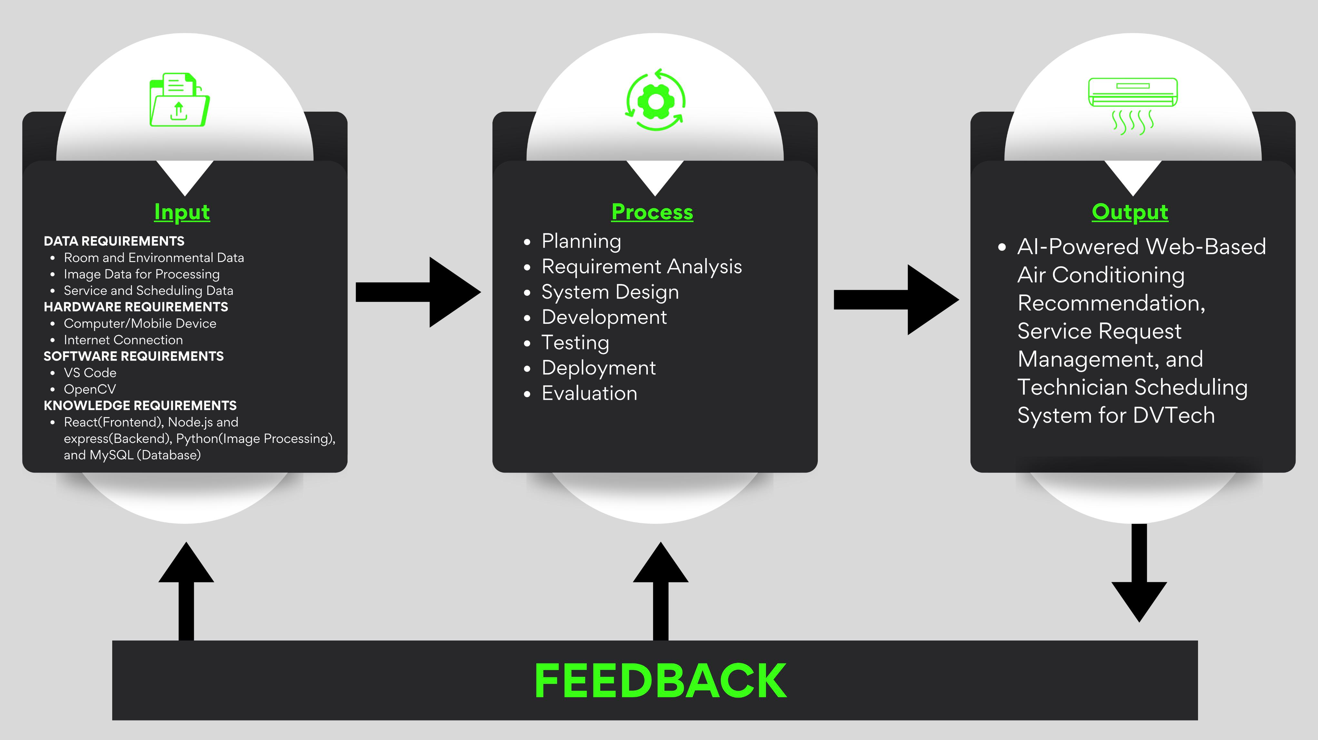
Conceptual Framework
Figure 1. Conceptual Framework of the AI-Powered Web-Based Air Conditioning Recommendation, Service Request Management, and Technician Scheduling System for DVTech
The conceptual framework of the proposed system follows the Input-Process-Output (IPO) model integrated with a feedback mechanism. The input stage consists of the necessary data and resources required for the system such as software requirements, hardware requirements, and knowledge requirements. These inputs include room and environmental data, service and scheduling data, image data for processing, programming language, as well as the devices and internet connection used to operate the system. The process stage is based on the Agile software development methodology, which includes planning, requirements analysis, system design, system development, testing, deployment, and evaluation. These phases represent the systematic approach used in the development and continuous improvement of the system. The output stage presents the developed system, which is the AI-Based Air Conditioning Recommendation and Service Request Management System. The system provides intelligent recommendations for air conditioning units and efficiently manages service requests. A feedback mechanism is incorporated in the framework, wherein the input, process, and output are all connected to ensure continuous system improvement. This allows the system to be refined and enhanced whenever necessary.
System Design
The system design phase defines the overall structure and architecture of the proposed AI-Powered Web-Based Air Conditioning Recommendation, Service Request Management, and Technician Scheduling System for DVTech. It illustrates how system components interact, how data flows, and how user inputs are processed into meaningful outputs through various modules. This phase serves as the blueprint for development, ensuring that all system requirements are translated into an efficient, reliable, and user-friendly design.

Context Diagram
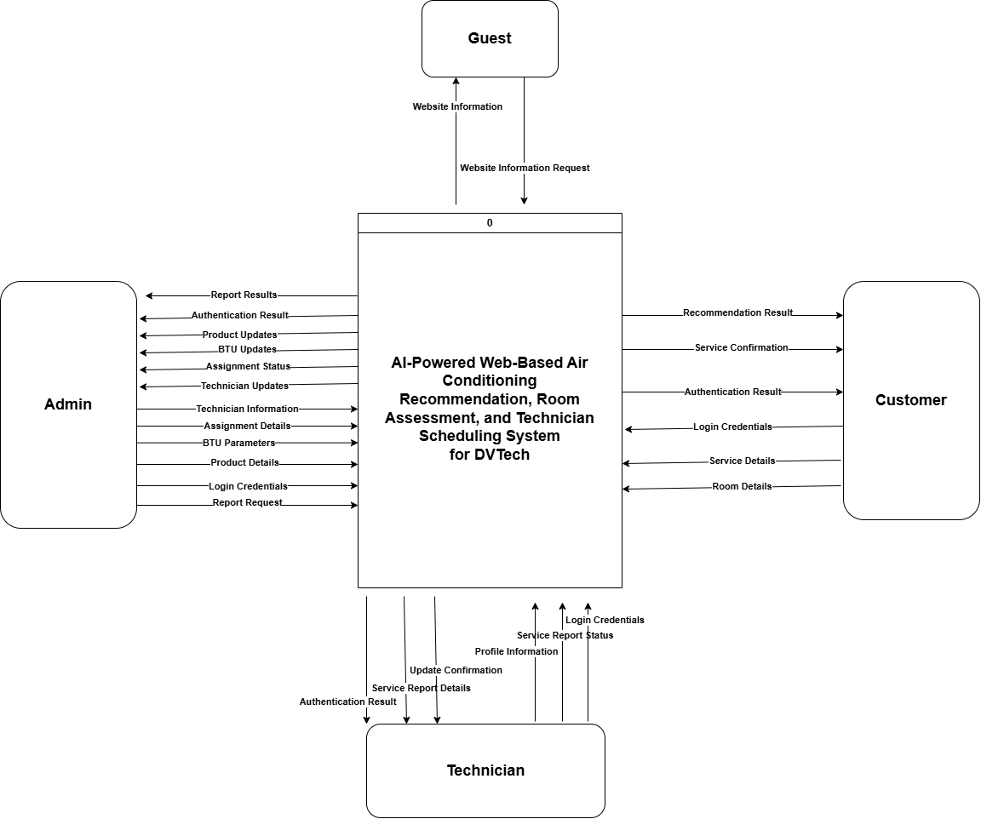

Use Case Diagram

Figure 2. Context Diagram
This figure presents the overall structure of the system by showing its interaction with external entities, namely the Customer, Admin, and Technician. It illustrates how data flows between these entities and the system as a whole, including inputs such as login credentials, service details, room information, and administrative data, as well as outputs such as authentication results, recommendations, service confirmations, reports, and updates. The context diagram provides a high-level view of the system, defining its scope and boundaries while highlighting the primary data exchanges that occur between the system and its users.
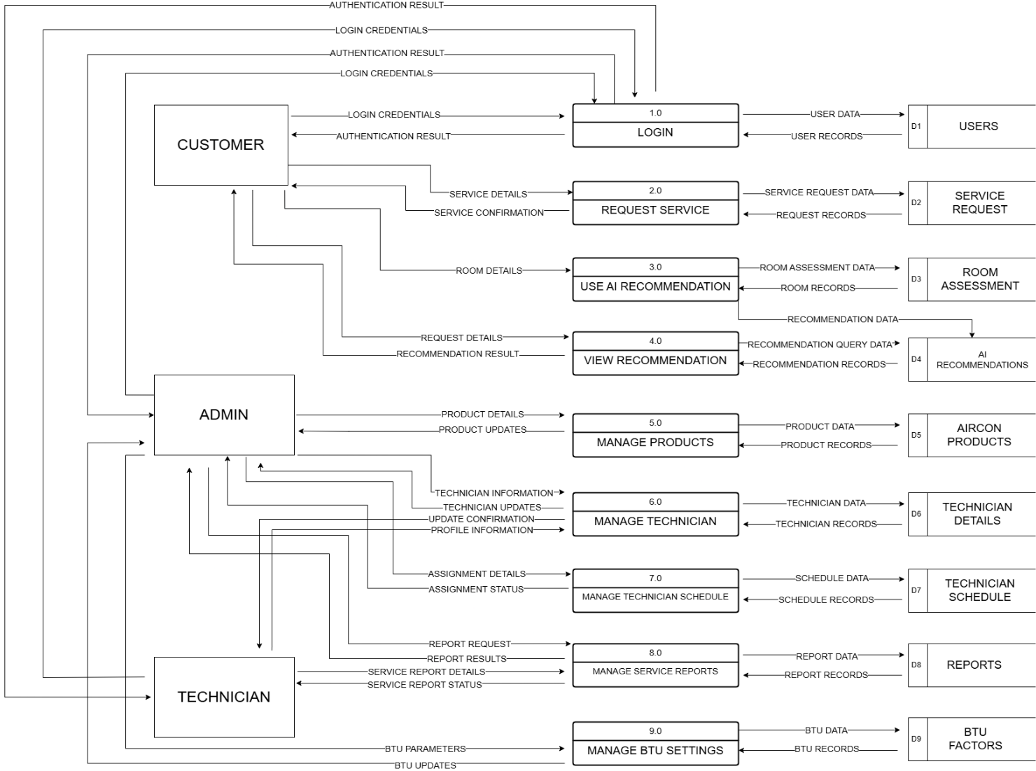
Data Flow Diagram Level 1

Figure 3. Data Flow Diagram (Level 1)
This figure illustrates the detailed flow of data within the system by breaking down the main processes into specific functional components. It shows how external entities such as the Customer, Admin, and Technician interact with the system through various processes including Login, Request Service, AI Recommendation, and Management functions. The diagram also presents how data is stored, retrieved, and processed across multiple data stores such as Users, Service Requests, Room Assessments, AI Recommendations, Aircon Products, Technician Details, Schedules, Reports, and BTU Factors. Overall, this level provides a clearer view of how information moves through the system, ensuring proper data handling, process interaction, and system functionality.

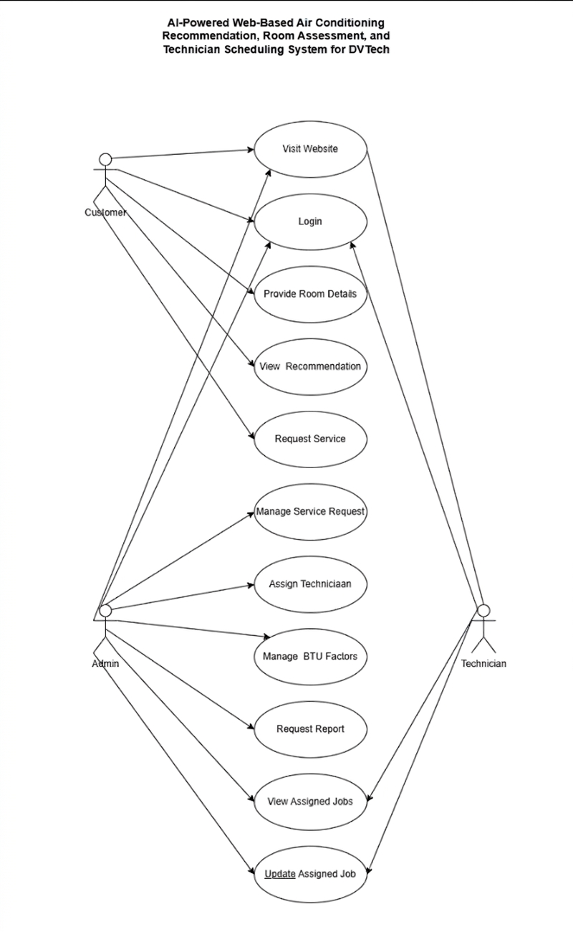
Use Case Diagram

Figure 4. Use Case Diagram

This figure illustrates the actors involved in the system, namely the Customer, Admin, and Technician, and their corresponding interactions with the system’s functionalities. Each actor is associated with specific use cases such as submitting service requests, accessing website information, managing records, scheduling technicians, and handling service reports. The diagram provides a clear representation of how different users engage with the system, highlighting their roles and responsibilities while demonstrating the overall functionality and user interaction within the system.

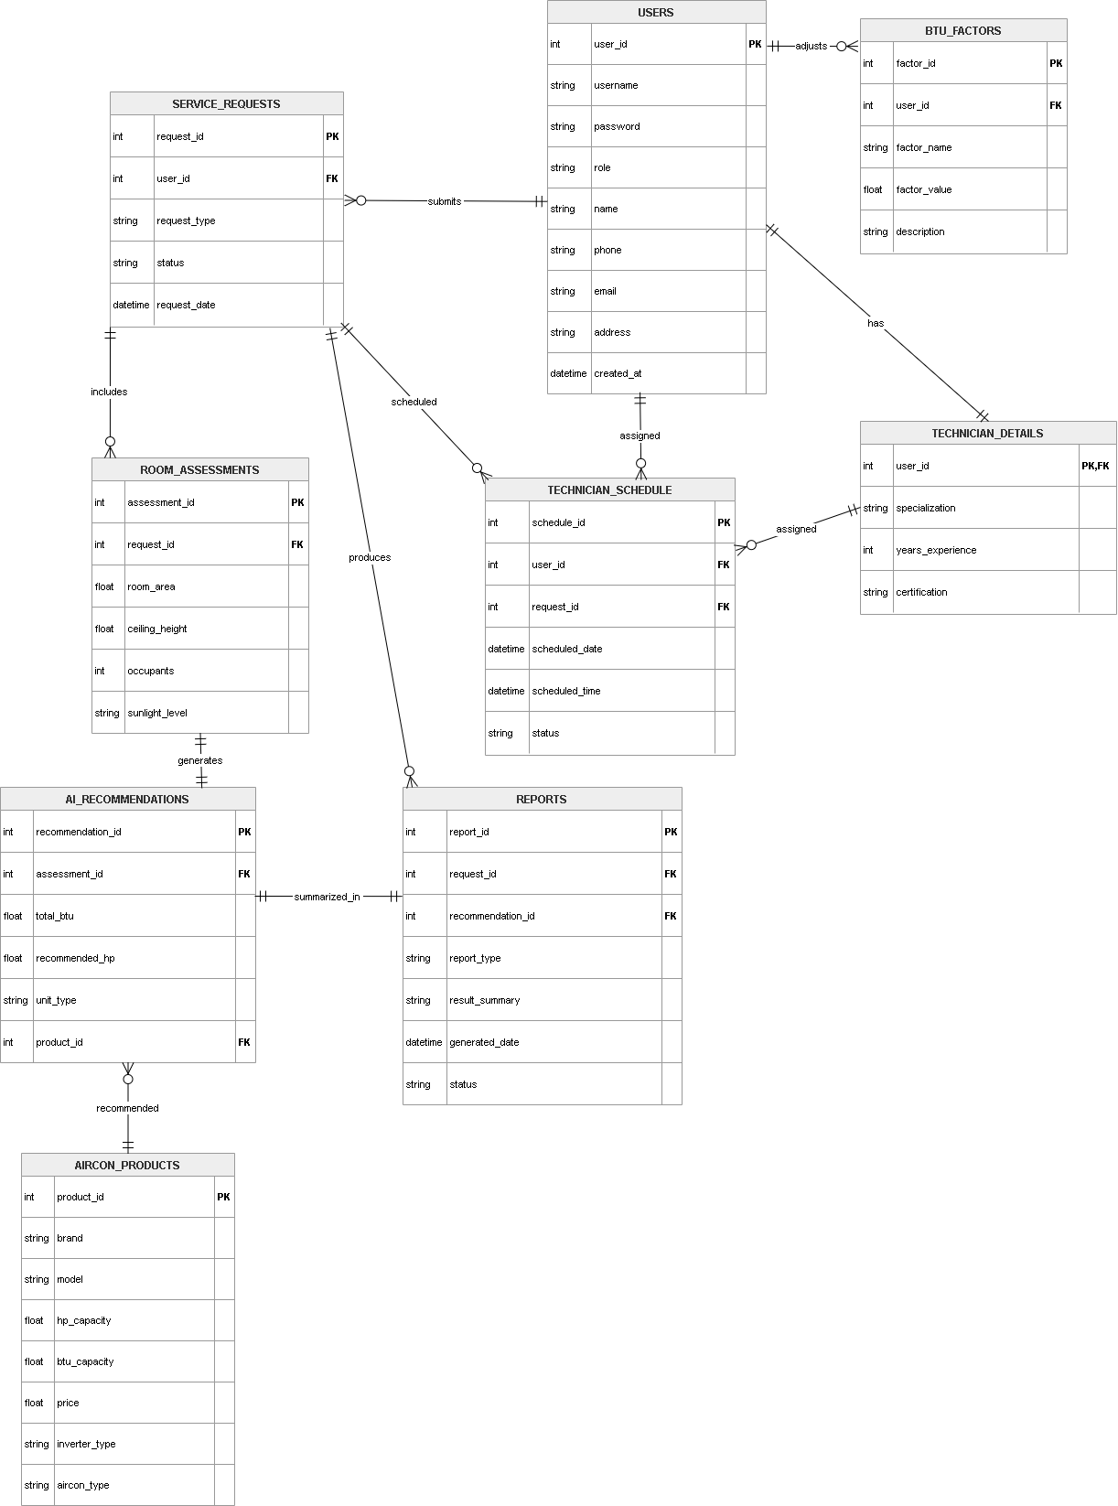
Entity Relationship Diagram (ERD)

Figure 5. Entity Relationship Diagram (ERD)

This Entity Relationship Diagram (ERD) illustrates how the database is structured, with the USERS table serving as the central entity that manages admin, technician, and customer accounts through the role attribute. A 1-to-N relationship exists between USERS and SERVICE_REQUESTS, where one user can submit multiple service requests. The user_id in the SERVICE_REQUESTS table acts as a foreign key to maintain referential integrity.
Each service request is associated with the ROOM_ASSESSMENTS table, which stores room-specific parameters such as area, ceiling height, occupancy, and sunlight level. These values are used to generate records in the AI_RECOMMENDATIONS table, which contains computed outputs including total BTU, recommended horsepower, unit type, and a product_id linked to the AIRCON_PRODUCTS table.
The AIRCON_PRODUCTS table stores detailed specifications of air conditioning units, ensuring that all recommendations correspond to valid products. Additionally, each service request is linked to the REPORTS table, where summarized results, report type, and generated date are stored, forming a 1-to-N relationship.
For scheduling, the TECHNICIAN_SCHEDULE table assigns technicians to service requests, referencing both USERS and SERVICE_REQUESTS through foreign keys. The TECHNICIAN_DETAILS table further extends technician information, forming a 1-to-1 relationship with USERS. The BTU_FACTORS table is also linked to USERS in a 1-to-N relationship, allowing admin users to manage parameters used in BTU calculations.
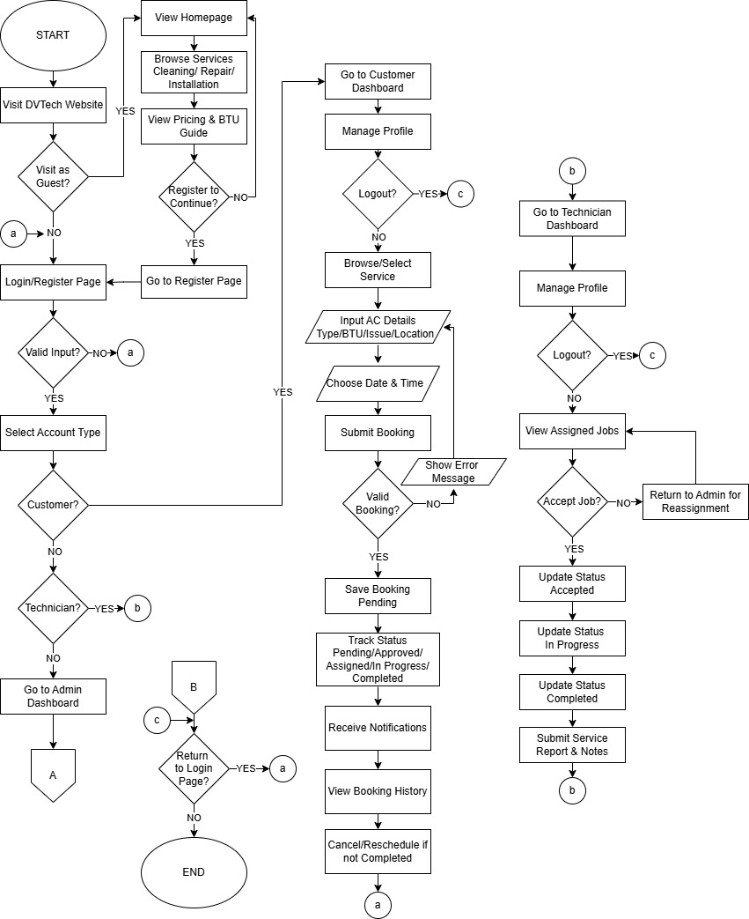
Flowchart

Figure 6.1. Flowchart
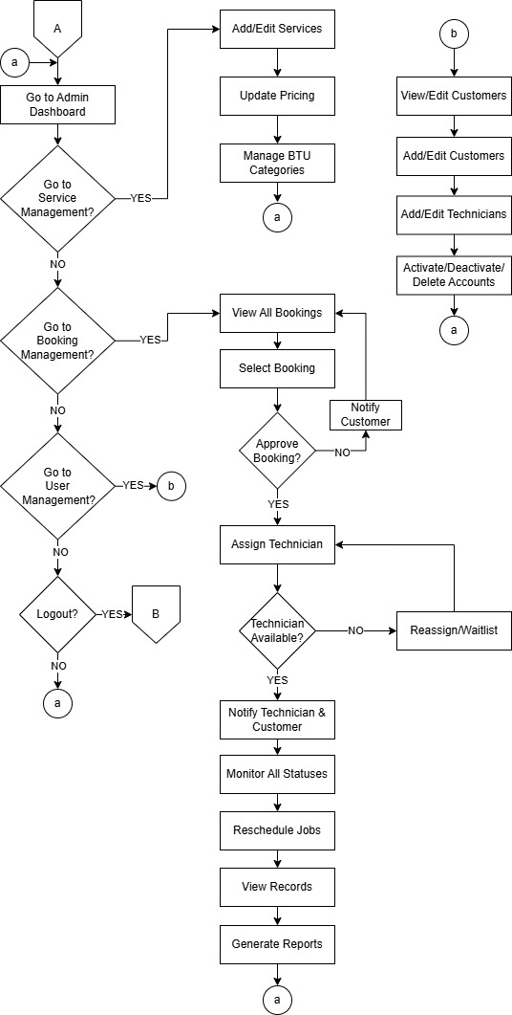

Figure 6.2. Flowchart
The DVTech web-based air conditioning service system's complete workflow, from user access to service completion and administration, is shown in the flowchart. As a guest user, users can access the website and peruse the services provided and associated costs. Additionally, they can sign up and access the website. The system will reroute the user based on their user role customer, technician, or admin after they have successfully logged in.
Costumers can make changes to their profiles, peruse the services available, choose the necessary services, enter the specifics of the air conditioners, and make a reservation. The reservation will be validated by the system and saved with a pending status.
After logging onto their interface, technicians can accept or reject the jobs that have been allocated to them. Following acceptance, the tasks are updated with various statuses, such as in progress or completed, and the technicians submit reports once they have finished the duties they were given. The administrator receives the rejected tasks back.
All aspects of the system, including pricing, BTU categories, and services, are under the administrator's control. Additionally, the administrator is in charge of creating reports, assigning work to the technicians, and approving reservations. Additionally, the administrator is in charge of overseeing the technicians' and customers' accounts.

In conclusion, the flowchart indicates that the process is well organized, with different roles to ensure that the tasks are carried out in the most efficient manner possible.
Tools, Technologies, and Development Environment
The system will be developed as a web-based application utilizing a modern and robust technology stack to ensure efficiency, scalability, and maintainability. The frontend will be built using React to provide a dynamic and responsive user interface, while the backend will be powered by Node.js with the Express.js framework to handle server-side logic and API integrations efficiently. Node.js enables scalable server-side development, while Express.js simplifies the creation of web applications and APIs.
For image processing functionalities, Python is incorporated together with OpenCV to perform advanced image processing, computer vision tasks, and analysis. The system utilizes MySQL for reliable and structured data storage. Additionally, the integration of the OpenAI API enables intelligent features and enhances system capabilities through artificial intelligence.
The development process is carried out using Visual Studio Code, providing a comprehensive environment for coding, debugging, and deployment. To ensure that the system functions correctly and meets requirements, the following testing tools will be used Selenium for UI testing, Postman for backend testing, and Jest for unit testing.
These technologies and tools are necessary to ensure that the system functions effectively and meets modern application standards. React is needed to create an interactive and seamless user experience, essential for user satisfaction and engagement. Node.js and Express.js efficiently handle multiple user requests and ensure smooth communication between the frontend and backend. Python with OpenCV provides accurate and efficient image processing, which cannot be easily achieved using standard web technologies alone. MySQL organizes and stores large amounts of data securely. The OpenAI API incorporates intelligent features such as automated recommendations and smart responses, improving overall system functionality. Visual Studio Code equips developers with the necessary tools to build, test, and maintain the system efficiently. Selenium, Postman, and Jest ensure that every module is thoroughly tested, contributing to a reliable, scalable, and high-performing web-based system.
Development Methodology
The project follows the Agile Software Development Methodology.
The phases include:
1. Planning
During the planning phase, the researchers identified the main objectives and scope of the system. Initial discussions were conducted to understand the operational needs of DVTech, particularly in air conditioning unit recommendation, technician scheduling, and service management. The system requirements, expected features, and project timeline were also established during this stage.

2. Requirement Analysis
In this phase, the researchers gathered detailed system requirements through interviews, observation of existing processes, and document analysis. Functional requirements such as AI-based recommendations, chatbot interaction, technician scheduling, and report generation were identified. Non-functional requirements including system performance, usability, and reliability were also determined to ensure the system meets quality standards.
3. System Design
The system architecture and overall structure were designed in this phase. Various design diagrams were created to illustrate how the system functions, including the conceptual framework, context diagram, data flow diagram, use case diagram, entity relationship diagram, and flowchart. These diagrams helped define how data flows within the system and how users interact with its components.
4. Development
In this phase, the researchers will develop the system based on the approved system design and requirements gathered in the previous stages. The development process will involve coding the different system components including the AI-based air conditioning unit recommendation module, chatbot interaction module for collecting user information, technician scheduling module for administrators, and the database management system for storing customer and service records. The researchers will utilize React for the front-end interface, Node.js with Express.js for the back-end development, and MySQL for data storage and management. For the AI and image processing functionalities, Python will be used, incorporating libraries such as OpenCV for image processing tasks. Additionally, development tools such as Visual Studio Code will support coding, and deployment processes. The integration of the different modules will also be performed to ensure that the entire system works as a unified platform.
5. Testing
After the development phase, the system will undergo comprehensive testing to ensure that all features function correctly and meet the specified requirements. The researchers will conduct different types of testing, including functionality testing, usability testing, and system performance testing. Each module, including the AI recommendation feature, chatbot interface, technician scheduling system, and reporting functions, will be evaluated to identify errors, bugs, or inconsistencies. The following tools will be used during testing: Selenium for UI testing, Postman for API (backend) testing, and Jest for unit testing. Necessary corrections and improvements will be implemented to ensure the reliability, accuracy, and stability of the system before deployment.
6. Deployment
Once the system has successfully passed the testing phase, it will be deployed for actual use within the target environment of DVTech. The system will be installed on the designated platform and connected to the centralized database. Administrators and intended users will be oriented on how to operate the system, including how to access recommendations, manage service requests, and schedule technicians. This phase ensures that the developed system becomes fully operational and accessible to the organization.
7. Evaluation
After deployment, the system will be evaluated to determine its effectiveness, efficiency, and usability in supporting DVTech’s operations. The evaluation will utilize the ISO/IEC 25010 to assess overall system quality, focusing on reliability and suitability for professional or administrator use. In addition, the Technology Acceptance Model will measure user acceptance, evaluating Perceived Usefulness (PU), Perceived Ease of Use (PEOU), and Attitude Towards Using (ATU) to determine effectiveness, ease of operation, and willingness to adopt the system. The results will guide improvements and future enhancements to ensure optimal service management.
System Modules and Features
The system is composed of several functional modules designed to support air conditioning unit recommendation, service request management, and technician scheduling in an integrated and efficient manner.
Login Module
The Login Module manages user authentication and access control by allowing users to log in as administrator, technician, or customer using secure credentials. It ensures that only authorized users can access the system and provides role-based access to features and functionalities, thereby maintaining data security and proper system usage.
AI Recommendation Module
The AI Recommendation Module generates suitable air conditioning unit recommendations based on room data and user inputs such as room size, occupancy, and environmental conditions. It applies intelligent processing to determine the appropriate cooling capacity, helping users select efficient and accurate air conditioning units while reducing energy consumption and improving decision-making.
Chatbot Module
The Chatbot Module provides an interactive interface that collects user inputs and offers automated assistance in a conversational manner. It helps users easily input room details and service requests while receiving real-time responses, improving user experience, speeding up data collection, and minimizing manual input errors.
Technician Scheduling Module
The Technician Scheduling Module allows administrators to assign technicians to service requests based on availability, workload, and priority. It helps organize schedules, prevent conflicts, and ensure timely service delivery, while also enabling technicians to view and manage their assigned tasks efficiently.
Reporting Module
The Reporting Module generates organized reports that summarize service requests, technician assignments, and system-generated recommendations. It provides administrators with valuable insights for monitoring operations, evaluating system performance, and supporting data-driven decision-making.
Evaluation Methods
ISO/IEC 25010 Evaluation
The system will be evaluated by three (3) IT experts using the ISO 25010 quality standards. A 5-point Likert scale will be used to measure the system’s functional suitability, usability, performance efficiency, compatibility, reliability, maintainability, security and portability. This process ensures the software is technically sound and ready for professional use.
Technology Acceptance Model (TAM)
To measure user acceptance, the Technology Acceptance Model (TAM) will be utilized. A total of twenty-seven (27) respondents will evaluate the system based on three key constructs: Perceived Usefulness (PU), Perceived Ease of Use (PEOU), and Attitude Towards Using (ATU). This assessment aims to determine the users' willingness to adopt the system and their overall perception of its practical value.
Data Handling and Analysis
Outline how your evaluation data will be processed after collection. This is a plan, not results.
Tabulation: Survey responses will be organized into summary tables.
Mean Calculation: Mean scores will be computed for each criterion or construct.
Interpretation Scale: The interpretation of mean scores for system evaluation will follow the following scale: a mean score between 4.51 and 5.00 is interpreted as Highly Acceptable; a score between 3.51 and 4.50 as Acceptable; 2.51 to 3.50 as Moderately Acceptable; 1.51 to 2.50 as Slightly Acceptable; and 1.00 to 1.50 as Not Acceptable.

REFERENCES

Bills, E. (2025). What Is an HVAC Load Calculation ? 0–3.
Board, J., & Cooksey, B. (2025). Smarter Retrofits Start with HVAC Load Calculation. https://building-performance.org/bpa-journal/smarter-retrofits-start-with-hvac-load-calculation/
Dr. Shareef N. M. (2025). Optimizing Technician Scheduling and Routing at V Zone International LLC. International Journal of Latest Technology in Engineering Management & Applied Science, 14(7), 1050–1054. https://doi.org/10.51583/ijltemas.2025.1407000124
FAB Balance Check. (2025). Field Service Scheduling Best Practices for Optimized Operations and Customer Satisfaction.
Gassar, A. A. A., & Jafar, R. (2025). Artificial Intelligence-Enabled Heating, Ventilation, and Air Conditioning Systems Toward Zero-Emission Buildings: A Systematic Review of Applications, Challenges, and Future Directions. Applied Sciences (Switzerland), 15(19), 1–30. https://doi.org/10.3390/app151910497
Importance, I., & Posts, R. (2025). AC Sizing : Why It Matters.
International Energy Agency (IEA). (2023). Sustainable, Affordable Cooling Can Save Tens of Thousands of Lives Each Year. 17. https://www.iea.org/reports/sustainable-affordable-cooling-can-save-tens-of-thousands-of-lives-each-year
Jeong, S. H., Irakoze, A., Lee, Y. A., & Kim, K. H. (2025). Balancing Thermal Comfort and Energy Efficiency of a Public Building Through Adaptive Setpoint Temperature. Buildings, 15(24), 1–24. https://doi.org/10.3390/buildings15244568
K. Johnson. (2020). Energy Efficiency Assessment of Industrial Steam Boilers. www.iea.org/terms
Kumar, J., & Darreddy, R. (2025). Optimizing Field Service Management With Ai- Powered Virtual Agents and Real-Time Data. 01, 1–8.
Marcineková, K., Sujová, A. J., & Ďurica, R. (2025). Implementing AI Chatbots in Customer Service Optimization—A Case Study in Micro-Enterprise. Information (Switzerland), 16(12), 1–18. https://doi.org/10.3390/info16121078
Muller, N., & King, N. (2025). Keeping homes cool on a warming planet Ukraine updates : POW swap deal reached at Abu Dhabi talks. 2025–2026.
Nakai, M., Yajima, N., & Ravago, M. L. (2025). Cooling the tropics sustainably: Evidence from a choice experiment on energy efficient air conditioners in the Philippines. Energy Economics, 148(May), 108582. https://doi.org/10.1016/j.eneco.2025.108582
Opsmatters, B. (2025). The Importance of Correct Sizing for Efficiency Reducing the Risk of Frequent Breakdowns The Role of Proper Sizing in Preventing System Overload.
Pavanello, F., De Cian, E., Davide, M., Mistry, M., Cruz, T., Bezerra, P., Jagu, D., Renner, S., Schaeffer, R., & Lucena, A. F. P. (2021). Air-conditioning and the adaptation cooling deficit in emerging economies. Nature Communications, 12(1). https://doi.org/10.1038/s41467-021-26592-2
Ramon Albert, J. G., Mark Quimba, F. A., Serafica, R. B., Flor Vizmanos, J. V, Irwin Moreno, N. S., Andrada, A. E., Muñoz, M. S., & Hernandez, A. C. (2023). The Extent of Innovation in Philippine Business and Industry: Results of the 2021 PIDS Survey of Innovation Activities. Discussion Paper Series, 2023–2034. https://www.pids.gov.ph
Rodrigues, T., Morgado, J., Barros, M., Oliveira De Sá, A., & Cecílio, J. (2026). AI-driven IoT recommender system for enhancing energy efficient management in smart houses. Expert Systems with Applications, 296(PC), 129108. https://doi.org/10.1016/j.eswa.2025.129108
Savellano, J. N. (2025). Technology-driven business management: The impact of digitalization on operational strategies. International Journal of Advanced and Applied Sciences, 12(8), 53–62. https://doi.org/10.21833/ijaas.2025.08.005
Sizing, H., Mistakes, C., & Them, A. (2025). HVAC Sizing : Common Mistakes and How to Avoid Them.
Zhang, Q., Lu, J., & Jin, Y. (2021). Artificial intelligence in recommender systems. Complex and Intelligent Systems, 7(1), 439–457. https://doi.org/10.1007/s40747-020-00212-w
Zhu, X., & Li, H. (2025). Heating, Ventilation, and Air Conditioning (HVAC) Temperature and Humidity Control Optimization Based on Large Language Models (LLMs). Energies, 18(7). https://doi.org/10.3390/en18071813

