**PM227**

**"Building an Effective Early Warning System"**

**Instructions:**

1. **Divide the class into small groups** (3 members per group).
2. **Choose a hazard** (e.g., typhoon, earthquake, tsunami, volcanic eruption, flood).
3. Each group will **create an Early Warning System (EWS)** for their hazard by answering the following:
   1. **Risk Knowledge:**
      * What are the specific risks or vulnerabilities related to the hazard in your assigned area?
      * What historical data or community knowledge exists?
   2. **Monitoring & Warning Service:**
      * How will you detect the hazard early?
      * What technology, methods, or organizations will you involve?
   3. **Information Dissemination:**
      * How will you communicate warnings?
      * What tools (sirens, SMS, social media, radio, etc.) will you use?
   4. **Response Capacity:**
      * What actions will people need to take once they receive the warning?
      * What preparedness measures should already be in place?
4. **Presentation:**  
   Each group will present their Early Warning System in front of the class using a short poster, diagram, or skit showing the four elements working together.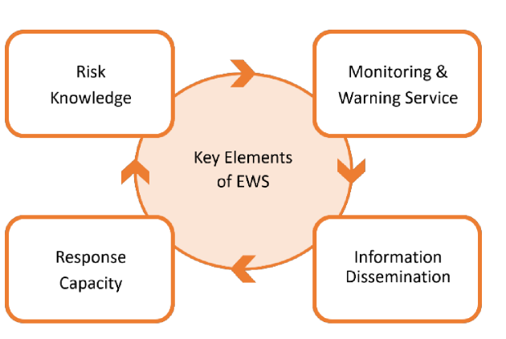

### ****Scoring Rubric:****

| **Criteria** | **Excellent (5)** | **Good (4)** | **Fair (3)** | **Needs Improvement (1-2)** |
| --- | --- | --- | --- | --- |
| Clear understanding of elements |  |  |  |  |
| Creativity in the warning system |  |  |  |  |
| Feasibility and practicality |  |  |  |  |
| Teamwork and Presentation |  |  |  |  |