

|  |
| --- |
| APLICACIÓN DE SEGUIMIENTO A INSCRIPCIONES DE DIPLOMADOS DE LA FACULTAD DE INGENIERÍA |
| 22/06/18 14:28 |
| **Author:** Iván Mondragón Sotres  **File name:** Prototype3.vp  **Version** 1.0 |

01. Wireframe / Prototype3 

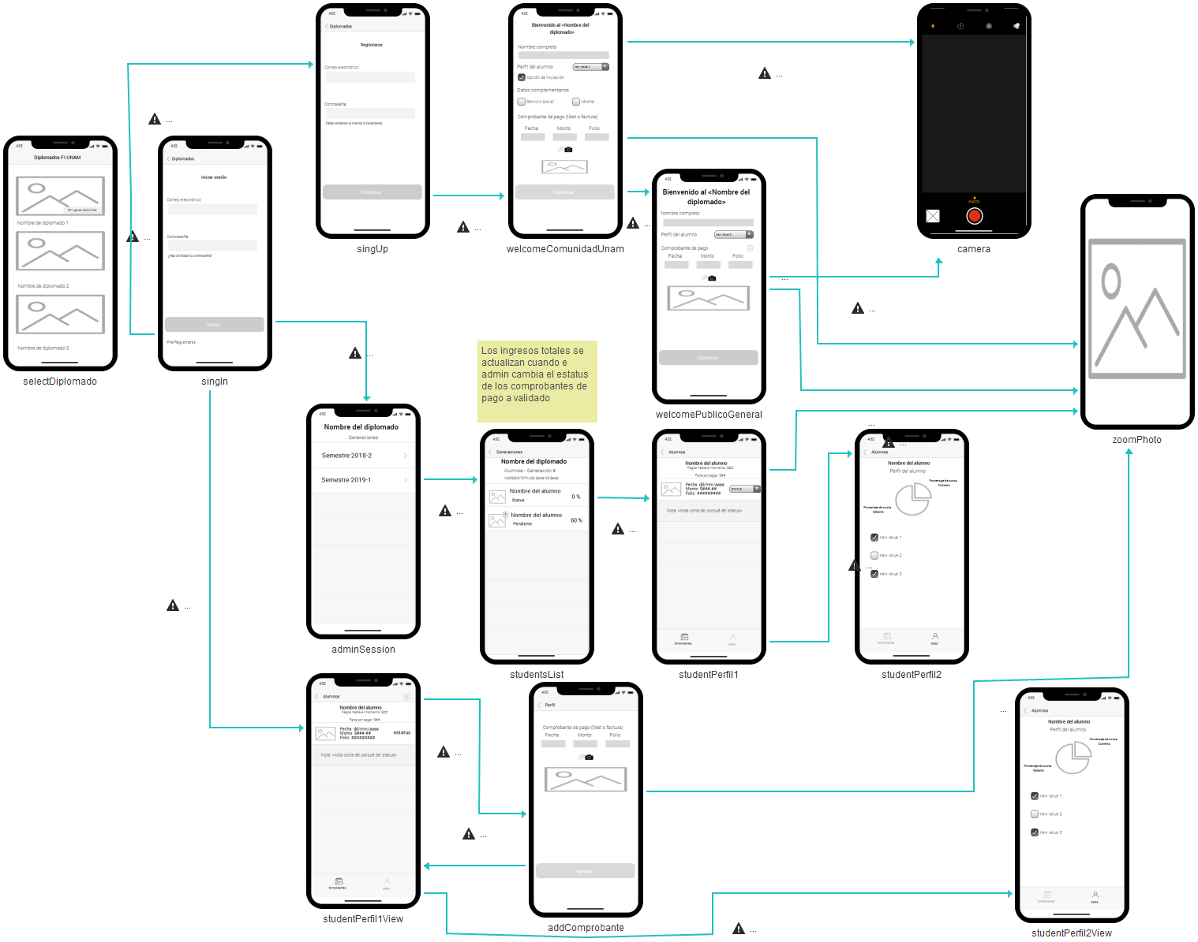

02. Screens / Prototype3 

singUp

|  |
| --- |
|  |

02. Screens / Prototype3 

singIn

|  |
| --- |
|  |

02. Screens / Prototype3 

selectDiplomado

|  |
| --- |
|  |

02. Screens / Prototype3 

welcomeComunidadUnam

|  |
| --- |
|  |

02. Screens / Prototype3 

addComprobante

|  |
| --- |
|  |

Interactions

|  |  |
| --- | --- |
| 7 | **on Click:** goes to 'zoomPhoto' with effect: slide left 🡪 |

02. Screens / Prototype3 

studentPerfil2

|  |
| --- |
|  |

02. Screens / Prototype3 

studentPerfil2View

|  |
| --- |
|  |

02. Screens / Prototype3 

studentPerfil1

|  |
| --- |
|  |

02. Screens / Prototype3 

studentPerfil1View

|  |
| --- |
|  |

02. Screens / Prototype3 

welcomePublicoGeneral

|  |
| --- |
|  |

Interactions

|  |  |
| --- | --- |
| 8 | **on Click:** goes to 'zoomPhoto' with effect: slide left 🡪 |

02. Screens / Prototype3 

adminSession

|  |
| --- |
|  |

02. Screens / Prototype3 

studentsList

|  |
| --- |
|  |

02. Screens / Prototype3 

zoomPhoto

|  |
| --- |
|  |

02. Screens / Prototype3 

camera

|  |
| --- |
|  |