1. If need to ADD NEW STARTEK FP_XXX command for JNI, you need to modify below file :

\JNI\com\startek_eng\fm220sdk\FM220SDKWrapper.java

As you need

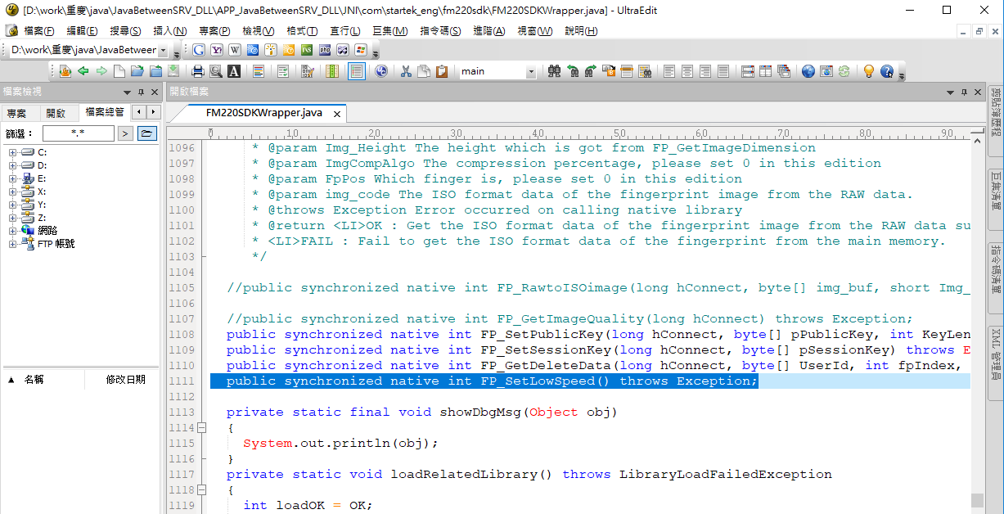

1. After add function you need, we need to generate .h file for C++:
2. Double click on \JNI\build_h.bat
3. OR under command line:

javah.exe" -jni -classpath . com.startek_eng.fm220sdk.FM220SDKWrapper

you should now have “com_startek_eng_fm220sdk_FM220SDKWrapper.h”

generated.

1. You should now see your newly added FP_XXX functions in this .h file

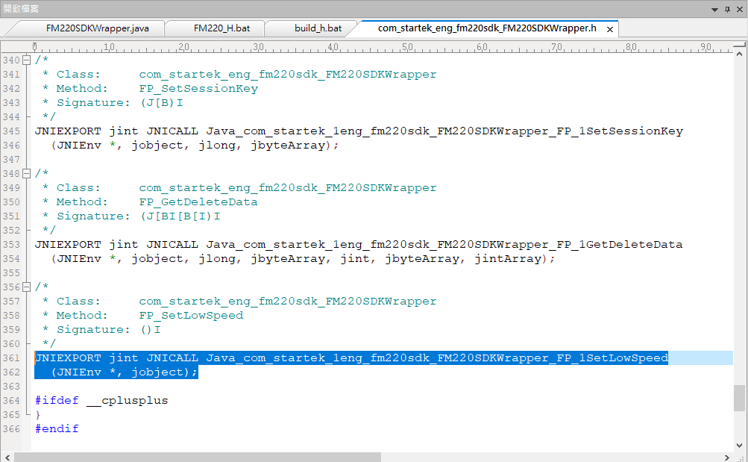

1. Copy/Overwrite this .h file into you VC ++ project directory

\JNI\FM220SDKWrapper\FM220SDKWrapper\**com_startek_eng_fm220sdk_FM220SDKWrapper.h**

1. Open VC++ solution

\JNI\FM220SDKWrapper\FM220SDKWrapper.sln

1. Add new extern function into **fp_api.h**

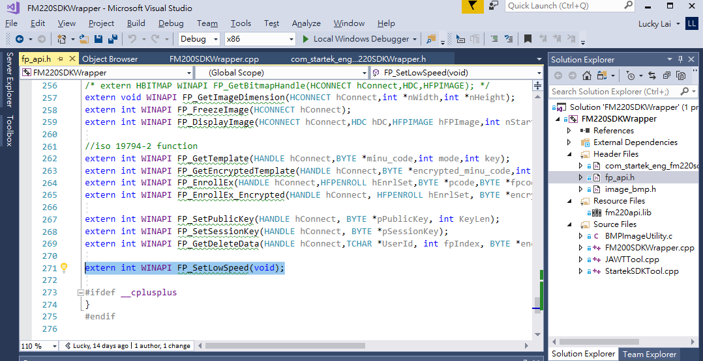

1. Implement new function fit to .h file in **FM200SDKWrapper.cpp**

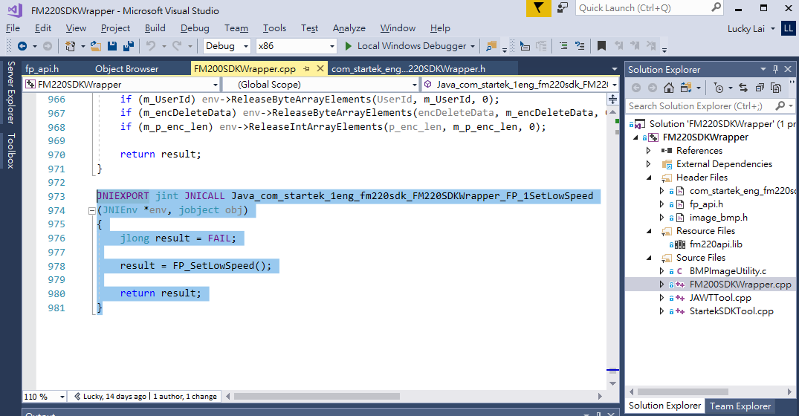

1. If this is your first time compile this VS c++ solution, you need to make sure:
2. JDK 1.8 must installed.
3. JDK path exist as below.
4. C:\Program Files (x86)\Java\jdk1.8.0_181\include\win32\
5. C:\Program Files (x86)\Java\jdk1.8.0_181\include\
6. If point (b) is not the same, means your JDK is in different version, you can modify VC project properties as follow:
7. Right click on project🡪properties

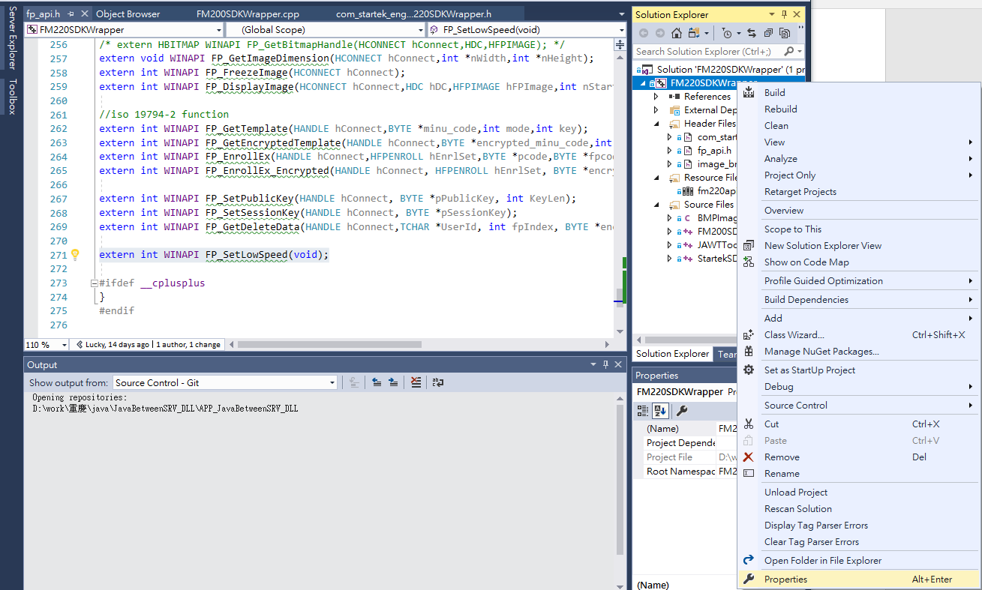

1. VC++ Directories🡪include directories🡪EDIT

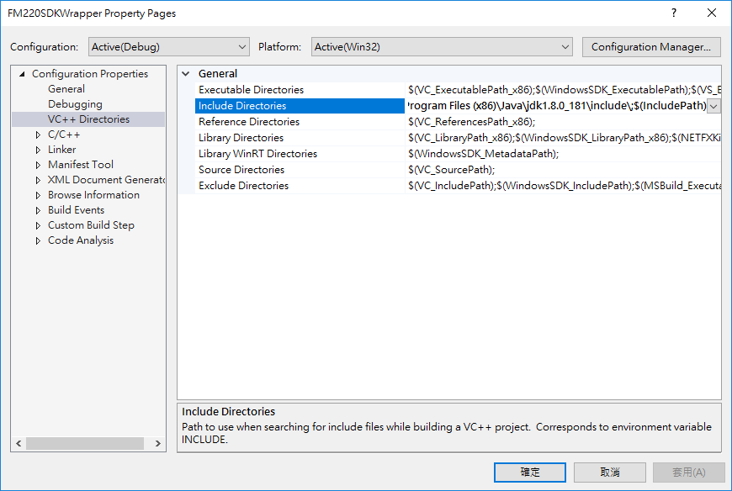

1. Modify the 2 path to fit you JDK

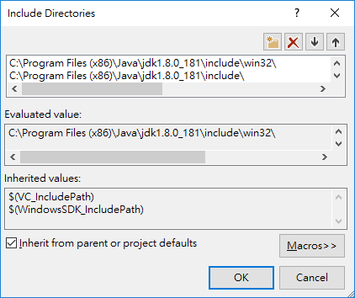

1. And you should now able to build the c++ solution, the dll will now be generated.