IVÁN BÁSCONES CUBILLO

APAche Practice

Index

Practice 2

Apache’s Installation 2

Config files 2

Directives Modifying 3

Document Root 4

Options Index 4

Port changing 5

Virtual Host 6

Site available vs site enabled 6

Creating site configuration file 6

Enabled the site 6

Hosts file 7

HTTP Access 7

User creation .httppasswd 7

Directives inside the virtual host file 8

Use of .htaccess 9

SLL 10

Create an SSL Certificate 10

Configurate Apache to Use SSL 10

Force HTTPS 12

# Practice

## Apache’s Installation

To install Apache on ubuntu we just need to run the following command in the terminal:



Check if the server Apache install correctly:

## Config files

All the Apache config files are inside the carpet /etc/apache2/

The main config file is apache2.conf inside you can config the permission of the directory you host the website

Other important config files you need to know if you want to configurate apache server are:

* ports.conf: to configurate the ports apache need to listen.
* Mods-enabled/dir.conf: to configurate the names of the directory index name
* sites-available: inside this carpet you can config one or more virtualhost in the same server but not enabled
* sites-enabled: inside this carpet all the files are create throw a command line and enabled all the virtualhost there are inside this carpet.

## Directives Modifying

To modify the directory directives, you need to go to the apache2.conf file inside there is the next content:

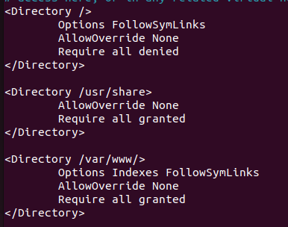

Or you can going to the sites-available/xxx.conf file to modify the directory directives there

## Document Root

To find the document root of your website there is inside the next config file /etc/apache2/sites-available/website_name.conf

## Options Index

Is a directory directive what enabled a little menu where you can see all the files inside this directory if in this directory don’t have a archive with the name storage in the file /etc/apache2/mods-enabled/dir.conf

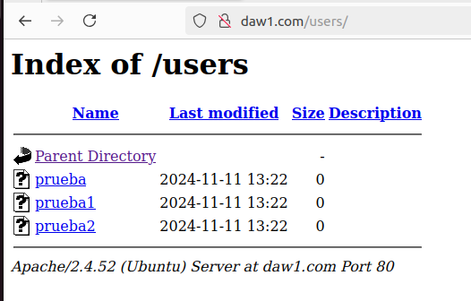

## Port changing

To change the port of a website first of all you need to go to the website file inside /etc/apache2/sites-available/name_file.conf and change the port to 9090:

Next step go to the file ports.conf and add the new port or change the port modifying the listen command for the port do you want to use.

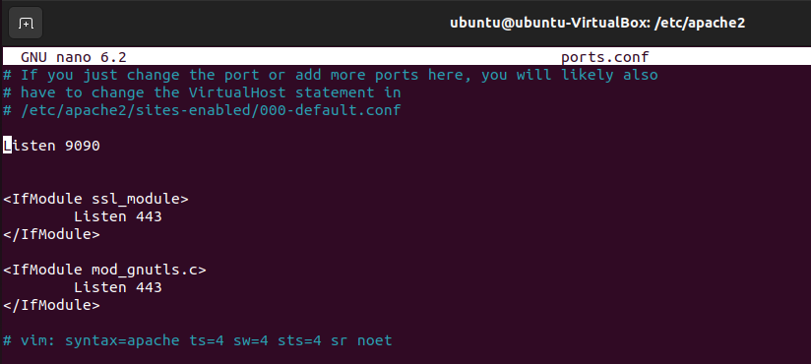

Reset the server apache and check if the server is working

# Virtual Host

## Site available vs site enabled

Site available directory is stored all the file config of the virtual hosting inside your Apache server, but all the Virtual Hosts aren’t enabled and the users can’t access to the Virtual Host.

Sites enabled directory is stored all the references of the Virtual Hosts config files. All the config file inside this folder indicate the virtual host site is enabled.

## Creating site configuration file

To create the site configuration file, we use the command cp to copy the file 000-default.conf



Next step enters to the new file and apply the new configuration:

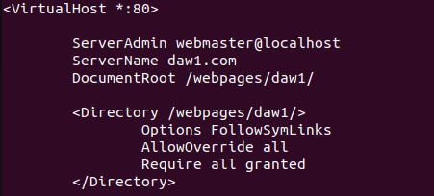ç

The next step is enabled the new virtual host

## Enabled the site

To enabled the new site we need to use the next command:



We go to check if the site is enabled. We go to visit the carpet site-enabled:

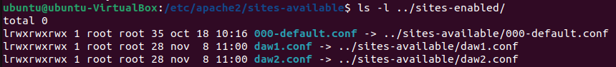

# Hosts file

The file to configurate the hosts in ubuntu is /etc/hosts

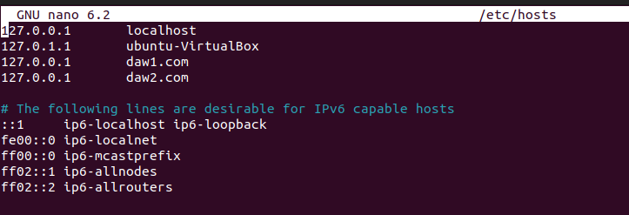

To configurate the new hosts you write the first the ip and second the name you want to use.

# HTTP Access

First of all you need to install the apache2-utils to use this function



## User creation .httppasswd

To create user and storage inside the file .htpasswd use the next command:

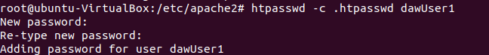

The final step we give permission to the apache2 user:



## Directives inside the virtual host file

The directive we use to applicate the HTTP access inside the archive /etc/apache2/sites-available/daw1.conf are the next

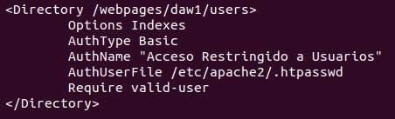

Restart the service and check it is working

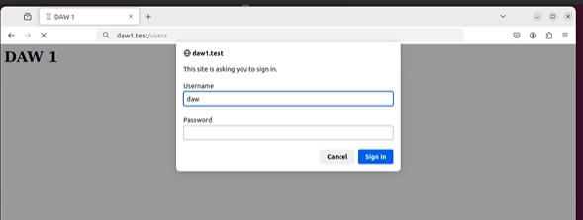

## Use of .htaccess

If you want to use .htaccess only new to crate inside the folder do you want to protect the file .htaccess and write the next commands inside

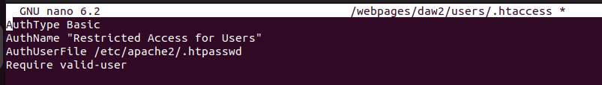

Restart the service and check if working the HTTP access

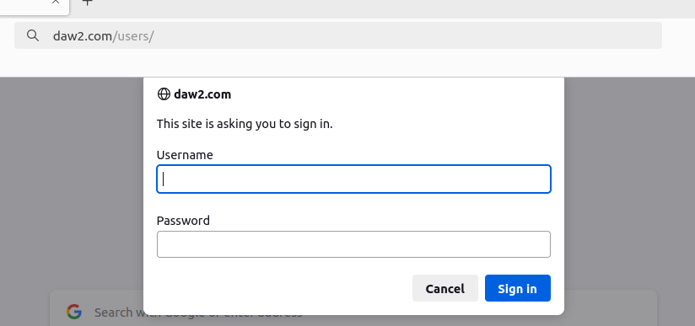

# SLL

## Create an SSL Certificate

First of all need to create a folder inside the folder /etc



And install the openSSL:

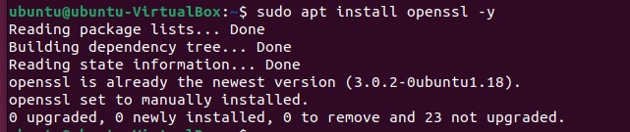

To create a new SSL certificate and fill in all the data



Check if the SSL certificate is created

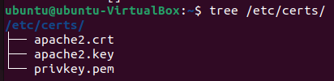

## Configurate Apache to Use SSL

First active the module SSL in apache2 with the next command

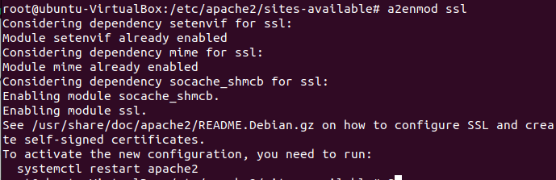

To configure the SSL certificate create in sites-available a new conf archive with the website and add the next important part indicate with a red mark

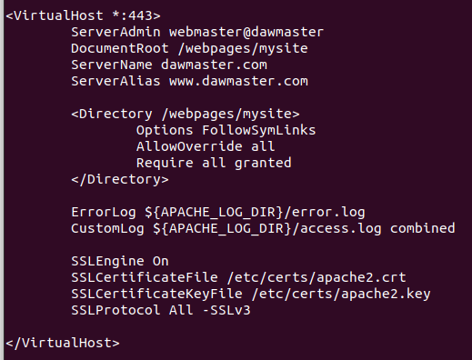

Enable the site with the command indicate enable site part a2ensite command and restart and check if it working the website

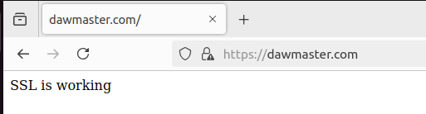

## Force HTTPS

To force https you need to modifice the conf file with the code is mark in a red box

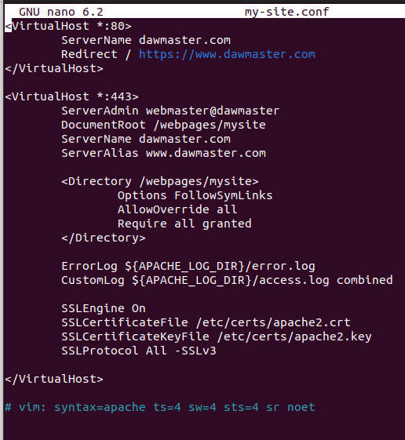

Restart the server and check if it working the redirect

Before



After

