IVAN BASCONES CUBILLO

FTP PRACTICE

# Practice

# Install vsFtpd

To install vsFtpd we use the next command:



# Directives

The config file of ftp server is the next



### Change the ftpd banner

To change the server name you need to modify the next line inside the config file

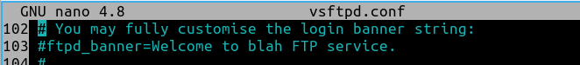

### Enable and disable passive mode

### Change the directory where you write

To change the directory you need implement the new directive in the config file



# Users

## Anonymous user

### Enable and disable connection as anonymous

To change enable the anonymous user you need to change the next line in the config file

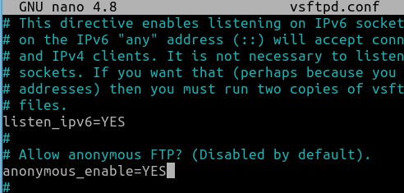

### Make the anonymous user able to write in the server

## Local users

### Change users so that they don’t leave their directory

To the local users can’t go out the directory we need to uncomment this directive

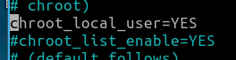

You configurate the chroot list file to permit a user go outside the directory:

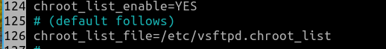

First of all we need to create the file and write a name user in one line:



If we disable the chroot list all users can’t leave the directory.

### Create a new user on the server and test that he can also connect

### Create the free or caged users file and enable the chroot option

# Virtual users

### Create the virtual users file, by the htpasswd application

Directives to change in the config file

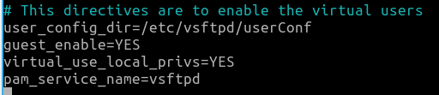

To create the virtual user file using httpasswd we use the next command line:

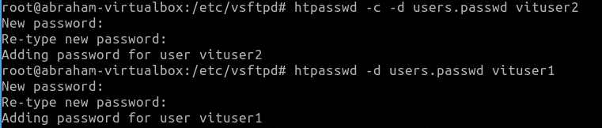

### Create a directory for each user

Create the directories in the next folder

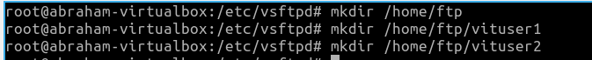

Change the owner of the new folders



Change the permission of the folders



In the config file for a virtual user indicate the folder you can enter



### Add PAM to the server

To install Pam we use the next command



We go to the config file is in the folder /etc/pam.d and change the directives



To enable the SSL yo need to modify the next line in the config files



And enable de ssl service.



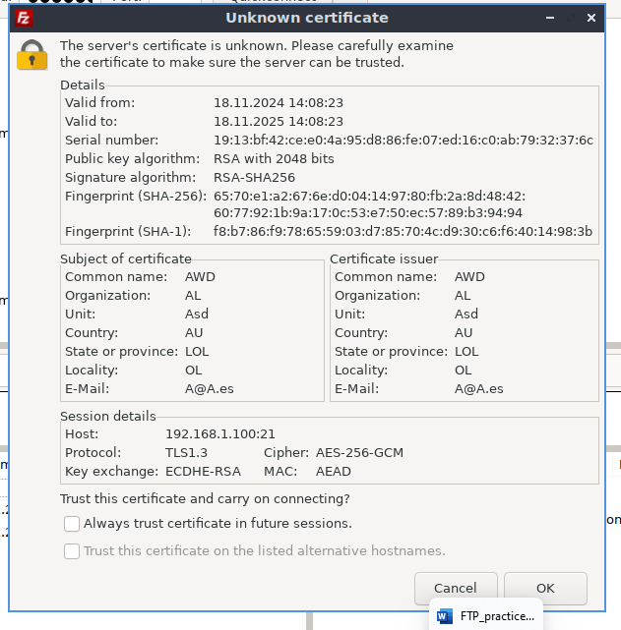

# Test Done

# Problems Found

Give permission to write in the server

Give to the anonymous user permission to upload the server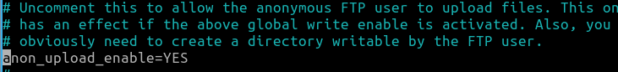

Went you have a root directory in the server ftp the users can’t write and have an error

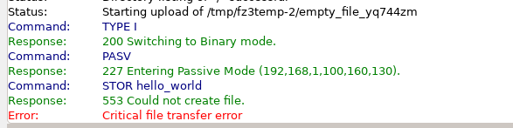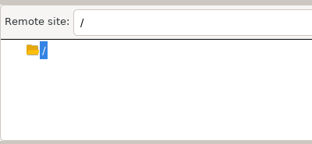

But you create a folder inside you can modify or create a file

