ABRAHAM PEREZ BARRERA

[Nombre de la empresa]  [Dirección de la compañía]

DNS Server

# Objetive

Install Bind9

Set up a Zone (Domain) name.test

**** -> What is the zone

name.test (File)

SOA

A -> web server

# Theorical Base

# Practice

Install DNS server use the next command



Enter in the config file named.conf.local and add next lines of commands

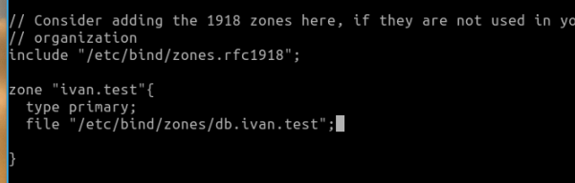

Create the file indicate in the config file

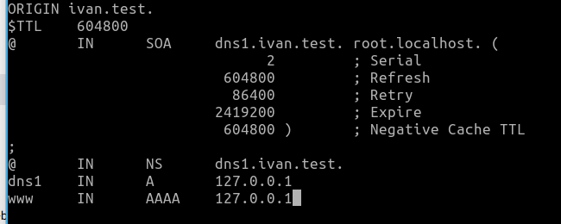

Reset the service

## UBUNTU SERVER

# Test Done

# Problems Found