IVAN BASCONES CUBILLO

CIFP CAMINO DE LA MIRANDA  DAW

Docker

[Cheat Sheet Docker Commands](https://www.hostinger.com/tutorials/docker-cheat-sheet?utm_campaign=Generic-Tutorials-DSA|NT:Se|LO:ES-EN&utm_medium=ppc&gad_source=1&gclid=EAIaIQobChMI8IDs3JaOiwMVuz0GAB0HCBSGEAAYASAAEgKwCfD_BwE#Docker_Commands_Cheat_Sheet)

# SetUp Docker Engine in Lubuntu

To install Docker Engine in Lubuntu use the next commands lines

The next lines in to prepare the apt repository

sudo apt-get update

sudo apt-get install ca-certificates curl

sudo install -m 0755 -d /etc/apt/keyrings

sudo curl -fsSL https://download.docker.com/linux/ubuntu/gpg -o /etc/apt/keyrings/docker.asc

sudo chmod a+r /etc/apt/keyrings/docker.asc

echo \

"deb [arch=$(dpkg --print-architecture) signed-by=/etc/apt/keyrings/docker.asc] https://download.docker.com/linux/ubuntu \

$(. /etc/os-release && echo "$UBUNTU_CODENAME") stable" | \

sudo tee /etc/apt/sources.list.d/docker.list > /dev/null

sudo apt-get update

This command install the docker engine

sudo apt-get install docker-ce docker-ce-cli containerd.io docker-buildx-plugin docker-compose-plugin

Check if docker is working

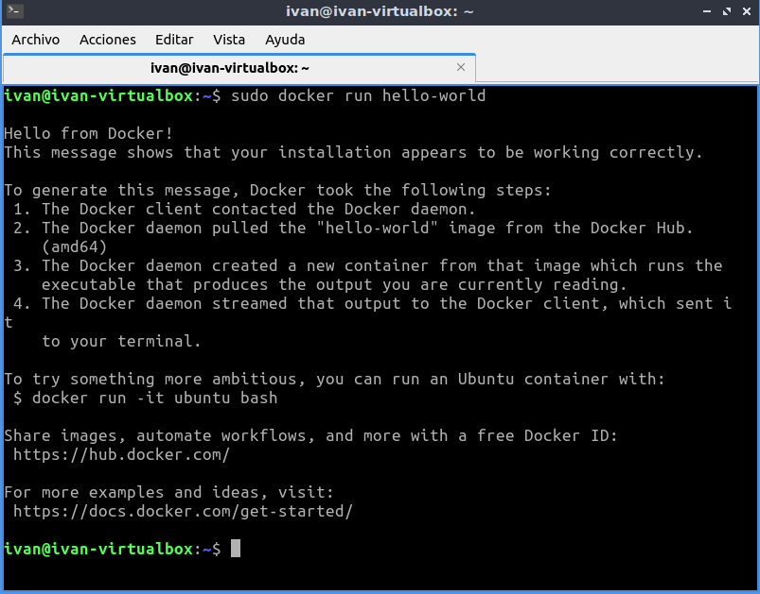

# Install DNS server in Docker

To install the dns server first of all need to find a image inside the docker hub

https://hub.docker.com/r/ubuntu/bind9

Install de image with the next command

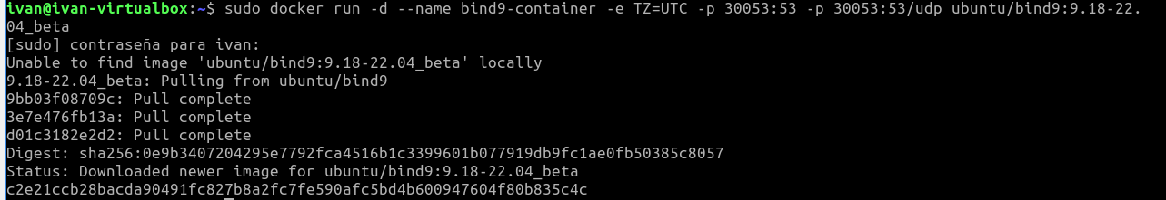

Check If the container is running with the command docker ps



## Prepare the DNS server inside the container

First of all stop the dns service in the machine



Install the docker dns service (you need install the image in the machine)



Lest to copy the config file inside the virtual machine with the dns config files





Enter in to the container



## Volumes

First of all prepare the directory we want to use and copy the config files

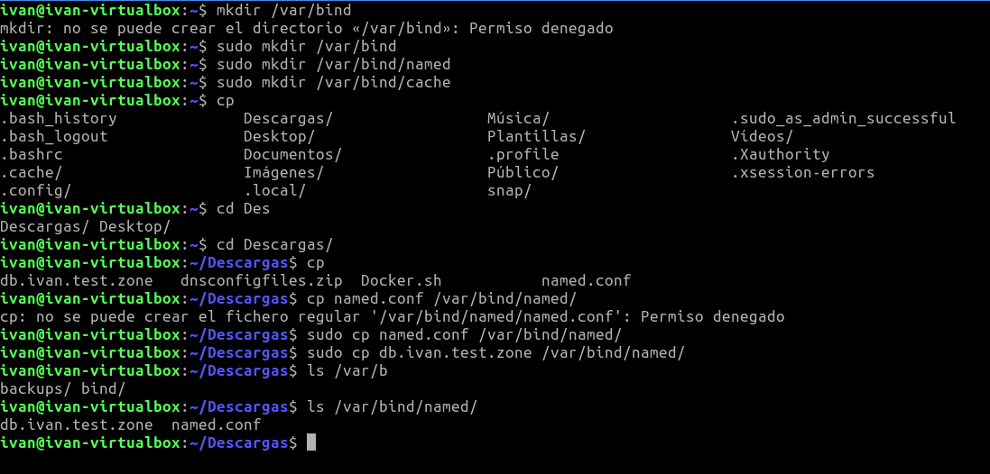

Install the container with the volumes



Check if the container have the config files inside the volume

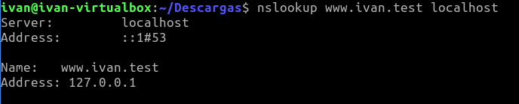

## Tomcat container

# Test Done

# Problems Found