OMNIS EDUCATION – FULL TECHNICAL DUE DILIGENCE REPORT

1. Executive Summary
Omnis Education appears positioned as an AI-enhanced education platform supporting learner-driven journeys. The system combines LMS functionality, content libraries, adaptive learning pathways, and AI-assisted tools. This report outlines functional scope, infrastructure assumptions, AI integration model, risks, and rebuild strategy.

2. Core Functional Modules
- User Management & Identity (role-based access, safeguarding controls)
- Learning Content Delivery (curriculum-aligned lessons, media, structured pathways)
- Personalised Learning Journeys (progress tracking, adaptive recommendations)
- Collaboration & Community (discussion, peer groups, educator oversight)
- AI-Assisted Learning (lesson planning, feedback, assessment generation)
- Commercial Operations (subscriptions, analytics, institutional licensing)

3. Infrastructure Overview
Cloud-hosted SaaS architecture (AWS/Azure/GCP) with CDN delivery. Frontend built in React or similar SPA framework. Backend API layer (Node.js or Python). Relational database (PostgreSQL/MySQL). Object storage for media. Stripe or similar payment integration. Analytics and monitoring tools integrated.

Architecture Diagram
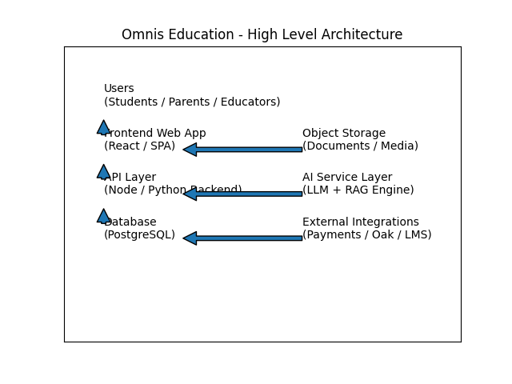

4. AI Capability & RAG Model
AI capability built using large language models integrated via API. Retrieval-Augmented Generation (RAG) grounds responses in curriculum resources. Knowledge sources include curriculum-aligned libraries such as Oak National Academy, internal lesson materials, educator-authored content, and approved Open Educational Resources.

5. AI Integration Roadmap
- Phase 1 – AI Lesson Assistant (teacher planning support)
- Phase 2 – Adaptive Learning Recommendations (student personalisation)
- Phase 3 – Automated Assessment & Feedback
- Phase 4 – Predictive Analytics & Institutional Reporting

6. Technical Risks & Governance Questions
- IP ownership clarity
- Data protection and child safeguarding compliance
- Security posture and penetration testing status
- Scalability readiness for institutional rollout
- AI bias mitigation and content moderation controls

7. MVP Rebuild Specification (Clean IP Strategy)
A clean rebuild should include secure authentication, modular LMS core, AI-ready API architecture, and curriculum-grounded RAG engine. Initial MVP should focus on user onboarding, structured content delivery, basic AI lesson assistant, subscription capability, and governance-ready logging.
- - Secure Authentication with Role-Based Access
- - Content Library & Structured Learning Paths
- - Basic AI Lesson Assistant (RAG-based)
- - Subscription & Billing Integration
- - Admin & Reporting Dashboard

