Visoka skola strukovnih studija za informacione I komunikacione tehnologije



DOKUMENTACIJA

Ivana Panic 176/16

Predmet: Web programiranje 1
SADRZAJ

1. Uvod
1.1Korišćeni programski jezici i tehnologije
1.2Opis funkcionalnosti
1.3Template

2. Organizacija
2.1Organizaciona šema
2.2Mapa sajta
2.3Slike stranice

3.Kodovi
3.1 HTML
3.2 CSS
3.3 Sitemap
3.4 JavaScrip

UVOD

1.1.Korisceni programski jezici:

- HTML
- CSS
- JavaScript
- jQuery
- Bootstrap

-Radno okruzenje : Visual Studio Code

1.2Opis funkcionalnosti:

- -Responsive sajt
- Dinamičko ispisivanje proizvoda na index.html strani sajta
- -Pretrazivanje proizvoda po nazivu na index.html strani sajta
- -Filtriranje proizvoda po zanru i dinamicko ispisivanje odabranog na index.html strani sajta sa prikazivanjem slike
- -Menjanje odredjenog sadržaja klikom na dugme
- -Klikom na “View more” dugme, u sekciji About, pojavljuje se modal sa dodatnim informacijama I uklanja se klikom na x
- -Forma sa validacijom urađenom kros JavaScript sa regularnim izrazima
- -Validacija newsletter forme,notifikacije za pogrešan mail
- -Galeriju za koju je korišćen jQuery plug-in i koja je uneta dinamički.

1.3Template

- Nije korišćen gotov template.

ORGANIZACIJA

2.1Organizaciona šema

- Single-page website, svim linkovima je moguce pristupiti sa index stranice.

2.2Mapa sajta

<?xml version="1.0" encoding="UTF-8"?>

<urlset
xmlns="http://www.sitemaps.org/schemas/sitemap/0.9"
xmlns:xsi="http://www.w3.org/2001/XMLSchema-instance"
xsi:schemaLocation="http://www.sitemaps.org/schemas/sitemap/0.9
http://www.sitemaps.org/schemas/sitemap/0.9/sitemap.xsd">

<url>
<loc>https://admiring-mclean-34f842.netlify.app/#</loc>
<lastmod>2020-12-11T19:47:32+00:00</lastmod>
</url>

</urlset>

2.3Slike stranice

- index.html

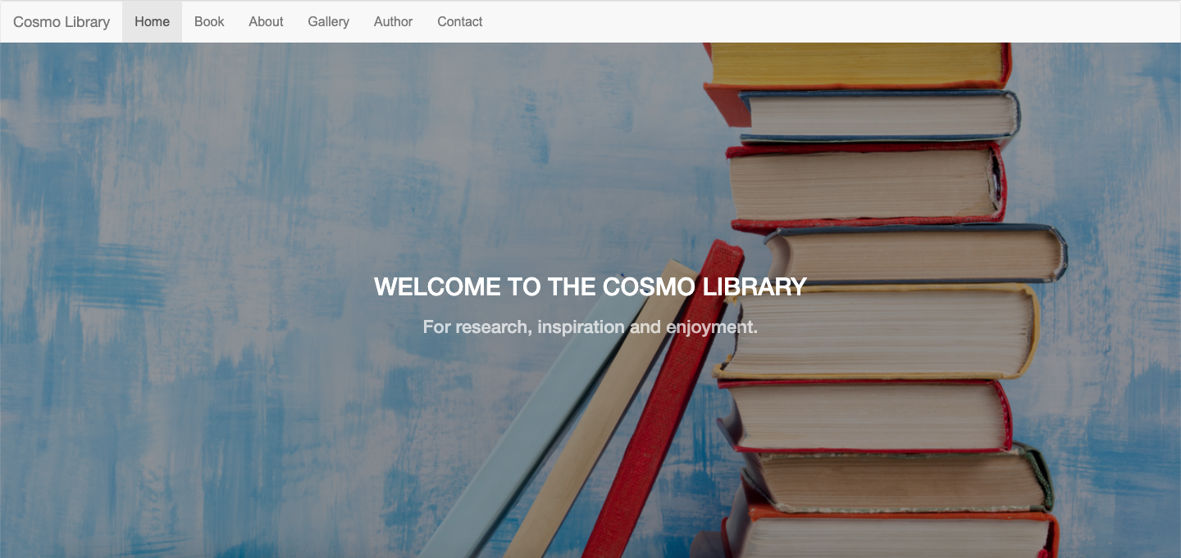
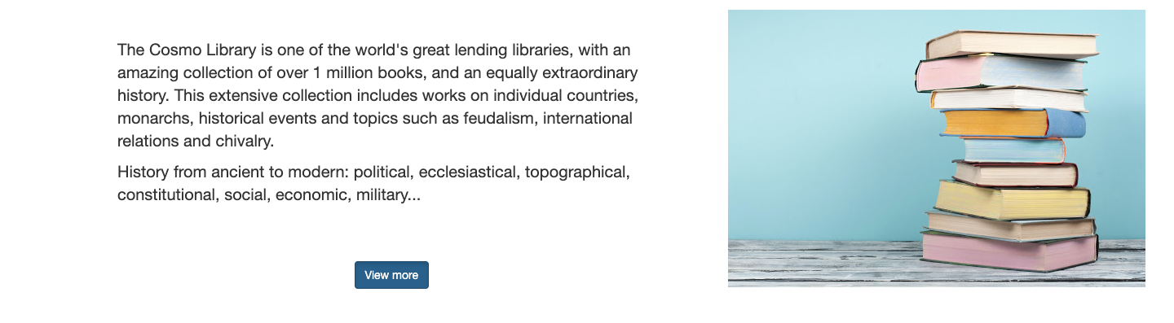
- header-manu I pozadinska slika

- U sekciji About nalaze se informacije o biblioteci
- Kada se klikne na dugme “View more” pojavljuje se modal sa dodatnim informacijama vezanim za samu biblioteku. U gornjem desnom uglu nalazi se dugme x,kada se klikne na njega modal se iskljucuje.

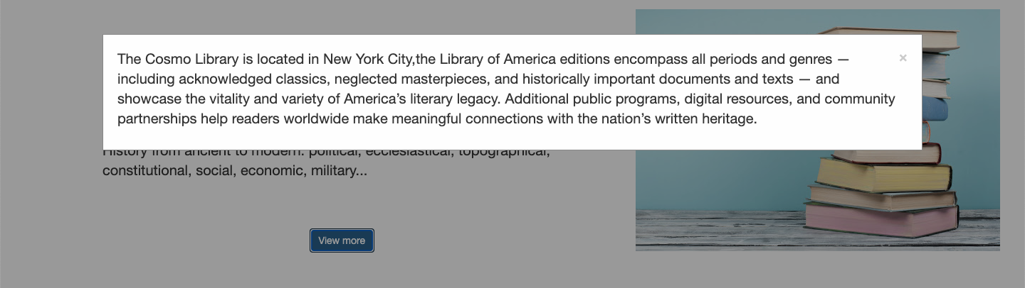

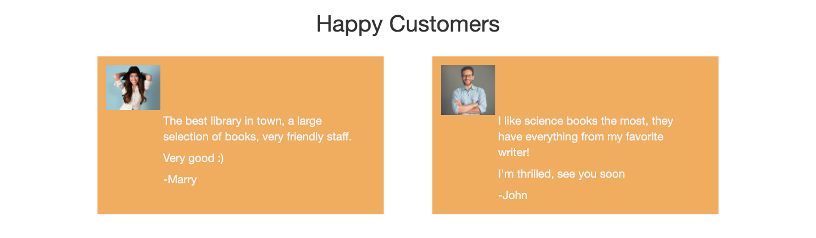
-zadovoljni korisnici

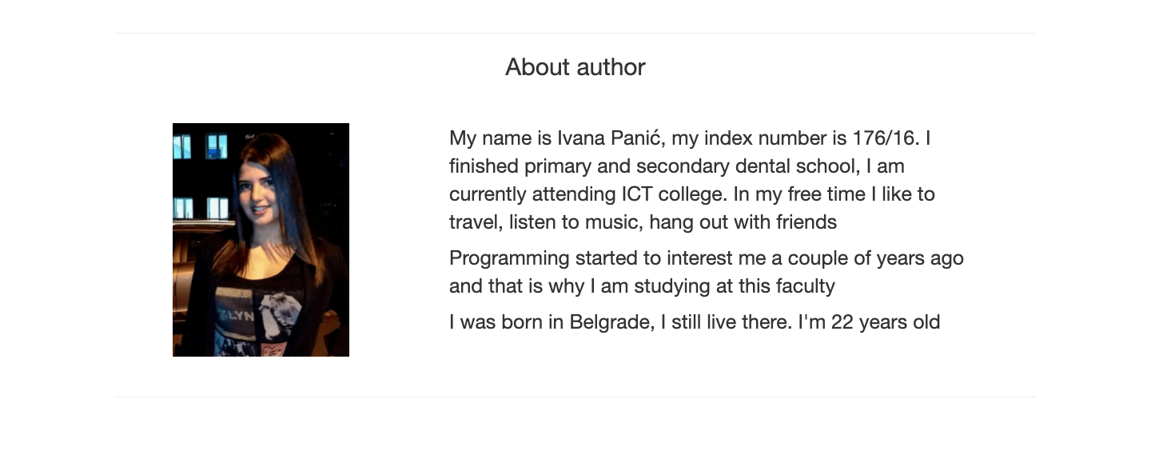

-Sekcija o autoru sa slikom I textom

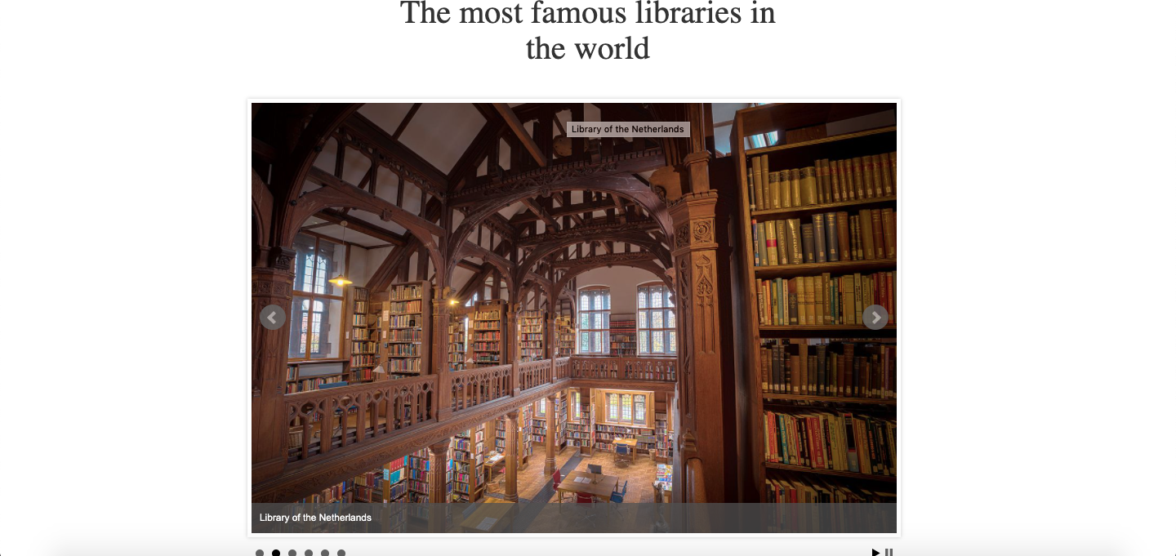

- Slider galerija na kojoj se smenjuju slike najpoznatijih biblioteka na svetu, napravljen je u JavaScriptu.
- Takođe strelicama levo-desno može da se upravlja slikama

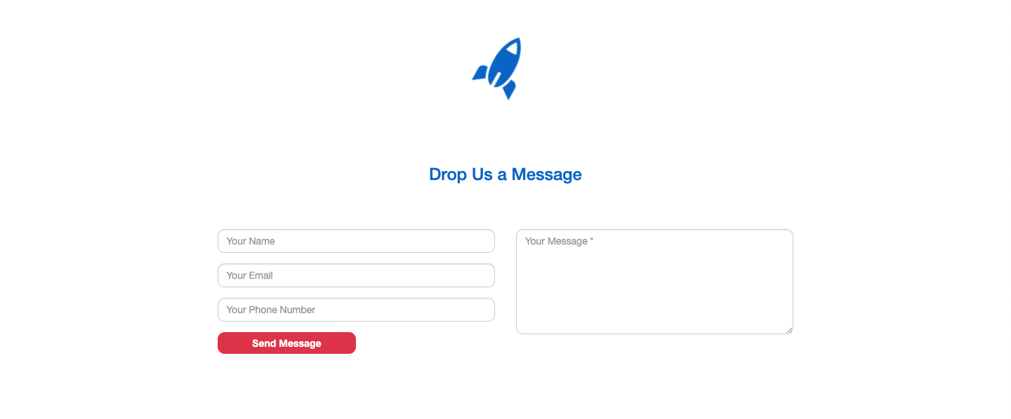

- Ovde se nalazi forma na kojoj su korisceni regularni izrazi
- Regularni izrazi su korisceni za polja name,email,phone number I text
- Obavezno je da se popune sva polja
- Kada se klikne na “send message” ako nije pravilno popunjeno izbacuje greske

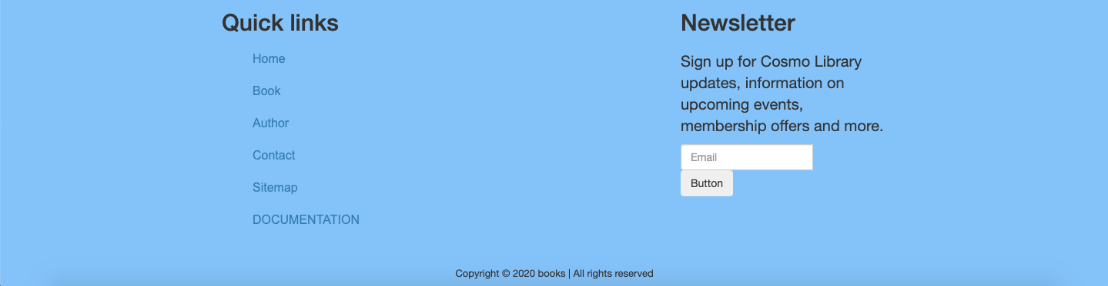

- Na ovom delu sajta nalazi se futer
- Tu su linkovi I newsletter forma
- Uradjen je regularni izraz za polje email
- Sva prava su zadrzana

KODOVI

3.1HTML

<!DOCTYPE html>
<html lang="en">

<head>
<link rel="stylesheet" href="style.css" />
<meta charset="UTF-8" />
<meta name="viewport" content="width=device-width, initial-scale=1.0" />
<meta http-equiv="X-UA-Compatible" content="ie=edge" />

<link rel="stylesheet" href="https://maxcdn.bootstrapcdn.com/bootstrap/3.4.1/css/bootstrap.min.css" />

<script src="https://code.jquery.com/jquery-3.5.1.min.js"
integrity="sha256-9/aliU8dGd2tb6OSsuzixeV4y/faTqgFtohetphbbj0=" crossorigin="anonymous"></script>

<script defer src="https://cdn.jsdelivr.net/npm/bootstrap@4.5.3/dist/js/bootstrap.bundle.min.js"
integrity="sha384-ho+j7jyWK8fNQe+A12Hb8AhRq26LrZ/JpcUGGOn+Y7RsweNrtN/tE3MoK7ZeZDyx"
crossorigin="anonymous"></script>

<script defer src="https://code.jquery.com/ui/1.12.0/jquery-ui.min.js"
integrity="sha256-eGE6blurk5sHj+rmkfsGYeKyZx3M4bG+ZlFyA7Kns7E=" crossorigin="anonymous"></script>

<link rel="stylesheet" href="https://cdnjs.cloudflare.com/ajax/libs/jqueryui/1.12.1/jquery-ui.min.css"
integrity="sha512-aOG0c6nPNzGk+5zjwyJaoRUgCdOrfSDhmMID2u4+OIslr0GjpLKo7Xm0Ao3xmpM4T8AmIouRkqwj1nrdVsLKEQ=="
crossorigin="anonymous" />

<!--<link rel="stylesheet" type="text/css" href="slick/slick.css" />

<link rel="stylesheet" type="text/css" href="slick/slick-theme.css" />
-->
<link rel="stylesheet" href="https://cdn.jsdelivr.net/bxslider/4.2.12/jquery.bxslider.css">

<script src="https://ajax.googleapis.com/ajax/libs/jquery/3.5.1/jquery.min.js"></script>

<script "text/javascript" src="https://ajax.googleapis.com/ajax/libs/jquery/3.1.1/jquery.min.js"></script>
<script "text/javascript" src="https://cdn.jsdelivr.net/bxslider/4.2.12/jquery.bxslider.min.js"></script>

<script src="https://ajax.googleapis.com/ajax/libs/jquery/3.5.1/jquery.min.js"></script>

<script "text/javascript" src="https://ajax.googleapis.com/ajax/libs/jquery/3.1.1/jquery.min.js"></script>
<script "text/javascript" src="https://cdn.jsdelivr.net/bxslider/4.2.12/jquery.bxslider.min.js"></script>

<title>Document</title>
<script src="script.js" defer></script>

</head>

<body>
<div id="wrap">
<div id="header">
<div id="nav_bar">
<nav class="navbar navbar-default">
<div class="container-fluid">
<div class="navbar-header">
<a class="navbar-brand" href="#">Cosmo Library</a>
</div>
<ul class="nav navbar-nav" id="manu">
<li class="active"><a href="#" id="goToHome">Home</a></li>
<li><a href="#" id="goToBook">Book</a></li>
<li><a href="#" id="goToAbout">About</a></li>
<li><a href="#" id="goToGallery">Gallery</a></li>
<li><a href="#" id="goToAuthor">Author</a></li>
<li><a href="#" id="goToContact">Contact</a></li>

</ul>
</div>
</nav>
</div>
</div>
<div id="motivation_text_image">
<div class="motivation_text">
<h1>WELCOME TO THE COSMO LIBRARY</h1>
<h2>For research, inspiration and enjoyment.</h2>
</div>
</div>
<div id="library_info">
<div id="library_info_text">
<p>
The Cosmo Library is one of the world's great lending libraries, with an amazing collection of over 1 million
books, and an equally extraordinary history. This extensive collection includes works on individual countries,
monarchs, historical events and topics such as feudalism, international relations and chivalry.
</p>
<p>
History from ancient to modern: political, ecclesiastical, topographical, constitutional, social, economic,
military...
</p>
<div id="library_text_button">
<button type="button" class="btn btn-primary" id="MyBtn" data-toggle="button" aria-pressed="false"
autocomplete="off">
View more
</button>
<div id="modal">
<div class="modal_content">
<span class="close">&times;</span>
<p>
The Cosmo Library is located in New York City,the Library of America editions encompass all periods and
genres — including acknowledged classics,
neglected masterpieces, and historically important documents and texts — and showcase the vitality and
variety of America’s literary legacy. Additional public programs, digital resources, and community
partnerships help readers worldwide make meaningful connections with the nation’s written heritage.</p>
</div>
</div>
</div>
</div>
<div id="library_info_image">
<img src="image/book.jpg" alt="suitcase" />
</div>
</div>
<hr style="width: 80%; margin-top: 50px;">

<div id="book_list" class="container-fluid">
<div id="title_book_list">
<h1 style="text-align: center; font-family: auto; font-size: 40px; margin: 0px;">Book List</h1>
<input type="text" id="search">
</div>
<div class="row" id="bookListing">
<div class="col-md-6 col-lg-4 col-sm-12">
<div class="book_image1">
<div class="content_book_image">
<button class="px-3 mb-3 category bg-primary btn" style="width: 100px;
margin: 0 auto;">$340.00</button>
<h2 class="headline_book">Bora Bora</h2>
<button type="button" class="btn btn-secondary" style="width: 40%;
margin: 0 auto; color: white; margin-top: 17px;">View more</button>
</div>
</div>
</div>
<div class="col-md-6 col-lg-4">
<div class="book_image1">
<div class="content_book_image">
<button class="px-3 mb-3 category bg-primary btn" style="width: 100px;
margin: 0 auto;">$340.00</button>
<h2 class="headline_book">Bora Bora</h2>
<button type="button" class="btn btn-secondary" style="width: 40%;
margin: 0 auto; color: white; margin-top: 17px;">View more</button>
</div>
</div>
</div>
<div class=" col-md-6 col-lg-4">
<div class="book_image1">
<div class="content_book_image">
<button class="px-3 mb-3 category bg-primary btn" style="width: 100px;
margin: 0 auto; ">$340.00</button>
<h2 class="headline_book">Bora Bora</h2>
<button type="button" class="btn btn-secondary" style="width: 40%;
margin: 0 auto; color: white; margin-top: 17px;">View more</button>
</div>
</div>
</div>
<div class="col-md-6 col-lg-4">
<div class="book_image1">
<div class="content_book_image">
<button class="px-3 mb-3 category bg-primary btn" style="width: 100px;
margin: 0 auto;">$340.00</button>
<h2 class="headline_book">Bora Bora</h2>
<button type="button" class="btn btn-secondary" style="width: 40%;
margin: 0 auto; color: white; margin-top: 17px;">View
more</button>
</div>
</div>
</div>
<div class="col-md-6 col-lg-4">
<div class="book_image1">
<div class="content_book_image">
<button class="px-3 mb-3 category bg-primary btn" style="width: 100px;
margin: 0 auto; ">$340.00</button>
<h2 class="headline_book">Bora Bora</h2>
<button type="button" class="btn btn-secondary" style="width: 40%;
margin: 0 auto; color: white; margin-top: 17px;">View
more</button>
</div>
</div>
</div>
<div class="col-md-6 col-lg-4">
<div class="book_image1">
<div class="content_book_image">
<button class="px-3 mb-3 category bg-primary btn" style="width: 100px;
margin: 0 auto;">$340.00</button>
<h2 class="headline_book">Bora Bora</h2>
<button type="button" class="btn btn-secondary" style="width: 40%;
margin: 0 auto; color: white; margin-top: 17px;">View
more</button>
</div>
</div>
</div>
</div>

</div>
<hr style="width: 80%; margin-top: 50px;">
<div class="customer_title">Happy Customers</div>
<div class="happy_customers" class="container-fluid">

<div class="row">
<div class="col-md-6">

<div class="customer">

<div class="customer_picture">
<img src="image/girl.jpg" class="girl_customer">
</div>
<div class="customer_text">
<p class="p_customer_text">
The best library in town, a large selection of books, very friendly staff.</p>
<p class="p_customer_text">
Very good :)</p>
<p class="p_customer_text">-Marry </p>
</div>

</div>

</div>
<div class="col-md-6">

<div class="customer">
<span class="icon-keyboard_arrow_left"></span>
<div class="customer_picture">
<img src="image/man.jpg" class="girl_customer">
</div>
<div class="customer_text">
<p class="p_customer_text">I like science books the most, they have everything from my favorite writer!
</p>
<p class="p_customer_text">I'm thrilled, see you soon</p>
<p class="p_customer_text">-John</p>
</div>
</div>
</div>

</div>

</div>
<hr style="width: 80%; margin-top: 50px;">
<div class="row" id="wrapp_slider">
<div class="title_galery">
<h2>
The most famous libraries in the world</h2>
</div>
<div class="col-md-12">
<div class="slider">
<div><img src="image/library3.jpg" title="Hungarian Library"></div>
<div><img src="image/library2.jpg" title="Library of the Netherlands"></div>
<div><img src="image/library1.jpg" title="Library of Russia"></div>
<div><img src="image/library4.jpg" title="German library"></div>
<div><img src="image/library5.jpg" title="Library of America"></div>
<div><img src="image/library6.jpg" title="library in Japan"></div>
</div>
</div>
</div>

<hr style="width: 80%; margin-top: 50px;">
<div class="author">
<div class="author_title">
<div class="row">
<div class="col-md-12">
<p>About author</p>
</div>
</div>
</div>
<div class="row">
<div class="col-md-4"><img src="image/1607199200_tmp_129588921_3570720903043116_8532136150659752564_n.png"
class="author_image">
</div>
<div class="col-md-8">
<p class="author_text">My name is Ivana Panić, my index number is 176/16. I finished primary and secondary
dental school, I am
currently attending ICT college. In my free time I like to travel, listen to music, hang out with
friends
</p>
<p class="author_text">
Programming started to interest me a couple of years ago and that is why I am studying at this faculty
</p>
<p class="author_text">

I was born in Belgrade, I still live there. I'm 22 years old</p>
<p class="author_text">
</p>
</div>
</div>
</div>
<hr style="width: 80%; margin-top: 50px;">
<div class="container contact-form">
<div class="contact-image">
<img src="https://image.ibb.co/kUagtU/rocket_contact.png" alt="rocket_contact" />
</div>
<form method="post" id="cnt_form">
<h3>Drop Us a Message</h3>
<div class="row">
<div class="col-md-6">
<div class="form-group">
<input type="text" name="name" class="form-control" id="form-name" placeholder="Your Name " value="" />
</div>
<div class="form-group">
<input type="text" name="txtEmail" class="form-control" id="form-email" placeholder="Your Email "
value="" />
</div>
<div class="form-group">
<input type="text" name="txtPhone" class="form-control" id="form-phone" placeholder="Your Phone Number "
value="" />
</div>
<div class="form-group">
<input type="submit" name="btnSubmit" class="btnContact" id="submit" value="Send Message" />
</div>
</div>
<div class="col-md-6">
<div class="form-group">
<textarea name="txtMsg" class="form-control" id="form-text" placeholder="Your Message *"
style="width: 100%; height: 150px;"></textarea>
</div>
</div>
</div>
</form>
</div>
<footer>
<div class="wrapp_footer">
<div class="row">
<div class="col-md-8">
<div class="footer_link_title">
<h2 class="footer_title">Quick links</h2>
</div>
<ul>
<li><a href="#" id="footer-home">Home</a></li>
<li><a href="#" id="footer-book">Book</a></li>
<li><a href="#" id="footer-author">Author</a></li>
<li><a href="#" id="footer-contact">Contact</a></li>
<li><a href="sitemap.xml" id="footer-sitemap">Sitemap</a></li>
<li><a href="#" id="footer-contact">DOCUMENTATION</a></li>
</ul>

</div>
<div class="col-md-4">
<div class="newsletter_title">
<h2 class="footer_title">Newsletter</h2>
</div>
<div class="newsletter_text">
<p>Sign up for Cosmo Library updates, information on upcoming events, membership offers and more.</p>
</div>
<div class="input-group mb-3">
<input type="text" class="form-control" id="ffooter" placeholder="Email" aria-label="Recipient's username"
aria-describedby="basic-addon2">
<div class="input-group-append">
<button class="btn btn-outline-secondary" id="footer-button" type="button">Button</button>
</div>
</div>
</div>
</div>
<div class="row">
<div class="col-md-12">
<p class="copyright_text">Copyright © 2020 books | All rights reserved Ivana Panic</p>
</div>
</div>
</div>

</footer>
</div>

</body>

</html>

3.2CSS

@import url("https://fonts.googleapis.com/css?family=Rubik:500,700|Roboto:400,600");
body {
width: 100%;
height: 100%;
}
#wrap {
width: 100%;
height: 100%;
margin: 0 auto;
display: flex;
flex-direction: column;
}
#header {
width: 100%;
height: 51px;
margin: 0 auto;
}
#nav_bar {
width: 100%;
height: 100%;
float: right;
}

.motivation_text {
z-index: 2;
position: relative;
width: 50%;
margin: 0 auto;
text-align: center;
}

.motivation_text h1 {
font-size: 30px;
color: #fff;
}

.motivation_text h2 {
font-size: 22px;
color: rgba(255, 255, 255, 0.7);
}

#motivation_text_image {
width: 100%;
height: 630px;
background-image: url("image/book2.jpg");
background-repeat: no-repeat;
background-size: cover;
background-position: center;
position: relative;
display: flex;
justify-content: center;
align-items: center;
}

#motivation_text_image:before {
position: absolute;
content: "";
left: 0;
bottom: 0;
right: 0;
top: 0;
background: rgba(0, 0, 0, 0.4);
}

#library_info {
width: 80%;
height: 100%;
margin: 0 auto;
}
#library_info_text {
width: 60%;
height: 100%;
float: left;
margin-top: 50px;
display: flex;
flex-direction: column;
}
#library_info_image {
width: 35%;
height: 100%;
float: right;
margin-top: 15px;
}
.library_text {
font: small-caps bold 24px/1 sans-serif;
}
#image {
width: 400px;
height: 300px;
}
#library_text_button {
width: 110px;
margin: 0 auto;
padding-top: 58px;
}
.btn-primary {
margin: 0 auto;
}
.btn-warning {
color: #fff;
background-color: #6495ed;
border-color: #6495ed;
}
.btn-secondary {
background-color: #6495ed;
border-color: #6495ed;
}

#book_list {
width: 80%;
margin: 0 auto;
display: flex;
flex-direction: column;
}
hr {
display: block;
margin-top: 0.5em;
margin-bottom: 0.5em;
margin-left: auto;
margin-right: auto;
border-style: inset;
border-width: 1px;
}
.book_box {
width: 90%;
height: 100%;
margin: 0 auto;
padding-top: 20px;
display: flex;
justify-content: center;
}

.book_image1 {
height: 90%;
background-image: url("image/10.-Daydream-Full-Island-looking-East-to-Molle-Islands-Large-350x450.jpg");
margin-top: 25px;
margin-right: 15px;
padding: 10px;
box-shadow: 5px 10px 18px #888888;
}
.book_image2 {
width: 33%;
height: 90%;
background-image: url("image/unnamed.jpg");
margin-top: 25px;
margin-left: 15px;
padding: 10px;
box-shadow: 5px 10px 18px #888888;
}
.book_image3 {
width: 33%;
height: 90%;
background-image: url("image/c04c0aefd226d55fd27c60a18a131812.jpg");
margin-top: 25px;
margin-left: 30px;
padding: 10px;
box-shadow: 5px 10px 18px #888888;
}
.book_image4 {
width: 33%;
height: 90%;
background-image: url("image/healthy-nature.jpg");
margin-top: 25px;
margin-right: 15px;
padding: 10px;
box-shadow: 5px 10px 18px #888888;
}
.book_image5 {
width: 33%;
height: 90%;
background-image: url("image/Lifetime.jpg");
margin-top: 25px;
margin-left: 15px;
padding: 10px;
box-shadow: 5px 10px 18px #888888;
}
.book_image6 {
width: 33%;
height: 90%;
background-image: url("image/Copy-of-Activities-02-350x450.jpg");
margin-top: 25px;
margin-left: 30px;
padding: 10px;
box-shadow: 5px 10px 18px #888888;
}
.content_book_image {
width: 90%;
height: 40%;
text-align: center;
margin-top: 220px;
margin-left: 16px;
margin-right: 10px;
display: flex;
flex-direction: column;
}
.headline_book {
width: 70%;
height: 40px;
margin: 0 auto;
text-align: center;
margin-top: 18px;
font-size: 18px;
font-family: "Work Sans", sans-serif;
color: white;
}
#customers_sections {
width: 80%;
margin: 0 auto;
}
.customer_title {
width: 350px;
margin: 0 auto;
text-align: center;
padding-bottom: 30px;
font: auto;
font-size: 40px;
}
.happy_customers {
width: 80%;
margin: 0 auto;
display: flex;
flex-direction: column;
}
.customer {
display: flex;
height: 280px;
width: 90%;
margin: 0 auto;
background-color: #f0ad4e;
}
.customer_picture {
width: 22%;
height: 70px;
padding-top: 15px;
padding-left: 15px;
}
.girl_customer {
width: 100%;
}
.customer_text {
width: 70%;
margin-top: 100px;
padding-left: 5px;
}
p {
font-size: 20px;
font: auto;
}
.p_customer_text {
font-size: 20px;
font: auto;
color: whitesmoke;
}
.author_title {
margin: 0 auto;
text-align: center;
padding-bottom: 40px;
}
.author {
margin: 0 auto;
width: 70%;
}
.author_image {
width: 70%;
}
.author_text {
font-size: 25px;
}
footer {
margin: 0 auto;
width: 100%;

background-color: #83c2ff;
}
.copyright_text {
text-align: center;
padding-top: 20px;
font-size: 13px;
}
.wrapp_footer {
width: 60%;
margin: 0 auto;
}
.library_info_text p {
font-size: 15px;
font-family: Arial, "Helvetica Neue", Helvetica, sans-serif;
}
.contact-form {
background: #fff;
margin-top: 10%;
margin-bottom: 5%;
width: 70%;
}
.contact-form .form-control {
border-radius: 1rem;
}
.contact-image {
text-align: center;
}
.contact-image img {
border-radius: 6rem;
width: 11%;
margin-top: -3%;
transform: rotate(29deg);
}
.contact-form form {
padding: 14%;
}
.contact-form form .row {
margin-bottom: -7%;
}
.contact-form h3 {
margin-bottom: 8%;
margin-top: -10%;
text-align: center;
color: #0062cc;
}
.contact-form .btnContact {
width: 50%;
border: none;
border-radius: 1rem;
padding: 1.5%;
background: #dc3545;
font-weight: 600;
color: #fff;
cursor: pointer;
}
.btnContactSubmit {
width: 50%;
border-radius: 1rem;
padding: 1.5%;
color: #fff;
background-color: #0062cc;
border: none;
cursor: pointer;
}
#wrapp_slider {
margin: 0 auto;
width: 60%;
}
.title_galery {
width: 60%;
margin: 0 auto;
text-align: center;
padding-bottom: 30px;
}
.title_galery h2 {
font-family: auto;
font-size: 40px;
}
ul li {
list-style-type: none;
padding-bottom: 20px;
font-family: Arial, Sans-Serif;
font-size: 16px;
}
.footer_title {
padding-bottom: 10px;
font: auto;
}
.author_title p {
font-size: 30px;
}
#modal {
display: none;
position: fixed;
z-index: 1;
left: 0;
top: 0;
width: 100%;
height: 100%;
overflow: auto;
background-color: rgb(0, 0, 0);
background-color: rgba(0, 0, 0, 0.4);
}
.modal_content {
background-color: #fefefe;
margin: 15% auto;
padding: 20px;
border: 1px solid #888;
width: 80%;
}
.close {
color: #aaa;
float: right;
font-size: 28px;
font-weight: bold;
}
.close:hover,
.close:focus {
color: black;
text-decoration: none;
cursor: pointer;
}
#manu {
}
@media (max-width: 960px) and (min-width: 501px) {
#manu li {
width: 50%;
}
}
@media (max-width: 500px) {
#manu li {
width: 100%;
}
}
@media (max-width: 960px) {
#manu {
display: block;
}

#manu li {
display: inline-block;
}
}

.wrapp_footer a:hover {
color: white;
}
.wrapp_footer a:link {
text-decoration: none;
}
button {
border-color: #2196f3;
color: white;
}
button:hover {
background: #2196f3;
color: white;
}

3.3 javaScript

$(document).ready(function() {
const apiSearchBaseUrl = searchTerm => {
return `http://openlibrary.org/search.json?title=${searchTerm}`;
};
const apiCoverBaseUrl = (bookId, size) => {
return `http://covers.openlibrary.org/b/id/${bookId}-${size}.jpg`;
};

let suggestedBooks = [];
const searchJquery = $("#bookListing");
const search = document.querySelector("#search");

search.addEventListener("input", event => {
if (event.target.value.length > 1) {
getSearchResults(event.target.value).then(data => {
const filterOutNonCover = data.docs.filter(ele => {
return ele.cover_i;
});

const topResults = filterOutNonCover.slice(0, 6);
suggestedBooks = [];
const finalResult = topResults.map(ele => {
return genereateBookItem(ele.title);
});
suggestedBooks.push(...finalResult);
console.log(suggestedBooks);
searchJquery.empty();
$.each(suggestedBooks, function(i, val) {
searchJquery.append(val);
});
});
}
});

const getSearchResults = async searchTerm => {
const results = await fetch(apiSearchBaseUrl(searchTerm), {
method: "GET"
});
return results.json();
};

const genereateBookItem = title => {
return $(`<div class="col-md-6 col-lg-4">
<div class="trip_image1">
<div class="content_trip_image">
<button class="px-3 mb-3 category bg-primary btn" style="width: 100px;
margin: 0 auto; background-color: #f0ad4e;">$340.00</button>
<h2 class="headline_trip">${title}</h2>
<button type="button" class="btn btn-secondary" style="width: 40%;
margin: 0 auto; background-color: #f0ad4e; color: white; margin-top: 17px;">View more</button>
</div>
</div>
</div>`);
};
});
// GALLERY SLIDER
$(document).ready(function() {
$(".slider").bxSlider({
autoControls: true,
auto: true,
pager: true,
slideWidth: 800,
mode: "fade",
captions: true,
speed: 1000
});
});

//FORM VALIDATION
document
.getElementById("submit")
.addEventListener("click", function proveri(event) {
event.stopImmediatePropagation();
event.preventDefault();
var name = document.querySelector("#form-name").value;
var email = document.querySelector("#form-email").value;
var phone = document.querySelector("#form-phone").value;
var text = document.querySelector("#form-text").value;

var inputName = document.querySelector("#form-name");
var inputEmail = document.querySelector("#form-email");
var inputPhone = document.querySelector("#form-phone");
var inputText = document.querySelector("#form-text");

var regexName = /^[A-Z][a-z]+$/;
if (!regexName.test(name)) {
inputName.classList.remove("Tacno");
inputName.classList.add("Netacno");
inputName.innerHTML = "Please write a correct Name!";
} else {
inputName.classList.remove("Netacno");
inputName.classList.add("Tacno");
inputName.innerHTML = "";
}
var regexEmail = /^\w+([\.-]?\w+)*@\w+([\.-]?\w+)*(\.\w{2,4})+$/;
if (!regexEmail.test(email)) {
inputEmail.classList.remove("Tacno");
inputEmail.classList.add("Netacno");
inputEmail.innerHTML = "Please write a correct Name!";
} else {
inputEmail.classList.remove("Netacno");
inputEmail.classList.add("Tacno");
inputEmail.innerHTML = "";
}
var regexPhone = /^06[01234569]\/[\d]{6,7}$/;
if (!regexPhone.test(phone)) {
inputPhone.classList.remove("Tacno");
inputPhone.classList.add("Netacno");
inputPhone.innerHTML = "Please write a correct phone!";
} else {
inputPhone.classList.remove("Netacno");
inputPhone.classList.add("Tacno");
inputPhone.innerHTML = "";
}
var regexText = /^[A-ZČĆŽŠĐ][a-zčćžšđ]([\d \w]{5,100})$/;
if (!regexText.test(text)) {
inputText.classList.remove("Tacno");
inputText.classList.add("Netacno");
inputText.innerHTML = "please";
inputText.innerHTML.style.color = "red";
} else {
inputText.classList.remove("Netacno");
inputText.classList.add("Tacno");
inputText.innerHTML = "";
}
});
//FOOTER VALIDATION
document
.getElementById("footer-button")
.addEventListener("click", function validationF(event) {
event.stopImmediatePropagation();
event.preventDefault();
var emailFooter = document.querySelector("#ffooter").value;
var inputEmailFooter = document.querySelector("#ffooter");

var regexemailFooter = /^\w+([\.-]?\w+)*@\w+([\.-]?\w+)*(\.\w{2,4})+$/;
if (!regexemailFooter.test(emailFooter)) {
inputEmailFooter.classList.remove("Tacno");
inputEmailFooter.classList.add("Netacno");
inputEmailFooter.innerHTML = "Please write a correct email!";
} else {
inputEmailFooter.classList.remove("Netacno");
inputEmailFooter.classList.add("Tacno");
inputEmailFooter.innerHTML = "";
}
});
//FOOTER VALIDATION END
$(document).ready(function() {
$("#goToHome").click(function() {
$("html").animate(
{
scrollTop: $("#motivation_text_image").offset().top - 55
},
500
);
});
$("#goToBook").click(function() {
$("html").animate(
{
scrollTop: $("#bookListing").offset().top - 55
},
500
);
});
$("#goToGallery").click(function() {
$("html").animate(
{
scrollTop: $("#wrapp_slider").offset().top - 55
},
500
);
});
$("#goToAuthor").click(function() {
$("html").animate(
{
scrollTop: $(".author").offset().top - 55
},
500
);
});

$("#goToContact").click(function() {
$("html").animate(
{
scrollTop: $(".contact-image").offset().top - 55
},
500
);
});
$("#goToAbout").click(function() {
$("html").animate(
{
scrollTop: $("#library_info").offset().top - 55
},
500
);
});

$("#footer-home").click(function() {
$("html").animate(
{
scrollTop: $("#motivation_text_image").offset().top - 55
},
500
);
});
$("#footer-book").click(function() {
$("html").animate(
{
scrollTop: $("#bookListing").offset().top - 55
},
500
);
});
$("#footer-author").click(function() {
$("html").animate(
{
scrollTop: $(".author").offset().top - 55
},
500
);
});
$("#footer-contact").click(function() {
$("html").animate(
{
scrollTop: $(".contact-image").offset().top - 55
},
500
);
});
});
//MODAL ZA SEKCIJU ABOUTH
window.onload = function() {
var Mymodal = document.getElementById("modal");
var btn = document.getElementById("MyBtn");
var span = document.getElementsByClassName("close")[0];
btn.onclick = function() {
Mymodal.style.display = "block";
};
span.onclick = function() {
modal.style.display = "none";
};
window.onclick = function(event) {
if (event.target == Mymodal) {
Mymodal.style.display = "none";
}
};
};

