Milestone 01: Concept

**Title:** River Drifter

* A game about a boy’s camping items that fell in the river, and now must go collect them!

**Gameplay Description:**

* Your character will be in a boat drifting in a river at night. They cannot move forward or backwards, only side-to-side to avoid hitting branches or other obstacles. You can throw a rock at branches in order to “sink” them and clear the river ahead
* Top screen displays lives remaining, how far the player has progressed in the river, number of items collected
* How to win: reach the end of the river with at least 5 of the following items
  + - Shirts (5)
    - Shorts (3)
    - Boots (2)
    - Blanket (2)
    - Hat (2)
    - Sleeping Bag (1)
* How to lose: get hit by 3 rocks (lose 3 lives) or reach the end with less than 5 of the above items

**Controls:**

Up Arrow: move up

Down Arrow: move down

A/X: throw rock

Start/enter: pause/un-pause game

**Features:**

* Simultaneous backgrounds (parallax movement): River in the background, foreground is clouds/moon
* River background possibly uses mosaic effect to create wave effect ?
* Animation:
  + Player: catching an item (triggered by collision with it), throwing rocks, paddling in river when idle
  + Shirt floating in river
* Progress bar of how far you’ve made it in the river, lives, items collected on top of screen (create as a function of hOff and add a sprite every time it increases by 20 ? ):



* Selection on menu of start or instructions will be indicated through an arrow (controlled by up or down arrow):



* Sound:
  + Main Menu: Pink + White by Frank Ocean instrumentals loop (https://youtu.be/-AsYAjvpLZI)
  + Pause: same as Main Menu
  + Instructions: Same as Main Menu
  + Game: Moon River by Frank Ocean (inspired this game)
  + Win: happy, upbeat instrumentals (https://youtu.be/9t1nGNKdIgE)
  + Lose: lo-fi music slowed down (<https://youtu.be/LCa3gRKydHY>)
  + Collect item: Arcade-type sound effect
  + Hit by rock: Power-down sound
* Cheat: player is invincible (different color) and is unaffected by rocks

Inspiration/Ideas:

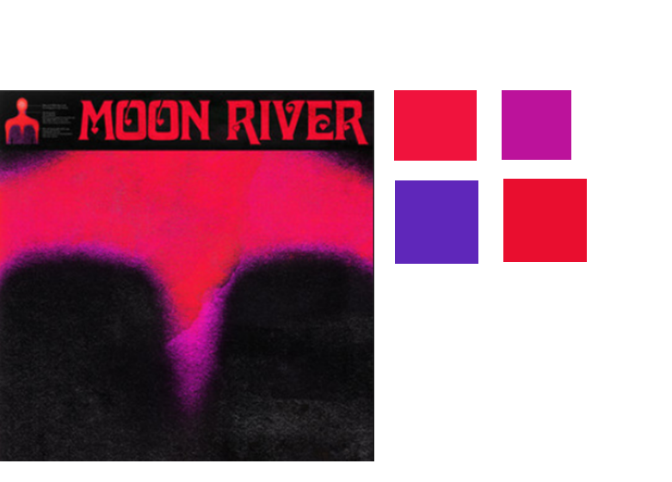

River Map with cloud foreground:

