这部分重点讨论编写解壳部分。

有几个关键点：

因为解壳程序是硬编码到壳中的，而且一旦加壳后的程序一加载，就直接从这个解壳程序处执行，这是因为入口点被更改到这里了。

解壳程序中将会用到很多很多的win32api比如CreateProcess以及C运行库中的函数比如mallocfree等，这时候如果你直接调用这些函数，最后扣出硬编码，放到壳里，它能执行成功吗？答案是，这样执行成功的机率几乎为0.

因为你在编写解壳程序时，如果直接使用这些函数，最后生成的指令里肯定包含了一些全局数据，然而全局数据并不在你的硬编码中，当你复制你的硬编码到壳里后，当壳运行的时候，如果再按照硬编码中的指令去寻找全局数据，肯定是找不到的，你想要的全局数据也许并不在壳里。

解决这个问题的方法就是把硬编码中所有的函数地址动态获取到！并且不要使用任何的全局数据。

我用的是VS2013的编译器，如果你不做任何设置，即使你不调用全局函数，编译可能也会暗箱操作，给你加一些东西。主要是就去掉编译器的安全检查的编译选项，我就改了基本运行时检查和安全检查这两个选项。

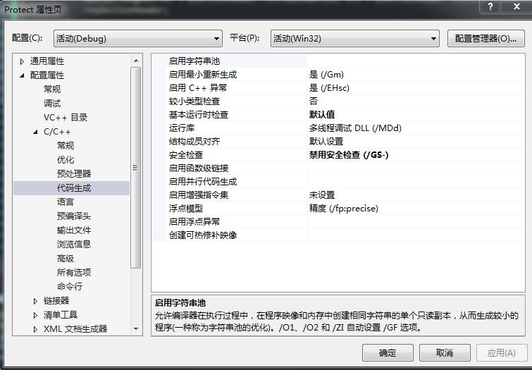

动态获取函数地址，肯定是要用到函数指针的

首先定义好我们要用到的函数指针

代码：

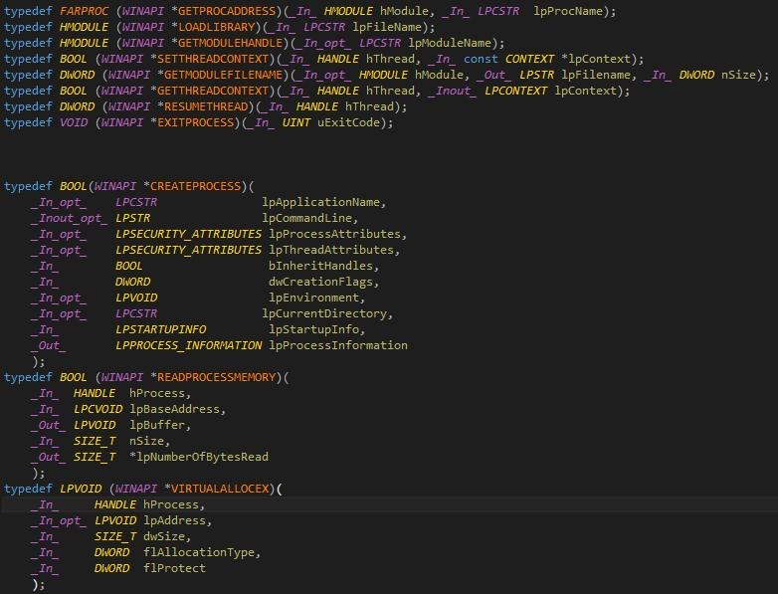

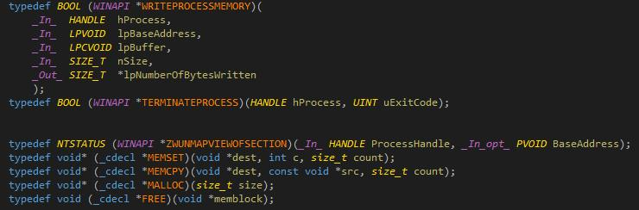

由于动态函数都是从kernel32.dll和ntdll.dll这两个模块中获取到的。硬编码第一步是要找到kernel32.dll模块或ntdll.dll的在内存中的位置。

当一个程序加载运行后，会有一个ldr链的数据结构（参考笔记0003和0002），它存储了这个程序里所有用到的模块的信息。幸运的是，这个ldr链的数据存储在PEB这个数据结构的0x0c这个偏移的地方。那么问题来了，PEB这个结构又在内存哪里？？？

这里直接说答案了，在fs:[0x30]这个位置就是PEB数据的位置，，为什么这样，大概要去问比尔盖茨了吧

拿到PEB后，可以根据ldr链(这是一个双向链表)遍历到kernel32模块的信息，kernel32通常排在第三个：

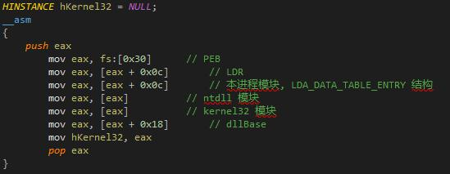

有了kernel32后，一切就变得简单了，为了找到这个模块里所有要用到的函数地址，第一种办法就是遍历这个模块的导出表，，，如果每个函数都去这样遍历，会累死人。比如投机的方法就是先拿到GetProcAddress这个函数的地址。接下来的事情就让GetProcAddress这个函数去干吧。

不过GetProcAddress这个函数你还是得通过遍历导出表来查找，，因为这个时候你手上除了只有kernel32这个大咖你还没有任何资本，一切只能从0开始。遍历导出表的代码是下面这个样子：

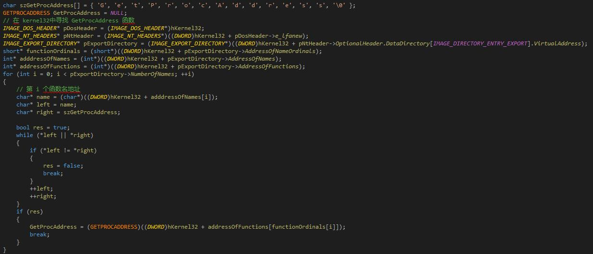

看看上面的代码，有几个细节要非常注意，初始化函数名的时候一定不要用字符串，只能一个一个初始化，因为字符串会存储在一个叫静态数据区的地方，然后再从静态数据区复制你的每个字符到栈中。

看这里多可怜，我们连strcmp这样简单的函数都不能使用。只能自己一个一个去比较了。

有了GetProcAddress这个函数后，一切事情会变得简单了，这好像我们找到了一个帮手，接下来的找函数的事情就让这个帮手去干嘛吧！

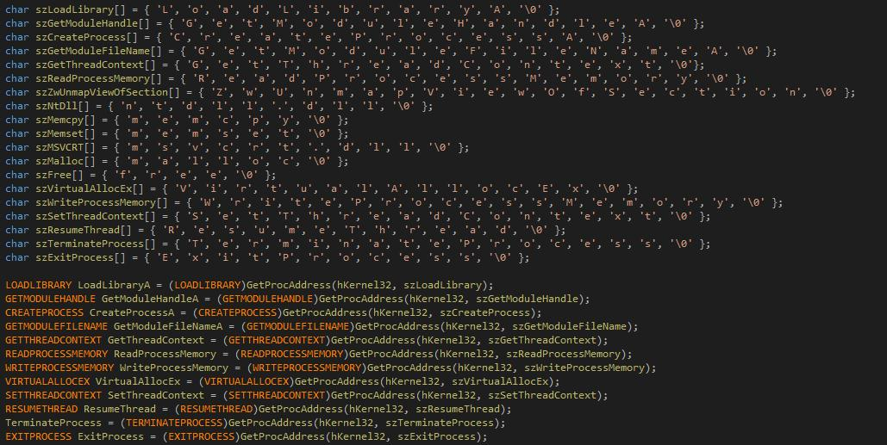

还有像memset、memcpy这样的函数在模块ntdll.dll里，貌似msvcrt.dll也有，具体你们自己验证吧，我们可以利用GetModuleHandle去找到这个模块

malloc和free在msvcrt.dll里，所以也要找到msvcrt.dll这个模块，但是这个模块不一定被加载，我们通过Loadliarbry把它加载进来。

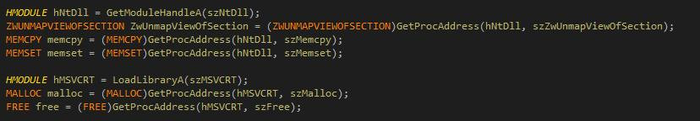

这里一切准备就绪了，可以开始干大事了

获取到本进程的模块地址，通过PE分析技术找到最后一个节的源码数据，就是object，如果这个被加密了，那你还得解密。因为我之前是没有加密的，所以也就不用解密了。拿到object后，需要展开成镜像。

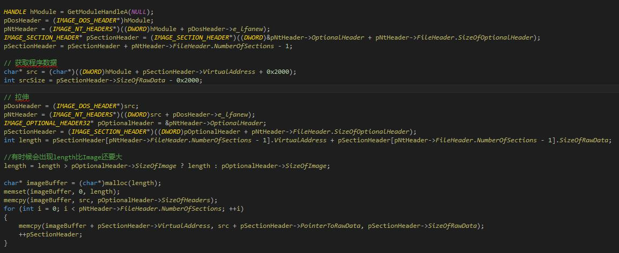

接下来就是创建傀儡进程（随便找一个程序就行，不过我这里就选择了自己），记得以挂起方式创建，这样创建出一进程只是一个4GB的空壳，低2G里除了文件镜像什么也没有。高2G肯定是有东西的。。。

创建完成后，拿到这个进程的ImageBase后，卸载文件镜像，就是把这个进程本身的镜像给赶出去。。。

接下来就把你的object复制进去，，，

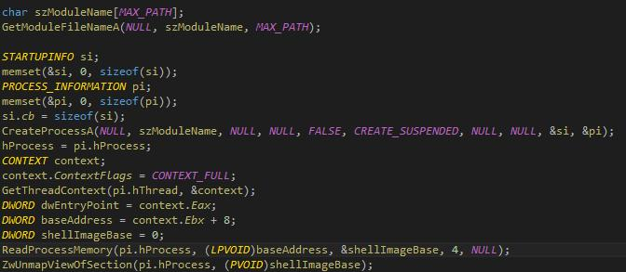

首先你得重新在这个空壳进程里申请空间，可以利用VirtualAllocEx，注意要从你的object的imageBase的地方开始申请，如果这个位置你申请不到的话，会有点小麻烦。你需要修复重定位表。

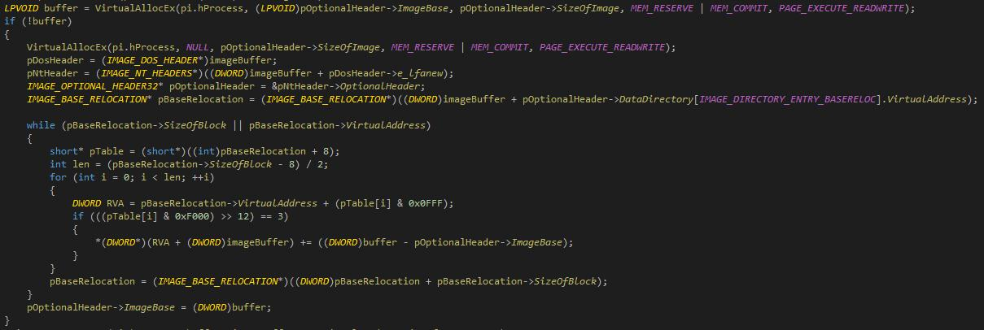

空间申请完毕了，接下来要做两件事情：

第一，把你的object复制进去。

第二，你得在这个进程空壳里写入你新的imagebase

C:\Users\Allen\AppData\Local\YNote\data\ivan_allen@163.com\595d7b3070014dccaad4b52e9682f28d\06783fa0aa444bc8969fd381625d971a.jpg

一切准备就绪，我们要把这个新的进程的线程上下文中的EIP改成你的object的入口点，然后恢复执行。

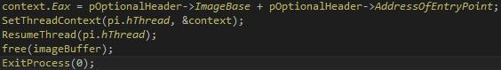

到这里就结束了，下面就是扣出上面这段程序的硬编码，可以从汇编代码里查看到，复制出来就行了。我复制出来是下面这个样子

太多了，只复制了一部分。。。

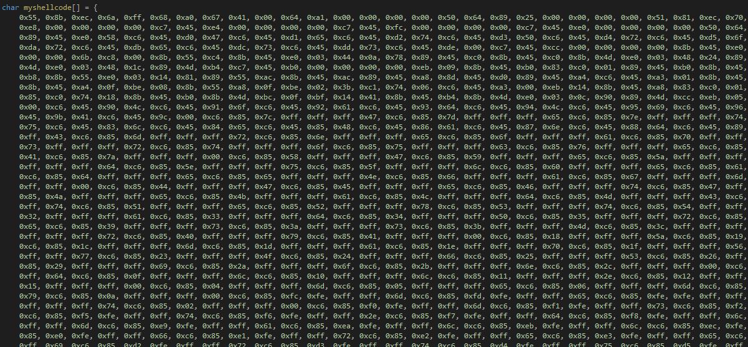

效果图：

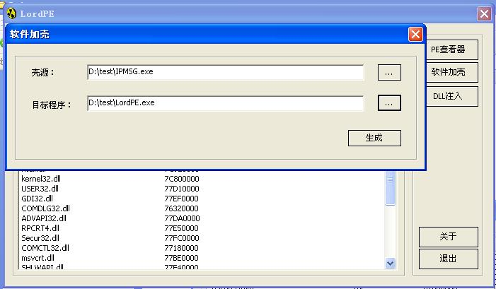

这是壳：

C:\Users\Allen\AppData\Local\YNote\data\ivan_allen@163.com\8ded71dd406044e7b7050e3eafcf77c4\cf17341e144941f1b94682f559b79f06.jpg

这是目标程序，我就选的自己。。。

C:\Users\Allen\AppData\Local\YNote\data\ivan_allen@163.com\0e172c442ce041bca66bd4166cc84369\9ffeb0bb7389473aa0e81d4b0a497751.jpg

加完壳后：

C:\Users\Allen\AppData\Local\YNote\data\ivan_allen@163.com\e18644faf34e4b46a2191486b1a37c78\2e7187919c9747e69211888a366e8034.jpg

运行是这样的：

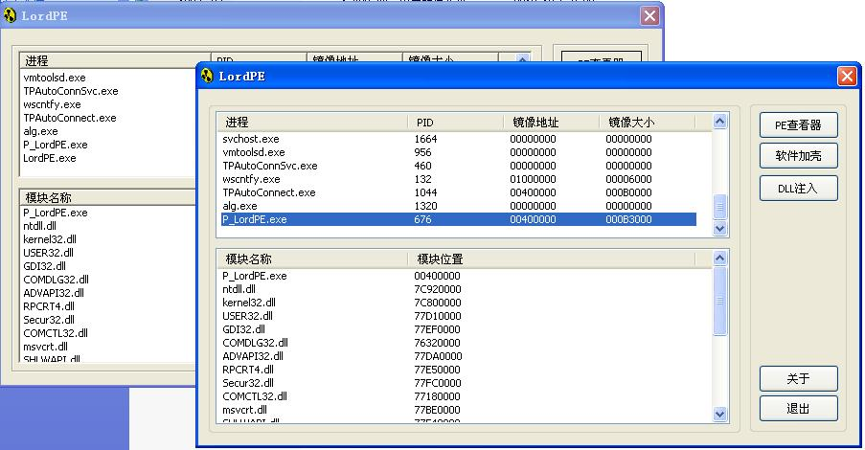

发现按钮什么的竟然变样子了，，，具体啥原因暂时还不清楚。但是我把壳换成别的就没事。

这里粘一个文件形式的吧：

0x55,0x8b,0xec,0x6a,0xff,0x68,0xa0,0x67,0x41,0x00,0x64,0xa1,0x00,0x00,0x00,0x00,0x50,0x64,0x89,0x25,0x00,0x00,0x00,0x00,0x51,0x81,0xec,0x70,0x06,0x00,0x00,0x53,0x56,0x57,0x89,0x65,0xf0,0xc7,0x45,0xec,0x01,0x00,0x00,0x00,0xc7,0x45,

0xe8,0x00,0x00,0x00,0x00,0xc7,0x45,0xe4,0x00,0x00,0x00,0x00,0xc7,0x45,0xfc,0x00,0x00,0x00,0x00,0xc7,0x45,0xe0,0x00,0x00,0x00,0x00,0x50,0x64,0xa1,0x30,0x00,0x00,0x00,0x8b,0x40,0x0c,0x8b,0x40,0x0c,0x8b,0x00,0x8b,0x00,0x8b,0x40,0x18,

0x89,0x45,0xe0,0x58,0xc6,0x45,0xd0,0x47,0xc6,0x45,0xd1,0x65,0xc6,0x45,0xd2,0x74,0xc6,0x45,0xd3,0x50,0xc6,0x45,0xd4,0x72,0xc6,0x45,0xd5,0x6f,0xc6,0x45,0xd6,0x63,0xc6,0x45,0xd7,0x41,0xc6,0x45,0xd8,0x64,0xc6,0x45,0xd9,0x64,0xc6,0x45,

0xda,0x72,0xc6,0x45,0xdb,0x65,0xc6,0x45,0xdc,0x73,0xc6,0x45,0xdd,0x73,0xc6,0x45,0xde,0x00,0xc7,0x45,0xcc,0x00,0x00,0x00,0x00,0x8b,0x45,0xe0,0x89,0x45,0xc8,0x8b,0x45,0xc8,0x8b,0x4d,0xe0,0x03,0x48,0x3c,0x89,0x4d,0xc4,0xb8,0x08,0x00,

0x00,0x00,0x6b,0xc8,0x00,0x8b,0x55,0xc4,0x8b,0x45,0xe0,0x03,0x44,0x0a,0x78,0x89,0x45,0xc0,0x8b,0x45,0xc0,0x8b,0x4d,0xe0,0x03,0x48,0x24,0x89,0x4d,0xbc,0x8b,0x45,0xc0,0x8b,0x4d,0xe0,0x03,0x48,0x20,0x89,0x4d,0xb8,0x8b,0x45,0xc0,0x8b,

0x4d,0xe0,0x03,0x48,0x1c,0x89,0x4d,0xb4,0xc7,0x45,0xb0,0x00,0x00,0x00,0x00,0xeb,0x09,0x8b,0x45,0xb0,0x83,0xc0,0x01,0x89,0x45,0xb0,0x8b,0x45,0xc0,0x8b,0x4d,0xb0,0x3b,0x48,0x18,0x0f,0x83,0x82,0x00,0x00,0x00,0x8b,0x45,0xb0,0x8b,0x4d,

0xb8,0x8b,0x55,0xe0,0x03,0x14,0x81,0x89,0x55,0xac,0x8b,0x45,0xac,0x89,0x45,0xa8,0x8d,0x45,0xd0,0x89,0x45,0xa4,0xc6,0x45,0xa3,0x01,0x8b,0x45,0xa8,0x0f,0xbe,0x08,0x85,0xc9,0x75,0x0a,0x8b,0x45,0xa4,0x0f,0xbe,0x08,0x85,0xc9,0x74,0x2a,

0x8b,0x45,0xa4,0x0f,0xbe,0x08,0x8b,0x55,0xa8,0x0f,0xbe,0x02,0x3b,0xc1,0x74,0x06,0xc6,0x45,0xa3,0x00,0xeb,0x14,0x8b,0x45,0xa8,0x83,0xc0,0x01,0x89,0x45,0xa8,0x8b,0x45,0xa4,0x83,0xc0,0x01,0x89,0x45,0xa4,0xeb,0xc2,0x0f,0xb6,0x45,0xa3,

0x85,0xc0,0x74,0x18,0x8b,0x45,0xb0,0x8b,0x4d,0xbc,0x0f,0xbf,0x14,0x41,0x8b,0x45,0xb4,0x8b,0x4d,0xe0,0x03,0x0c,0x90,0x89,0x4d,0xcc,0xeb,0x05,0xe9,0x66,0xff,0xff,0xff,0xc7,0x45,0xc8,0x00,0x00,0x00,0x00,0xc7,0x45,0xc4,0x00,0x00,0x00,

0x00,0xc6,0x45,0x90,0x4c,0xc6,0x45,0x91,0x6f,0xc6,0x45,0x92,0x61,0xc6,0x45,0x93,0x64,0xc6,0x45,0x94,0x4c,0xc6,0x45,0x95,0x69,0xc6,0x45,0x96,0x62,0xc6,0x45,0x97,0x72,0xc6,0x45,0x98,0x61,0xc6,0x45,0x99,0x72,0xc6,0x45,0x9a,0x79,0xc6,

0x45,0x9b,0x41,0xc6,0x45,0x9c,0x00,0xc6,0x85,0x7c,0xff,0xff,0xff,0x47,0xc6,0x85,0x7d,0xff,0xff,0xff,0x65,0xc6,0x85,0x7e,0xff,0xff,0xff,0x74,0xc6,0x85,0x7f,0xff,0xff,0xff,0x4d,0xc6,0x45,0x80,0x6f,0xc6,0x45,0x81,0x64,0xc6,0x45,0x82,

0x75,0xc6,0x45,0x83,0x6c,0xc6,0x45,0x84,0x65,0xc6,0x45,0x85,0x48,0xc6,0x45,0x86,0x61,0xc6,0x45,0x87,0x6e,0xc6,0x45,0x88,0x64,0xc6,0x45,0x89,0x6c,0xc6,0x45,0x8a,0x65,0xc6,0x45,0x8b,0x41,0xc6,0x45,0x8c,0x00,0xc6,0x85,0x6c,0xff,0xff,

0xff,0x43,0xc6,0x85,0x6d,0xff,0xff,0xff,0x72,0xc6,0x85,0x6e,0xff,0xff,0xff,0x65,0xc6,0x85,0x6f,0xff,0xff,0xff,0x61,0xc6,0x85,0x70,0xff,0xff,0xff,0x74,0xc6,0x85,0x71,0xff,0xff,0xff,0x65,0xc6,0x85,0x72,0xff,0xff,0xff,0x50,0xc6,0x85,

0x73,0xff,0xff,0xff,0x72,0xc6,0x85,0x74,0xff,0xff,0xff,0x6f,0xc6,0x85,0x75,0xff,0xff,0xff,0x63,0xc6,0x85,0x76,0xff,0xff,0xff,0x65,0xc6,0x85,0x77,0xff,0xff,0xff,0x73,0xc6,0x85,0x78,0xff,0xff,0xff,0x73,0xc6,0x85,0x79,0xff,0xff,0xff,

0x41,0xc6,0x85,0x7a,0xff,0xff,0xff,0x00,0xc6,0x85,0x58,0xff,0xff,0xff,0x47,0xc6,0x85,0x59,0xff,0xff,0xff,0x65,0xc6,0x85,0x5a,0xff,0xff,0xff,0x74,0xc6,0x85,0x5b,0xff,0xff,0xff,0x4d,0xc6,0x85,0x5c,0xff,0xff,0xff,0x6f,0xc6,0x85,0x5d,

0xff,0xff,0xff,0x64,0xc6,0x85,0x5e,0xff,0xff,0xff,0x75,0xc6,0x85,0x5f,0xff,0xff,0xff,0x6c,0xc6,0x85,0x60,0xff,0xff,0xff,0x65,0xc6,0x85,0x61,0xff,0xff,0xff,0x46,0xc6,0x85,0x62,0xff,0xff,0xff,0x69,0xc6,0x85,0x63,0xff,0xff,0xff,0x6c,

0xc6,0x85,0x64,0xff,0xff,0xff,0x65,0xc6,0x85,0x65,0xff,0xff,0xff,0x4e,0xc6,0x85,0x66,0xff,0xff,0xff,0x61,0xc6,0x85,0x67,0xff,0xff,0xff,0x6d,0xc6,0x85,0x68,0xff,0xff,0xff,0x65,0xc6,0x85,0x69,0xff,0xff,0xff,0x41,0xc6,0x85,0x6a,0xff,

0xff,0xff,0x00,0xc6,0x85,0x44,0xff,0xff,0xff,0x47,0xc6,0x85,0x45,0xff,0xff,0xff,0x65,0xc6,0x85,0x46,0xff,0xff,0xff,0x74,0xc6,0x85,0x47,0xff,0xff,0xff,0x54,0xc6,0x85,0x48,0xff,0xff,0xff,0x68,0xc6,0x85,0x49,0xff,0xff,0xff,0x72,0xc6,

0x85,0x4a,0xff,0xff,0xff,0x65,0xc6,0x85,0x4b,0xff,0xff,0xff,0x61,0xc6,0x85,0x4c,0xff,0xff,0xff,0x64,0xc6,0x85,0x4d,0xff,0xff,0xff,0x43,0xc6,0x85,0x4e,0xff,0xff,0xff,0x6f,0xc6,0x85,0x4f,0xff,0xff,0xff,0x6e,0xc6,0x85,0x50,0xff,0xff,

0xff,0x74,0xc6,0x85,0x51,0xff,0xff,0xff,0x65,0xc6,0x85,0x52,0xff,0xff,0xff,0x78,0xc6,0x85,0x53,0xff,0xff,0xff,0x74,0xc6,0x85,0x54,0xff,0xff,0xff,0x00,0xc6,0x85,0x30,0xff,0xff,0xff,0x52,0xc6,0x85,0x31,0xff,0xff,0xff,0x65,0xc6,0x85,

0x32,0xff,0xff,0xff,0x61,0xc6,0x85,0x33,0xff,0xff,0xff,0x64,0xc6,0x85,0x34,0xff,0xff,0xff,0x50,0xc6,0x85,0x35,0xff,0xff,0xff,0x72,0xc6,0x85,0x36,0xff,0xff,0xff,0x6f,0xc6,0x85,0x37,0xff,0xff,0xff,0x63,0xc6,0x85,0x38,0xff,0xff,0xff,

0x65,0xc6,0x85,0x39,0xff,0xff,0xff,0x73,0xc6,0x85,0x3a,0xff,0xff,0xff,0x73,0xc6,0x85,0x3b,0xff,0xff,0xff,0x4d,0xc6,0x85,0x3c,0xff,0xff,0xff,0x65,0xc6,0x85,0x3d,0xff,0xff,0xff,0x6d,0xc6,0x85,0x3e,0xff,0xff,0xff,0x6f,0xc6,0x85,0x3f,

0xff,0xff,0xff,0x72,0xc6,0x85,0x40,0xff,0xff,0xff,0x79,0xc6,0x85,0x41,0xff,0xff,0xff,0x00,0xc6,0x85,0x18,0xff,0xff,0xff,0x5a,0xc6,0x85,0x19,0xff,0xff,0xff,0x77,0xc6,0x85,0x1a,0xff,0xff,0xff,0x55,0xc6,0x85,0x1b,0xff,0xff,0xff,0x6e,

0xc6,0x85,0x1c,0xff,0xff,0xff,0x6d,0xc6,0x85,0x1d,0xff,0xff,0xff,0x61,0xc6,0x85,0x1e,0xff,0xff,0xff,0x70,0xc6,0x85,0x1f,0xff,0xff,0xff,0x56,0xc6,0x85,0x20,0xff,0xff,0xff,0x69,0xc6,0x85,0x21,0xff,0xff,0xff,0x65,0xc6,0x85,0x22,0xff,

0xff,0xff,0x77,0xc6,0x85,0x23,0xff,0xff,0xff,0x4f,0xc6,0x85,0x24,0xff,0xff,0xff,0x66,0xc6,0x85,0x25,0xff,0xff,0xff,0x53,0xc6,0x85,0x26,0xff,0xff,0xff,0x65,0xc6,0x85,0x27,0xff,0xff,0xff,0x63,0xc6,0x85,0x28,0xff,0xff,0xff,0x74,0xc6,

0x85,0x29,0xff,0xff,0xff,0x69,0xc6,0x85,0x2a,0xff,0xff,0xff,0x6f,0xc6,0x85,0x2b,0xff,0xff,0xff,0x6e,0xc6,0x85,0x2c,0xff,0xff,0xff,0x00,0xc6,0x85,0x0c,0xff,0xff,0xff,0x6e,0xc6,0x85,0x0d,0xff,0xff,0xff,0x74,0xc6,0x85,0x0e,0xff,0xff,

0xff,0x64,0xc6,0x85,0x0f,0xff,0xff,0xff,0x6c,0xc6,0x85,0x10,0xff,0xff,0xff,0x6c,0xc6,0x85,0x11,0xff,0xff,0xff,0x2e,0xc6,0x85,0x12,0xff,0xff,0xff,0x64,0xc6,0x85,0x13,0xff,0xff,0xff,0x6c,0xc6,0x85,0x14,0xff,0xff,0xff,0x6c,0xc6,0x85,

0x15,0xff,0xff,0xff,0x00,0xc6,0x85,0x04,0xff,0xff,0xff,0x6d,0xc6,0x85,0x05,0xff,0xff,0xff,0x65,0xc6,0x85,0x06,0xff,0xff,0xff,0x6d,0xc6,0x85,0x07,0xff,0xff,0xff,0x63,0xc6,0x85,0x08,0xff,0xff,0xff,0x70,0xc6,0x85,0x09,0xff,0xff,0xff,

0x79,0xc6,0x85,0x0a,0xff,0xff,0xff,0x00,0xc6,0x85,0xfc,0xfe,0xff,0xff,0x6d,0xc6,0x85,0xfd,0xfe,0xff,0xff,0x65,0xc6,0x85,0xfe,0xfe,0xff,0xff,0x6d,0xc6,0x85,0xff,0xfe,0xff,0xff,0x73,0xc6,0x85,0x00,0xff,0xff,0xff,0x65,0xc6,0x85,0x01,

0xff,0xff,0xff,0x74,0xc6,0x85,0x02,0xff,0xff,0xff,0x00,0xc6,0x85,0xf0,0xfe,0xff,0xff,0x6d,0xc6,0x85,0xf1,0xfe,0xff,0xff,0x73,0xc6,0x85,0xf2,0xfe,0xff,0xff,0x76,0xc6,0x85,0xf3,0xfe,0xff,0xff,0x63,0xc6,0x85,0xf4,0xfe,0xff,0xff,0x72,

0xc6,0x85,0xf5,0xfe,0xff,0xff,0x74,0xc6,0x85,0xf6,0xfe,0xff,0xff,0x2e,0xc6,0x85,0xf7,0xfe,0xff,0xff,0x64,0xc6,0x85,0xf8,0xfe,0xff,0xff,0x6c,0xc6,0x85,0xf9,0xfe,0xff,0xff,0x6c,0xc6,0x85,0xfa,0xfe,0xff,0xff,0x00,0xc6,0x85,0xe8,0xfe,

0xff,0xff,0x6d,0xc6,0x85,0xe9,0xfe,0xff,0xff,0x61,0xc6,0x85,0xea,0xfe,0xff,0xff,0x6c,0xc6,0x85,0xeb,0xfe,0xff,0xff,0x6c,0xc6,0x85,0xec,0xfe,0xff,0xff,0x6f,0xc6,0x85,0xed,0xfe,0xff,0xff,0x63,0xc6,0x85,0xee,0xfe,0xff,0xff,0x00,0xc6,

0x85,0xe0,0xfe,0xff,0xff,0x66,0xc6,0x85,0xe1,0xfe,0xff,0xff,0x72,0xc6,0x85,0xe2,0xfe,0xff,0xff,0x65,0xc6,0x85,0xe3,0xfe,0xff,0xff,0x65,0xc6,0x85,0xe4,0xfe,0xff,0xff,0x00,0xc6,0x85,0xd0,0xfe,0xff,0xff,0x56,0xc6,0x85,0xd1,0xfe,0xff,

0xff,0x69,0xc6,0x85,0xd2,0xfe,0xff,0xff,0x72,0xc6,0x85,0xd3,0xfe,0xff,0xff,0x74,0xc6,0x85,0xd4,0xfe,0xff,0xff,0x75,0xc6,0x85,0xd5,0xfe,0xff,0xff,0x61,0xc6,0x85,0xd6,0xfe,0xff,0xff,0x6c,0xc6,0x85,0xd7,0xfe,0xff,0xff,0x41,0xc6,0x85,

0xd8,0xfe,0xff,0xff,0x6c,0xc6,0x85,0xd9,0xfe,0xff,0xff,0x6c,0xc6,0x85,0xda,0xfe,0xff,0xff,0x6f,0xc6,0x85,0xdb,0xfe,0xff,0xff,0x63,0xc6,0x85,0xdc,0xfe,0xff,0xff,0x45,0xc6,0x85,0xdd,0xfe,0xff,0xff,0x78,0xc6,0x85,0xde,0xfe,0xff,0xff,

0x00,0xc6,0x85,0xbc,0xfe,0xff,0xff,0x57,0xc6,0x85,0xbd,0xfe,0xff,0xff,0x72,0xc6,0x85,0xbe,0xfe,0xff,0xff,0x69,0xc6,0x85,0xbf,0xfe,0xff,0xff,0x74,0xc6,0x85,0xc0,0xfe,0xff,0xff,0x65,0xc6,0x85,0xc1,0xfe,0xff,0xff,0x50,0xc6,0x85,0xc2,

0xfe,0xff,0xff,0x72,0xc6,0x85,0xc3,0xfe,0xff,0xff,0x6f,0xc6,0x85,0xc4,0xfe,0xff,0xff,0x63,0xc6,0x85,0xc5,0xfe,0xff,0xff,0x65,0xc6,0x85,0xc6,0xfe,0xff,0xff,0x73,0xc6,0x85,0xc7,0xfe,0xff,0xff,0x73,0xc6,0x85,0xc8,0xfe,0xff,0xff,0x4d,

0xc6,0x85,0xc9,0xfe,0xff,0xff,0x65,0xc6,0x85,0xca,0xfe,0xff,0xff,0x6d,0xc6,0x85,0xcb,0xfe,0xff,0xff,0x6f,0xc6,0x85,0xcc,0xfe,0xff,0xff,0x72,0xc6,0x85,0xcd,0xfe,0xff,0xff,0x79,0xc6,0x85,0xce,0xfe,0xff,0xff,0x00,0xc6,0x85,0xa8,0xfe,

0xff,0xff,0x53,0xc6,0x85,0xa9,0xfe,0xff,0xff,0x65,0xc6,0x85,0xaa,0xfe,0xff,0xff,0x74,0xc6,0x85,0xab,0xfe,0xff,0xff,0x54,0xc6,0x85,0xac,0xfe,0xff,0xff,0x68,0xc6,0x85,0xad,0xfe,0xff,0xff,0x72,0xc6,0x85,0xae,0xfe,0xff,0xff,0x65,0xc6,

0x85,0xaf,0xfe,0xff,0xff,0x61,0xc6,0x85,0xb0,0xfe,0xff,0xff,0x64,0xc6,0x85,0xb1,0xfe,0xff,0xff,0x43,0xc6,0x85,0xb2,0xfe,0xff,0xff,0x6f,0xc6,0x85,0xb3,0xfe,0xff,0xff,0x6e,0xc6,0x85,0xb4,0xfe,0xff,0xff,0x74,0xc6,0x85,0xb5,0xfe,0xff,

0xff,0x65,0xc6,0x85,0xb6,0xfe,0xff,0xff,0x78,0xc6,0x85,0xb7,0xfe,0xff,0xff,0x74,0xc6,0x85,0xb8,0xfe,0xff,0xff,0x00,0xc6,0x85,0x98,0xfe,0xff,0xff,0x52,0xc6,0x85,0x99,0xfe,0xff,0xff,0x65,0xc6,0x85,0x9a,0xfe,0xff,0xff,0x73,0xc6,0x85,

0x9b,0xfe,0xff,0xff,0x75,0xc6,0x85,0x9c,0xfe,0xff,0xff,0x6d,0xc6,0x85,0x9d,0xfe,0xff,0xff,0x65,0xc6,0x85,0x9e,0xfe,0xff,0xff,0x54,0xc6,0x85,0x9f,0xfe,0xff,0xff,0x68,0xc6,0x85,0xa0,0xfe,0xff,0xff,0x72,0xc6,0x85,0xa1,0xfe,0xff,0xff,

0x65,0xc6,0x85,0xa2,0xfe,0xff,0xff,0x61,0xc6,0x85,0xa3,0xfe,0xff,0xff,0x64,0xc6,0x85,0xa4,0xfe,0xff,0xff,0x00,0xc6,0x85,0x84,0xfe,0xff,0xff,0x54,0xc6,0x85,0x85,0xfe,0xff,0xff,0x65,0xc6,0x85,0x86,0xfe,0xff,0xff,0x72,0xc6,0x85,0x87,

0xfe,0xff,0xff,0x6d,0xc6,0x85,0x88,0xfe,0xff,0xff,0x69,0xc6,0x85,0x89,0xfe,0xff,0xff,0x6e,0xc6,0x85,0x8a,0xfe,0xff,0xff,0x61,0xc6,0x85,0x8b,0xfe,0xff,0xff,0x74,0xc6,0x85,0x8c,0xfe,0xff,0xff,0x65,0xc6,0x85,0x8d,0xfe,0xff,0xff,0x50,

0xc6,0x85,0x8e,0xfe,0xff,0xff,0x72,0xc6,0x85,0x8f,0xfe,0xff,0xff,0x6f,0xc6,0x85,0x90,0xfe,0xff,0xff,0x63,0xc6,0x85,0x91,0xfe,0xff,0xff,0x65,0xc6,0x85,0x92,0xfe,0xff,0xff,0x73,0xc6,0x85,0x93,0xfe,0xff,0xff,0x73,0xc6,0x85,0x94,0xfe,

0xff,0xff,0x00,0xc6,0x85,0x78,0xfe,0xff,0xff,0x45,0xc6,0x85,0x79,0xfe,0xff,0xff,0x78,0xc6,0x85,0x7a,0xfe,0xff,0xff,0x69,0xc6,0x85,0x7b,0xfe,0xff,0xff,0x74,0xc6,0x85,0x7c,0xfe,0xff,0xff,0x50,0xc6,0x85,0x7d,0xfe,0xff,0xff,0x72,0xc6,

0x85,0x7e,0xfe,0xff,0xff,0x6f,0xc6,0x85,0x7f,0xfe,0xff,0xff,0x63,0xc6,0x85,0x80,0xfe,0xff,0xff,0x65,0xc6,0x85,0x81,0xfe,0xff,0xff,0x73,0xc6,0x85,0x82,0xfe,0xff,0xff,0x73,0xc6,0x85,0x83,0xfe,0xff,0xff,0x00,0x8d,0x45,0x90,0x50,0x8b,

0x4d,0xe0,0x51,0xff,0x55,0xcc,0x89,0x85,0x80,0xf9,0xff,0xff,0x8b,0x95,0x80,0xf9,0xff,0xff,0x89,0x95,0x74,0xfe,0xff,0xff,0x8d,0x85,0x7c,0xff,0xff,0xff,0x50,0x8b,0x4d,0xe0,0x51,0xff,0x55,0xcc,0x89,0x85,0x80,0xf9,0xff,0xff,0x8b,0x95,

0x80,0xf9,0xff,0xff,0x89,0x95,0x70,0xfe,0xff,0xff,0x8d,0x85,0x6c,0xff,0xff,0xff,0x50,0x8b,0x4d,0xe0,0x51,0xff,0x55,0xcc,0x89,0x85,0x80,0xf9,0xff,0xff,0x8b,0x95,0x80,0xf9,0xff,0xff,0x89,0x95,0x6c,0xfe,0xff,0xff,0x8d,0x85,0x58,0xff,

0xff,0xff,0x50,0x8b,0x4d,0xe0,0x51,0xff,0x55,0xcc,0x89,0x85,0x80,0xf9,0xff,0xff,0x8b,0x95,0x80,0xf9,0xff,0xff,0x89,0x95,0x68,0xfe,0xff,0xff,0x8d,0x85,0x44,0xff,0xff,0xff,0x50,0x8b,0x4d,0xe0,0x51,0xff,0x55,0xcc,0x89,0x85,0x80,0xf9,

0xff,0xff,0x8b,0x95,0x80,0xf9,0xff,0xff,0x89,0x95,0x64,0xfe,0xff,0xff,0x8d,0x85,0x30,0xff,0xff,0xff,0x50,0x8b,0x4d,0xe0,0x51,0xff,0x55,0xcc,0x89,0x85,0x80,0xf9,0xff,0xff,0x8b,0x95,0x80,0xf9,0xff,0xff,0x89,0x95,0x60,0xfe,0xff,0xff,

0x8d,0x85,0xbc,0xfe,0xff,0xff,0x50,0x8b,0x4d,0xe0,0x51,0xff,0x55,0xcc,0x89,0x85,0x80,0xf9,0xff,0xff,0x8b,0x95,0x80,0xf9,0xff,0xff,0x89,0x95,0x5c,0xfe,0xff,0xff,0x8d,0x85,0xd0,0xfe,0xff,0xff,0x50,0x8b,0x4d,0xe0,0x51,0xff,0x55,0xcc,

0x89,0x85,0x80,0xf9,0xff,0xff,0x8b,0x95,0x80,0xf9,0xff,0xff,0x89,0x95,0x58,0xfe,0xff,0xff,0x8d,0x85,0xa8,0xfe,0xff,0xff,0x50,0x8b,0x4d,0xe0,0x51,0xff,0x55,0xcc,0x89,0x85,0x80,0xf9,0xff,0xff,0x8b,0x95,0x80,0xf9,0xff,0xff,0x89,0x95,

0x54,0xfe,0xff,0xff,0x8d,0x85,0x98,0xfe,0xff,0xff,0x50,0x8b,0x4d,0xe0,0x51,0xff,0x55,0xcc,0x89,0x85,0x80,0xf9,0xff,0xff,0x8b,0x95,0x80,0xf9,0xff,0xff,0x89,0x95,0x50,0xfe,0xff,0xff,0x8d,0x85,0x84,0xfe,0xff,0xff,0x50,0x8b,0x4d,0xe0,

0x51,0xff,0x55,0xcc,0x89,0x85,0x80,0xf9,0xff,0xff,0x8b,0x95,0x80,0xf9,0xff,0xff,0x89,0x55,0xe4,0x8d,0x85,0x78,0xfe,0xff,0xff,0x50,0x8b,0x4d,0xe0,0x51,0xff,0x55,0xcc,0x89,0x85,0x80,0xf9,0xff,0xff,0x8b,0x95,0x80,0xf9,0xff,0xff,0x89,

0x95,0x4c,0xfe,0xff,0xff,0x8d,0x85,0x0c,0xff,0xff,0xff,0x50,0xff,0x95,0x70,0xfe,0xff,0xff,0x89,0x85,0x80,0xf9,0xff,0xff,0x8b,0x8d,0x80,0xf9,0xff,0xff,0x89,0x8d,0x48,0xfe,0xff,0xff,0x8d,0x85,0x18,0xff,0xff,0xff,0x50,0x8b,0x8d,0x48,

0xfe,0xff,0xff,0x51,0xff,0x55,0xcc,0x89,0x85,0x80,0xf9,0xff,0xff,0x8b,0x95,0x80,0xf9,0xff,0xff,0x89,0x95,0x44,0xfe,0xff,0xff,0x8d,0x85,0x04,0xff,0xff,0xff,0x50,0x8b,0x8d,0x48,0xfe,0xff,0xff,0x51,0xff,0x55,0xcc,0x89,0x85,0x80,0xf9,

0xff,0xff,0x8b,0x95,0x80,0xf9,0xff,0xff,0x89,0x95,0x40,0xfe,0xff,0xff,0x8d,0x85,0xfc,0xfe,0xff,0xff,0x50,0x8b,0x8d,0x48,0xfe,0xff,0xff,0x51,0xff,0x55,0xcc,0x89,0x85,0x80,0xf9,0xff,0xff,0x8b,0x95,0x80,0xf9,0xff,0xff,0x89,0x95,0x3c,

0xfe,0xff,0xff,0x8d,0x85,0xf0,0xfe,0xff,0xff,0x50,0xff,0x95,0x74,0xfe,0xff,0xff,0x89,0x85,0x80,0xf9,0xff,0xff,0x8b,0x8d,0x80,0xf9,0xff,0xff,0x89,0x8d,0x38,0xfe,0xff,0xff,0x8d,0x85,0xe8,0xfe,0xff,0xff,0x50,0x8b,0x8d,0x38,0xfe,0xff,

0xff,0x51,0xff,0x55,0xcc,0x89,0x85,0x80,0xf9,0xff,0xff,0x8b,0x95,0x80,0xf9,0xff,0xff,0x89,0x95,0x34,0xfe,0xff,0xff,0x8d,0x85,0xe0,0xfe,0xff,0xff,0x50,0x8b,0x8d,0x38,0xfe,0xff,0xff,0x51,0xff,0x55,0xcc,0x89,0x85,0x80,0xf9,0xff,0xff,

0x8b,0x95,0x80,0xf9,0xff,0xff,0x89,0x95,0x30,0xfe,0xff,0xff,0x6a,0x00,0xff,0x95,0x70,0xfe,0xff,0xff,0x89,0x85,0x80,0xf9,0xff,0xff,0x8b,0x85,0x80,0xf9,0xff,0xff,0x89,0x85,0x2c,0xfe,0xff,0xff,0x8b,0x85,0x2c,0xfe,0xff,0xff,0x89,0x45,

0xc8,0x8b,0x45,0xc8,0x8b,0x8d,0x2c,0xfe,0xff,0xff,0x03,0x48,0x3c,0x89,0x4d,0xc4,0x8b,0x45,0xc4,0x0f,0xb7,0x48,0x14,0x8b,0x55,0xc4,0x8d,0x44,0x0a,0x18,0x89,0x85,0x28,0xfe,0xff,0xff,0x8b,0x45,0xc4,0x0f,0xb7,0x48,0x06,0x6b,0xd1,0x28,

0x8b,0x85,0x28,0xfe,0xff,0xff,0x8d,0x4c,0x10,0xd8,0x89,0x8d,0x28,0xfe,0xff,0xff,0x8b,0x85,0x28,0xfe,0xff,0xff,0x8b,0x48,0x0c,0x8b,0x95,0x2c,0xfe,0xff,0xff,0x8d,0x84,0x0a,0x00,0x20,0x00,0x00,0x89,0x85,0x24,0xfe,0xff,0xff,0x8b,0x85,

0x28,0xfe,0xff,0xff,0x8b,0x48,0x10,0x81,0xe9,0x00,0x20,0x00,0x00,0x89,0x8d,0x20,0xfe,0xff,0xff,0x8b,0x85,0x24,0xfe,0xff,0xff,0x89,0x45,0xc8,0x8b,0x45,0xc8,0x8b,0x8d,0x24,0xfe,0xff,0xff,0x03,0x48,0x3c,0x89,0x4d,0xc4,0x8b,0x45,0xc4,

0x83,0xc0,0x18,0x89,0x85,0x1c,0xfe,0xff,0xff,0x8b,0x45,0xc4,0x0f,0xb7,0x48,0x14,0x03,0x8d,0x1c,0xfe,0xff,0xff,0x89,0x8d,0x28,0xfe,0xff,0xff,0x8b,0x45,0xc4,0x0f,0xb7,0x48,0x06,0x83,0xe9,0x01,0x6b,0xd1,0x28,0x8b,0x45,0xc4,0x0f,0xb7,

0x48,0x06,0x83,0xe9,0x01,0x6b,0xc1,0x28,0x8b,0x8d,0x28,0xfe,0xff,0xff,0x8b,0x44,0x01,0x0c,0x8b,0x8d,0x28,0xfe,0xff,0xff,0x03,0x44,0x11,0x10,0x89,0x85,0x18,0xfe,0xff,0xff,0x8b,0x85,0x1c,0xfe,0xff,0xff,0x8b,0x8d,0x18,0xfe,0xff,0xff,

0x3b,0x48,0x38,0x76,0x0e,0x8b,0x95,0x18,0xfe,0xff,0xff,0x89,0x95,0x80,0xf9,0xff,0xff,0xeb,0x0f,0x8b,0x85,0x1c,0xfe,0xff,0xff,0x8b,0x48,0x38,0x89,0x8d,0x80,0xf9,0xff,0xff,0x8b,0x95,0x80,0xf9,0xff,0xff,0x89,0x95,0x18,0xfe,0xff,0xff,

0x8b,0x85,0x18,0xfe,0xff,0xff,0x50,0xff,0x95,0x34,0xfe,0xff,0xff,0x83,0xc4,0x04,0x89,0x85,0x80,0xf9,0xff,0xff,0x8b,0x8d,0x80,0xf9,0xff,0xff,0x89,0x8d,0x14,0xfe,0xff,0xff,0x8b,0x85,0x18,0xfe,0xff,0xff,0x50,0x6a,0x00,0x8b,0x8d,0x14,

0xfe,0xff,0xff,0x51,0xff,0x95,0x3c,0xfe,0xff,0xff,0x83,0xc4,0x0c,0x8b,0x85,0x1c,0xfe,0xff,0xff,0x8b,0x48,0x3c,0x51,0x8b,0x95,0x24,0xfe,0xff,0xff,0x52,0x8b,0x85,0x14,0xfe,0xff,0xff,0x50,0xff,0x95,0x40,0xfe,0xff,0xff,0x83,0xc4,0x0c,

0xc7,0x85,0x10,0xfe,0xff,0xff,0x00,0x00,0x00,0x00,0xeb,0x0f,0x8b,0x85,0x10,0xfe,0xff,0xff,0x83,0xc0,0x01,0x89,0x85,0x10,0xfe,0xff,0xff,0x8b,0x45,0xc4,0x0f,0xb7,0x48,0x06,0x39,0x8d,0x10,0xfe,0xff,0xff,0x7d,0x44,0x8b,0x85,0x28,0xfe,

0xff,0xff,0x8b,0x48,0x10,0x51,0x8b,0x95,0x28,0xfe,0xff,0xff,0x8b,0x85,0x24,0xfe,0xff,0xff,0x03,0x42,0x14,0x50,0x8b,0x8d,0x28,0xfe,0xff,0xff,0x8b,0x95,0x14,0xfe,0xff,0xff,0x03,0x51,0x0c,0x52,0xff,0x95,0x40,0xfe,0xff,0xff,0x83,0xc4,

0x0c,0x8b,0x85,0x28,0xfe,0xff,0xff,0x83,0xc0,0x28,0x89,0x85,0x28,0xfe,0xff,0xff,0xeb,0x9e,0x68,0x04,0x01,0x00,0x00,0x8d,0x85,0x0c,0xfd,0xff,0xff,0x50,0x6a,0x00,0xff,0x95,0x68,0xfe,0xff,0xff,0x6a,0x44,0x6a,0x00,0x8d,0x85,0xc8,0xfc,

0xff,0xff,0x50,0xff,0x95,0x3c,0xfe,0xff,0xff,0x83,0xc4,0x0c,0x6a,0x10,0x6a,0x00,0x8d,0x85,0xb8,0xfc,0xff,0xff,0x50,0xff,0x95,0x3c,0xfe,0xff,0xff,0x83,0xc4,0x0c,0xc7,0x85,0xc8,0xfc,0xff,0xff,0x44,0x00,0x00,0x00,0x8d,0x85,0xb8,0xfc,

0xff,0xff,0x50,0x8d,0x8d,0xc8,0xfc,0xff,0xff,0x51,0x6a,0x00,0x6a,0x00,0x6a,0x04,0x6a,0x00,0x6a,0x00,0x6a,0x00,0x8d,0x95,0x0c,0xfd,0xff,0xff,0x52,0x6a,0x00,0xff,0x95,0x6c,0xfe,0xff,0xff,0x8b,0x85,0xb8,0xfc,0xff,0xff,0x89,0x45,0xe8,

0xc7,0x85,0xec,0xf9,0xff,0xff,0x07,0x00,0x01,0x00,0x8d,0x85,0xec,0xf9,0xff,0xff,0x50,0x8b,0x8d,0xbc,0xfc,0xff,0xff,0x51,0xff,0x95,0x64,0xfe,0xff,0xff,0x8b,0x85,0x9c,0xfa,0xff,0xff,0x89,0x85,0xe8,0xf9,0xff,0xff,0x8b,0x85,0x90,0xfa,

0xff,0xff,0x83,0xc0,0x08,0x89,0x85,0xe4,0xf9,0xff,0xff,0xc7,0x85,0xe0,0xf9,0xff,0xff,0x00,0x00,0x00,0x00,0x6a,0x00,0x6a,0x04,0x8d,0x85,0xe0,0xf9,0xff,0xff,0x50,0x8b,0x8d,0xe4,0xf9,0xff,0xff,0x51,0x8b,0x95,0xb8,0xfc,0xff,0xff,0x52,

0xff,0x95,0x60,0xfe,0xff,0xff,0x8b,0x85,0xe0,0xf9,0xff,0xff,0x50,0x8b,0x8d,0xb8,0xfc,0xff,0xff,0x51,0xff,0x95,0x44,0xfe,0xff,0xff,0x6a,0x40,0x68,0x00,0x30,0x00,0x00,0x8b,0x85,0x1c,0xfe,0xff,0xff,0x8b,0x48,0x38,0x51,0x8b,0x95,0x1c,

0xfe,0xff,0xff,0x8b,0x42,0x1c,0x50,0x8b,0x8d,0xb8,0xfc,0xff,0xff,0x51,0xff,0x95,0x58,0xfe,0xff,0xff,0x89,0x85,0x80,0xf9,0xff,0xff,0x8b,0x95,0x80,0xf9,0xff,0xff,0x89,0x95,0xdc,0xf9,0xff,0xff,0x83,0xbd,0xdc,0xf9,0xff,0xff,0x00,0x0f,

0x85,0x64,0x01,0x00,0x00,0x6a,0x40,0x68,0x00,0x30,0x00,0x00,0x8b,0x85,0x1c,0xfe,0xff,0xff,0x8b,0x48,0x38,0x51,0x6a,0x00,0x8b,0x95,0xb8,0xfc,0xff,0xff,0x52,0xff,0x95,0x58,0xfe,0xff,0xff,0x8b,0x85,0x14,0xfe,0xff,0xff,0x89,0x45,0xc8,

0x8b,0x45,0xc8,0x8b,0x8d,0x14,0xfe,0xff,0xff,0x03,0x48,0x3c,0x89,0x4d,0xc4,0x8b,0x45,0xc4,0x83,0xc0,0x18,0x89,0x85,0xd8,0xf9,0xff,0xff,0xb8,0x08,0x00,0x00,0x00,0x6b,0xc8,0x05,0x8b,0x95,0xd8,0xf9,0xff,0xff,0x8b,0x85,0x14,0xfe,0xff,

0xff,0x03,0x44,0x0a,0x60,0x89,0x85,0xd4,0xf9,0xff,0xff,0x8b,0x85,0xd4,0xf9,0xff,0xff,0x83,0x78,0x04,0x00,0x75,0x0f,0x8b,0x85,0xd4,0xf9,0xff,0xff,0x83,0x38,0x00,0x0f,0x84,0xd8,0x00,0x00,0x00,0x8b,0x85,0xd4,0xf9,0xff,0xff,0x83,0xc0,

0x08,0x89,0x85,0xd0,0xf9,0xff,0xff,0x8b,0x85,0xd4,0xf9,0xff,0xff,0x8b,0x48,0x04,0x83,0xe9,0x08,0xd1,0xe9,0x89,0x8d,0xcc,0xf9,0xff,0xff,0xc7,0x85,0xc8,0xf9,0xff,0xff,0x00,0x00,0x00,0x00,0xeb,0x0f,0x8b,0x85,0xc8,0xf9,0xff,0xff,0x83,

0xc0,0x01,0x89,0x85,0xc8,0xf9,0xff,0xff,0x8b,0x85,0xc8,0xf9,0xff,0xff,0x3b,0x85,0xcc,0xf9,0xff,0xff,0x7d,0x72,0x8b,0x85,0xc8,0xf9,0xff,0xff,0x8b,0x8d,0xd0,0xf9,0xff,0xff,0x0f,0xbf,0x14,0x41,0x81,0xe2,0xff,0x0f,0x00,0x00,0x8b,0x85,

0xd4,0xf9,0xff,0xff,0x03,0x10,0x89,0x95,0xc4,0xf9,0xff,0xff,0x8b,0x85,0xc8,0xf9,0xff,0xff,0x8b,0x8d,0xd0,0xf9,0xff,0xff,0x0f,0xbf,0x14,0x41,0x81,0xe2,0x00,0xf0,0x00,0x00,0xc1,0xfa,0x0c,0x83,0xfa,0x03,0x75,0x2b,0x8b,0x85,0xd8,0xf9,

0xff,0xff,0x8b,0x8d,0xdc,0xf9,0xff,0xff,0x2b,0x48,0x1c,0x8b,0x95,0xc4,0xf9,0xff,0xff,0x03,0x95,0x14,0xfe,0xff,0xff,0x03,0x0a,0x8b,0x85,0xc4,0xf9,0xff,0xff,0x03,0x85,0x14,0xfe,0xff,0xff,0x89,0x08,0xe9,0x71,0xff,0xff,0xff,0x8b,0x85,

0xd4,0xf9,0xff,0xff,0x8b,0x8d,0xd4,0xf9,0xff,0xff,0x03,0x48,0x04,0x89,0x8d,0xd4,0xf9,0xff,0xff,0xe9,0x0d,0xff,0xff,0xff,0x8b,0x85,0xd8,0xf9,0xff,0xff,0x8b,0x8d,0xdc,0xf9,0xff,0xff,0x89,0x48,0x1c,0x6a,0x00,0x8b,0x85,0x1c,0xfe,0xff,

0xff,0x8b,0x48,0x38,0x51,0x8b,0x95,0x14,0xfe,0xff,0xff,0x52,0x8b,0x85,0xdc,0xf9,0xff,0xff,0x50,0x8b,0x8d,0xb8,0xfc,0xff,0xff,0x51,0xff,0x95,0x5c,0xfe,0xff,0xff,0x6a,0x00,0x6a,0x04,0x8d,0x85,0xdc,0xf9,0xff,0xff,0x50,0x8b,0x8d,0x90,

0xfa,0xff,0xff,0x83,0xc1,0x08,0x51,0x8b,0x95,0xb8,0xfc,0xff,0xff,0x52,0xff,0x95,0x5c,0xfe,0xff,0xff,0x8b,0x85,0x1c,0xfe,0xff,0xff,0x8b,0x48,0x1c,0x8b,0x95,0x1c,0xfe,0xff,0xff,0x03,0x4a,0x10,0x89,0x8d,0x9c,0xfa,0xff,0xff,0x8d,0x85,

0xec,0xf9,0xff,0xff,0x50,0x8b,0x8d,0xbc,0xfc,0xff,0xff,0x51,0xff,0x95,0x54,0xfe,0xff,0xff,0x8b,0x85,0xbc,0xfc,0xff,0xff,0x50,0xff,0x95,0x50,0xfe,0xff,0xff,0x8b,0x85,0x14,0xfe,0xff,0xff,0x50,0xff,0x95,0x30,0xfe,0xff,0xff,0x83,0xc4,

0x04,0x6a,0x00,0xff,0x95,0x4c,0xfe,0xff,0xff,0xeb,0x1b,0x83,0x7d,0xe8,0x00,0x74,0x09,0x6a,0x00,0x8b,0x45,0xe8,0x50,0xff,0x55,0xe4,0xb8,0x8d,0x40,0x41,0x00,0xc3,0xb8,0x84,0x40,0x41,0x00,0xc3,0xc7,0x45,0xfc,0xff,0xff,0xff,0xff,0xeb,

0x07,0xc7,0x45,0xfc,0xff,0xff,0xff,0xff,0x8b,0x4d,0xf4,0x64,0x89,0x0d,0x00,0x00,0x00,0x00,0x5f,0x5e,0x5b,0x8b,0xe5,0x5d,0xc3,0xcc,0xcc,0xcc,0xcc,0xcc,0xcc,0xcc,0xcc,0xcc,0xcc,0xcc,0xcc,0xcc,0xcc,0xcc,0xcc,0xcc,0xcc,0xcc,0xcc,0xcc,