IVAN AMANI
BBIT/2024/74317
BACHELOR OF SCIENCE IN BUSINESS AND INFORMATION TECHNOLOGY SEPTEMBER 2024
UNIT CODE: BIT3208
UNIT NAME: ADVANCED WEB DESIGN AND DEVELOPMENT
LECTRURE: MR. NYORO MICHAEL
YEAR/SEMESTER: YEAR 3 SEMESTER 2
PROJECT TITLE: SEA OF GAMES
TECHNOLOGIES USE:
- PHP+MYSQL
- CANVA
- PHPMYADMIN
GITHUB REPOSITORY LINK:

TABLE OF CONTENTS
Contents
WEEK ONE: LOCAL ENVIRONMENT SETUP 3
TITLE: Installation and Testing of Local Development Environment 3
WEEK 1 REFLECTIONS 5
WEEK 2: WIREFRAMES AND GUI DESIGN. 6
TITLE: USER INTERFACEE PLANNING AND SYSTEM DESIGN 6
Week 2 Reflection. 8

WEEK ONE: LOCAL ENVIRONMENT SETUP

TITLE: Installation and Testing of Local Development Environment

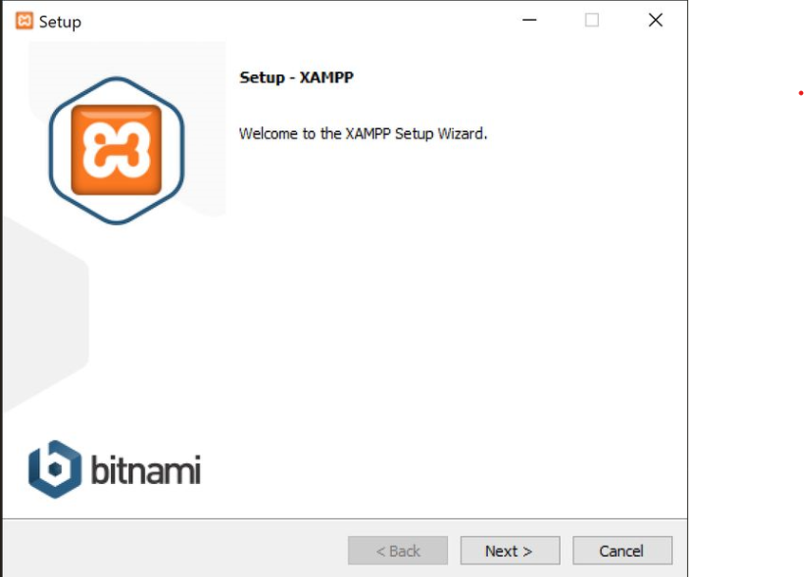
Figure 1: Installation of XAMPP
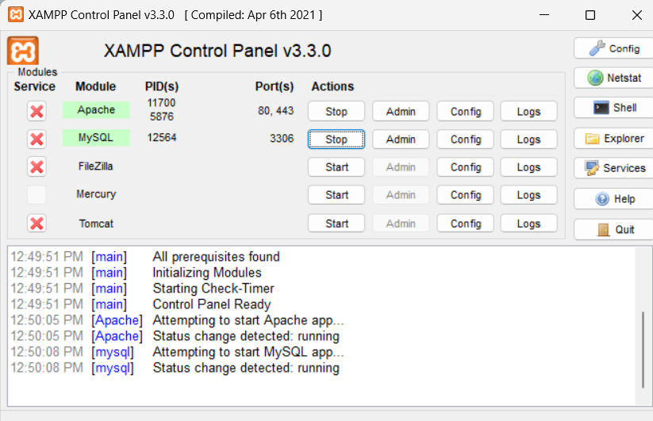
Figure 2: Apache and MySQL running
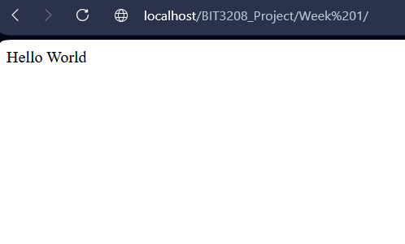
Figure 3: Opera browser running localhost
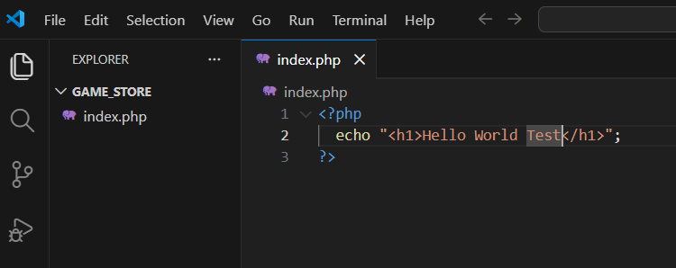
Figure 4: First PHP running "Hello World Test"
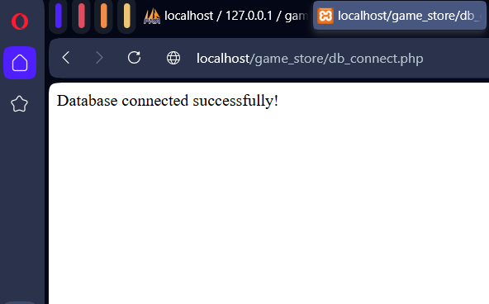
Figure 5: Database connection successful

WEEK 1 REFLECTIONS
This week I learnt about localhost development tool i.e., XAMPP and was able to test that the localhost was functional by the use of phpMyAdmin. This being a new concept was slightly tricky to navigate around but core concepts are now grasped. Fig 1 shows the installation and setup guide for XAMPP. Fig 2 shows the XAMPP control panel with both Apache and MySQL perfectly running as highlighted in green. Fig 3 shows the localhost page running with no issues. Fig 4 shows the PHP code for “Hello World” being executed. Fig 5 shows the databse being connected successfully.

WEEK 2: WIREFRAMES AND GUI DESIGN.

TITLE: USER INTERFACEE PLANNING AND SYSTEM DESIGN
LOG IN
WELCOME TO THE SEA OF GAMES

SIGN UP
NO ACCOUNT?
TERMS AND CONDITIONS

Figure 6: Login Page wireframe
Name
Home
Top selling games
Game Sales
Statistics
Trending
User
Deals
Dashboard

Top Selling Games
Hot Right Now
All-time Best Sellers
Search
Figure 7: Dashboard Layout Design

Figure 8: Mobile Mockup

Search
Top Selling Games
Hot Right Now
All-time Best Sellers
inventory
Home
Deals
User
Trending Now!!!
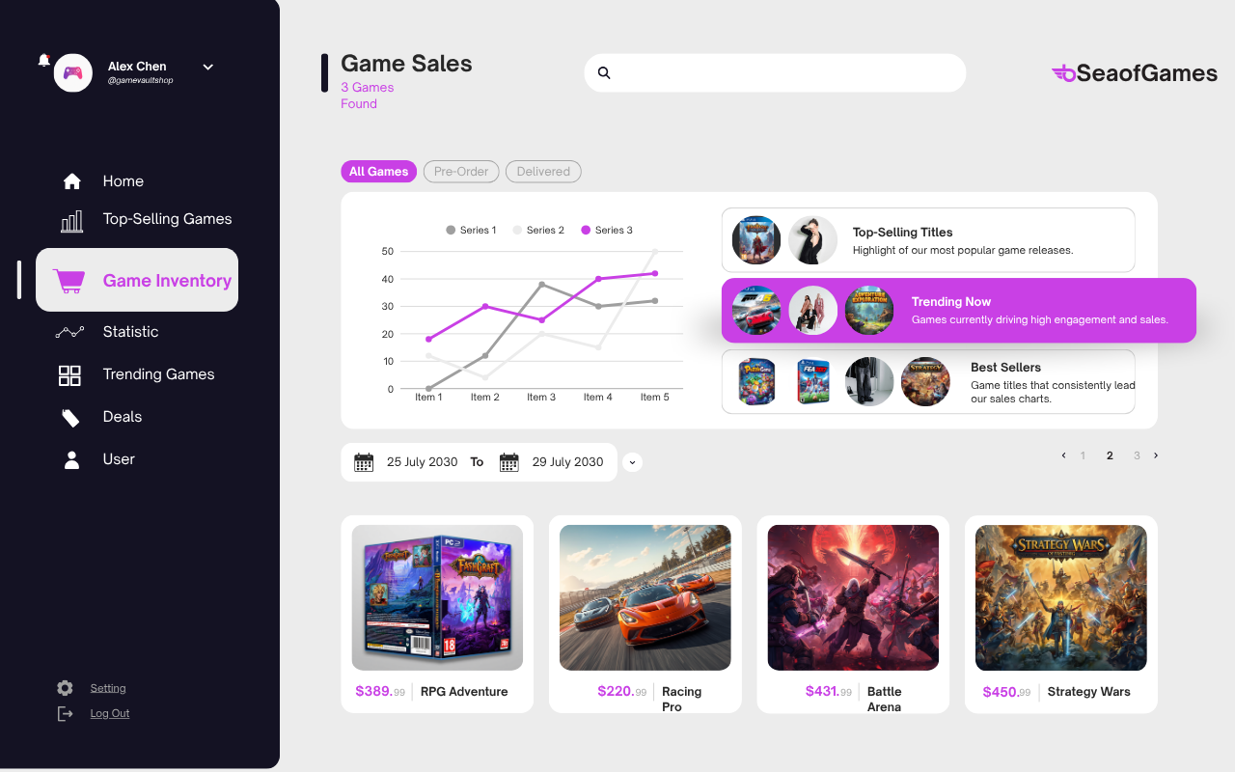
Figure 9: GUI Prototype in Canva

Week 2 Reflection.
I chose this particular design as I wanted something that would not only grab but also retain the attention of the user. I wanted a design that perfectly captures every aspect of the system but at the same time wasn’t convoluted. The system is designed in such a way that the user experience is seamless and they know where they are being redirected. Of course, this system is intended for gamers to buy games at the lowest price possible.

Week 3: JavaScript and PHP Basics

TITLE: Frontend Interaction and Backend Foundations

