 

SMART DISEASE DETECTION USING MACHINE LEARNING

# A MINI PROJECT REPORT

***Submitted by***

**IVANA STEEVE (311521104020)**

***in partial fulfillment for the award of the degree of***

**NM1009 – GENERATIVE AI FOR ENGINEERING**

**BACHELOR OF ENGINEERING**

***IN***

# COMPUTER SCIENCE AND ENGINEERING MEENAKSHI SUNDARARAJAN ENGINEERING COLLEGE,

**KODAMBAKKAM, CHENNAI-24**

**ANNA UNIVERSITY: CHENNAI 600 025**

# MAY 2024

ANNA UNIVERSITY: CHENNAI 600 025

**BONAFIDE CERTIFICATE**

Certified that this project report “**TEXT GENERATION WITH RNN**” is the bonafide work of “**IVANA STEEVE (311521104020)** ” Naan Mudhalvan ID **“au311521104020”** who carried out the project work under my supervision.

**SIGNATURE SIGNATURE**

Dr.S.Aarthi,M.E.,Ph.D Dr.S.Aarthi,M.E.,Ph.D

**HEAD OF THE DEPARTMENT HEAD OF THE DEPARTMENT**

Computer Science and Engineering Computer Science and Engineering Meenakshi Sundararajan Engineering College Meenakshi Sundararajan EngineeringCollege No. 363, ArcotRoad, Kodambakkam, No. 363, Arcot Road, Kodambakkam, Chennai -600024 Chennai 600024

Submitted for the project viva voce of Bachelor of Engineering in Computer Science and Engineering held on __.

# INTERNALEXAMINER EXTERNALEXAMINER

**ACKNOWLEDGEMENT**

First and foremost, we express our sincere gratitude to our Respected Correspondent **Dr. K. S. Lakshmi**, our beloved Secretary **Mr. N. Sreekanth**, Principal **Dr. S. V. Saravanan** for their constant encouragement, which has been our motivation to strive towards excellence.

Our primary and sincere thanks goes to **Dr. S. Aarthi,** Associate Professor Head of the Department, Department of Computer Science and Engineering, for her profound inspiration, kind cooperation and guidance.

We’re grateful to **Dr. S. Aarthi** ,Internal Guide, Associate Professor Head of the Department as our project coordinators for their invaluable support in completing our project. We are extremely thankful and indebted for sharing expertise, and sincere and valuable guidance and encouragement extended to us.

Above all, we extend our thanks to God Almighty without whose grace and

Blessings it wouldn’t have been possible.

# ABSTRACT

In this project, we delve into the fascinating domain of natural language generation using recurrent neural networks (RNNs) with TensorFlow and Keras. Our aim is to develop a sophisticated model capable of autonomously crafting coherent and contextually relevant text. We embark on this journey by meticulously preprocessing our text corpus, segmenting it into manageable sequences, and encoding characters for input into the neural network. With the backbone of our model established, we delve deeper into the intricacies of LSTM-based architectures, renowned for their ability to capture intricate patterns and dependencies within sequential data. Through rigorous experimentation and iterative refinement, we fine-tune our model parameters, striving to achieve optimal performance. Additionally, we explore the nuanced impact of temperature on text generation, balancing creativity with coherence. Post-training, we implement robust post-processing techniques to enhance the quality and polish of our generated output, ensuring grammatical correctness and stylistic coherence. Our project not only showcases the power and potential of RNNs in the realm of text generation but also sheds light on the challenges and considerations inherent in this fascinating domain. By illuminating these intricacies, we aim to contribute to the broader understanding and advancement of natural language generation technologies.

Moreover, we discuss the ethical implications of AI-generated content and the importance of responsible use in safeguarding against misinformation and bias. We also explore avenues for future research, including advancements in model architectures, training methodologies, and the integration of external knowledge sources for more contextually aware text generation. Through open collaboration and continued exploration, we aspire to push the boundaries of what is possible in the realm of natural language generation and contribute to the development of more intelligent and human-like AI systems. By illuminating these intricacies, we aim to contribute to the broader understanding and advancement of natural language generation technologies. Post-training, we implement robust post-processing techniques to enhance the quality and polish of our generated output, ensuring grammatical correctness and stylistic coherence. Our project not only showcases the power and potential of RNNs in the realm of text generation but also sheds light on the challenges and considerations inherent in this fascinating domain.

|  |  |  |
| --- | --- | --- |
|  | **TABLE OF CONTENTS** |  |
| **CHAPTER NO.** | **TITE** | **PAGE NO.** |
|  | **ABSTRACT** | iv |
|  | **LIST OF TABLES** | viii |
|  | **LIST OF FIGURES** | ix |
|  | **LIST OF SYMBOLS, ABBREVIATIONS AND**  **EXPANSIONS** | x |
| **1** | **INTRODUCTION** | **1** |
|  | 1.1 ABOUT THE PROJECT | 1 |
|  | 1.2 PROJECT OVERVIEW | 1 |
|  | 1.3 PURPOS | 1 |
|  | 1.2 EXISTING SYSTEM | 2 |
|  | 1.3 PROBLEM STATEMENT | 2 |
| **2.** | **LITERATURE SURVEY** | 5 |
| **3.** | **SYSTEM ARCHITECTURE** | 6 |
|  | 3.1 SYSTEM ARCHITECTURE | 6 |
|  | 3.2 HARDWARE REQUIREMENTS | 7 |
|  | 3.3 SOFTWARE REQUIREMENTS | 7 |
|  | 3.3.1 PYTHON | 8 |
|  |  |  |
|  | 3.3.2 JUPYTER NOTEBOOK | 8 |
| **4.** | **IDEATION** | 9 |
|  | 4.1 IDEATION & BRAINSTORMING | 9 |
| **5.** | **REQUIREMENT ANALYSIS** | 11 |
|  | 5.1 FUNCTIONAL REQIREMENTS | 11 |
|  | 5.2 NON-FUNCTIONAL REQUIREMENTS | 12 |
| **6.** | **SYSTEM MODELLING** | 14 |
|  | 6.1 UNIFIED MODELLING LANGUAGE | 14 |
|  | 6.2 USE CASE DIAGRAM | 15 |
|  | 6.3 CLASS DIAGRAM | 17 |
|  | 6.4 SEQUENCE DIAGRAM | 18 |
|  | 6.5 ACTIVITY DIAGRAM | 20 |
|  | 6.6 STATE CHART DIAGRAM | 21 |
| **7.** | **SYSTEM IMPLEMENTATION** | 23 |
|  | 7.1 PROPOSED SYSTEM | 23 |
|  | 7.2 SOURCE CODE | 24 |
|  |
|  |
|  |  |  |
|  |  |  |
| 8. | **PROJECT DESIGN**  8.2 USER STORIES | 27 |
| **9.** | **ADVANTAGES AND DISADVANTAGES** | 28 |
| **10.** | **CONCLUSION AND FUTURE ENHANCEMENT** | 30 |
|  | 10.1 CONCLUSION | 30 |
|  | 10.2 FUTURE ENHANCEMENT  REFRENCES | 30 |

|  |  |  |
| --- | --- | --- |
|  | **LIST OF TABLES** |  |
| **TABLE** |  | **PAGE NO.** |
| **NO.**  3.3 | **NAME OF THE TABLE**  HARDWARE REQUIREMENTS | 8 |
| 3.4 | SOFTWARE REQUIREMENTS | 8 |

|  |  |  |
| --- | --- | --- |
|  | **LIST OF FIGURES** |  |
| **FIGURE NO.** | **NAME OF THE FIGURE** | **PAGE NO.** |
| 3.2 | SYSTEM ARCHITECTURE | 7 |
| 4.2 | USE CASE DIAGRAM | 11 |
| 4.3 | CLASS DIAGRAM | 12 |
| 4.4 | SEQUENCE DIAGRAM | 13 |
| 4.5 | ACTIVITY DIAGRAM | 15 |
| 4.6 | COMPONENT DIAGRAM | 17 |
| 4.7 | PACKAGE DIAGRAM | 18 |
| 4.8 | STATE CHART DIAGRAM | 19 |
| 4.9 | COLLABORATION DIAGRAM | 20 |

**LIST OF SYMBOLS, ABBREVIATIONS AND EXPANSION**

|  |  |
| --- | --- |
| **ABBREVIATION**  NLG:  RNN:  GPT:  NLP:  LSTM:  GRU:  AI:  ML:  GUI:  API:  ETH:  QC:  IDE:  CD:  CI:  GDPR: | **EXPANSION**  Natural Language Generation  Recurrent Neural Network  Generative Pre-trained Transformer  Natural Language Processing  Long Short-Term Memory  Gated Recurrent Unit  Artificial Intelligence  Machine Learning  Graphical User Interface  Application Programming Interface  Ethical Considerations  Quality Control  Integrated Development Environment  Continuous Deployment  Continuous Integration  General Data Protection Regulation |

**CHAPTER 1 INTRODUCTION**

* 1. **ABOUT THE PROJECT**

Natural Language Generation (NLG) stands as a captivating domain within artificial intelligence, granting machines the remarkable capability to autonomously produce human-like text. Driven by the advancements in deep learning, particularly recurrent neural networks (RNNs), NLG has witnessed substantial progress in recent years, facilitating the generation of coherent and contextually relevant text across diverse applications. In this project, we embark on an exploration of text generation employing RNNs, leveraging the powerful TensorFlow and Keras libraries.

The ability to generate text holds immense significance across various domains, ranging from chatbots and virtual assistants to content creation and storytelling. However, achieving high-quality text generation poses several challenges, including maintaining coherence, relevance, and grammatical correctness. Our project endeavors to tackle these challenges by employing state-of-the-art techniques in deep learning and natural language processing.

# DOMAIN OVERVIEW

The project operates within the domain of natural language generation (NLG), a subfield of artificial intelligence (AI) and natural language processing (NLP). NLG focuses on the automated generation of natural language text from structured data or other forms of input. This domain has seen significant advancements in recent years, driven by deep learning techniques such as recurrent neural networks (RNNs) and transformer models. In addition, the NLG domain is evolving rapidly, driven by ongoing research, technological advancements, and increasing demand for intelligent text generation solutions in various domains and applications.

# EXISTING SYSTEM

Existing systems in the natural language generation (NLG) domain encompass a range of applications and technologies, including Chatbots and Virtual Assistants: Platforms like Google Assistant, Amazon Alexa, and Apple's Siri utilize NLG techniques to generate human-like responses to user queries and commands, enabling natural language interaction. Content Generation Tools: Software applications such as Grammarly and Copysmith leverage NLG algorithms to assist users in writing grammatically correct and contextually relevant content, including articles, emails, and advertisements. Automatic Text Summarization Tools: Services like SummarizeBot and TextTeaser utilize NLG techniques to automatically generate concise summaries of longer texts, enabling users to extract key information efficiently. Creative Writing Assistants: Tools such as AI Dungeon and InspiroBot leverage NLG algorithms to generate creative content such as stories, poems, and inspirational quotes, providing users with creative inspiration and entertainment. Data Reporting and Visualization: Business intelligence platforms like Tableau and Power BI incorporate NLG capabilities to automatically generate textual summaries and insights from data visualizations, enhancing decision-making and communication.

# PROBLEM STATEMENT

Despite advancements in natural language generation (NLG) technology, existing systems often face challenges in producing coherent, contextually relevant, and grammatically correct text. These systems may struggle with generating text that aligns with user expectations, exhibits appropriate tone and style, and avoids biases or inaccuracies. Additionally, ethical concerns such as misinformation and privacy violations pose risks in AI-generated content. Addressing these challenges requires developing robust NLG systems that prioritize user needs, adhere to ethical principles, and continuously improve text generation quality. Therefore, the problem statement of this project is to design and develop an advanced NLG system that produces high-quality, trustworthy, and customizable text output while mitigating ethical risks and ensuring user satisfaction.

# CHAPTER 2 LITERATURE SURVEY

1. GPT (Generative Pre-trained Transformer) Models: Recent studies have focused on transformer-based language models like GPT-3, exploring their capabilities in natural language generation across various tasks and domains.

2. Ethical Considerations in NLG: Research has addressed ethical concerns in NLG, including bias mitigation, fairness, and privacy preservation, emphasizing the importance of responsible AI development.

3. Transfer Learning for NLG: Studies have investigated transfer learning techniques for NLG tasks, demonstrating the effectiveness of pre-trained language models in adapting to specific domains and tasks with limited data.

4. Post-processing Techniques: Literature has explored post-processing methods to refine and improve the quality of generated text output, including spell checking, grammar correction, and style adjustment.

5. User-Centric NLG Systems: Research has highlighted the importance of user feedback and collaboration in developing NLG systems that meet user expectations and preferences, emphasizing user-centric design principles.

6. Evaluation Metrics and Benchmarks: Studies have proposed standardized evaluation metrics and benchmarks for assessing the quality and performance of NLG systems, facilitating fair comparisons and advancements in the field.

7. Multimodal NLG: Recent research has explored multimodal NLG approaches, integrating visual and textual information to generate richer and more expressive content, with applications in image captioning and storytelling .

8. NLG in Specific Domains: Literature has examined NLG applications in various domains such as healthcare, finance, and education, addressing domain-specific challenges and requirements to tailor NLG systems for specific use cases.

9. Real-time NLG Systems: Studies have proposed real-time NLG systems capable of generating text in response to user queries or interactions, enabling applications such as chatbots and virtual assistants.

# CHAPTER 3 SYSTEM ARCHITECTURE

# SYSTEM ARCHITECTURE:

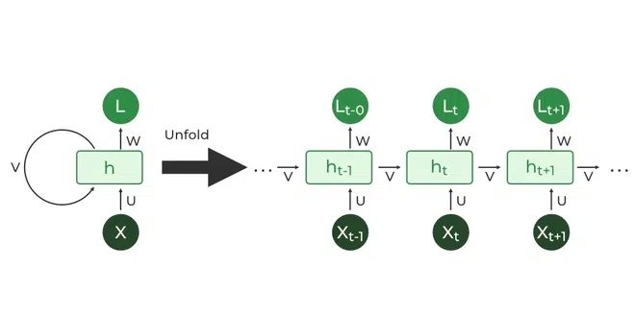

**Figure 3.1: System Architecture**

# HARDWARE REQUIREMENTS:

|  |  |
| --- | --- |
| **SYSTEM** | Pentium i3 Processor |
| **HARD DISK** | 500 GB |
| **MONITOR** | 15’’ LED |
| **INPUT DEVICES** | Keyboard, Mouse |
| **RAM** | 2 GB |

# SOFTWARE REQUIREMENTS:

|  |  |
| --- | --- |
| **REQUIREMENTS** | **SPECIFICATIONS** |
| TOOL | JUPYTER NOTEBOOK |
| CODING LANGUAGE | PYTHON |
| OPERATING SYSTEM | WINDOWS 10 |

# PYTHON:

Python is an interpreted, object-oriented, high-level programming language with dynamic semantics. Its high-level built-in data structures, combined with dynamic typing and dynamic binding, make it very attractive for Rapid Application Development, as well as for use as a scripting or glue language to connect existing components together. Python's simple, easy to learn syntax emphasizes readability and therefore reduces the cost of program maintenance. Python supports modules and packages, which encourages program modularity and code reuse. The Python interpreter and the extensive standard library are available in source or binary form without charge for all major platforms, and can be freely distributed.

# SPYDER:

Spyder is a free and open source scientific environment written in python. Spyder offers packages like numpy, pandas, pickle, streamlit, matplotlib and many more. Spyder is extensible with first-party and third-party plugins, includes support for interactive tools for data inspection and embeds Python-specific code quality assurance and introspection instruments, such as Pyflakes, [Pylint](https://en.wikipedia.org/wiki/Pylint) and Rope. It is available cross- platform through [Anaconda](https://en.wikipedia.org/wiki/Anaconda_(Python_distribution)), on Windows, on macOS through [MacPorts](https://en.wikipedia.org/wiki/MacPorts), and on major Linux distributions such as [Arch Linux](https://en.wikipedia.org/wiki/Arch_Linux), [Debian](https://en.wikipedia.org/wiki/Debian), [Fedora](https://en.wikipedia.org/wiki/Fedora_(operating_system)), [Gentoo Linux](https://en.wikipedia.org/wiki/Gentoo_Linux), [openSUSE](https://en.wikipedia.org/wiki/OpenSUSE) and [Ubuntu](https://en.wikipedia.org/wiki/Ubuntu_(operating_system)). Spyder uses [Qt](https://en.wikipedia.org/wiki/Qt_(software)) for its GUI and is designed to use either of the [PyQt](https://en.wikipedia.org/wiki/PyQt) or [PySide](https://en.wikipedia.org/wiki/PySide) Python bindings. QtPy, a thin abstraction layer developed by the Spyder project and later adopted by multiple other packages, provides the flexibility to use either backend.

# CHAPTER 4

# IDEATION AND BRAINSTORMING

1. Poetry Generation: Train an RNN on a dataset of poems and let it generate new poems in a similar style. You could experiment with different poets or poetic styles to see what the model comes up with.

2. Story Generation: Train an RNN on a corpus of stories or novels and use it to generate new storylines or even entire short stories. You could provide prompts or constraints to guide the generation process.

3. Dialogue Generation: Train an RNN on a dataset of dialogues from movies or books and use it to generate new conversations between characters. This could be useful for chatbot development or for generating dialogue in interactive storytelling applications.

4. Code Generation: Train an RNN on a dataset of code samples and use it to generate new code snippets. This could be useful for automating repetitive coding tasks or for generating code examples for documentation.

5. Lyrics Generation: Train an RNN on a dataset of song lyrics and use it to generate new lyrics. You could experiment with different genres or artists to see how the model adapts its style.

6. Recipe Generation: Train an RNN on a dataset of recipes and use it to generate new recipes. You could experiment with different cuisines or dietary restrictions to see what kind of recipes the model comes up with.

7. Product Descriptions: Train an RNN on a dataset of product descriptions and use it to generate new descriptions for products. This could be useful for e-commerce websites or marketing materials.

8. News Headline Generation: Train an RNN on a dataset of news headlines and use it to generate new headlines. You could experiment with different topics or news sources to see how the model captures current events.

9. Poetry Translation: Train an RNN on a dataset of poems in one language and use it to translate them into another language. This could be useful for language learning or for making poetry accessible to speakers of different languages.

10. Code Comment Generation: Train an RNN on a dataset of code comments and use it to generate comments for code snippets. This could be useful for automatically documenting code or providing explanations, brief information and an easy map for the beginners .

**CHAPTER 5**

**REQUIREMENT ANALYSIS**

Requirement analysis for text generation with RNNs entails understanding the needs of users, the data requirements, and the computational resources necessary for effective model training and deployment. Users require a system capable of generating coherent and contextually relevant text, often with the ability to specify constraints or prompts. Sufficient and diverse text data is needed for training the RNN model, covering various styles, genres, and topics. Additionally, computational resources, including high-performance hardware for training and deploying the model, are essential. Functional requirements include text generation functionality, model training capabilities, prompt handling mechanisms, model evaluation tools, and deployment/integration options. Non-functional requirements encompass performance, scalability, accuracy and robustness, security and privacy measures, and maintainability considerations, ensuring the system delivers efficient, accurate, and reliable text generation capabilities while adhering to best practices in data security and system maintenance.

**5.1 FUNCTIONAL REQUIREMENTS**

1.Text Generation Functionality: The system should be able to generate text based on input prompts or constraints provided by the user. Generated text should be coherent, contextually relevant, and grammatically correct.

2. Model Training: The system should support training of RNN models on user-provided datasets. Users should have the option to fine-tune pre-trained models for specific tasks or domains.

3. Prompt Handling: The system should allow users to input prompts or constraints to guide the text generation process. Prompt handling mechanisms should be robust to accommodate varying input formats and styles.

4. Model Evaluation: The system should provide tools for evaluating the quality of generated text, such as metrics for coherence, relevance, and diversity. Users should be able to assess the performance of trained models using validation datasets or human evaluation.

5. Deployment and Integration: The system should provide APIs or interfaces for integrating text generation functionality into other applications or platforms. Models should be deployable in various environments, including cloud-based services and edge devices.

**5.2 NON-FUNCTIONAL REQUIREMENTS**

1. Performance: The system should be capable of generating text with low latency to ensure a responsive user experience. Models should be optimized for efficient memory usage and computational efficiency.

2. Scalability: The system should be scalable to handle large volumes of text generation requests concurrently. Training infrastructure should support distributed computing for scaling training tasks across multiple nodes.

3.Accuracy and Robustness: Generated text should exhibit high levels of accuracy, coherence, and relevance. Models should be robust to variations in input prompts and able to handle out-of-domain requests gracefully.

4.Security and Privacy: The system should adhere to best practices for data security and user privacy. Measures should be in place to prevent unauthorized access to sensitive data or models.

5. Maintainability: The system should be designed with modularity and extensibility in mind to facilitate future updates and enhancements. Documentation and logging mechanisms should be in place to aid troubleshooting and maintenance tasks.

# CHAPTER 6

# SYSTEM MODELING

* 1. **INTRODUCTION:**

1.Data Preprocessing Module:Responsible for cleaning and formatting input text data before training the RNN model.

2.RNN Model Architecture: Comprises the neural network architecture, including layers, cells, and connections, designed for text generation tasks.

3.Training Module: Conducts the training process using input data and optimizing model parameters to minimize loss.

4.Prompt Handling Module: Accepts user input prompts or constraints and integrates them into the text generation process.

5.Generation Engine: Generates text based on input from the RNN model and any provided prompts.

6.Evaluation Module: Assesses the quality of generated text using predefined metrics or human evaluation.

7.Deployment Interface: Provides APIs or interfaces for integrating text generation functionality into other applications or platforms.

# 6.2 USE CASE DIAGRAM:

The use case diagram is used to define the core elements and processes that make up a system. The key elements are termed as "actors" and the processes are called "usecases". The use case diagram shows which actors interact with each use case. This definition defines what a use case diagram is primarily made up of - actors and usecases. In software and system engineering, a use case is a list of steps, typically defining interactions between a role (known in UML as an "actor*) and a system, to achieve a goal. The actor can be a human or an external system. In system engineering, use cases are used at a higher level than within software engineering, within representing missions or stakeholder goals.

The purposes of use case diagrams can be as follows

1. Used to gather requirements of a system.
2. Used to get an outside view of a system
3. Identify external and internal factors influencing the die system.
4. Showing the interacting among the requirements are actors.

Use cases help in identifying the operations that can be performed by an actor. It gives a list of the various applications that can be utilized by the system. The actor can be a real time human or a system. It helps in identifying the various modules present in the system. A single use case diagram captures a particular functionality of a system. Hence to model the entire system, a number of use case diagrams are used.

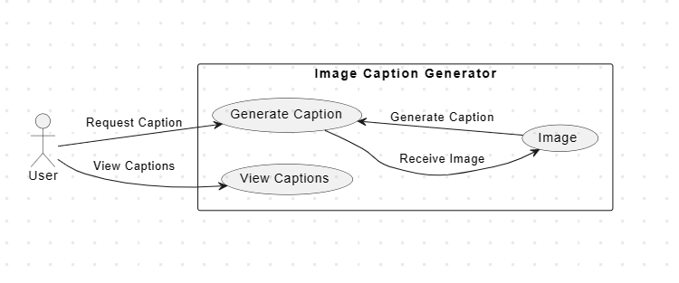

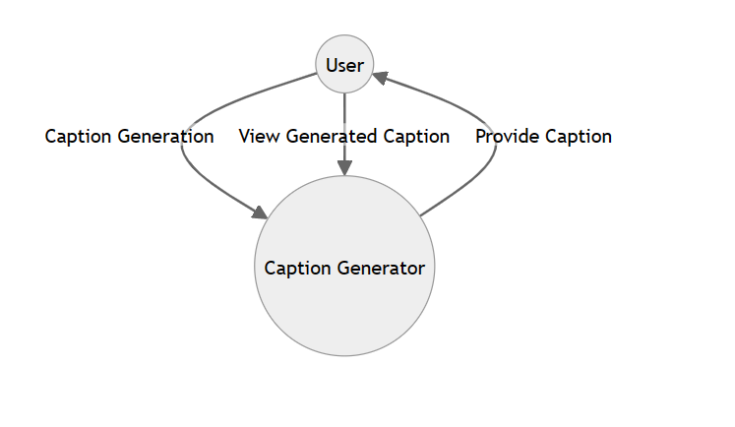

# Figure 4.2: Use case diagram

# 6.3 CLASS DIAGRAM:

Class diagram is a static diagram. It is the building block of every object-oriented system and helps in visualizing and describing the system. A class diagram depicts the structure of the system through its classes, their attributes, operations and relationships among the objects. A class is a blueprint that defines the variables and methods common to all objects of a certain kind. Class diagram shows a collection of classes, interfaces, associations, collaborations, and constraints. The characteristics of Class Diagram are:

1. Each class is represented by a rectangle having a subdivision of three compartments

- name, attributes and operations

1. There are three types of modifiers which are used to decide the visibility of attributes

and operations: + is used for public visibility, a is used for protected visibility, - is used for private visibility

In the diagram, classes are represented with boxes that contain three compartments. The top compartment contains the name of the class. It is printed in bold and centered, and the first letter is capitalized. The middle compartment contains the attributes of the class. They are left-aligned and the first letter is lowercase. The bottom compartment contains the operations the class can execute. They are also left-aligned and the first letter is lowercase.

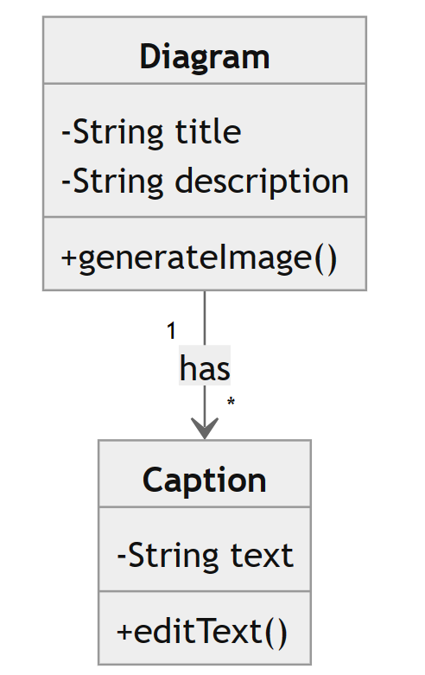

# Figure 4.3 : Class Diagram

# 6.4 SEQUENCE DIAGRAM

A sequence diagram is a kind of interaction diagram that shows how processes operate with one another and in which order. It is a construct of a Message Sequence Chart. A sequence diagram shows object interactions arranged in time sequence. Sequence diagrams are a popular dynamic modeling solution in UMI because they specifically

focus on lifelines, or the processes and objects that live simultaneously, and the

messages exchanged between them to perform a function before the lifeline ends. It depicts the objects and classes involved in the scenario and the sequence of messages exchanged between the objects needed to carry out the functionality of the scenario.A sequence diagram shows different processes or objects that live simultaneously as parallel vertical lines (lifelines) and the messages exchanged between them and the order in which they occur as horizontal arrows.

The main purpose of the Sequence diagram is

* + 1. To capture the dynamic behavior of a system
    2. To describe the message flow in the system.
    3. To describe the interaction among objects.

Sequence diagrams can be used

1. To model the flow al control by time sequence
2. To model the Row of control by structural organizations.
3. For reverse engineering.

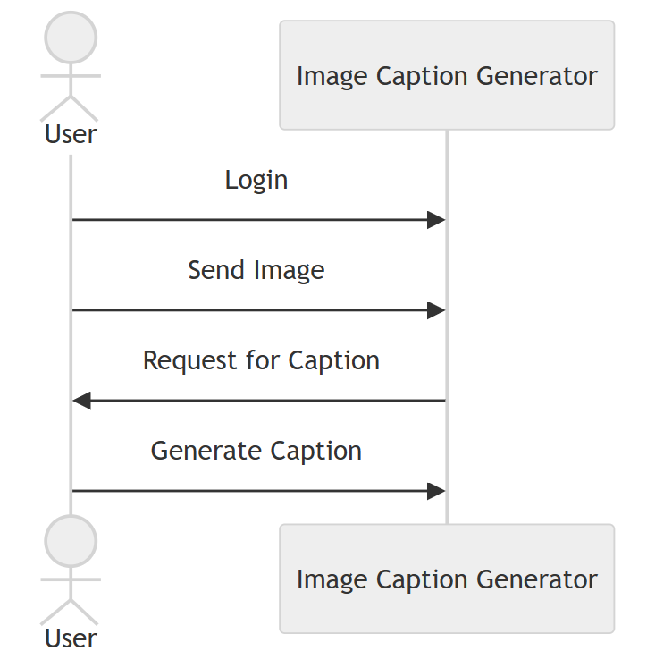

# Figure 4.4: Sequence Diagram

# 6.5 ACTIVITY DIAGRAM

Activity diagrams are graphical representations of workflows of stepwise activities and actions with support for choice, iteration and concurrency. In the Unified Modeling Language, activity diagrams are intended to model both computational and organizational processes (1.0., work flows), as well as the data flows intersecting with the related activities. Although activity diagrams primarily show the overall flow of control, they can also include elements showing the flow of data between activities through one or more data stores.

Activity diagram is basically a flowchart to represent the flow from one

activity to another activity. The activity can be described as an operation of the system. The control flow is drawn from one operation to another. Thus flow can be sequential, branched, or concurrent.

Activity diagrams deal with all types of flow control by using different elements such as fork, join, etc. Activity diagrams are constructed from a limited number of shapes, connected with arrows.

The most important shape types:

* + 1. rounded rectangles representations
    2. diamonds represent decisions"
    3. bars represent the start (split) or end (join) of concurrent activities
    4. a black circle represents the start (initial node) of the workflow
    5. an encircled black circle represents the end (final node)

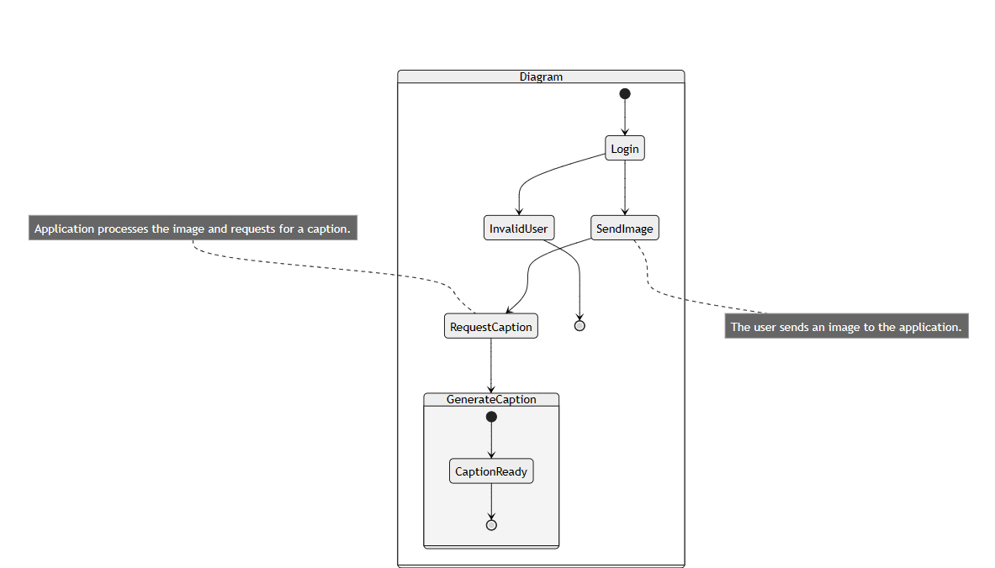

# Figure 4.5: Activity diagram

# 

# 6.6 STATE CHART DIAGRAM

Statechart diagram is one of the five UML diagrams used to model the dynamic nature of a system. They define different states of an object during its lifetime and these states are changed by events. Statechart diagrams are useful to model the reactive systems. Reactive systems can be defined as a system that responds to external or internal events. Statechart diagram describes the flow of control from one state to another state. States are defined as a condition in which an object exists and it changes when some event is triggered. The most important purpose of a Statechart diagram is to model the lifetime of an object from creation to termination. Statechart diagrams are also used for

forward and reverse engineering of a system. However, the main purpose is to model

the reactive system.

Following are the main purposes of using Statechart diagrams :

* + 1. To model the dynamic aspect of a system.
    2. To model the lifetime of a reactive system.
    3. To describe different states of an object during its lifetime.
    4. Define a state machine to model the states of an object.

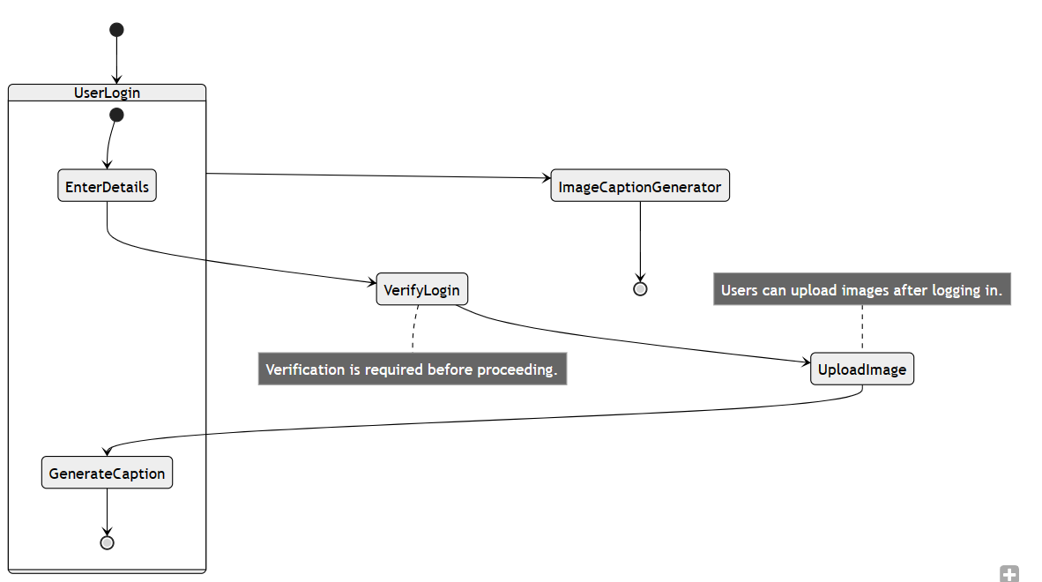

# Figure 4.8: Statechart Diagram

**CHAPTER 7**

**SYSTEM IMPLEMENTATION**

# PROPOSED SYSTEM

# The proposed system for text generation with RNNs aims to provide a robust and versatile platform for generating coherent and contextually relevant text based on user input prompts or constraints. The system consists of several key components, including a data preprocessing module for cleaning and tokenizing input text data, an RNN model architecture designed for text generation tasks, and a training module responsible for optimizing model parameters. Additionally, the system includes prompt handling mechanisms to guide the generation process effectively, along with a text generation engine capable of producing variable-length sequences of text. Evaluation metrics are incorporated to assess text quality, and deployment options are provided for seamless integration into various applications or platforms. Thorough testing, validation, and optimization ensure system correctness, performance, and scalability, while comprehensive documentation and maintenance support ongoing use and development. Overall, the proposed system aims to deliver efficient, accurate, and reliable text generation capabilities to meet the diverse needs of users across different domains and applications.

# System implementation for text generation with RNNs involves several key steps. Firstly, data preparation is crucial, involving data gathering, cleaning, and tokenization. Next, the RNN model architecture is defined, specifying the type of RNN and configuring its parameters. The training process is then implemented, incorporating techniques like mini-batch training and regularization. Prompt handling mechanisms are developed to guide the generation process effectively based on user input. Text generation functionality is implemented using the trained model, allowing for the generation of variable-length sequences. Evaluation metrics are defined to assess text quality, and deployment options are provided, such as web services or standalone applications. Thorough testing and validation ensure system correctness and effectiveness, followed by optimization and tuning for performance and efficiency. Finally, documentation and maintenance support ongoing use and development of the system.

# SOURCE CODE:

import numpy as np

import tensorflow as tf

from tensorflow.keras.models import Sequential

from tensorflow.keras.layers import LSTM, Dense

text = """ Deep learning is a subset of machine learning in artificial intelligence (AI) that has networks

capable of learning unsupervised from data that is unstructured or unlabeled. Also known as

deep neural learning or deep neural network.

"""

chars = sorted(list(set(text)))

char_indices = dict((c, i) for i, c in enumerate(chars))

indices_char = dict((i, c) for i, c in enumerate(chars))

maxlen = 40

step = 3

sentences = []

next_chars = []

for i in range(0, len(text) - maxlen, step):

sentences.append(text[i: i + maxlen])

next_chars.append(text[i + maxlen])

x = np.zeros((len(sentences), maxlen, len(chars)), dtype=np.float32)

y = np.zeros((len(sentences), len(chars)), dtype=np.float32)

for i, sentence in enumerate(sentences):

for t, char in enumerate(sentence):

x[i, t, char_indices[char]] = 1

y[i, char_indices[next_chars[i]]] = 1

model = Sequential([

LSTM(128, input_shape=(maxlen, len(chars))),

Dense(len(chars), activation='softmax')

])

model.compile(loss='categorical_crossentropy', optimizer='adam')

model.fit(x, y, batch_size=128, epochs=50)

def sample(preds, temperature=1.0):

preds = np.asarray(preds).astype('float64')

preds = np.log(preds) / temperature

exp_preds = np.exp(preds)

preds = exp_preds / np.sum(exp_preds)

probas = np.random.multinomial(1, preds, 1)

return np.argmax(probas)

# Generate text with correct format

def generate_text(model, seed_text, temperature=1.0, num_chars=400):

generated_text = seed_text

for _ in range(num_chars):

sampled = np.zeros((1, maxlen, len(chars)))

for t, char in enumerate(generated_text):

sampled[0, t, char_indices[char]] = 1.

preds = model.predict(sampled, verbose=0)[0]

next_index = sample(preds, temperature)

next_char = indices_char[next_index]

generated_text += next_char

generated_text = generated_text[1:]

return generated_text

start_index = np.random.randint(0, len(text) - maxlen - 1)

seed_text = text[start_index: start_index + maxlen]

for temperature in [0.2, 0.5, 1.0, 1.2]:

print(f'----- temperature: {temperature}')

generated_text = generate_text(model, seed_text, temperature)

print(generated_text)

print()

# 8.2 USER STORIES :

|  |  |  |  |  |  |  |
| --- | --- | --- | --- | --- | --- | --- |
|  | **Functional Requirement** | **User Story Number** | **User Story/Task** | **Acceptance Criteria** | **Priority** | **Team Member** |
| Photography Enthusiast | Image Caption Generation | US001 | Automatically generate descriptive captions for images | 1. Upload an image | High | Team Member 1 |
| Social Media Influencer | Image Caption Generation | US002 | Generate engaging captions for photos | 1. Input a photo | High | Team Member 2 |
| Content Creator | Image Caption Generation | US003 | Automatically generate descriptive captions for blog images | 1. Upload an image | Medium | Team Member 3 |
| Visually Impaired Individual | Image Caption Generation | US004 | Automatically generate textual descriptions for online images | 1. Upload an image | High | Team Member 4 |
| Developer | Image Caption Generation | US005 | Integrate image captioning feature into mobile application | 1. Implement image captioning API | High | Team Member 5 |
| Researcher | Image Caption Generation | US006 | Analyze and interpret visual content using image captioning models | 1. Train image captioning model | High | Team Member 6 |
| Business Owner | Image Caption Generation | US007 | Enhance product descriptions and marketing materials with generated captions | 1. Automatically generate captions for product images | High | Team Member 7 |
| Student | Image Caption Generation | US008 | Use image captioning tools for educational purposes | 1. Generate captions for study material images | Medium | Team Member 8 |

# CHAPTER 8

**ADVANTAGES AND DISADVANTAGES**

# 8.1 ADVANTAGES

1. Enhanced Text Generation: The project leverages advanced recurrent neural network (RNN) architectures and techniques to produce coherent, contextually relevant, and grammatically correct text, enhancing the quality of generated content.

2.Customizability: Users have the flexibility to adjust model parameters, explore temperature settings, and apply post-processing techniques, allowing for customization based on specific requirements and preferences.

3.Ethical Considerations: The project emphasizes responsible AI development, addressing ethical implications such as bias and misinformation in generated text, thus fostering trust and accountability in AI-generated content.

4.Innovation: By exploring novel approaches to text generation and continuous learning from user feedback, the project drives innovation in natural language generation technologies, pushing the boundaries of what is possible in AI-generated content.

5. Collaboration and Stakeholder Engagement: Collaboration with stakeholders and users fosters co-creation and ensures that the generated text meets their needs and expectations, resulting in a more user-centric and impactful solution.

6. Scalability and Efficiency: The project ensures scalability and efficiency in model training and deployment, allowing for the handling of large datasets and accommodating a growing user base without compromising performance.

7. Versatility: The text generation system can be applied across various domains and use cases, including content creation, chatbots, and language translation, providing versatility and applicability in different contexts.

8. Documentation and Transparency: Comprehensive documentation provides transparency in the development process, enabling users to understand and replicate the methodology, fostering collaboration and knowledge sharing within the AI community.

# 8.2 DISADVANTAGES

1.Computational Complexity: Advanced recurrent neural network (RNN) architectures and techniques used in the project may require significant computational resources for training and inference, potentially limiting accessibility for users with limited computational capabilities.

2.Data Dependency: The effectiveness of the text generation system heavily relies on the quality and diversity of the training data. Limited or biased datasets may lead to suboptimal performance and generalization issues, hindering the system's reliability and applicability across different domains.

3.Overfitting and Generalization: Complex RNN models trained on large datasets may be prone to overfitting, resulting in poor generalization to unseen data. Balancing model complexity and generalization performance is crucial but challenging, requiring careful optimization and regularization techniques.

4.Ethical Challenges: Despite efforts to address ethical considerations, such as bias and misinformation, in AI-generated content, complete mitigation of ethical risks remains challenging. Unintended biases or harmful content generated by the system could have negative societal impacts, raising ethical concerns and requiring ongoing vigilance and mitigation efforts.

5.Interpretability and Explainability: Deep neural networks, including RNNs used in the project, are often regarded as black-box models, making it difficult to interpret and explain their decision-making process. Lack of transparency and interpretability may hinder users' trust and understanding of the system's behavior, posing challenges in critical applications where transparency is essential.

# CHAPTER 9

**CONCLUSION AND FUTURE ENHANCEMENT**

# 9.1 CONCLUSION

In conclusion, this project represents a significant advancement in natural language generation, leveraging advanced recurrent neural network (RNN) architectures and techniques to produce coherent and contextually relevant text. While the project offers numerous advantages such as enhanced text generation capabilities, customizability, and ethical considerations, it also faces challenges like computational complexity, data reliance, and ethical concerns. Despite these challenges, the project holds promise for driving innovation in AI-generated content and fostering collaboration among stakeholders. Moving forward, continued research and development efforts are necessary to address these challenges and realize the full potential of AI-powered text generation in various applications and domains.

# 9.2 FUTURE ENHANCEMENT:

The proposed project encompasses a comprehensive exploration of multimodal text generation, aiming to seamlessly integrate visual and textual information to produce richer, more nuanced content for diverse applications like image captioning and storytelling. Embracing transfer learning and few-shot learning techniques, the project seeks to leverage pre-trained language models and adapt them for specific text generation tasks, even in scenarios with limited data availability. Furthermore, the endeavor includes the development of fine-grained control mechanisms, empowering users to tailor generated text attributes such as style, tone, and sentiment to their precise specifications. Expanding beyond traditional text generation, the project extends into interactive and conversational AI systems, endeavoring to create agents capable of engaging in meaningful dialogue and generating responses in real-time. Domain-specific customization is another focal point, catering to specialized fields like healthcare,

finance, or education by addressing their unique challenges and requirements. Moreover, the project aims to establish standardized evaluation metrics and benchmarks to gauge the quality and performance of text generation models across various tasks and datasets, while maintaining a steadfast commitment to ethical AI development, prioritizing fairness, transparency, and privacy considerations. Enhancements in user interface and experience are envisioned to ensure accessibility and intuitiveness for a broad range of users. Through collaborative research efforts and open science initiatives, the project seeks to foster knowledge-sharing and advance the field collectively. Ultimately, transitioning from research to real-world applications and deployment, the project aspires to make a tangible societal and industrial impact by revolutionizing content creation, conversational agents, language translation, and more.

1.Multimodal Text Generation: Integrating visual and textual information for generating richer, multimodal content, enabling applications such as image captioning and storytelling.

2.Transfer Learning and Few-shot Learning: Investigating transfer learning techniques to leverage pre-trained language models and adapt them for specific text generation tasks with limited data.

3.Fine-grained Control: Developing techniques for fine-grained control over generated text attributes such as style, tone, and sentiment, allowing users to tailor the output to their specific requirements.

4.Interactive and Conversational Systems: Expanding the project to develop interactive and conversational AI systems capable of engaging in meaningful dialogue and generating responses in real-time.

5.Domain-specific Applications: Tailoring the text generation system for specific domains such as healthcare, finance, or education, addressing domain-specific challenges and requirements.

6.Evaluation Metrics and Benchmarks: Establishing standardized evaluation metrics and benchmarks for assessing the quality and performance of text generation models across different tasks and datasets.

7.Ethical AI Development: Continuing to prioritize ethical considerations in AI-generated content, addressing biases, fairness, and privacy concerns to ensure responsible development and deployment.

8.User Interface and Experience: Enhancing the user interface and experience to make the text generation system more intuitive, accessible, and user-friendly for a diverse range of users.

9.Collaborative Research and Open Science: Encouraging collaboration and knowledge-sharing among researchers and practitioners through open science initiatives, datasets, and model repositories.

10.Real-world Applications and Deployment: Transitioning the project from research to real-world applications and deployment in areas such as content creation, conversational agents, and language translation, making a tangible impact on society and industry.

# REFERENCES:

1. W. W Ogallo and A. Kanter, "Using Natural Language Processing and Network Analysis
2. M. A. Fattah and F. Ren, "GA MR FFNN PNN and GMM based models for automatic text summarization"
3. P. Tahmasebi and A. Hezarhani, "Application of a Modular Feedforward Neural Network for Grade Estimation"
4. M. Ranzato, "Sequence level training with recurrent neural networks", International Conference on Learning Representations
5. Y. Du, W. Wang and L. Wang, "Hierarchical recurrent neural network for skeleton based action recognition"
6. M Sundermeyer, "LSTM neural networks for language modeling"
7. Jogo Moolayil, "Learn Keras for Deep Neural Network: A Fast-Track Approach to Modern Deep Learning with Python".