Assignment 3 – Virtual PC

Student – Jared Fowler

Learn Mode:

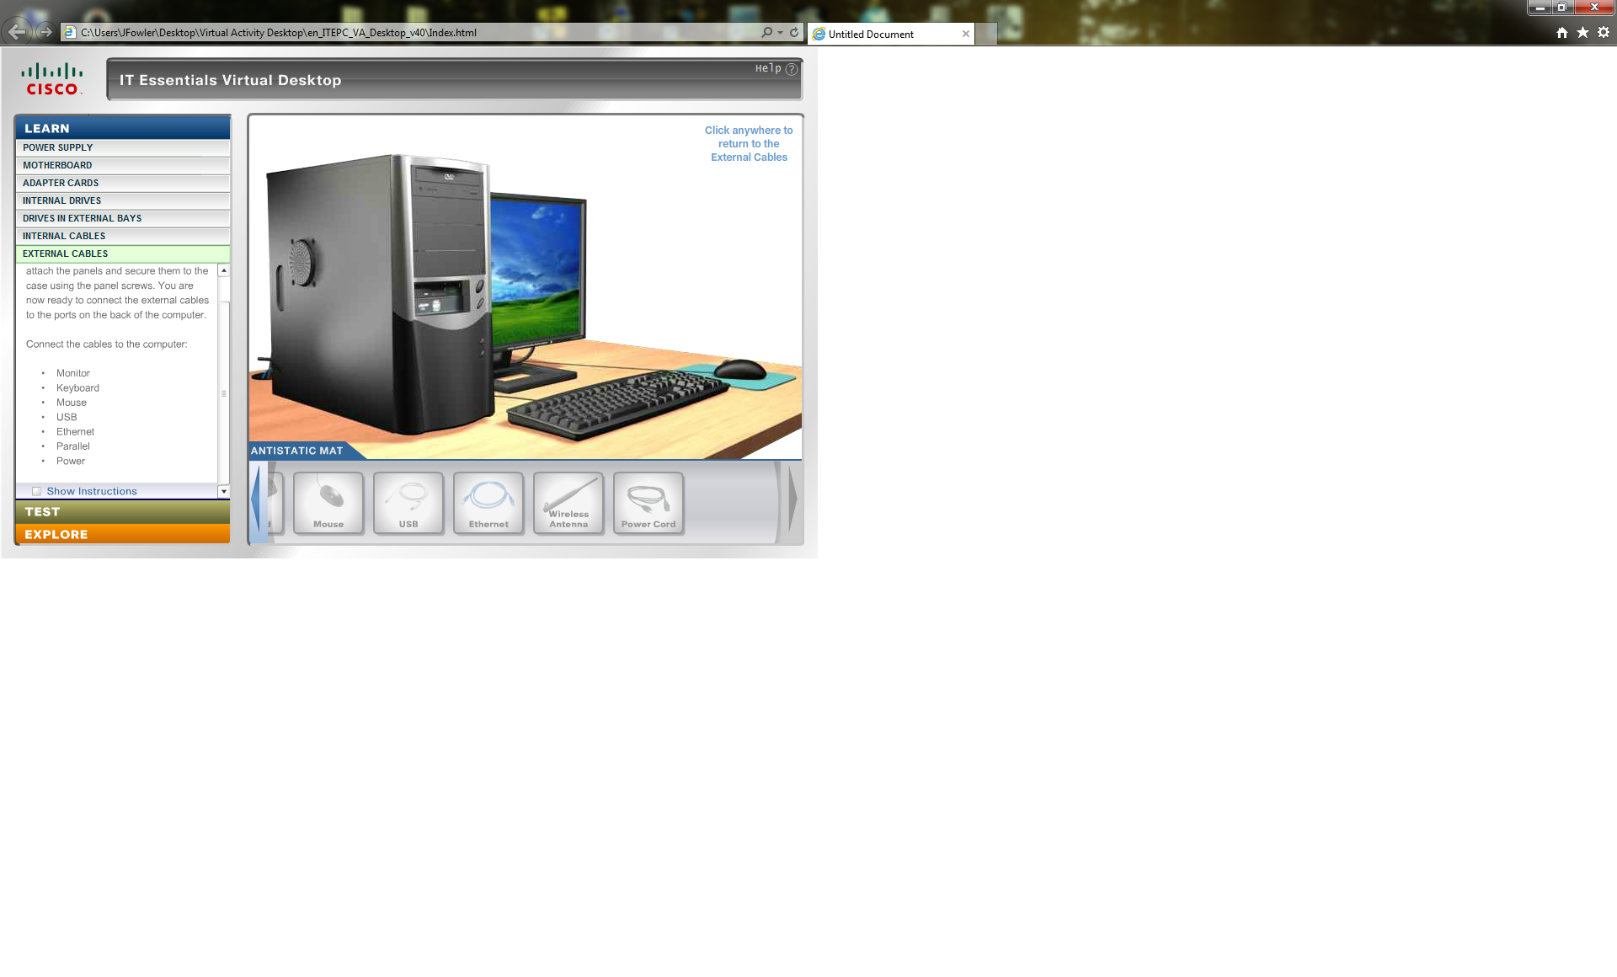

Test Mode:

