Jared Fowler

Comp 310 Homework #1

September 12, 2014

**Problem 1.** (10 points) Let X = {1,2,3,4}, Y = {2,4,5,6}, and Z = {1,3,6}. Find each of the following:

* (X ∪ Y) ∩ Z = $\left\{1,2,3,4\right\}∪ \left\{2,4,5,6\right\}=\left\{1,2,3,4,5,6\right\} ∩\left\{1,3,6\right\}=\{1,3,6\}$
* (X ∩ Y) ∪ Z = $\left\{1,2,3,4\right\} ∩\left\{2,4,5,6\right\}=\left\{2,4\right\} ∪\left\{1,3,6\right\}=\{1,2,3,4,6\}$
* (X – Y) – Z = $\left\{1,2,3,4\right\}-\left\{2,4,5,6\right\}=\left\{1,3\right\}-\left\{1,3,6\right\}=\{ \}$
* X – (Y – Z) =
* |X ∪ Y ∪ Z| =
* 2Z – 2X =
* X x Y = $\{\left(1,2\right\},\left(1,4\right),\left(1,5\right),\left(1,6\right),\left(2,2\right),\left(2,4\right),\left(2,5\right),\left(2,6\right),\left(3,2\right),\left(3,4\right),\left(3,5\right),\left(3,6\right),\left(4,2\right),\left(4,4\right),\left(4,5\right),\left(4,6\right)\}$
* X ∆ (Y ∆ Z) = $\left\{2,4,5,6\right\} ∆ \left\{1,3,6\right\}=\left\{1,2,3,4,5\right\} ; \left\{1,2,3,4\right\}∆ \left\{1,2,3,4,5\right\}=\{5\}$
* (X ∆ Y) ∆ Z = $\left\{1,2,3,4\right\} ∆ \left\{2,4,5,6\right\}=\left\{1,3,5,6\right\} ∆ \left\{1,3,6\right\}=\{5\}$
* X * Y = **{12,14,15,16,22,24,25,26,32,34,35,36,42,44,45,46}**

**Problem 2.** (10 points) Let S = {a,b,c,d} be the base set and R = {(a,b),(a,c),(b,a),(b,b),(b,d),(c,a),(d,b)} be a relation over S x S.

Is the relation R reflexive? If not, what is the smallest set of ordered pairs that can be added to make it reflexive?

**No.** Add {(a,a), (c,c), (d,d)}

Is the relation R symmetric? If not, what is the smallest set of ordered pairs that can be added to make it symmetric?

**Yes.**

Is the relation R transitive? If not, what is the smallest set of ordered pairs that can be added to make it transitive?

**No.** Add {(a,a), (a,d), (b,c), (c,b), (c,c), (d,a), (d,d)} -> {(a,a), (a,b), (a,c), (a,d), (b,a), (b,b), (b,c), (b,d), (c,a), (c,b), (c,c), (d,a), (d,b), (d,d)} (At this point it’s missing (c,d) and (d,c) … which with the additions need to be added too)

Therefore, Add {(a,a), (a,d), (b,c), (c,b), (c,c), (d,a), (d,d), (c,d), (d,c)}

Is the relation R an equivalence relation? If not, what is the smallest set of ordered pairs that can be added to make it an equivalence relation?

**No.** Add {(a,a), (a,d), (b,c), (c,b), (c,c), (d,a), (d,d), (c,d), (d,c)}

**Problem 3.** (10 points) Assume that at the end of the semester there will be 30 students receiving grades for this class. Prove that some group of 3 students will get exactly the same letter grade (eg 3 students all earning an A-, or 3 students all earning an F). Prove that it is possible that no set of 4 students will get the same grade.

$$Given that the carnality of the set of possible grades is 12: \left\{A,A-, B+,B,B-,C+,C,C-,D+,D,D-,F\right\}$$

Modifying the pigeon hold principle to allow every hole (grade) to hold at most 2 students, we fill every grade with 2 students. We are still left with 6 students (30 – (12 * 3)) = 6. This means that at least one grade must be held by 3 or more students.

Using the above reasoning, consider placing the remaining 6 students into all different grades. The result would be 6 grades held by 3 students each, and 6 grades being held by 2 students each. Therefore, it is possible that no set of 4 students get the same grade.

**Problem 4.** (10 points) Let G be a graph with n > 2 vertices with (n2-3n+4)/2 edges. Prove that G is connected.

Note: I will be assuming the worst case, and by doing so, prove it true for any case. We know that the best case is n-1 edges for n vertices. This “worst” case I’m talking about is if all previous vertices are connected with max number of edges and only 1 edge is left over to connect the remaining vertex.

Proof by Induction:

Base Case: n = 3 ; #edges = (9-9+4)/2 = 2

Technique:

Start with an empty graph. Add the vertices one at a time, connecting each new added vertex to all other vertices which have already been placed in the graph. Do this for all but the last vertex, i.e. (n-1). At this point, we’ll need at least one more edge, which will link the last vertex with any other vertex in the graph, in order to make G connected.

(Sub-Proof)

In general, the number of edges needed to link (n-1) vertices all to one another is 1 + 2 + … + n-2 = (n-2)(n-1)/2.

Let m = n-1 -> (m-1)(m)/2

Proof by Induction:

 Base Case: m = 2 ; (2-1)(2)/(2) = 1 Edge

Assume true for m = k, prove true for m = k + 1

Note that by adding one more vertex to the graph we would have to draw edges from each of the previous vertices to the new one. This means that we need a total of k more edges.

$$\frac{\left(k-1\right)\left(k\right)}{2}+k={(k}^{2}-k)/2+2k/2=(k^{2}+k)/2=k(k+1)/2$$

(Back to original proof)

Assume true for n = k, prove true for n = k + 1

Note: Picking up from where we were in the first part of this proof, we have k-1 vertices all connected to one another, 1 vertex, kth, that is connected to any one of the k-1 vertices, and one new vertex, (k + 1)th, that we still need to connect to the graph. Finish connecting the kth vertex to the rest of the vertices. It is already connected to one vertex, so that leaves k-2. We will then need 1 more edge in order to connect the (k + 1)th vertex.

$$\frac{k^{2}-3k+4}{2}+k-2+1=\frac{k^{2}-k+2}{2}=\frac{k^{2}+\left(2k-3k\right)+1-3+4}{2}=\frac{{\left(k+1\right)}^{2}-3\left(k+1\right)+4}{2}$$

**Problem 5.** (10 points) Assume that G is a connected (undirected) graph with 109 nodes and that no node has degree higher than 4. Prove incorrect that for any vertex v there is another vertex w such that the shortest path from v to w has at least 5 edges.

Basically, we want to break this… so if we can show that just one vertex v can be positioned so that every single other vertex in the graph is within 4 edges away. I call this the snow-flake:

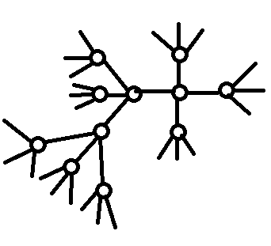Note that I only followed on path for simplicity. We can see that every time we split off from a node we are creating 3 new nodes for every node in the current outermost layer, where layer # >= 2. (i.e. Layer 2: 4 nodes; Layer 3: 12 nodes; Layer 4: 36 nodes; Layer 5: 108 nodes) We can add these nodes together to determine the maximum number of nodes that can exist within 4 edges of the center vertex V. (1+4+12+36+144) = 161.

**Problem 6.** (10 points) For each of the lists below either draw a connected (undirected) graph with **nine** nodes having one node of each degree listed or give a convincing argument why it is impossible.

* 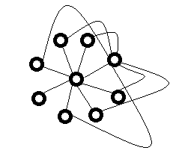8, 7, 7, 4, 3, 3, 3, 1, 1

The first node in the middle needs to connect to the remaining 8 nodes. After adding edges to accommodate the 7 degree node, we realize that only one node has 1 degree. We are required to have two nodes with one degree. This is therefore impossible.

* 7, 5, 3, 3, 3, 3, 3, 2, 2

Attempts:

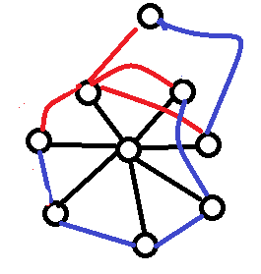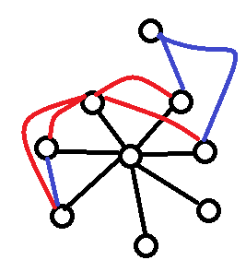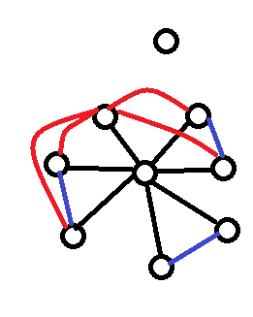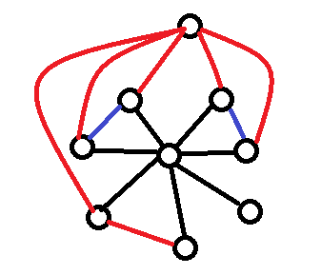Conclusion: There are 3 general paths we could take after putting down the 7 degree node. We can have the 5d node be the 9th node that isn’t connect to the 7d node, or we can have the 5d node be connected to the 7d and can either connect or not connect to the 9th node. In each of these cases, the same problem occurs in that we are left with a single node of degree 1, or we are left with either 3 or 1 nodes of degree 2. This combination is not possible.

* 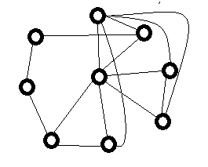6, 5, 3, 3, 3, 3, 3, 2, 2

POSSIBLE!

* 2, 2, 2, 2, 2, 1, 1, 1, 1

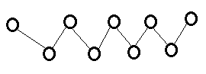Because the nodes with highest degrees are limited to 2 degrees, we can only accommodate a single stream of nodes. As can be seen, inputting all 9 nodes results in a series of 2 nodes with degree 1, and 7 nodes with degree 2. The given requirements are impossible.

**Problem 7.** (10 points) Prove that $\sum_{i=0}^{n}{\left({n \atop i}\right)}=2^{n}$

Proof by Induction:

Base Case: n = 0; $\sum_{i=0}^{0}{\left({0 \atop i}\right)}=\left({0 \atop 0}\right)=1= 2^{0}$

Assume true for n = k. Prove true for n = k + 1.

$Begin by visualizing the summations that will take place:$

$\left({k+1 \atop 0}\right)+\left({k+1 \atop 1}\right)+\left({k+1 \atop 2}\right)+\left({k+1 \atop 3}\right)+…+\left({k+1 \atop k-2}\right)+\left({k+1 \atop k-1}\right)+\left({k+1 \atop k}\right)+\left({k+1 \atop k+1}\right)$

$This can be rewritten as follows:$

$\left({k+1 \atop 0}\right)+\left({k \atop 0}\right)+\left({k \atop 1}\right)+\left({k \atop 1}\right)+…+\left({k \atop k-1}\right)+\left({k \atop k}\right)+\left({k+1 \atop k+1}\right)$

$How? The pattern is based of pascals triangle. I actually calculated a few of them out to verify the$

$$the above statement. We can see that every element is paired up with an equal value. Therefore, we$$

$$can multiply our original assumed function by 2.$$

$2*\sum_{i=0}^{n}{\left({n \atop i}\right)}=2*2^{n}=2^{n+1}$

Outside Reference used: The above proof was tough. In fact, it was the only one I couldn’t do by myself. My friend Google was consulted on this and I did my best to understand the logic.

**Problem 8.** (10 points) Prove that a binary tree with 2n nodes has at least n levels.

Note: To minimize the number of levels in a binary tree, we want to add nodes to it level by level, filling up one level before continuing to the next.

Note: By the properties of binary trees, we know that each level should contain 2n nodes, where n is the level number.

**Direct Proof:**

This proof seems almost intuitive, as the number of levels of a complete binary tree can be found using this formula: $\left\lceil \lg_{2}{m}\right\rceil$, where m is the number of nodes, aka, 2n. If we substitute 2n for m, we are left with n levels. Of course, n >= n which is what we wanted to prove.

Depending on the professor, the above proof may not suffice… How about an inductive proof?

**Induction Proof:**

Base Case: n = 0; 20 = 1; This is the root node by itself, and it indeed has 1 level.

Assume true for n = k. Prove true for n = k + 1.

For every new level of nodes added, we need two children for every node on the previous level. The previous level has 2k nodes. So:

$$2*2^{k}=2^{k+1}$$

If we take the log base 2 of this, we end up with k+1 levels. k + 1 >= k + 1.

**Problem 9.** (10 points) Assume that you have a big business meeting with n attendees. Some of these attendees may have shaken hands with one another (a particular attendee may have shaken hands with anywhere between none and all of the other attendees, but for any other particular attendee has shaken hands with that person at most once.) (For example, if n = 3 then the number of handshakes is between 0 and 3.)

What is the maximum possible total number of handshakes performed? Prove your answer.

This proof was done in the sub-proof of problem 4. Let’s treat each person as a node and each handshake as an edge.

Starting off with an empty graph, add one node at a time. Open the insertion of every new node, draw an edge from it to all other nodes that already exist in the graph. The number of edges that will be inserted at every new kth node will be (k-1). Following this pattern, we have 1 + 2 + … + (k – 1). This summation can be expressed as: (k-1)(k)/2.

Proof by Induction:

Base Case: #nodes k = 2 ; #edges = (2-1)(2)/2 = 1

Assume true for k = m, prove true for k = m+1

As explained above, upon adding a new node, we will need to insert m new edges. Therefore, we have:

$$\frac{\left(m-1\right)\left(m\right)}{2}+m=\frac{m^{2}-m}{2}+\frac{2m}{2}=\frac{m^{2}+m}{2}=\frac{m\left(m+1\right)}{2}$$

If you asked each attendee how many times he shook hands and totaled the answers can the total be even? Can it be odd? Clearly explain your answer.

**The total would have to be even**. The simplest way to understand this is by recognizing that for every handshake 2 handshakes will be added to the total count. For example, if we interview Fred first and he has shaken hands with George, we will later interview George and add to our total count the handshake he gave to Fred. Simply, 2 multiplied by any number will result in an even number.