Jared Fowler

Comp 310 HW# 2

Fall 2014

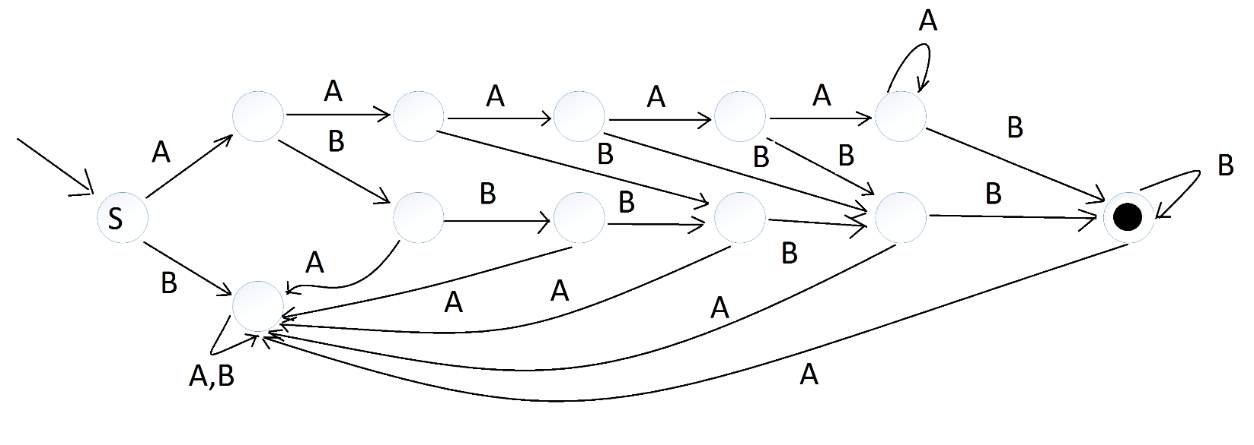**Problem 1.** (10 points) Construct a DFA that accepts the language $\{a^{i}b^{j} :i*j≥5\}$. Very briefly explain the idea behind your DFA.

The smallest two positive integers that can be multiplied together to form a number greater than 5 are 3 and 2. From the language definition, we must start with at least 1 a. From there, we can have any number of a’s, but at the moment we branch off with a b we must have a bear minimal number of b’s. Of course, once we are looking at the b’s, we cannot have an a again and, therefore, all a’s at this point will lead to the ‘black-hole’ where there is no escape.

**Problem 2.** (10 points) Construct a DFA that accepts the language $\{w ∈{\left\{a,b\right\}}^{*} :w doesn^{'}tcontain the substring abba\}$. Very briefly explain the idea behind your DFA.

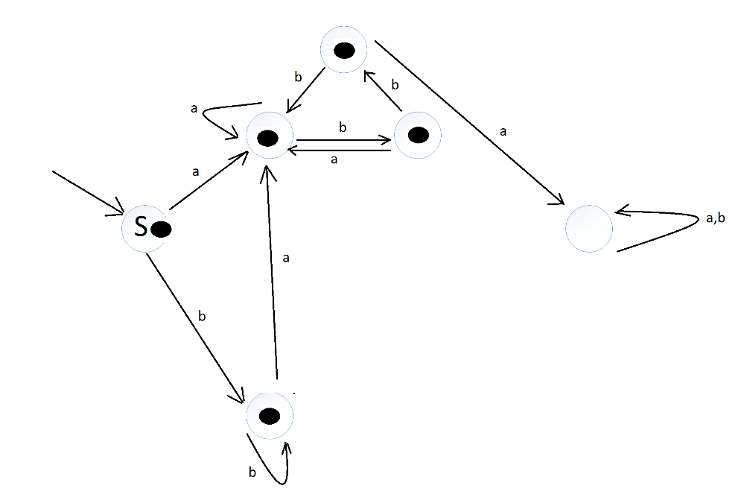

Starting from S, the ‘a’ side is a bit easier to understand. Basically, we allow for all letters until a double ‘b’ is hit. At this point we will only allow for an ‘a’ to remain within the successful termination zone. The same idea applies to the ‘b’ side. Also note that the empty string will be accepted.

**Problem 3.** (10 points) Construct a DFA that accepts the language $\{w ∈{\left\{a,b\right\}}^{*} :n_{a} \& n_{b} are both even\}$.

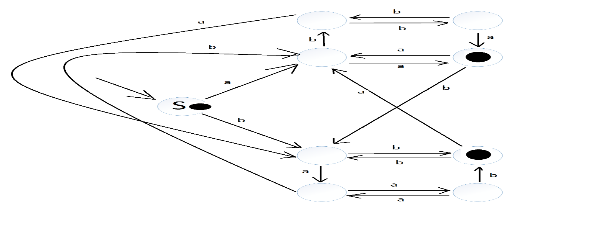

**Problem 4.** (10 points) What language is accepted by the DFA below? Very briefly explain your answer.

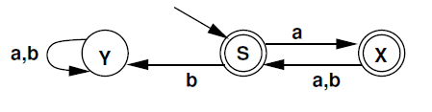

Some accepted Strings: “”, a, aa, ab, aba, aaab, abaa, aaaaaaab

Some not accepted Strings: b, abb, aaaaaaabaabb, aab

We can see from the list of accepted and not accepted strings that we can have an odd number of a’s and get away with having 1 b. It will not work if we have an even number of a’s and then add a b. We can never have bb.

Language: w element of {a,b}* : Between any 2 b’s there must be an odd number of a’s, or if only 1 b exists it must be preceded by an odd number of a’s. The empty string will also be accepted.

**Problem 5.** (10 points) Construct an NFA which accepts the language $\{w ∈{\left\{a,b\right\}}^{*} :w contains the substrings aaa and bbb\}$.

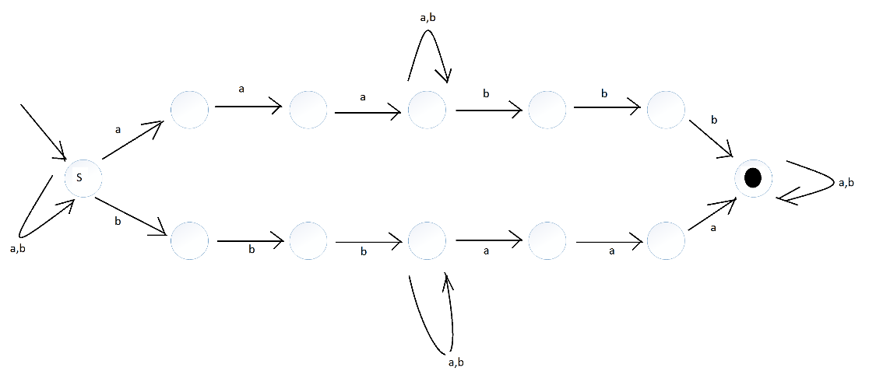

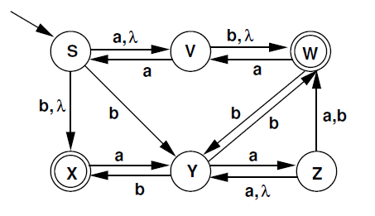**Problem 6.** (10 points) Construct a DFA that accepts the same language as the NFA below.

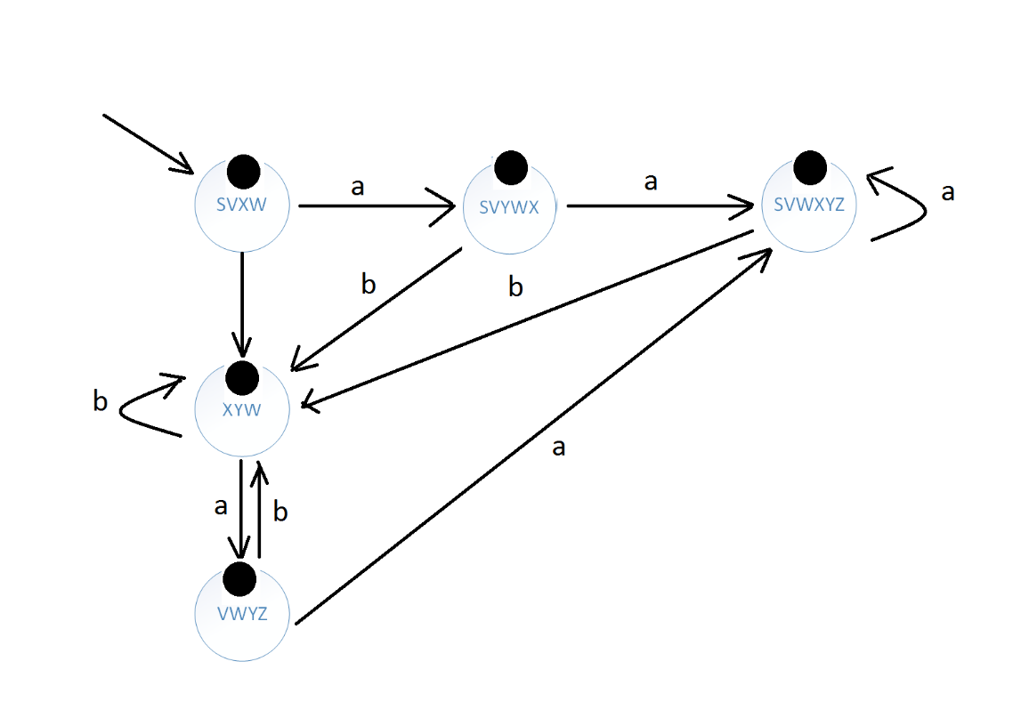

**Problem 7. (**10 points) Give regular expressions for each of the following languages.

$\left\{a^{i}b^{j} :\left(i*j\right)\%2=1\right\} → a{\left(aa\right)}^{*}b{\left(bb\right)}^{*}$

$\left\{a^{i}b^{j}a^{k}b^{l} :\left(i+k\right)\%3=0\right\} → {\left(aaa\right)}^{*}b^{*}{\left(aaa\right)}^{*}b^{*}+a{\left(aaa\right)}^{*}b^{*}aa{\left(aaa\right)}^{*}b^{*}+aa{\left(aaa\right)}^{*}b^{*}a{\left(aaa\right)}^{*}b^{*}$

$\left\{w ∈{\left\{a,b\right\}}^{*} :w starts with a and contains at least 3 b^{'}s\right\}→ aa^{*}ba^{*}ba^{*}b{\left(a+b\right)}^{*}$

**Problem 8.** (10 points) Give a simple (english or math) description for the language associated with each of the following regular expressions.

$a^{*}ba^{*}{\left(ba^{*}ba^{*}ba^{*}\right)}^{*} → \left\{w ∈{\left\{a,b\right\}}^{*} :\left(b_{n}-1\right)\%3=0\right\}$

$bbbbb^{*}+abbbb^{*}+aabbb^{*}+aaabb^{*}+aaaaa^{*}b^{*} → \left\{w ∈{\left\{a,b\right\}}^{*} :\left|w\right|≥4 \& ∀ a^{'}s come before ∀ b^{'}s\right\}$

${\left(0+1{\left({01}^{*}0\right)}^{*}1\right)}^{*} → \{w ∈{\left\{1,0\right\}}^{*} :w is λ or the binary equivalent of w \%3=0\}$