Comp 310 Homework # 3

Student: Jared Fowler

**Problem 1.** Create an NFA that accepts the language generated by the right linear grammar below.

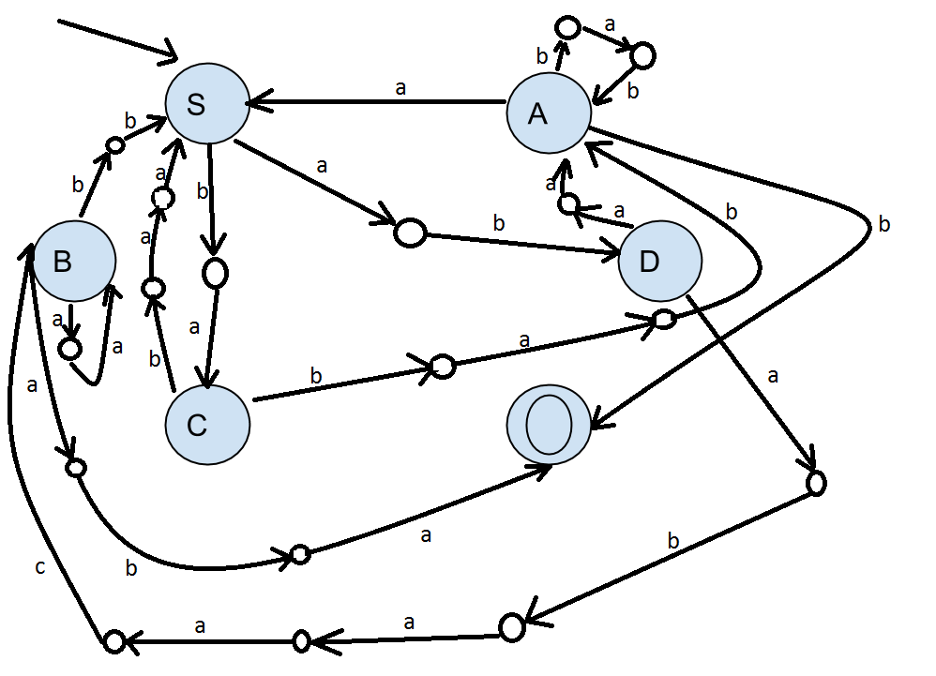 S -> abD | baC

A -> babA | aS | b

B -> aaB | bbS | aba

C -> baaS | babA

D -> aaA | abaacB

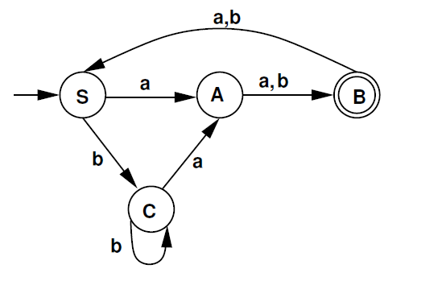**Problem 2.** Create a regular grammar that generates the same language accepted by the DFA below.

S -> aA | bC

A -> aB | bB

B -> aS | bS | λ

C -> aA | bC

**Problem 3.** Minimize the DFA below.

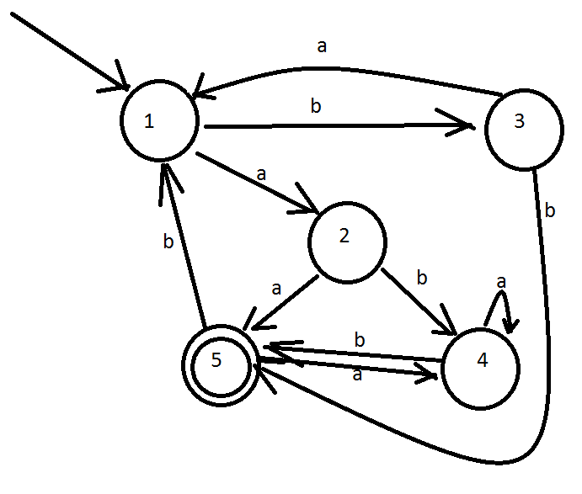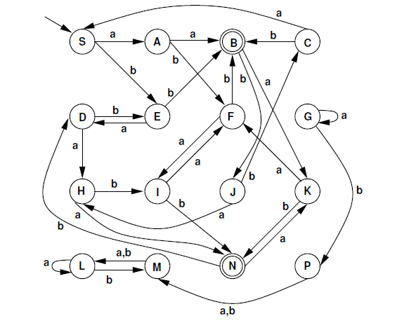

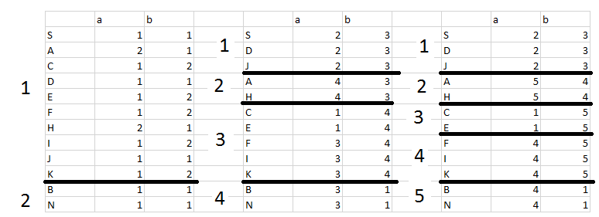

**Problem 4.** Show that $\left\{w ϵ {\left\{a,b\right\}}^{*} :n_{a}>n_{b}\right\}$ is not regular.

Assume $\left\{w ϵ {\left\{a,b\right\}}^{*} :n_{a}>n_{b}\right\}$ is regular, then P.L. applies.

Fix the N given by P.L.

Let $w= b^{N}a^{N}a Note:\left|b^{N}a^{N}a\right|=2^{N}+1≥N$

There is a split w = xyz with $\left|xy\right|≤N and \left|y\right|≠0$

Repeat y 400 times.

$xy^{400}z ϵ L because P.L. says so, but xy^{400}z=b^{f}b^{400j}b^{N-j-f}a^{N}a=b^{N+399j}a^{N}a which is not ϵ L because j ≠0$

**Problem 5.** Show that $\{a^{i}b^{i} :i<j\}$ is not regular.

Assume $\left\{a^{i}b^{i} :i<j\right\}$ is regular, then the Pumping Lemma applies.

Fix the N given by P.L.

Let w = $a^{n}b^{n+1}$

There exists a split $w=xyz with \left|xy\right|≤N and \left|y\right|≠0$

$x=a^{f}, y=a^{j}, f+j≤N, j ≠0$

Repeat y 20 times.

$xy^{20}z ϵ L because P.L. , on the other hand: a^{f}a^{20j}a^{N-f-j}b^{N+1}=a^{N+19j}b^{N+1} not ϵ L because j ≠0$

**Problem 6.** If L is regular and $L⊂=L^{'}$ then show:

1. L’ can be regular and
$$Let L=\left\{w ϵ{ \left\{a, b\right\}}^{*} :w=aa \right\} and L^{'}=\left\{w ϵ {\left\{a,b\right\}}^{*} \right\}$$

$$Note that L^{'}contains the string aa and is therefore a superset of L. Also not that L^{'}is regular.$$

2. L’ need not be regular.

$$Let L=\left\{w ϵ {\left\{a,b\right\}}^{*} :w=ab\right\} and L^{'}=\left\{w ϵ \left\{a^{i}b^{i}\right\}\right\}$$

$$Note that L^{'}contains the string ab and is therefore a superset of L, however, L^{'}is not regular$$

**Problem 7.** Show that if L1 and L2 are regular then L1ΔL2 must also be regular.

$$L_{1}ΔL_{2}=L_{1}^{'}L_{2}+L_{1}L_{2}^{'} Note:The character \text{ ' } represents the compliment in this case.$$

It can be shown that if a language L is regular then its compliment L’ must be regular also. (Simply make all the end states non-ending, and all the non-ending end states in a given DFA.) Given a NFA which divides from the start state via lambda into two branches, and transitions once again via lambda from L1’ to L2 and from L1 to L2’. Because this NFA exists, we can therefore conclude that L1ΔL2 must be regular.

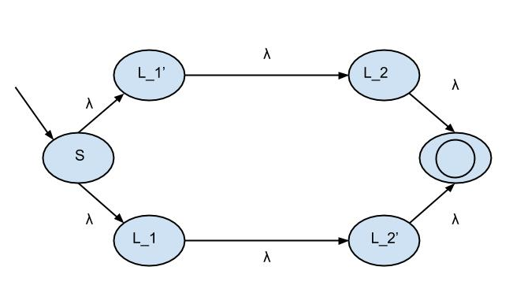

Note: The ending edges labeled as lambda to the final state should come from any ending state in the previous group of states (L_2, or L_2’).

**Problem 8.** For a language L define $SUFFIX\left(L\right)=\{w :∃ w^{'}such that w^{'}w is in L\}$. Show that if L is regular then Suffix (L) is regular.

Because L is regular, it has several NFA’s that accept it. Modify any of these NFA’s with an extra state which will act as the new start state. Add an edge between the new start state to every **reachable (traversable)** state from the original start state which from there can also be traversed to the final state. This results in a NFA which will represent Suffix(L) which is regular. Therefore, SUFFIX(L) must be regular.