COMP 310 Homework 4 Jared Fowler

**Problem 1.** Create a CFG which generates the language $L=\left\{a^{i}b^{j}c^{k} :i+j>k\right\}.$

$S→aX | bY$

$X→aX \left| aXc \right| Y$

$Y→bY \left| bYc \right|λ$

**Problem 2.** Create a CFG which generates the language $\left\{w ϵ {\left\{a, b\right\}}^{*}:n_{a}>n_{b}\right\}.$

$S→XaX$

$X→aX | Xa \left| aXb \right| bXa | λ$

**Problem 3.** Create a CFG which generates the language $L=\left\{w ϵ {\left\{a, b, c\right\}}^{*} :\left|w\right|is odd and first, last, and middle letters are different\right\}.$

$S→aCb \left| aBc \right| bCa \left| bAc \right| cBa | cAb$

$A→aAa \left| aAb \right| aAc \left| bAb \right| bAa \left| bAc \right| cAc \left| cAb \right| cAa | a$

$B→aBa \left| aBb \right| aBc \left| bBb \right| bBa \left| bBc \right| cBc \left| cBb \right| cBa | b$

$C→aCa \left| aCb \right| aCc \left| bCb \right| bCa \left| bCc \right| cCc \left| cCb \right| cCa | c$

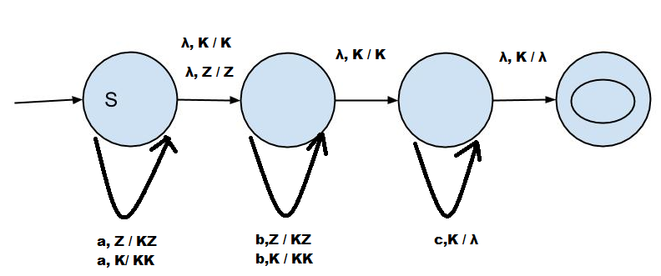**Problem 4.** Create a NPDA which accepts the language $L=\left\{a^{i}b^{j}c^{k} :i+j>k\right\}.$

**Problem 5.** Create a NPDA which accepts the language $\left\{w ϵ {\left\{a, b\right\}}^{*}:n_{a}>n_{b}\right\}.$

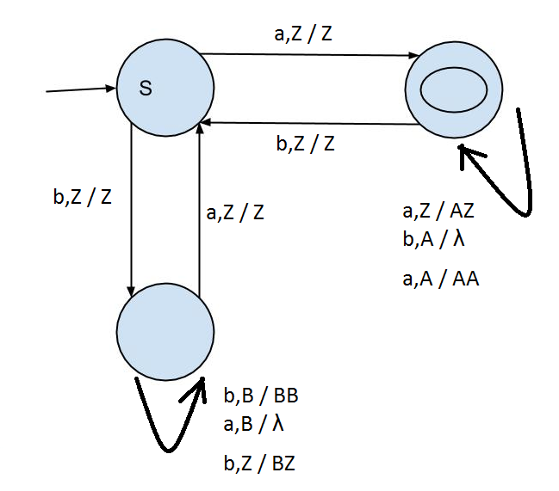

**Problem 6.** Create a NPDA which accepts the language $L=\left\{w ϵ {\left\{a, b, c\right\}}^{*} :\left|w\right|is odd and first, last, and middle letters are different\right\}.$

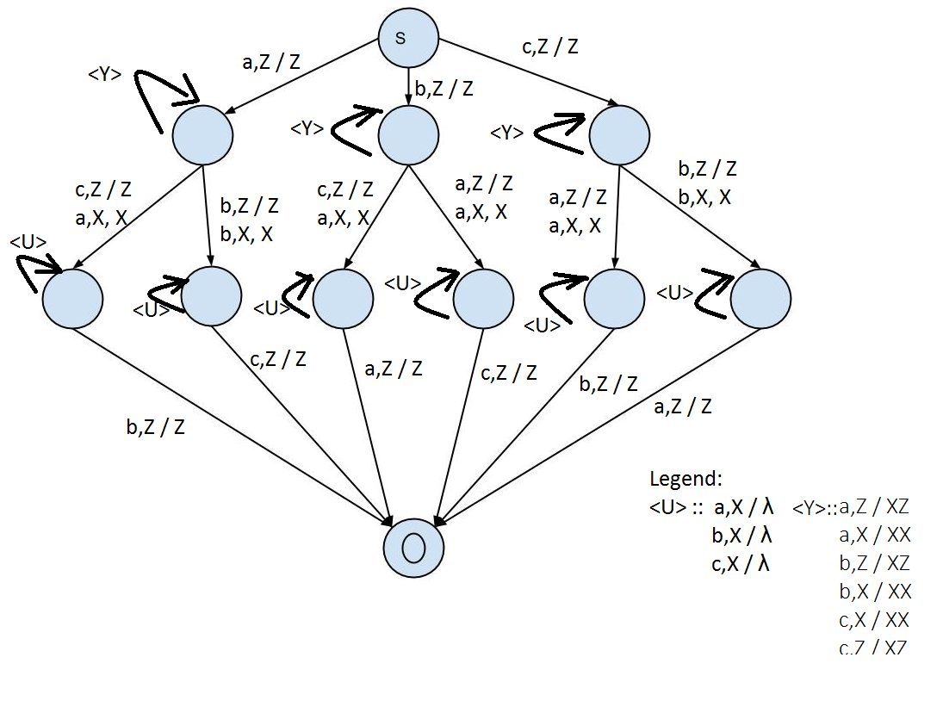

**Problem 7.** What language is generated by the context free grammar below? Briefly explain.

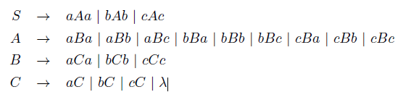

$$L=\{w ϵ {\left\{a,b,c\right\}}^{*} :\left|w\right|≥6 \&\& 1st and last letters are same, and 3rd and 3rd to last letters are the same.\}$$

Any word generated from this grammar is done in a pipeline fashion. First and last are the same letter. The next letters can be the same but don’t have to be. The next letters have to be the same. Finally, we can have any combination of a,b, or c.

**Problem 8.** What language is generated by the context free grammar below? Briefly explain.

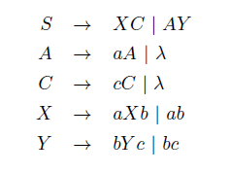

$$L=\{a^{i}b^{j}c^{k}: i=j or j=k\}$$

We begin with a split, which allows us to either do as many a’s or as many c’s as we want. After this split, either a and b, or b and c are paired up for as many times as we want.

**Problem 9.** Show that the grammar in problem 7 is not ambiguous (i.e. give an argument that any word in the language has only one parse tree).

We can see that there is some sort of pipeline action going on from S to A to B. Each time we move down the pipeline, we are forced to have 2 terminals, (one on each end), with a variable in the middle. We could actually make a list of all the possible incomplete words which could exist after passing through B. The total would be 81 incomplete words, and they would all be different. Finally, in C there is a uniform way in which the options are written : tV or lambda. Because of this unique and particular context, this grammar is in fact not ambiguous!

**Problem 10.** Show that the grammar in problem 8 is ambiguous (i.e. show a word in the language with 2 different parse trees).

