Comp 310 Homework 5 Jared Fowler



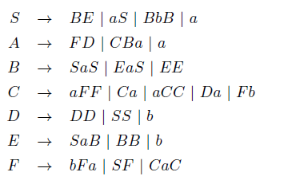…Remove Unreachable Productions…



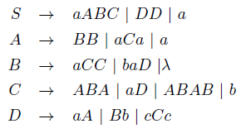NULLABLES: B, A, C



$S→aABC \left| DD \right| a \left| aAB \right|aA \left| aB \right| aC \left| aBC \right| aAC$

$A→BB \left| aCa \right|a \left| B \right| aa$

$B→aCC \left| baD \right|aC | a$

$C→ABA \left| aD \right|ABAB \left| b \right| AB \left| BA \right| A \left| B \right| AA \left| BAB \right| BB \left| AAB \right| ABB$

$D→aA \left| Bb \right| cCc \left| a \right| b | cc$

Assume that it is Context Free. Pumping Lemma gives a fixed M.

$$w_{1}=a^{M}b^{M} → w_{1}w_{2}=a^{M}b^{M}a^{M}b^{M}$$

There exists a split where $w=uvwyz where \left|vxy\right|≤M \& \left|vy\right| != 0$

Because |vxy| is less than or equal to M, this portion of the word can either exits entirely in w_1, or entirely in w_2, or it can exist in in the b’s in w_1 and the a’s in w_2. In any of these cases, the pumping lemma allows us to repeat v and y. By doing so we change the content of w_1, or that of w_2, or of both w_1 and w_2 but only the b’s in w_1 and the a’s in w_2. This is a valid word because the Pumping Lemma says so. On the other hand, after this repeat w_1 is no longer the same as w_2 and we therefore have a contradiction.



Assume that it is context free, therefore the pumping lemma applies. Fix the M given by the pumping lemma.



$$Let w=a^{Q} :Q is the next prime number≥M.$$

$$There exists a split where \left|vy\right|=k, some constant≥1>0$$

$$We can repeat v and y because pumping lemma says so. Repeat them \left(Q+1\right)k$$

$$This results in \left|a\right|=Q\left(k+1\right) which is not prime because factorization. Therefore, contradiction.$$

Yes. We can simply reverse the order the terminals and variables to the right of the production.

Example: $S→ aBCd would be changed to S→ dCBa$



$$Note:L_{1} xor L_{2}=L_{1}L_{2}^{'} U L_{1}^{'}L_{2}=\left(L_{1}-L_{2}\right) U \left(L_{2}-L_{1}\right)$$

Notes: We know that the union of two C.F.’s is C.F. . Therefore, what we really need to prove is if the set difference between two C.F. languages is C.F., or if the intersection of a C.F. and a non-C.F. is C.F. .

We can use the same example that we would use to prove set difference false.

$$L_{1}={\left\{a,b\right\}}^{*} and L_{2}=\left\{w_{1}w_{2}:\left|w_{1}\right|=\left|w_{2}\right| \&\& w_{1} ≠w_{2}\right\}$$

L_1 represents the universe, so the symmetric difference, would be the compliment of L_2 which was proven in class to not be context free. Therefore **NO.**



abaabbb : yes

|  |  |  |  |  |  |  |  |
| --- | --- | --- | --- | --- | --- | --- | --- |
|  | SAC | SABC | SABC | SABC | SABC | SABC | SABC |
| a |  | BC | ABC | ABC | ABC | ABC | ABC |
|  | b |  | SAC | SAC | SABC | SABC | SABC |
|  |  | a |  | SAC | SABC | SABC | SABC |
|  |  |  | a |  | BC | BC | BC |
|  |  |  |  | b |  | BC | BC |
|  |  |  |  |  | b |  | BC |
|  |  |  |  |  |  | b |  |

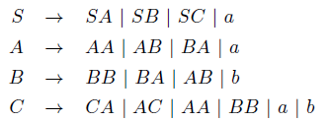 baabb : no

aabb : yes