|  |  |
| --- | --- |
| Name: | **Jared Fowler** |
|  |  |
| Date: | January 24, 2018 |
| Class: | Engr M20/L – Moorpark College |
| Instructor: | Hadi Darejeh |

Lab 1: Voltage and Current Division

|  |  |
| --- | --- |
| Lab Partner: | Roland Terezon |

**Objective**

Understand, and put into practice, voltage and current division concepts as well as the principles associated with the Wheatstone Bridge method for measuring resistance.

**Theory**

Note: Theories, concepts, and proofs heavily quoted from “Fundamentals of Electric Circuits” 5th edition.

**Ohm’s Law**

The voltage *v* across a resistor is directly proportional to the current *i* flowing through the resistor. The constant of proportionality is defined as the resistance, *R*. Therefore:

$$v=iR$$

**Kirchhoff’s Current Law**

The algebraic sum of currents entering a node (or a closed boundary) is zero. In other words, the sum of currents entering a node is equal to the sum of currents leaving a node.

|  |  |
| --- | --- |
| $$Assume a set of currents i_{k}\left(t\right), k=1, 2, …, flow into a node$$ | |
| $$i_{T}\left(t\right)=i_{1}\left(t\right)+i_{2}\left(t\right)+i_{3}\left(t\right)+ …$$ | $$Algebraic sum of currents$$ |
| $$q_{T}\left(t\right)= q_{1}\left(t\right)+q_{2}\left(t\right)+q_{3}\left(t\right)+…$$ | $$Integrate both sides.$$ |
| $$Note: q_{k}\left(t\right)= \int{i_{k}\left(t\right)dt} and q_{T}\left(t\right)=\int{i_{T}\left(t\right)dt}$$ | |
| $$q_{T}\left(t\right)=0→i_{T}\left(t\right)=0$$ | $$Law of conservation of electric charge$$ |

**Kirchhoff’s Voltage Law**

The algebraic sum of all voltages around a closed path (or loop) is zero. In other words, the sum of voltage drops is equal to the sum of voltage rises in a closed path. This law is based off, and proven by, the conservation of energy.

**Voltage Division**

Voltage can be “divided” by placing resistors in series. The equivalent resistance of any number of resistors connected in series is the sum of the individual resistances.

$$R_{eq}=R_{1}+R_{2}+R_{3}+…+R_{N}$$

Based upon KCL, the current running through each of these resistors is equal. Applying Ohm’s law, the resistance is directly proportional to the voltage across each resistor, hence, “dividing” the voltage.

**Current Division**

Current can be “divided” by placing resistors in parallel. The equivalent resistance of any number of resistors in parallel is the sum of the individual conductances.

$$R_{eq}={\left( \left(\frac{1}{R_{1}}\right)+\left(\frac{1}{R_{2}}\right)+\left(\frac{1}{R_{3}}\right)+…+\left(\frac{1}{R_{N}}\right)\right)}^{-1}$$

Based upon KVL, the voltage across each resistor is the same. Applying Ohm’s law, each resistor’s resistance is in inverse proportion to the current running through it, hence, “dividing” the current.

**Wheatstone Bridge**

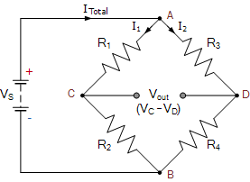Used to analyze two series strings in parallel. For the purpose of this experiment, by making the current through each series the same, the resistance of R4 can be determined by adjusting the resistance of R2 until Vout reads zero. (see Calculation 1.2)

**Procedure**

**Part 1:**

A bridge circuit was created to determine the value of an unknown resistor, Rx. Specification for this circuit can be seen below (see Figure 1.1).

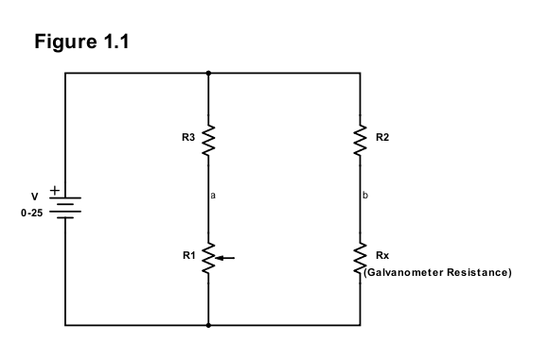

The current through Rx is limited to 0.5mA when the power supply is set at 25V. By limiting the current flowing through R1 to also be 0.5mA, the value of Rx can be found by adjusting the variable resistance of R1 until the voltage of Vab = 0V.

Based upon KCL, the current flowing through R3 and R2 must also be limited to 0.5mA. Using Ohm’s law, appropriate values for these two resistors were found to be greater than or equal to 50KΩ (see Calculation 1.1).

The expression for resistance Rx was derived in terms of R1, R2, R3 (see Calculation 1.2).

The circuit (see Figure 1.2) was built and Vab was monitored while R1 was adjusted. Once Vab was approximately zero, the resistance of R1 was measured to be 177.7Ω. Using the expression derived in Calculation 1.2, the value of Rx was calculated to be **180.9Ω** (see Calculation 1.3).

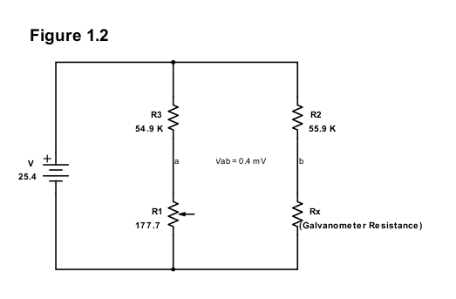

**Part 2:**

Two voltmeters were created, one having a 0-5 volt range and the other a 0-25 volt range, using the galvanometer from part 1 (see Figure 2.1).

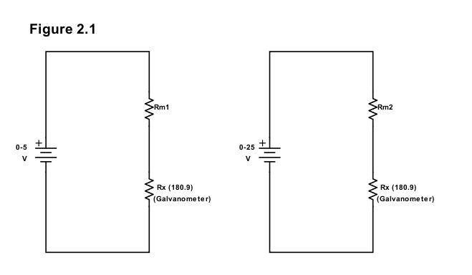

Given the current restriction of 0.5mA that can flow through the galvanometer, KVL and Ohm’s laws were used to find appropriate minimum resistance values Rm1 and Rm2 which are **9819Ω** and **49819Ω** respectively (see Calculation 2.1). The circuits were then built as seen below (see Figure 2.2).

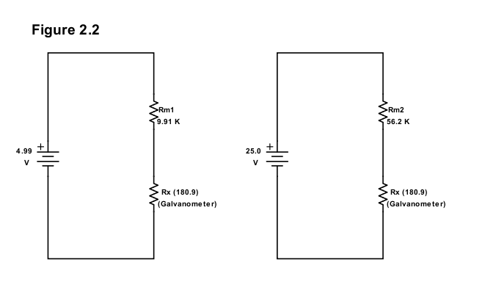

Two ammeters were created, one having a 0-50 mA range the other a 0-500 mA range, using the galvanometer from part 1 (see Figure 2.3).

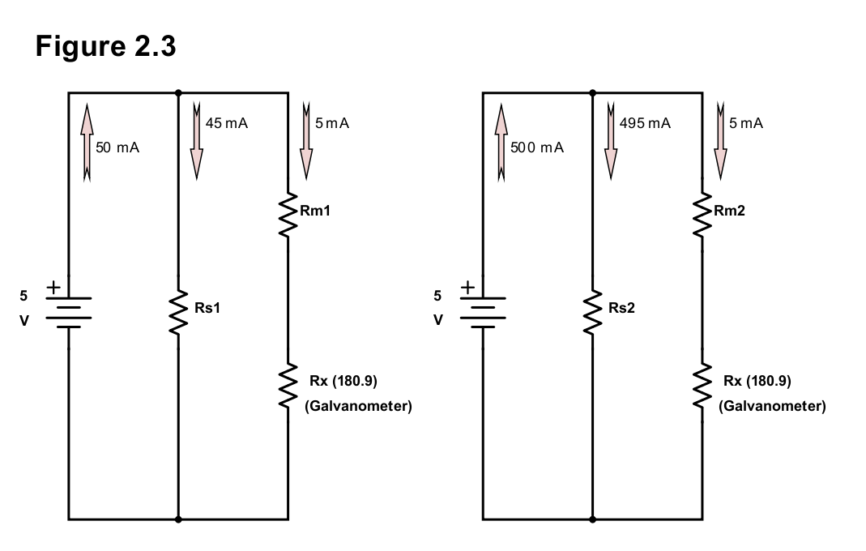

Given the current restriction of the galvanometer, KCL and Ohm’s law were used to determine the maximum resistance values for Rs1 and Rs2 which are **101.01Ω** and **10.101Ω** respectively (see Calculation 2.2). Because Rm1 and Rm2 continue to form a closed loop in their respective circuits, KVL applies the same as it did in Calculation 2.1. The circuits were then built as seen below (see Figure 2.4).

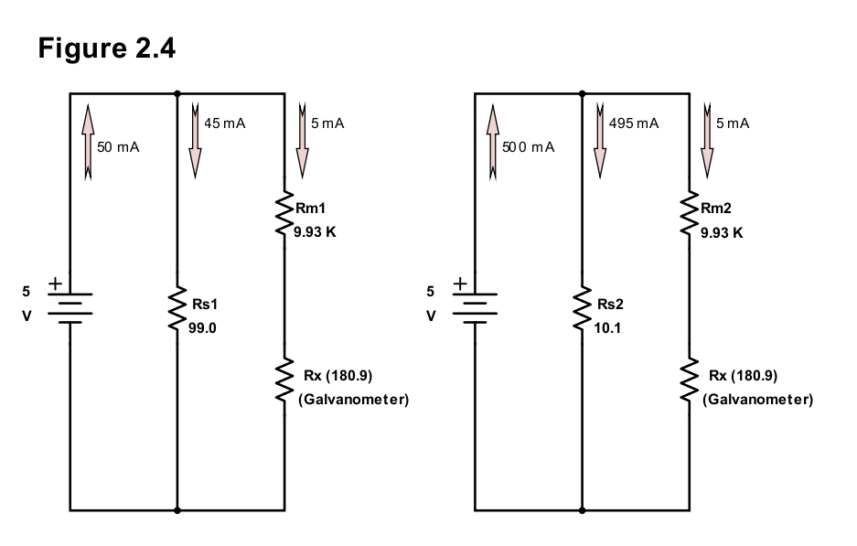

**Part 3:**

Given the circuit information below (see Figure 3.1a), the theoretical values for RL1, RL2, R1, R2, and RS were found (see Figure 3.1b and Calculation 3.1). Note that the maximum power output is *assumed* to be 1.5 watts.

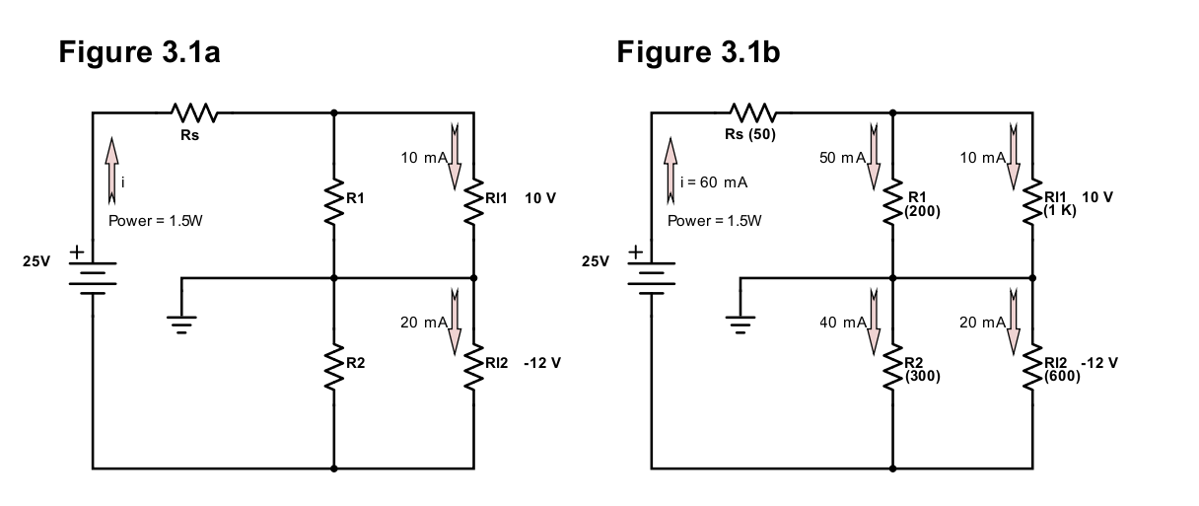

The circuit was built and voltages were measured across RL1 and RL2 (see Figure 3.2a). These resistors were then removed and voltages were measured across R1 and R2 (see Figure 3.2b). The theoretical and real values were found to vary slightly, perhaps largely contributed to variance between the theoretical and actual resistor values and the assumption made on the power output. The Voltage Regulation (V.R.) was found to be **12%** across R1 and **15%** across R2(see Calculation 3.2), which are both within the requirement of V.R. < 20%.

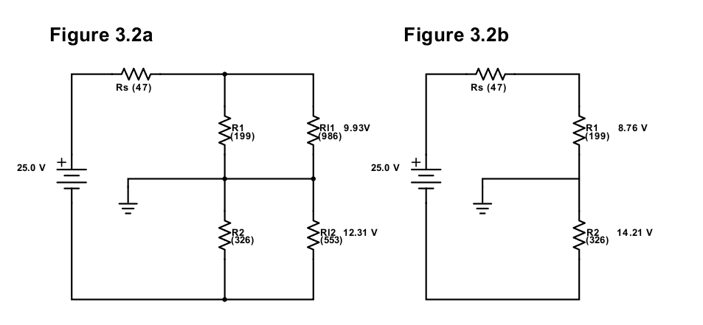

**Data & Calculations**

**Note:**

For convenience, variables V (voltage), R (resistance), and I (current) will be subscripted based upon subscriptions in their respective diagrams. For example, the current across resistor R3 will be represented as i3, and the voltage across R3 will be represented as V3.

**Calculation 1.1**

$V=iR and i_{3}<0.5 mA and i_{2}<0.5 mA$

$$Note that the maximum voltage across R_{3} is 25V. While it may never reach$$

$$this value, setting V_{3} to 25V will set R_{3}and R_{2} to higher, safer values.$$

$$Let V_{3}=25V→25=0.5mA\left(R_{3}\right)$$

$$R_{3}≥\frac{25}{0.0005}=50Kohms$$

$$Repeat for R_{2} to also get R_{2}≥50Kohms$$

**Calculation 1.2**

|  |  |
| --- | --- |
| $$25V=V_{3}+V_{1} and 25V=V_{2}+V_{x}$$ | $$Using KVL \left(Kirchhoff^{'}s Voltage Law\right)$$ |
| $$25V=V_{3}+V_{1} and 25V=V_{2}+V_{x}$$ |  |
| $$V_{3}+V_{1}=V_{2}+V_{x}$$ | $$Use Ohm^{'}s Law$$ |
| $$i_{3}R_{3}+i_{1}R_{1}=i_{2}R_{2}+i_{x}R_{x}$$ | $$Note that i_{3}=i_{1} and i_{2}=i_{x}$$ |
| $$i_{3}\left(R_{3}+R_{1}\right)=i_{2}(R_{2}+R_{x})$$ |  |
| $$R_{x}=\frac{i_{3}\left(R_{3}+R_{1}\right)}{i_{2}}-R_{2}$$ | $$Use Ohm^{'}s Law$$ |
| $$R_{x}=\frac{\left(\frac{V_{3}}{R_{3}}\right)\left(R_{3}+R_{1}\right)}{\left(\frac{V_{2}}{R_{2}}\right)}-R_{2}$$ | $${Note that V}_{2}= V_{3}$$ |
| $$R_{x}=\frac{\left(R_{2}R_{3}+R_{2}R_{1}\right)}{R_{3}}-\frac{R_{2}R_{1}}{R_{3}}$$ |  |
|  |  |
| $$R_{x}=\frac{R_{2}R_{1}}{R_{3}}$$ | $$Formula 1.2.1$$ |

**Calculation 1.3**

|  |  |
| --- | --- |
| $$R_{x}=\frac{R_{2}R_{1}}{R_{3}}=\frac{\left(55.9K\right)\left(177.7\right)}{54.9K}=180.9 ohms$$ | $$Using formula 1.2.1$$ |

**Calculation 2.1**

|  |  |
| --- | --- |
| $$V=V_{x}+V_{m}$$ | $$Using KVL \left(Kirchhoff^{'}s Voltage Law\right)$$ |
| $$V=R_{x}i_{x}+R_{m}i_{m}$$ | $$Use Ohm^{'}s Law. Note that i_{m}=i_{x}$$ |
| $$R_{m}=\frac{\left(V-\left(R_{x}i_{x}\right)\right)}{i_{m}}$$ | $$Formula 2.1.1$$ |
| $$R_{m}=\frac{\left(5-\left(180.9)(0.5mA\right)\right)}{0.5mA}=9819 ohms$$ | $$Apply formula 2.1.1, with V=5 Volts$$ |
| $$R_{m}=\frac{\left(25-\left(180.9)(0.5mA\right)\right)}{0.5mA}=49819 ohms$$ | $$Apply formula 2.1.1, with V=25 Volts$$ |

**Calculation 2.2**

|  |  |
| --- | --- |
| $$Note:V_{s}=5V, i_{m}=0.5mA, i_{x}=0.5mA$$ |  |
| $$V_{s}=i_{s}R_{s}$$ | $$Use Ohm^{'}s Law.$$ |
| $$R_{s}=\frac{V_{s}}{i_{s}}$$ | $$Formula 2.2.1 , where i_{s}=(i-i_{x})$$ |
| $$R_{s1}=\frac{V_{s1}}{i_{s1}}=\frac{5}{50mA-.5mA}=101.01 ohms$$ | $$Apply formula 2.2.1, with i=50 mA$$ |
| $$R_{s2}=\frac{V_{s2}}{i_{s2}}=\frac{5}{500mA-.5mA}=10.101 ohms$$ | $$Apply formula 2.2.1, with i=500 mA$$ |
| $$Note that R_{m1}=R_{m2}. KVL applies to the same loop as it did in Calculation 2.1. Therefore, R_{m1}=9819 ohms$$ | |
|  |  |

**Calculation 3.1**

|  |  |
| --- | --- |
| $$P=Vi$$ | $$Definition of Power$$ |
| $$1.5=25i$$ |  |
| $$i=60 mA$$ |  |
| $$Note:i_{1}=50mA and i_{2}=40mA$$ | $$Via KCL \left(Kirchhoff^{'}s Current Law\right)$$ |
|  |  |
| $$25V=V_{s}+V_{l1}+V_{l2}$$ | $$Using KVL \left(Kirchhoff^{'}s Voltage Law\right)$$ |
| $$V_{s}=25-10-12=3V$$ |  |
| $$V_{s}=R_{s}i_{s}→R_{s}=\frac{V_{s}}{i_{s}}=\frac{3}{60mA}=50 ohms$$ | $$Use Ohm^{'}s Law$$ |
| $$R_{l1}=\frac{V_{l1}}{i_{l1}}=\frac{10}{10mA}=1K ohm$$ |  |
| $$R_{l2}=\frac{V_{l2}}{i_{l2}}=\frac{12}{20mA}=600 ohm$$ |  |
|  |  |
| $$R_{1}=\frac{V_{1}}{i_{1}}=\frac{10}{50mA}=200 ohm$$ |  |
| $$R_{2}=\frac{V_{2}}{i_{2}}=\frac{12}{40mA}=300 ohm$$ |  |

**Calculation 3.2**

Note: Definition of Voltage Regulation (V.R.) as follows:

$$VR= \left(\frac{\left(V_{oc}-V_{l}\right)}{V_{l}}\right)*100\%$$

$$V.{R.}_{1}= \left(\frac{\left(V_{0c1}-V_{l1}\right)}{V_{l1}}\right)*100\%= = \left(\frac{\left(8.76-9.93\right)}{9.93}\right)*100\%=12\%$$

$$V.{R.}_{2}= \left(\frac{\left(V_{0c2}-V_{l2}\right)}{V_{l2}}\right)*100\%= = \left(\frac{\left(14.21-12.31\right)}{12.31}\right)*100\%=15\%$$

**Discussion of Results**

**Part 1:**

The experiment went as expected. The resistance of the galvanometer was found by using a Wheatstone bridge circuit. There was a bit of a snag with the galvanometer and potentiometer units. The first galvanometer unit had a very strange and volatile dial reading, and the first two potentiometer units were unable to reduce the read voltage to a near-zero value. After a bit of frustration, both the galvanometer and potentiometer units were replaced with working units.

**Part 2:**

The experiments went as expected. The galvanometer voltmeter and ammeter were successfully created, and by using the selected resistors the galvanometer’s dial was successfully limited to its 0.5mA range.

**Part 3:**

The measured voltage across R1, Rl1 was 9.93V, and across R2, Rl2 was 12.31V, which are comparable to the theoretical values of 10V and 12V respectively. While the calculated Voltage Regulation values, 12% and 15%, were within the acceptable thresholds of < 20%, they were far from ideal. It’s interesting that the voltage increased across R2 and decreased across R1 when the load resistors were removed. Using Ohm’s law, the current through Figure 3.2a is found to be 60mA, however, the current through Figure 3.2b is found to be only 44mA.

**Appendix**

Q: A particular galvanometer serves as a 2-V full scale voltmeter when a 2500 ohm is used as a multiplier resistor and it serves a 0.5 A ammeter when a 0.22 ohm shunt resistor is used. Determine the internal resistance of the galvanometer and the current required to produce full scale deflection.

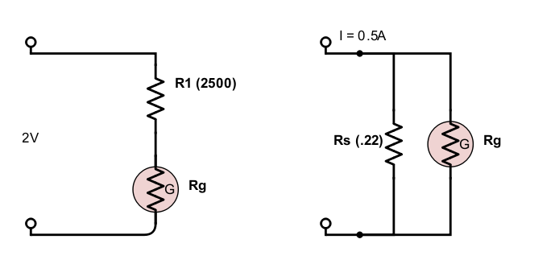

|  |  |
| --- | --- |
| $$V_{s}=V_{g}→ .22i_{s}=R_{g}i_{g}$$ | $$KVL and {Ohm}^{'}s Law 1.1$$ |
| $$I=i_{s}+i_{g}→0.5A=i_{s}+i_{g}→i_{s}= .5-i_{g}$$ | $KCL$ 1.2 |
| $$2V=V_{1}+V_{g}→2=2500i_{g}+R_{g}i_{g}→R_{g}i_{g}=2-2500i_{g}$$ | $KVL$ 1.3 |
| $$.22i_{s}=2-2500i_{g}$$ | $$Combine 1.1 and 1.3$$ |
|  |  |
| $$.22\left(.5-i_{g}\right)=2-2500i_{g}$$ | $$Insert 1.2 for i_{s}$$ |
| $$i_{g}= 0.756 mA$$ | $$Solve for Current i_{g}$$ |
| $$(0.756 mA)R_{g}=2-2500(0.756 mA)$$ | $$Substitue found i_{g} value into 1.3$$ |
| $$R_{g}= 145.5 ohms$$ | $$Solve for Resistance R_{g}$$ |

To produce full scale deflection, the galvanometer should have an internal resistance of 145.5 ohms and there should be a current of 0.756 mA.