|  |  |
| --- | --- |
| Name: | **Jared Fowler** |
|  |  |
| Date: | March 10, 2018 |
| Class: | Engr M20/L – Moorpark College |
| Instructor: | Hadi Darejeh |

Lab 3: Introduction to Operational Amplifiers

|  |  |
| --- | --- |
| Lab Partners: | Roland Terezon  Daniel Alaya |

**Objective**

Gain practical experience with OP-AMPS through building integrated circuits and using analytical tools, including the oscilloscope, to analyze.

**Theory**

Note: Theories, concepts, and proofs heavily quoted from “Fundamentals of Electric Circuits” 5th edition.

**OP-AMP**

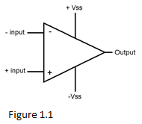An active circuit element designed to perform mathematical operations of addition, subtraction, multiplication, division, differentiation, and integration. The op-amp consists of a complex arrangement of resistors, transistors, capacitors, and diodes. For this lab, however, op-amps will be treated as a black-box with four inputs and one output, as seen in the figure 1.1. The (-) and (+) specify inverting and noninverting inputs, respectively. Positive and negative power supplies are connected to +Vss and -Vss, respectively. The op-amp senses the difference between the inverting and noninverting inputs, multiplies it by the gain A, and causes the resulting voltage to appear at the output.

|  |  |
| --- | --- |
|  | **Theorem 1.1** |

The output voltage is limited by the input power supply voltages, +Vss and -Vss. That is,

|  |  |
| --- | --- |
|  | **Theorem 1.2** |

To facilitate the understanding of op-amp circuits, ideal op-amps are generally assumed. Two important properties of the ideal op-amp are:

1. The currents into both the inverting and noninverting inputs are 0. (Principle of open.)
2. For feedback applications, the voltage across Vin(+) and Vin(-) is 0. (Principle of virtual short.)

**D.C. Amplifier**

The inverting amplifier reverses the polarity of the input signal while amplifying it. Both the input voltage and feedback are connected to the op-amps negative (-) input. As proven below, the output voltage is directly determined by the feedback resistor, R2, and the input resistor R3. A voltmeter connected across V4 and common ground is used to analyze the output voltage.

|  |  |
| --- | --- |
|  |  |
|  |  |
|  | Principle of Virtual Short |
|  | Principle of Open |
|  |  |
|  |  |
|  |  |
|  | Nodal Analysis |
|  |  |
|  | Substitute value of V2 |
|  |  |
|  | Solve for Vout |
|  |  |
|  | **Equation 1.1** |

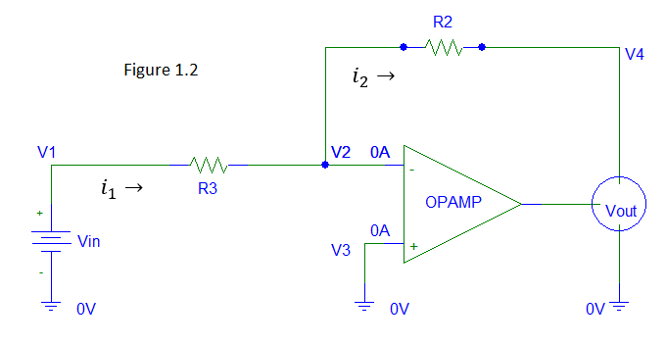

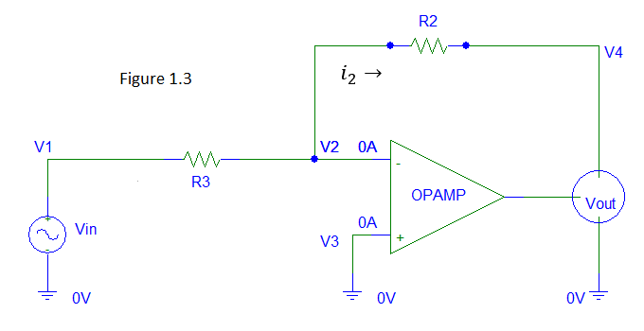**A.C. Amplifier**

Same principle as the D.C. inverting amplifier except the input voltage is Alternating Current type. (A.C.) An oscilloscope connected across V4 and common ground is used to analyze the output voltage Vpp (Peak to Peak) and Vrms (DC-Equivalent Voltage).

**Unity Gain Inverter**

Same principle as the D.C./A.C. inverting amplifier except that the resistances of R2 and R3 are equal, or ideally so. This op-amp flavor is used to transfer a voltage from a circuit with a high output impedance level, to a second circuit with a low impedance level.

**Non-Inverting Op-Amp**

The noninverting amplifier is an op amp circuit designed to provide a positive voltage gain. Unlike the inverting op-amp, the input voltage and feedback are connected to the positive (+) input of the op-amp. Though the gain is slightly different than the inverting amplifier, the value is still dependent upon the loopback resistor, R2, and the input resistor, R3. See proof below.

|  |  |
| --- | --- |
|  |  |
|  | Principle of Virtual Short |
|  | Principle of Open |
|  |  |
|  |  |
|  |  |
|  | Nodal Analysis |
|  |  |
|  |  |
|  |  |
|  |  |
|  |  |
|  | Solve for Vout |
|  |  |
|  | **Equation 1.2** |

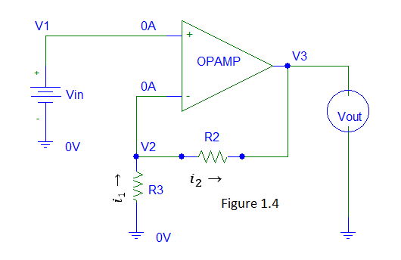

**Summing Op-Amp**

The summing amplifier is an op amp circuit that combines several inputs and produces an output that is the weighted sum of the inputs. As seen in figure 1.5, several input voltages all connect to V2, the negative (-) input of the op-amp. As proven below, the output voltage is the combination of each input, which is amplified based upon the loopback resistor and the input’s input resistor. The same idea can be applied in an noninverting architect, in which each voltage input would produce an output voltage based upon equation 1.2.

|  |  |
| --- | --- |
|  |  |
|  | Principle of Virtual Short |
|  | Principle of Open |
|  |  |
|  |  |
|  |  |
|  | Nodal Analysis |
|  |  |
|  | Solve for Vout |
|  |  |
|  | **Equation 1.3** |

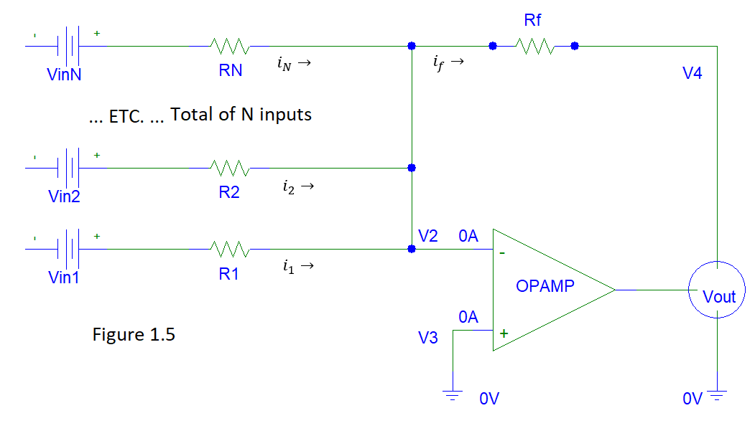

**Procedure**

**Part 1:**

An D.C. amplifier, as seen in figure 1.6, was built. The feedback resistor, R2, was measured at 9.93K-ohms, and the input resistor, R3, was measured at .98K-ohms. The output voltage was measured for three different input voltages. (0.202V, 0.503V, and 2.01V)

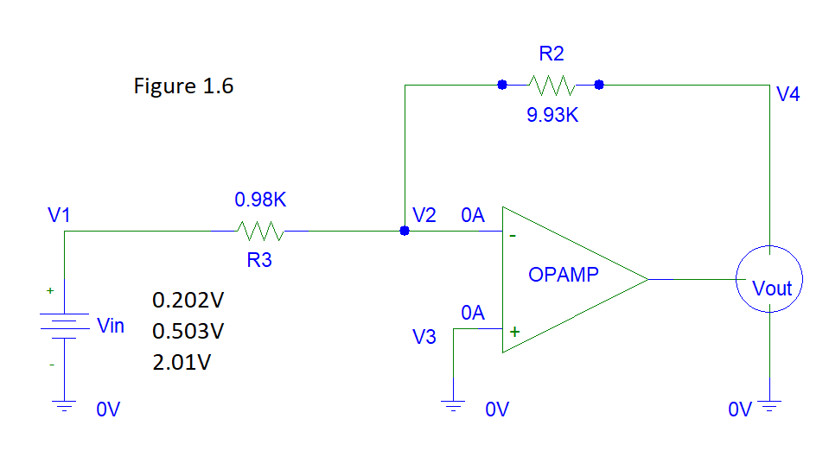

|  |  |  |  |  |
| --- | --- | --- | --- | --- |
| **Vin** | **A - (Calculation 1.2)** | **Theoretical Vout** | **Measured Vout** | **% Error (Calculation 1.1)** |
| 0.202V | 10.13 | -2.05V | 2.05V | 0 |
| 0.503V | 10.13 | -5.10V | -5.07V | 0.59 |
| 2.01 | 10.13 | -20.37V | -7.92V | 61.10 |

**Part 2:**

An A.C. amplifier, as seen in figure 1.7, was built. The feedback resistor, R2, was measured at 9.96K-ohms, and the input resistor, R3, was measured at 1.00K-ohms. The output voltage was measured for an A.C. input of 503mVRMS @ 1KHz, and for 0.998VRMS @ 1KHZ.

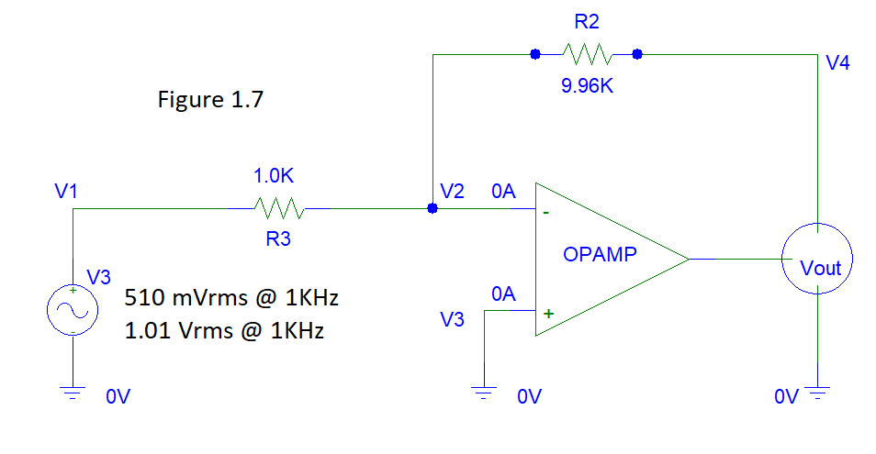

|  |  |  |  |  |
| --- | --- | --- | --- | --- |
| **Vin** | **A - (Calculation 1.2)** | **Theoretical Vout** | **Measured Vout** | **% Error (Calculation 1.1)** |
| 510 mVrms | 9.96 | -5.08 Vrms | -5.03V | 0.98 |
| 1.01 Vrms | 9.96 | -10.06 Vrms | -7.39V | 26.5 |

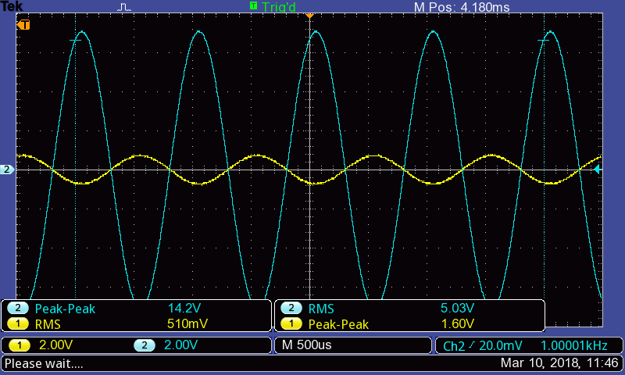

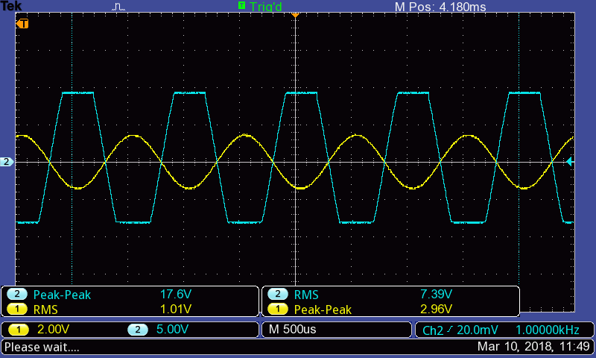

**Part 3a:**

An D.C. unity gain inverter, as seen in figure 1.8, was built. The feedback resistor, R2, was measured at 9.93K-ohms, and the input resistor, R3, was measured at 9.95K-ohms. The output voltage was measured for D.C. input voltages of 3.01V and 5.00V.

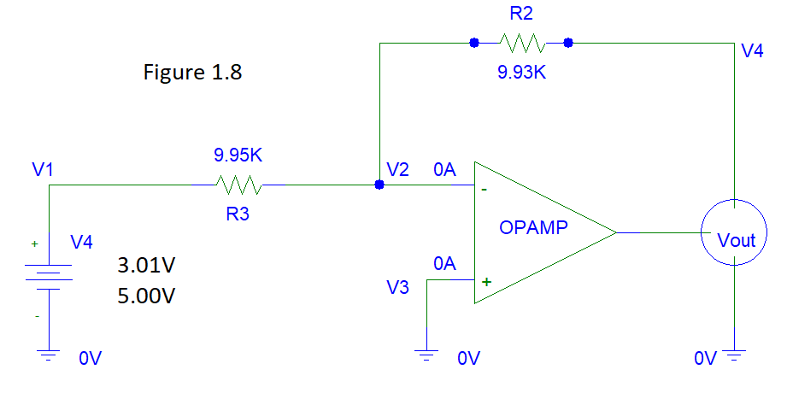

|  |  |  |  |  |
| --- | --- | --- | --- | --- |
| **Vin** | **A - (Calculation 1.2)** | **Theoretical Vout** | **Measured Vout** | **% Error (Calculation 1.1)** |
| 3.01V | .998 | -3.00V | 3.01V | 0.33 |
| 5.00V | .998 | -4.99V | -4.99V | 0 |

**Part 3b:**

An A.C. unity gain inverter, as seen in figure 1.9, was built. The feedback resistor, R2, was measured at 9.96K-ohms, and the input resistor, R3, was measured at 9.94K-ohms. The output voltage was measured for 1.04 VRMS @ 1KHz.

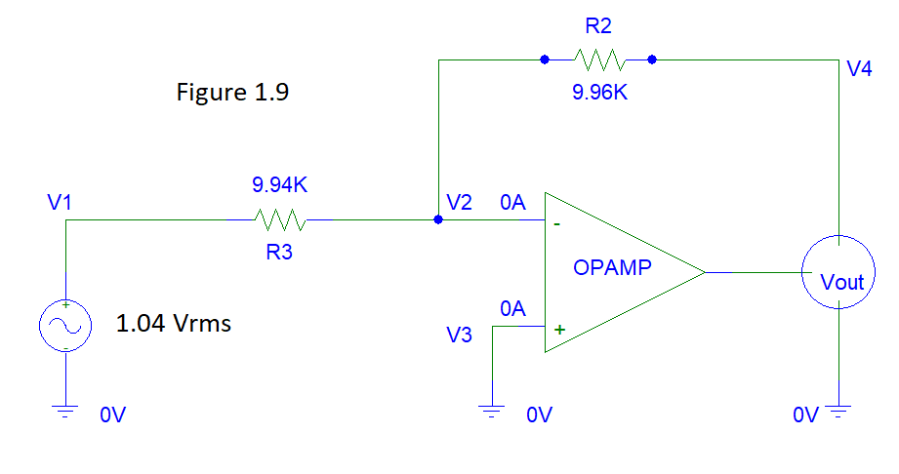

|  |  |  |  |  |
| --- | --- | --- | --- | --- |
| **Vin** | **A - (Calculation 1.2)** | **Theoretical Vout** | **Measured Vout** | **% Error (Calculation 1.1)** |
| 1.04 Vrms | 1.002 | -1.04V | -1.04V | 0 |

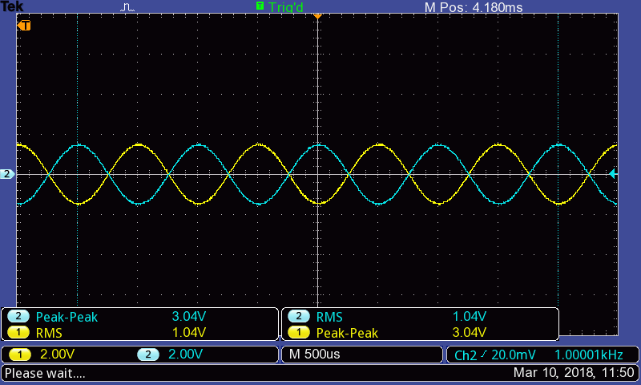

**Part 4a:**

An D.C. noninverting amplifier, as seen in figure 1.10, was built. The feedback resistor, R2, was measured at 9.93K-ohms, and the input resistor, R3, was measured at 0.99K-ohms. The output voltage was measured for D.C. input voltages of 0.200V, 0.501V, and 2.01V.

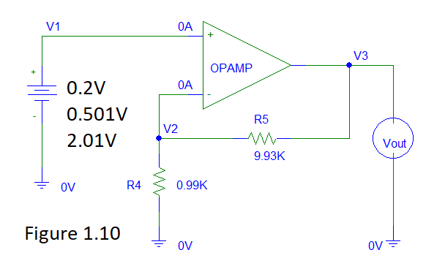

|  |  |  |  |  |
| --- | --- | --- | --- | --- |
| **Vin** | **A - (Calculation 1.3)** | **Theoretical Vout** | **Measured Vout** | **% Error (Calculation 1.1)** |
| 0.200V | 11.03 | 2.21V | 2.20V | 0.45 |
| 0.501V | 11.03 | 5.53V | 5.54V | 0.18 |
| 2.01 | 11.03 | 22.17V | 9.25V | 58.23 |

**Part 4b:**

An A.C. noninverting amplifier, as seen in figure 1.11, was built. The feedback resistor, R2, was measured at 9.96K-ohms, and the input resistor, R3, was measured at 1.0K-ohms. The output voltage was measured for A.C. input 509 VRMS.

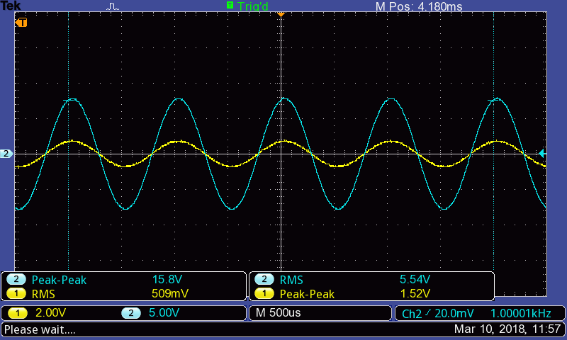

|  |  |  |  |  |
| --- | --- | --- | --- | --- |
| **Vin** | **A - (Calculation 1.3)** | **Theoretical Vout** | **Measured Vout** | **% Error (Calculation 1.1)** |
| 509 mVrms | 10.96 | 5.58V | 5.54V | 0.72 |

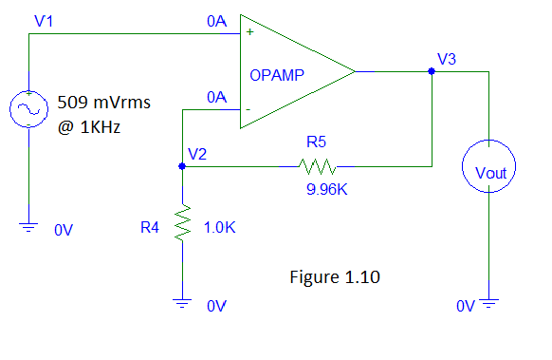

**Part 5a.**

**Data & Calculations**

**Note:**

For convenience, variables V (voltage), R (resistance), and I (current) will be subscripted based upon subscriptions in their respective diagrams. For example, the current across resistor R3 will be represented as i3, and the voltage across R3 will be represented as V3.

**Calculation 1.1**

**Calculation 1.2**

|  |  |
| --- | --- |
|  |  |
|  |  |
|  |  |
|  |  |
|  |  |
|  |  |
|  |  |
|  |  |
|  |  |
|  |  |

**Calculation 1.3**

|  |  |
| --- | --- |
|  |  |

**Calculation 2.1**

|  |  |
| --- | --- |
|  |  |
|  |  |
|  |  |
|  |  |
|  |  |

**Calculation 2.2**

|  |  |
| --- | --- |
|  |  |
|  |  |
|  |  |
|  |  |
|  |  |
|  | |
|  |  |

**Calculation 3.1**

|  |  |
| --- | --- |
|  |  |
|  |  |
|  |  |
|  |  |
|  |  |
|  |  |
|  |  |
|  |  |
|  |  |
|  |  |
|  |  |
|  |  |
|  |  |

**Calculation 3.2**

Note: Definition of Voltage Regulation (V.R.) as follows:

**Discussion of Results**

**Part 1:**

**Part 2:**

**Part 3:**

**Part 4:**

**Part 5:**

**Appendix**

**TODO – Show the max voltage chart thing.**