|  |  |
| --- | --- |
| Name: | **Jared Fowler** |
|  |  |
| Date: | April 8, 2018 |
| Class: | Engr M20/L – Moorpark College |
| Instructor: | Hadi Darejeh |

Lab 4: Transient Response

|  |  |
| --- | --- |
| Lab Partners: | Roland Terezon  Daniel Alaya |

**Objective**

Analyze first-order circuits using standardized methods and PSPICE, and compare the theoretical results with those found in the lab experiment.

**Theory**

Note: Theories, concepts, and proofs heavily quoted from “Fundamentals of Electric Circuits” 5th edition.

**First-Order Circuits**

Contain only one energy storage element (capacitor or inductor), and that can, therefore, be described using only a first order differential equation.

**Transient Response**

Time required for a capacitor to fully charge is equivalent to about 5 times constants or 5T. This transient response time T, is measured in terms of **τ = R x C**, in seconds. **(EQ 0.1)**

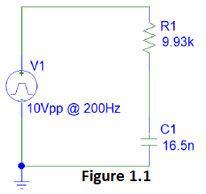**Low-Pass Filter**

A filter that passes signals with a frequency lower than a certain cutoff frequency and attenuates signals with frequencies higher than the cutoff frequency.

The low-pass filter circuit analyzed in this lab is shown in Figure 1.1. Note that resistor R1 is placed in series with, and before, the capacitor C1. The circuit is powered by a square wave of 10Vpp @ 200Hz.

The voltage across C1 is derived below. The derivation consists of two output equations, (EQ 1.3) and (EQ 1.4), which represent high peak and low peak voltages of the square wave respectively.

|  |  |  |
| --- | --- | --- |
|  | | |
|  |  |  |
|  |  | I.C. |
|  |  | K.C.L. |
|  |  |  |
|  |  |  |
|  |  | **(EQ 1.1)** |
|  |  |  |
|  |  | **(EQ 1.2)** |
|  |  | Because right side is constant |
|  |  | Substitute into (EQ 1.1), and solve for k2 |
|  |  |  |
|  |  | Assumed solution |
|  |  | Substitute into (EQ 1.1), and solve for s |
|  |  |  |
|  |  |  |
|  |  |  |
|  |  | Substitute into (EQ 1.2) |
|  |  | Solve for k1 at t=0 |
|  |  |  |
|  |  |  |
|  |  | **(EQ 1.3)** |
|  |  |  |
|  |  | I.C. |
|  |  |  |
|  |  | Source-less CKT |
|  |  | Solve for k1 at t=2.5ms |
|  |  |  |
|  |  |  |
|  |  | **(E.Q. 1.4)** |

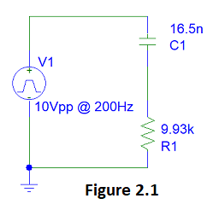**High-Pass Filter**

A filter that passes signals with a frequency higher than a certain cutoff frequency and attenuates signals with frequencies lower than the cutoff frequency.

The high-pass filter circuit analyzed in this lab is shown in Figure 2.1. Note that resistor R1 is placed in series with, and after, the capacitor C1. The circuit is powered by a square wave of 10Vpp @ 200Hz.

The voltage across C1 is derived below. The derivation consists of two output equations, (EQ 2.2) and (EQ 2.3), which represent high peak and low peak voltages of the square wave respectively.

|  |  |  |
| --- | --- | --- |
|  | | |
|  |  |  |
|  |  | I.C. (Vc cannot change instantaneously.) |
|  |  | **(EQ 2.1)** |
|  |  |  |
| .  .  . |  | Follow procedure from Equation 1 to arrive at (EQ 1.3), then substitute in (EQ 2.1) |
|  |  |  |
|  |  | Simplify |
|  |  | **(EQ 2.2)** |
|  |  |  |
| **.**  **.**  **.** |  | Follow procedure from Equation 1 to arrive at (EQ 1.4), then substitute in (EQ 2.1) |
|  |  |  |
|  |  | **(EQ 2.3)** |

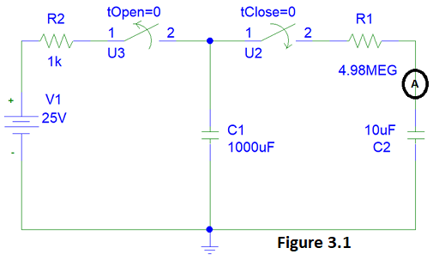**Big Charged Capacitor to Smaller Uncharged Capacitor**

The circuit as shown in Figure 3.1 is analyzed in this lab. Capacitor C1 reaches steady state while in series with the voltage source V1 and resistor R2. To be in steady state means that C1 acts like an “open” in the circuit, and has been charged to match the voltage of V1. Capacitor C2 is completely discharged. The “switch” is then flipped, disabling the first circuit and enabling a circuit of C1, R1, ammeter, and C2 in series. C1 discharges which causes a current to flow through the circuit. The current flowing through the circuit in respect to time is derived below.

|  |  |  |
| --- | --- | --- |
|  | | |
|  |  |  |
|  |  | K.V.L. |
|  |  | Substitute voltages with capacitor-current relationship equations. Take the derivative of the entire equation. |
|  |  |  |
|  |  |  |
|  |  | **(EQ 3.1)** |
|  |  |  |
|  |  | **(EQ 3.2)** |
|  |  |  |
|  |  | Right side is constant and 0 |
|  |  |  |
|  |  |  |
|  |  | Substitute into EQ 3.1 |
|  |  | Solve for s |
|  |  |  |
|  |  | Substitute into EQ 3.2 |
|  |  |  |
|  | | |
|  |  |  |
|  |  | Solve for k |
|  |  |  |
|  |  | **(EQ 3.3)** |

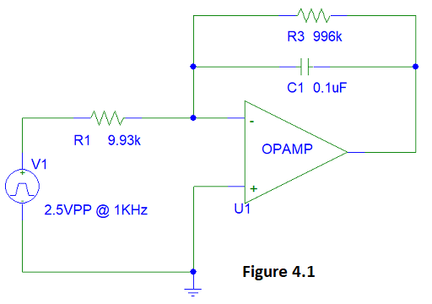**Op-Amp Integrator**

Operational amplifier circuit that performs the mathematical operation of **Integration**.

The integrator circuit analyzed in this lab is shown in Figure 4.1. Note that the feedback line is populated with capacitor C1. The resistor in parallel with C1 acts as a stabilizer. The circuit is powered by a square wave of 2.5Vpp @ 1KHz.

The Op-Amp output voltage in respect to time is derived below. The derivation consists of two output equations, (EQ 4.2) and (EQ 4.3), which represent high peak and low peak voltages of the square wave respectively.

|  |  |  |
| --- | --- | --- |
|  | | |
|  | | |
|  | | |
|  |  | I.C. (Vc cannot change instantaneously) |
|  |  | Principles of Short and Open for OpAmps |
|  |  |  |
|  |  | K.C.L. @ OpAmp (-) |
|  |  |  |
|  |  |  |
|  |  | **(EQ 4.1)** |
|  |  |  |
|  |  |  |
|  |  |  |
|  |  |  |
|  |  | **(EQ 4.2)**  **Negate b/c inverse op-amp** |
|  |  |  |
|  |  | I.C. |
|  |  |  |
|  |  | **(EQ 4.1)** |
|  |  |  |
|  |  |  |
|  |  |  |
|  |  |  |
|  |  | **(EQ 4.3)**  **Negate b/c inverse op-amp** |

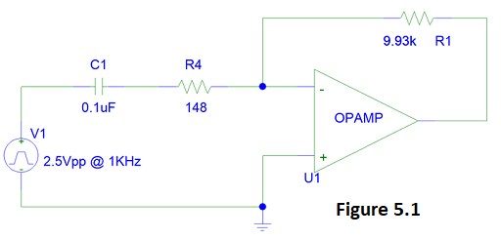**Op-Amp Differentiator**

Operational amplifier circuit performs the mathematical operation of **Differentiation.**

The differentiator circuit analyzed in this lab is shown in Figure 5.1. Note that the op-amp negative input line is populated with capacitor C1. The resistor in series with C1 acts as a stabilizer. The circuit is powered by a sawtooth wave of 2.5Vpp @ 1KHz.

The Op-Amp output voltage in respect to time is derived below. The derivation consists of two output equations, (EQ 4.2) and (EQ 4.3), which represent high peak and low peak voltages of the sawtooth wave respectively.

|  |  |  |
| --- | --- | --- |
|  | | |
|  | | |
|  | | |
|  |  | I.C. (Vc cannot change instantaneously.) |
|  |  |  |
|  |  | Principles of Short and Open for OpAmps |
|  |  | **(EQ 5.1)** |
|  |  | **(EQ 5.2)** |
|  |  |  |
|  |  | K.C.L. @ OpAmp (-) |
|  |  |  |
|  |  | Take the derivative. |
|  |  |  |
|  |  | **(EQ 5.3)** |
|  |  |  |
|  |  | **(EQ 5.4)** |
|  |  |  |
|  |  | K.C.L. @ OpAmp (-) |
|  |  |  |
|  |  |  |
|  |  | Take the derivative. |
|  |  |  |
|  |  | **(EQ 5.5)** |

**Procedure**

**Part 1:**

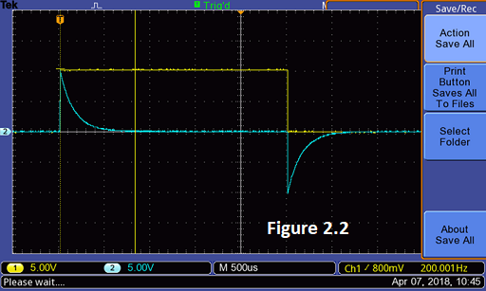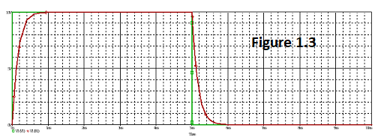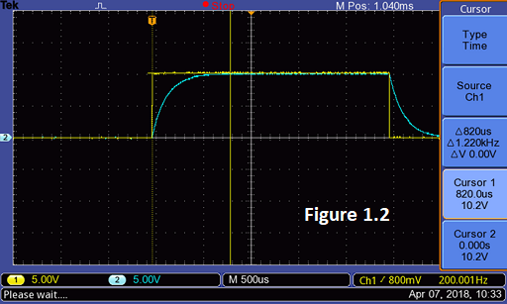The low-pass filter circuit, as seen in Figure 1.1, was built. The resistor was measured at 9.93K-ohms and the capacitor was of unknown value. An oscilloscope was used to analyze and measure the charge/discharge curve of the capacitor with respect to input voltage, as seen in Figure 1.2. The time to charge was found to be around 820us. Utilizing this data, the capacitor was calculated to have a capacitance of **16.5nF**. (Calculation 1.1) The real value was then measured by a separate device to be **14.9nF**, which is **10.7%** different than the calculated value. (Calculation 1.2) The waveforms were calculated to be **, @ 0<t<2.5ms,** and  **@2.5ms<t<5ms** for the square wave’s high and low voltage outputs of 0 < t < 5ms respectively. (Calculation 1.3) The circuit was built and analyzed in PSPICE, as seen in Figure 1.3.

**Part 2:**

The high-pass filter circuit, as seen in Figure 2.1, was built, simply by switching the capacitor and resistor from part 1. An oscilloscope was used to analyze and measure the charge/discharge curve of the capacitor with respect to input voltage, as seen in Figure 2.2. The waveforms were calculated to be **@ 0<t<2.5ms,** and  **@ 2.5ms<t<5ms,** for the square wave’s high and low voltage outputs of 0 < t < 5ms respectively. 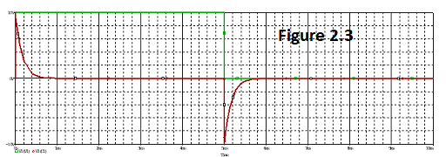(Calculation 2.1) The circuit was built and analyzed in PSPICE, as seen in Figure 2.3.

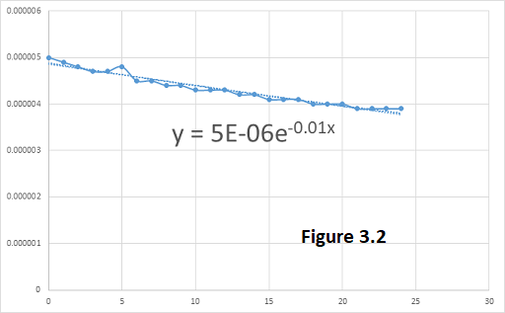

**Part 3:**

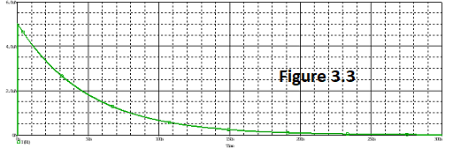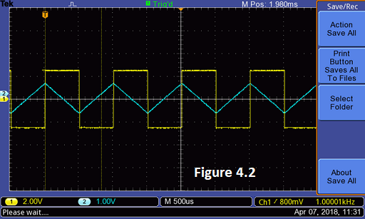The circuit, as seen in Figure 3.1, was built. Resistor R1 was measured at 4.98M-Ohms. An ammeter was connected in series with the circuit between R1 and C2. Capacitor C1 fully charged, and C2 fully discharged. The switch was pulled and the current flowing through the C1, R1, ammeter, C2 circuit was recorded at 1 second intervals. These data points were analyzed with Excel to produce the waveform and equation as show in Figure 3.2. The waveform was calculated to be , which is very close to the waveform calculated by excel. (Calculation 3.1) The circuit was built and analyzed in PSPICE, as seen in Figure 3.3.

**Part 4:**

The op-amp integrator circuit, as seen in Figure 4.1, was built. R1 was measured at 9.93k-ohm. An oscilloscope was used to analyze and measure the op-amp output voltage in relation to the input voltage, as seen in Figure 4.2. The waveforms were calculated to be **@ 0<t<500us,** 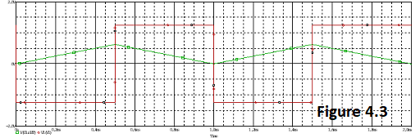and  **@ 500us<t<1000us** for the square wave’s low and high voltage outputs of 0 < t < 1ms respectively. (Calculation 4.1) The circuit was built and analyzed in PSPICE, as seen in Figure 4.3.

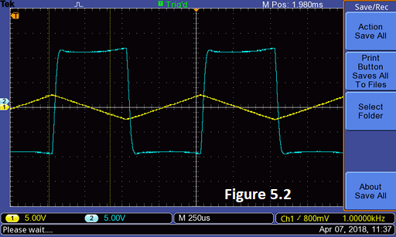

**Part 5:**

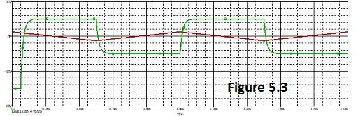The op-amp differentiator circuit, as seen in Figure 5.1, was built. R1 was measured at 9.93k-ohm. An oscilloscope was used to analyze and measure the op-amp output voltage in relation to the input voltage, as seen in Figure 5.2. The waveforms were calculated to be **@ 0<t<500us** and  **@ 500us<t<1000us** for the sawtooth wave’s high and low voltage outputs of 0 < t < 1ms respectively. (Calculation 5.1) The circuit was built and analyzed in PSPICE, as seen in Figure 5.3. The sawtooth waveform was created in PSPICE using a square wave input with a manipulated transition time to match ½ the period, thus producing a sawtooth wave.

**Data & Calculations**

**Calculation 1.1**

**Calculation 1.2**

**Calculation 1.3**

|  |  |  |
| --- | --- | --- |
|  |  | Substitute measured values into (EQ 1.3) |
|  |  |  |
|  |  |  |
|  |  | I.C. |
|  |  |  |
|  |  |  |
|  |  | Substitute measured values and calculated V_2 into (EQ 1.4) |
|  |  |  |

**Calculation 2.1**

|  |  |  |
| --- | --- | --- |
|  |  | Substitute measured values into (EQ 2.2) |
|  |  |  |
|  |  |  |
|  |  | I.C. |
|  |  |  |
|  |  |  |
|  |  | Substitute measured values and calculated V_2 into (EQ 2.3) |
|  |  |  |

**Calculation 3.1**

|  |  |  |
| --- | --- | --- |
|  |  | Substitute measured values into (EQ 3.3) |
|  |  | Simplify. Compare to |

**Calculation 4.1**

|  |  |  |
| --- | --- | --- |
|  |  | Substitute measured values into (EQ 4.2) |
|  |  | Simplify. |
|  |  |  |
|  |  | I.C. |
|  |  | Substitute measured values into (EQ 4.3) |
|  |  | Simplify. |

**Calculation 5.1**

|  |  |  |
| --- | --- | --- |
|  |  | Substitute measured values into (EQ 5.3) |
|  |  | Simplify. |
|  |  |  |
|  |  | Substitute measured values into (EQ 5.5) |
|  |  | Simplify. |

**Discussion of Results**

**Part 1:**

Experiment went as expected. The estimated/calculated capacitor value (16.5uF) came close to the actual value (14.9nF). The 10.7% error was most likely a factor of human error when choosing the start and end time points on the oscilloscope. The charge and discharge waveforms of the capacitor were clearly seen. The derived equation and theoretical graph produced with PSPICE matched nicely with the experimental output captured by the oscilloscope.

**Part 2:**

Experiment went as expected. The charge and discharge waveforms of the capacitor were clearly seen. The derived equation and theoretical graph produced with PSPICE matched nicely with the experimental output captured by the oscilloscope.

**Part 3:**

The final results of the experiment were as expected, however, the experiment itself did not go very smoothly. The current flowing through the circuit in response to the large capacitors discharge was clearly seen. Contrary to the instruction to take data points every 20 seconds, data points were taken every 1 second for 30 seconds. While 20 second intervals would work great in ideal conditions, it was found that the ammeter was incapable of accurately measuring the current once it dropped below 3.5uA or so. As a result, this portion of the experiment was repeated after having taken data points every 20 seconds for 15 minutes. Microsoft’s Excel produced an accurate equation based upon the gathered data points which nicely corresponded with the derived equation and PSPICE graph.

**Part 4:**

Experiment went as expected. The op-amp output voltage was clearly seen to correspond to the integration of the input voltage wave. The derived equation and theoretical graph produced with PSPICE matched nicely with the experimental output captured by the oscilloscope.

**Part 5:**

Experiment went as expected. The op-amp output voltage was clearly seen to correspond to the derivative of the input voltage wave. The derived equation and theoretical graph produced with PSPICE matched nicely with the experimental output captured by the oscilloscope.

**Appendix**

**A freshman goes into Radio Shack and asks for a capacitor.**

**“Will that be cash? Asks the clerk.**

**“Nah, charge it.” Says the freshman.**

