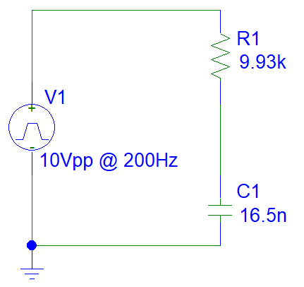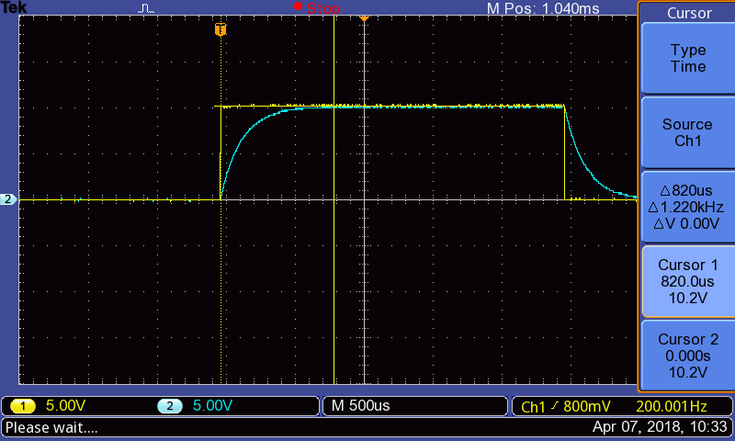

|  |  |  |
| --- | --- | --- |
|  |  | I.C. |
|  |  |  |
|  |  | K.C.L. |
|  |  |  |
|  |  |  |
|  |  | Substitute in c, c=0.1uF |
|  |  | (E.Q. 1.1) |
|  |  |  |
|  |  | (E.Q. 1.2) |
|  |  | Because 5000 is constant |
|  |  | Substitute into E.Q. 1.1, and solve for k2 |
|  |  |  |
|  |  | Assumed solution |
|  |  | Substitute into E.Q. 1.1, and solve for s |
|  |  |  |
|  |  |  |
|  |  |  |
|  |  | Substitute into E.Q. 1.2 |
|  |  | Solve for k1 at t=0 |
|  |  |  |
|  |  |  |
|  |  | (E.Q. 1.3) |
|  |  |  |
|  |  | I.C. |
|  |  |  |
|  |  | Source-less CKT |
|  |  | Solve for k1 at t=.007 |
|  |  |  |
|  |  |  |
|  |  | (E.Q. 1.4) |

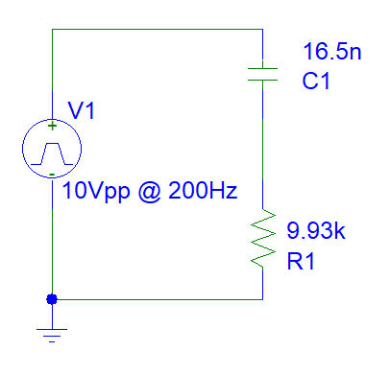

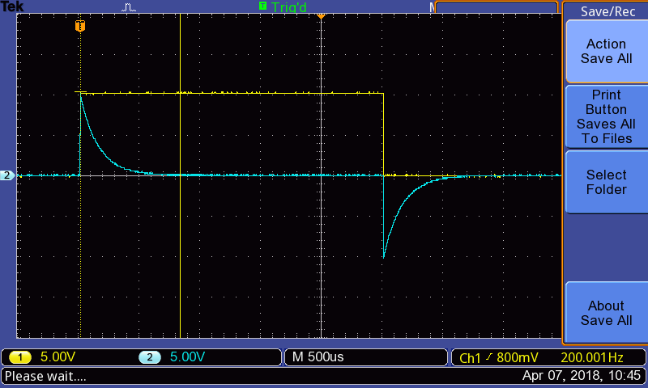

|  |  |  |
| --- | --- | --- |
|  |  | I.C. (Vc cannot change instantaneously.) |
|  |  | (E.Q. 2.1) |
|  |  |  |
| .  .  . |  | Follow procedure from Equation 1 to arrive at E.Q. 1.3, then substitute in E.Q. 2.1 |
|  |  |  |
|  |  | (E.Q. 2.2) |
|  |  |  |
| **.**  **.**  **.** |  | Follow procedure from Equation 1 to arrive at E.Q. 1.4, then substitute in E.Q. 2.1 |
|  |  |  |
|  |  | (E.Q. 2.3) |

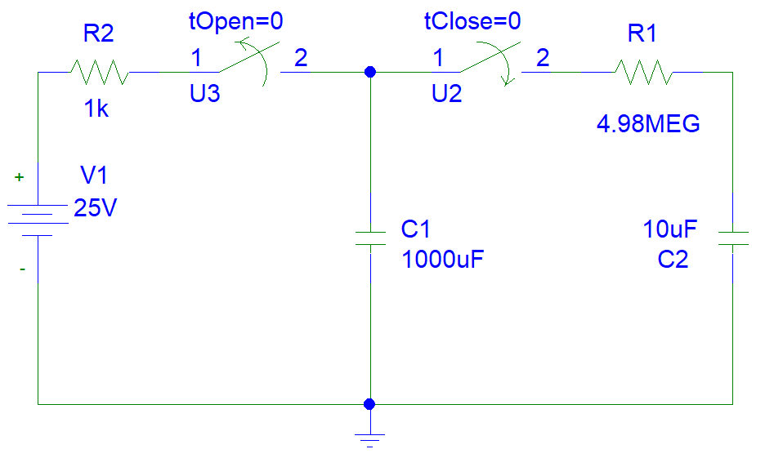



|  |  |  |
| --- | --- | --- |
|  | | |
|  |  |  |
|  |  | K.V.L. |
|  |  | Substitute voltages with capacitor-current relationship equations. Take the derivative of the entire equation. |
|  |  |  |
|  |  |  |
|  |  | (E.Q. 3.1) |
|  |  |  |
|  |  | (E.Q. 3.2) |
|  |  |  |
|  |  | Right side is constant and 0 |
|  |  |  |
|  |  |  |
|  |  | Substitute into E.Q. 3.1 |
|  |  | Solve for s |
|  |  |  |
|  |  | Substitute into E.Q. 3.2 |
|  |  |  |
|  | | |
|  |  |  |
|  |  | Solve for k |
|  |  |  |
|  |  | **(E.Q. 3.3)** |

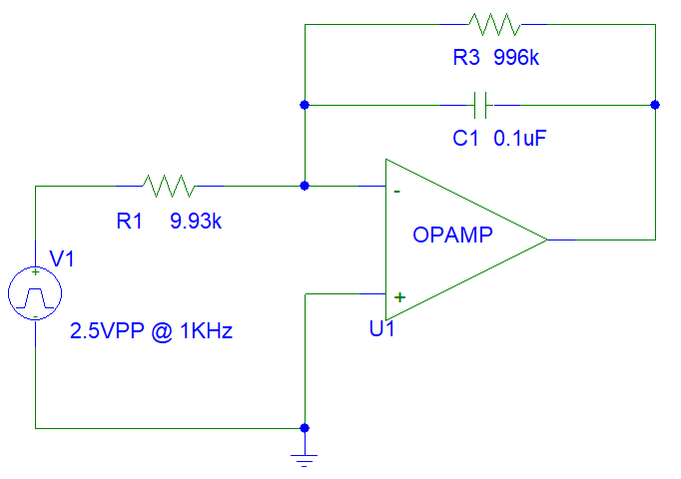



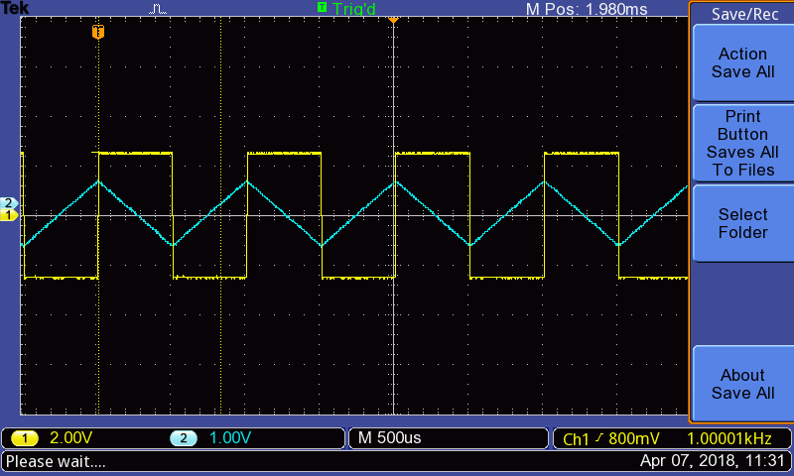

|  |  |  |
| --- | --- | --- |
|  |  | I.C. (Vc cannot change instantaneously.) |
|  |  | Principles of Short and Open for OpAmps |
|  |  |  |
|  |  | K.C.L. @ OpAmp (-) |
|  |  |  |
|  |  |  |
|  |  | Substitute in c, c=0.1uF and V1, V1=-1.25V  Note: Use +1.25V b/c OpAmp is inverting output. |
|  |  | (E.Q. 4.1) |
|  |  |  |
|  |  |  |
|  |  |  |
|  |  | (E.Q. 4.2) |
|  |  |  |
|  |  | I.C. |
|  |  |  |
|  |  | Substitute in c, c=0.1uF and V1, V1=+1.25V  Note: Use -1.25V b/c OpAmp is inverting output. |
|  |  | (E.Q. 4.3) |
|  |  |  |
|  |  |  |
|  |  |  |
|  |  | (E.Q. 4.4) |

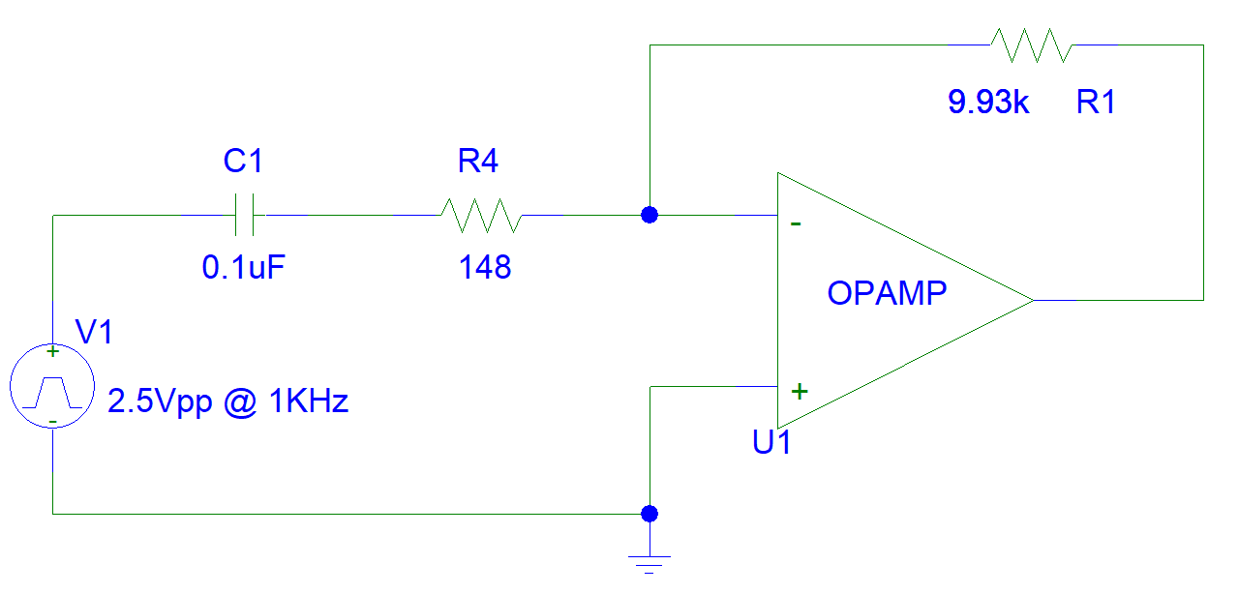



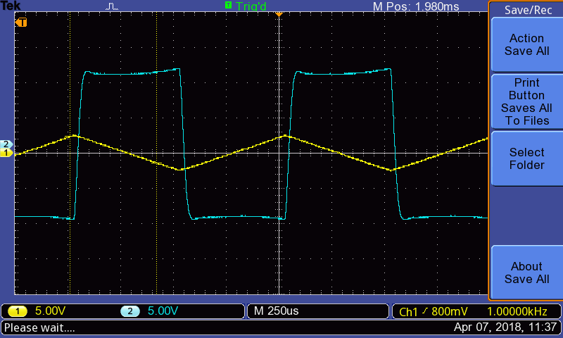

|  |  |  |
| --- | --- | --- |
|  | | |
|  |  | I.C. (Vc cannot change instantaneously.) |
|  |  |  |
|  |  | Principles of Short and Open for OpAmps |
|  |  | (E.Q. 5.1) |
|  |  | (E.Q. 5.2) |
|  |  |  |
|  |  | K.C.L. @ OpAmp (-) |
|  |  |  |
|  |  | Substitute in c, c=0.1uF, and E.Q. 5.2 |
|  |  | Take the derivative.  The output is inverted, so -5 becomes 5 |
|  |  |  |
|  |  | (E.Q. 5.3) |
|  |  |  |
|  |  | (E.Q. 5.4) |
|  |  |  |
|  |  | K.C.L. @ OpAmp (-) |
|  |  |  |
|  |  | Substitute in c, c=0.1uF, and E.Q. 5.4 |
|  |  | Take the derivative.  The output is inverted, so +5 becomes -5 |
|  |  |  |
|  |  | (E.Q. 5.5) |