|  |  |
| --- | --- |
| Name: | **Jared Fowler** |
|  |  |
| Date: | May 1, 2018 |
| Class: | Engr M20/L – Moorpark College |
| Instructor: | Hadi Darejeh |

Lab 5: Second Order Circuits

|  |  |
| --- | --- |
| Lab Partners: | Roland Terezon  Daniel Alaya |

**Objective**

Analyze second-order circuits using standardized methods and PSPICE, and compare the theoretical results with those found in the lab experiment.

**Theory**

Note: Theories, concepts, and proofs heavily quoted from “Fundamentals of Electric Circuits” 5th edition & Wikipedia.

**Second-Order Circuits**

A circuit which is characterized by a second-order differential equation. It consists of resistors and the equivalent of two energy storage elements.

**Capacitor, C**

Device used to store an electric charge, consisting of one or more pairs of conductors separated by an insulator. The voltage across a capacitor in respect to time: , and the current in respect to time: .

**Inductor, L**

Device that stores energy in a magnetic field when electric current flows through it. An inductor typically consists of an insulated wire wound into a coil around a core. The voltage across an inductor in respect to time: , and the current in respect to time: .

**Damping Ratio**

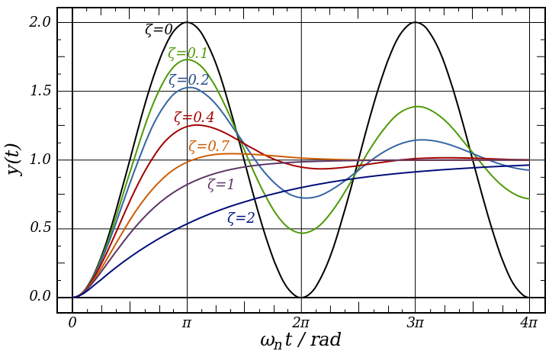Dimensionless measure describing how oscillations in a system decay after a disturbance. The value is denoted by ζ (zeta, z), which can vary from undamped (z=0), underdamped (z<1), critically damped (z=1), and overdamped (z>1).

Damping is caused by the resistance in the circuit. It determines whether or not the circuit will resonate naturally (that is, without a driving source). Circuits which will resonate in this way are described as underdamped and those that will not are overdamped.

|  |  |  |
| --- | --- | --- |
|  |  | **EQ 0.0.1** |

|  |  |  |
| --- | --- | --- |
|  |  | RCL in Series  **EQ 0.0.2** |
|  |  | CL in Parallel  **EQ 0.0.3** |
|  |  |  |

|  |  |  |
| --- | --- | --- |
|  | | |
|  |  |  |
|  |  | **EQ 0.1** “Critical Damping” |
|  |  |  |
|  |  | **EQ 0.2** “Over-Damped’ |
|  |  |  |
|  |  | **EQ 0.3** “Under-Damped” |
|  |  |  |
|  |  | **EQ 0.4** “Un-Damped” |

**RCL in Series**

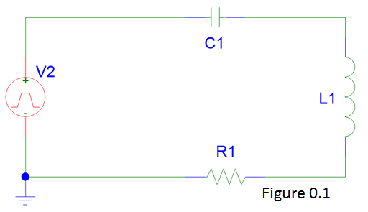The circuit shown in Figure 0.1 is analyzed in this lab. In this circuit, a capacitor, inductor, and resistor are in series. A square wave pulse is used for the input voltage. The pulse’s high and low times are large enough to allow a complete charge and discharge of the system over the course of one period. The voltage across the resistor is derived below. Note that the waveform will depend upon the damping ratio as seen in EQ 1.3.

|  |  |  |
| --- | --- | --- |
|  | | |
|  |  |  |
|  |  | KVL |
|  |  | Note: |
|  |  |  |
|  |  | Substitute and take derivative |
|  |  |  |
|  |  |  |
|  |  |  |
|  |  | Substitute current for VR |
|  |  |  |
|  |  | **EQ 1.1** |
|  |  |  |
|  |  |  |
|  |  |  |
|  |  | Because right side of ‘=’ is constant 0. |
|  |  |  |
|  |  | Differential Equations. (DE) |
|  |  |  |
|  |  |  |
|  |  |  |
|  |  | **EQ 1.2** |
|  |  |  |
|  |  | **EQ 1.3** |
|  |  |  |
|  |  | **EQ 1.4**  **Quadratic Equation.** |
|  |  |  |
|  | | |
|  | | |
|  |  |  |
|  | | |

**RCL in Parallel**

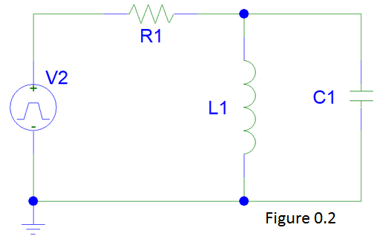The circuit shown in Figure 0.2 is analyzed in this lab. In this circuit, a capacitor and inductor in parallel. A square wave pulse is used for the input voltage. The pulse’s high and low times are large enough to allow a complete charge and discharge of the system over the course of one period. The voltage across the capacitor is derived below. Note that the waveform will depend upon the damping ratio as seen in EQ 2.4.

|  |  |  |
| --- | --- | --- |
|  |  | KCL |
|  |  |  |
|  |  |  |
|  |  |  |
|  |  | Take Derivative. |
|  |  |  |
|  |  | **EQ 2.1** |
|  |  |  |
|  |  |  |
|  |  |  |
|  |  | Because right side of ‘=’ is constant 0. |
|  |  |  |
|  |  | Differential Equations. (DE) |
|  |  |  |
|  |  |  |
|  |  |  |
|  |  | **EQ 2.2** |
|  |  |  |
|  |  | **EQ 2.3** |
|  |  |  |
|  |  | **EQ 2.4**  **Quadratic Equation.** |
|  |  |  |
|  | | |
|  | | |
|  |  |  |
|  | | |

**Internal Resistance of Power Supply (Square Wave Generator)**

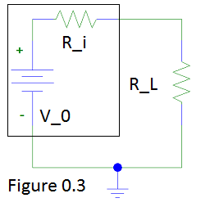The square wave generator used in Figures 0.1 and 0.2 has an internal resistance. This resistance can be found by sampling the voltage across the generator when no load is present, and then again when a load is present. It’s easiest to picture the internal resistance as a resistor in series with the voltage source, which Figure 0.3 illustrates. This is mere voltage division, where V0 is the voltage with no load, and VL is the voltage across the added load, RL. The internal resistance, Ri, is derived below.

|  |  |  |
| --- | --- | --- |
|  |  | Voltage Division |
|  |  |  |
|  |  |  |
|  |  |  |
|  |  |  |
|  |  |  |
|  |  | **EQ 3.1** |

**Procedure**

**Part 1:**

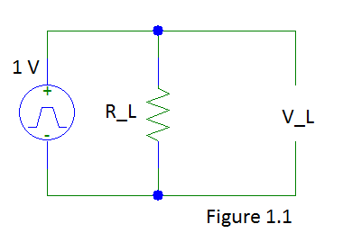The internal resistance of the square wave generator was determined. The circuit, as seen in Figure 1.1, was constructed. The voltage across the voltage source was first measured without any load resistor, R_L. Five additional voltage readings were taken with the load resistor connected, each time the load resistor being changed to a different value. The results can be seen in the table below.

The internal resistance was found experimentally to be 50.25 Ohms. The square wave generator voltage source claims to have an internal resistance of 50 Ohms. The experimental and actual internal resistances differ by 0.5%.

|  |  |  |  |
| --- | --- | --- | --- |
| **Vin** | **Resistance (R)** | **Vout** | **Internal Resistance (Ri) – See (Calculation 1.1)** |
| 1 VRMS | OPEN | 2.01 | - |
| 1 VRMS | 300 | 1.72 | 50.58 |
| 1 VRMS | 200 | 1.60 | 51.25 |
| 1 VRMS | 100 | 1.34 | 50.00 |
| 1 VRMS | 50 | 1.00 | 50.50 |
| 1 VRMS | 25 | 0.68 | 48.90 |
|  |  |  |  |
| **Average:** | | | 50.25-Ohm |
| **(Theoretical Value: 50 Ohms) -> % Error:** | | | 0.5% - See (Calculation 1.2) |

**Part 2:**

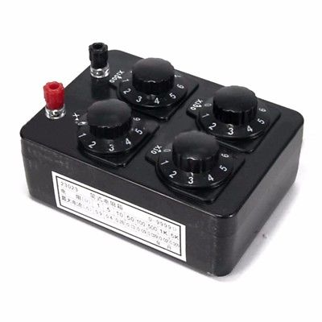The internal resistance of the inductor was found using an ohmmeter**.** The ohmmeter determines the resistance by sending a small current through the measured object and determining the voltage drop. While the inductor will initially read at a higher resistance due to its anti-current-change behavior, the inductor will eventually act like a short in the circuit, at which time the internal resistance can be measured. This internal resistance is the resistance of the material itself which makes up the inductor. Per this lab, an inductor decade box was used which means that the internal resistance changes based upon the box setting. At the 70mH setting, the internal resistance was measured to be around 0.5-Ohm. Because the internal resistance is such a low value, it will not be taken into consideration in the calculations.

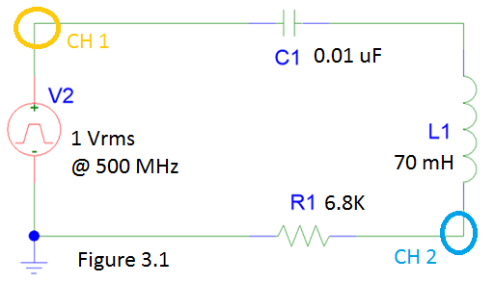**Part 3a:**

The circuit shown in Figure 3.1 was built. An oscilloscope was used to analyze both the input voltage from the square wave generator, and the voltage across the 6.8K-ohm resistor.

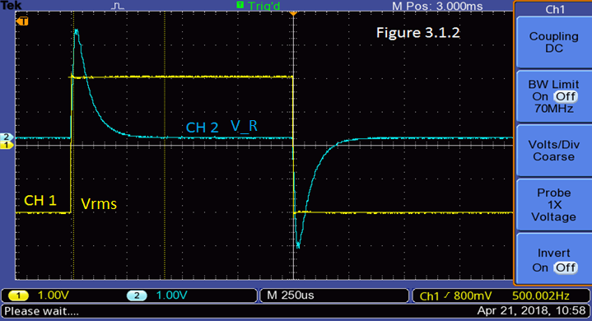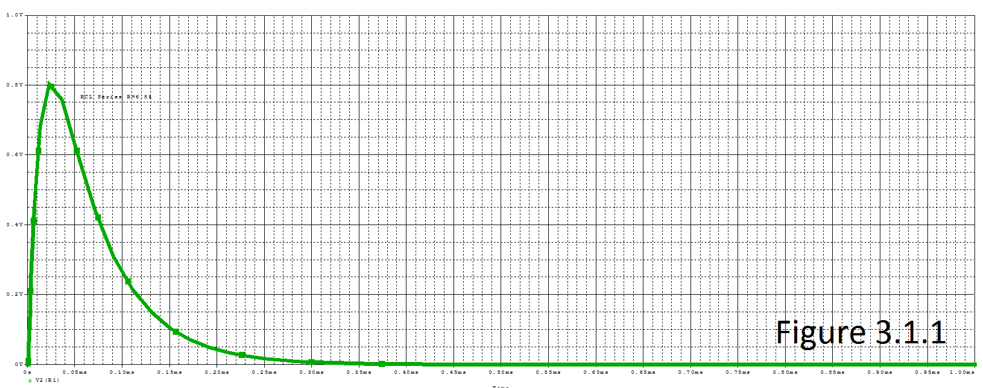PSpice was used to acquire a theoretical output curve as seen in Figure 3.1.1. The experimental output curve measured with the oscilloscope is shown in Figure 3.1.2. Both curves accurately identify the curve as being overdamped. The theoretical equation was found to be: (Calculation 3.1)

**Part 3b:**

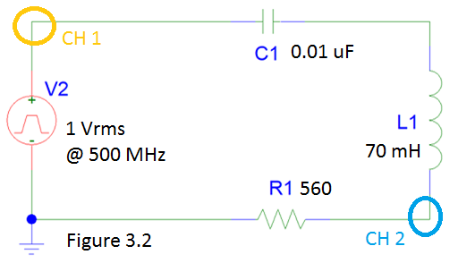The circuit shown in Figure 3.2 was built. An oscilloscope was used to analyze both the input voltage from the square wave generator, and the voltage across the 560-ohm resistor.

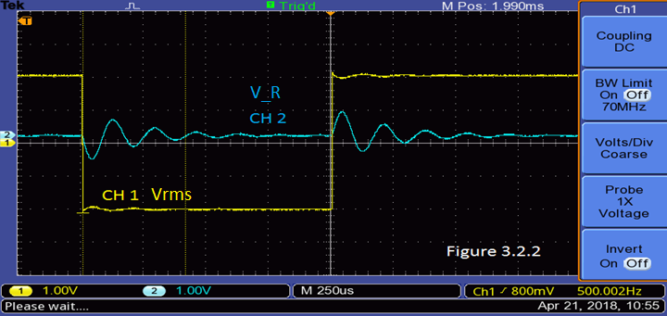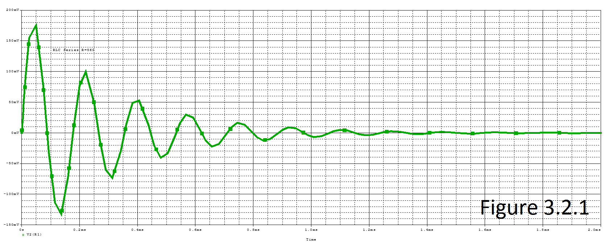PSpice was used to acquire a theoretical output curve as seen in Figure 3.2.1. The experimental output curve measured with the oscilloscope is shown in Figure 3.2.2. Both curves accurately identify the curve as being underdamped. The theoretical equation was found to be: (Calculation 3.2)From the oscilloscope reading, the oscillating period was observed to be about 175us. The damping frequency and ratio were estimated to be 35903 rads/sec and 0.111 respectively. (Calculation 3.2.1)

**Part 3c:**

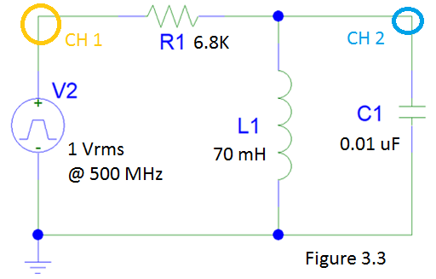The circuit shown in Figure 3.3 was built. An oscilloscope was used to analyze both the input voltage from the square wave generator, and the voltage across the capacitor.

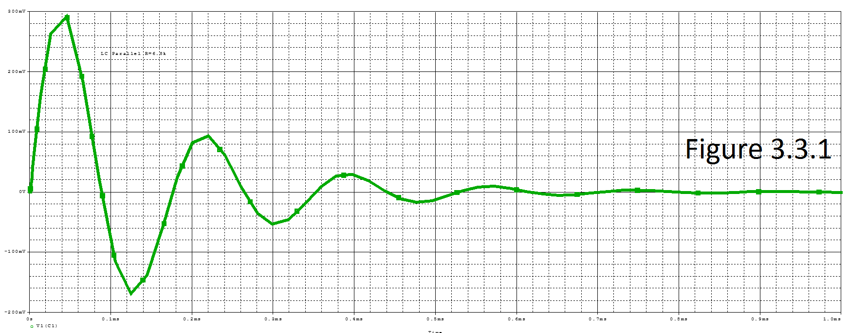PSpice was used to acquire a theoretical output curve as seen in Figure 3.3.1. The experimental output curve measured with the oscilloscope is shown in Figure 3.3.2. Both curves accurately identify the curve as being underdamped. The theoretical equation was found to be: (Calculation 3.3) From the oscilloscope reading, the oscillating period was observed to be about 175us. The damping frequency and ratio were estimated to be 35903 rads/sec and 0.205 respectively. (Calculation 3.3.1)

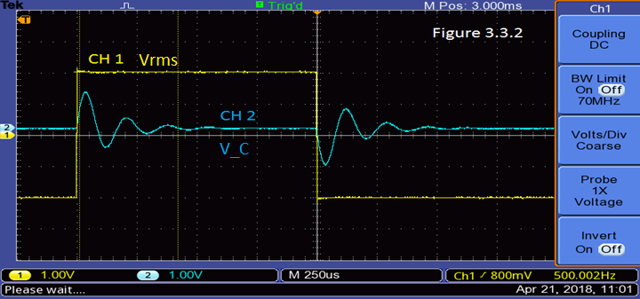

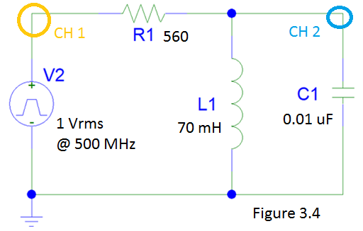**Part 3d:**

The circuit shown in Figure 3.4 was built. An oscilloscope was used to analyze both the input voltage from the square wave generator, and the voltage across the capacitor.

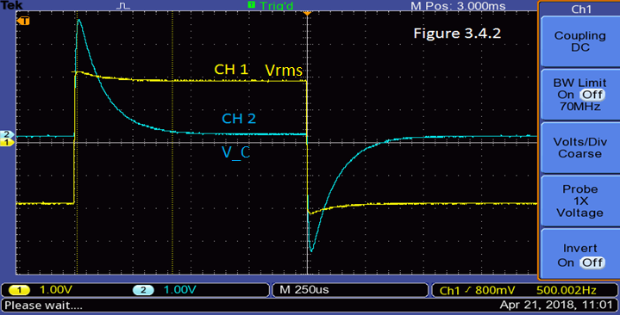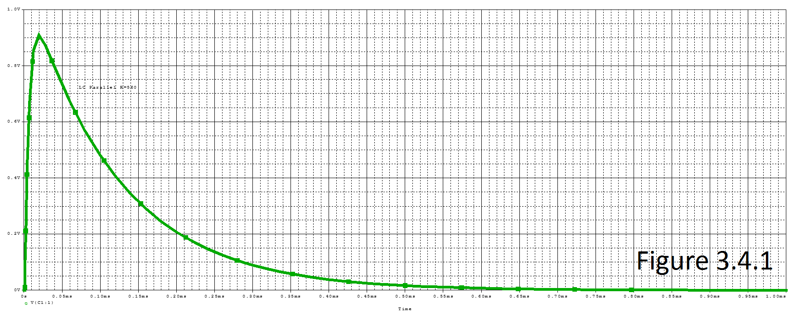PSpice was used to acquire a theoretical output curve as seen in Figure 3.4.1. The experimental output curve measured with the oscilloscope is shown in Figure 3.4.2. Both curves accurately identify the curve as being overdamped. The theoretical equation was found to be: (Calculation 3.4)

**Data & Calculations**

**Calculation 1.1**

|  |  |  |
| --- | --- | --- |
|  |  | Use EQ 3.1 |
|  |  |  |
|  |  | Plug in known values. |
|  |  |  |
|  |  | Solve for each scenario…  **Example: Load resistor is 300 Ohms** |
|  |  |  |
|  |  |  |

**Calculation 1.2**

|  |  |  |
| --- | --- | --- |
|  |  | Definition of % error. |
|  |  |  |
|  |  | Plug in actual resistance and averaged experimental resistance. |
|  |  |  |
|  |  | Solve |

**Calculation 3.1**

|  |  |  |
| --- | --- | --- |
|  |  | Use EQ 1.1 |
|  |  | Rewrite with actual values for R, L, C |
|  |  |  |
|  |  | Use EQ 1.3 |
|  |  |  |
|  |  | Use EQ 1.4 |
|  |  |  |
|  |  |  |
|  |  |  |
|  |  | Use EQ 0.2 |
|  |  |  |
|  |  |  |
| ­ |  |  |
|  |  |  |
|  | | |
|  |  |  |
|  |  | Solve for initial voltage across Inductor |
|  |  |  |
|  | | |
|  |  |  |
|  |  |  |
|  |  |  |
|  |  |  |
|  |  |  |

**Calculation 3.2**

|  |  |  |
| --- | --- | --- |
|  |  | Use EQ 1.1 |
|  |  | Rewrite with actual values for R, L, C |
|  |  |  |
|  |  | Use EQ 1.3 |
|  |  |  |
|  |  | Use EQ 1.4 |
|  |  |  |
|  |  |  |
|  |  |  |
|  |  | Use EQ 0.3 |
|  |  |  |
|  |  |  |
| ­ |  |  |
|  |  |  |
|  | | |
|  |  |  |
|  |  | Solve for initial voltage across Inductor |
|  |  |  |
|  | | |
|  |  |  |
|  |  |  |
|  |  |  |
|  |  |  |
|  |  |  |

**Calculation 3.2.1**

|  |  |  |
| --- | --- | --- |
|  |  | Use EQ 0.0.1  “Experimental” |
|  |  |  |
|  |  |  |
|  |  | Use EQ 1.3  “Theoretical” |
|  |  |  |
|  |  |  |
|  |  |  |
|  |  |  |
|  |  |  |

**Calculation 3.3**

|  |  |  |
| --- | --- | --- |
|  |  | Use EQ 2.1 |
|  |  | Rewrite with actual values for R, L, C |
|  |  |  |
|  |  | Use EQ 2.3 |
|  |  |  |
|  |  | Use EQ 2.4 |
|  |  |  |
|  |  |  |
|  |  |  |
|  |  | Use EQ 0.3 |
|  |  |  |
|  |  |  |
| ­ |  |  |
|  |  |  |
|  | | |
|  |  |  |
|  | | |
|  |  |  |
|  |  |  |
|  |  |  |
|  |  |  |
|  |  |  |
|  |  |  |

**Calculation 3.3.1**

|  |  |  |
| --- | --- | --- |
|  |  | Use EQ 0.0.1  “Experimental” |
|  |  |  |
|  |  |  |
|  |  | Use EQ 2.3  “Theoretical” |
|  |  |  |
|  |  |  |
|  |  |  |
|  |  |  |
|  |  |  |

**Calculation 3.4**

|  |  |  |
| --- | --- | --- |
|  |  | Use EQ 2.1 |
|  |  | Rewrite with actual values for R, L, C |
|  |  |  |
|  |  | Use EQ 2.3 |
|  |  |  |
|  |  | Use EQ 2.4 |
|  |  |  |
|  |  |  |
|  |  |  |
|  |  | Use EQ 0.2 |
|  |  |  |
|  |  |  |
| ­ |  |  |
|  |  |  |
|  | | |
|  |  |  |
|  | | |
|  |  |  |
|  |  |  |
|  |  |  |
|  |  |  |
|  |  |  |
|  |  |  |

**Discussion of Results**

**Part 1:**

Experiment went as expected. The experimentally found internal resistance of the square wave generator was found to be 50.25-Ohms, which is 0.5% different than the actual manufacture claimed value of 50-Ohms.

**Part 2:**

Experiment went as expected. The internal resistance of an inductor was practically negligible at less than 1-Ohm, which was expected. Ideal theoretical inductors have an internal resistance of 0-Ohms.

**Part 3:**

Experiment went as expected. The RCL circuit output exhibited an overdamped waveform with the 6.8K-Ohm resistor, and an underdamped waveform with a 560-Ohm resistor, while the parallel RCL circuit output exhibited an underdamped waveform with the 6.8K-Ohm resistor, and an overdamped waveform with a 560-Ohm resistor. In each case, the theoretical and experimental results matched-up nicely. Based upon the underdamped waveforms, the damping factor and frequencies were calculated and compared to theoretical values. As seen in Calculation 3.2.1, there was only a 5% difference between the theoretical and experimental values for the RCL circuit, and as seen in Calculation 3.3.1, there was only a 5% difference between the theoretical and experimental values for the parallel RCL circuit.

**Appendix**

