|  |  |  |
| --- | --- | --- |
| $$V_{c}+V_{L}+V_{R}=V$$ |  | KVL |
| $$\frac{1}{C}\int{idt}+V_{C}\left(0\right)+L\frac{di}{dt}+iR=V$$ |  | EQ 1.1 |
| $$\frac{d}{dt}\left[EQ 1.1\right]$$ |  | Take Derivative. |
| $$L\frac{d^{2}i}{dt^{2}}+R\frac{di}{dt}+\frac{1}{C}i=0$$ |  |  |
| $$\frac{d^{2}i}{dt^{2}}+\frac{Rdi}{Ldt}+\frac{1}{CL}i=0$$ |  | EQ 1.2 |
|  |  |  |
| $$x=x_{f}+x_{n}$$ |  | EQ 1.3 |
|  |  |  |
| $$x_{f}=0$$ |  | Because right side of ‘=’ is constant 0. |
|  |  |  |
| $$x_{n}=ke^{st}$$ |  | Differential Equations. (DE) |
| $$\frac{d^{2}ke^{st}}{dt^{2}}+\frac{Rdke^{st}}{Ldt}+\frac{1}{CL}ke^{st}=0$$ |  |  |
| $$S^{2}+\frac{R}{L}s+\frac{1}{CL}=0$$ |  |  |
|  |  |  |
| $$Note:ω^{2}=\frac{1}{CL} and 2ωz=\frac{R}{L}→z=\frac{R\sqrt{CL}}{2L}$$ |  | EQ 1.4 |
|  |  |  |
| $$s_{1},s_{2}=-\frac{R}{2L}±\frac{\sqrt{{\left(\frac{R}{L}\right)}^{2}-\frac{4}{CL}}}{2}$$ |  | Quadratic Equation. |
|  |  |  |
| $$From here, solve for k_{1} and k_{2} based upon expected output from damping factor z.$$ | | |
|  |  |  |
| $$if z=1→i\left(t\right)=k_{1}e^{s_{1}t}+k_{2}te^{s_{2}t}$$ |  | “Critical Damping” |
|  |  |  |
| $$if z>1→i\left(t\right)= k_{1}e^{s_{1}t}+k_{2}e^{s_{2}t}$$ |  | “Over-Damped’ |
|  |  |  |
| $$if z<1→i\left(t\right)=e^{a}\left(k_{1}\cos\left(bt\right)+k_{2}\sin\left(ct\right)\right)$$ |  | “Under-Damped” |
|  |  |  |
| $$if z=0→i\left(t\right)=k_{1}\cos\left(bt\right)+k_{2}sin⁡(ct)$$ |  | “Un-Damped” |
|  |  |  |
|  |  |  |
| $$Solve for k_{1} by solving at i\left(0\right).$$ $$Solve for k_{2} by taking the derivaative of the entire equation, convert to a function of voltage by$$ $$using the relation:v\left(t\right)=\frac{Ldi\left(t\right)}{dt}, and solving at v(0)$$ | | |
|  |  |  |
| $$V_{R}=R\left(i\left(t\right)\right)$$ |  | Solve in terms of V across R |

|  |  |  |
| --- | --- | --- |
|  |  | KCL |
| $$\frac{V-V_{C}}{R}=\frac{1}{L}\int{V_{C}dt}+i\left(0\right)+\frac{CdV_{C}}{dt}$$ |  | EQ 2.1 |
| $$\frac{d}{dt}\left[EQ 2.1\right]$$ |  | Take Derivative. |
| $$\frac{d^{2}V_{C}}{dt^{2}}+\frac{dV_{C}}{RC}+\frac{1}{LC}V_{C}=0$$ |  | EQ 2.2 |
|  |  |  |
| $$x=x_{f}+x_{n}$$ |  | EQ 2.3 |
|  |  |  |
| $$x_{f}=0$$ |  | Because right side of ‘=’ is constant 0. |
|  |  |  |
| $$x_{n}=ke^{st}$$ |  | Differential Equations. (DE) |
| $$\frac{d^{2}ke^{st}}{dt^{2}}+\frac{dke^{st}}{RCdt}+\frac{1}{LC}ke^{st}=0$$ |  |  |
| $$S^{2}+\frac{1}{RC}s+\frac{1}{LC}=0$$ |  |  |
|  |  |  |
| $$Note:ω^{2}=\frac{1}{LC} and 2ωz=\frac{1}{RC}→z=\frac{\sqrt{LC}}{2RC}$$ |  | EQ 2.4 |
|  |  |  |
| $$s_{1},s_{2}=-\frac{1}{2RC}±\frac{\sqrt{{\left(\frac{1}{RC}\right)}^{2}-\frac{4}{LC}}}{2}$$ |  | Quadratic Equation. |
|  |  |  |
| $$From here, solve for k_{1} and k_{2} based upon expected output from damping factor z.$$ | | |
|  |  |  |
| $$if z=1→V\left(t\right)=k_{1}e^{s_{1}t}+k_{2}te^{s_{2}t}$$ |  | “Critical Damping” |
|  |  |  |
| $$if z>1→V\left(t\right)= k_{1}e^{s_{1}t}+k_{2}e^{s_{2}t}$$ |  | “Over-Damped’ |
|  |  |  |
| $$if z<1→V\left(t\right)=e^{a}\left(k_{1}\cos\left(bt\right)+k_{2}\sin\left(ct\right)\right)$$ |  | “Under-Damped” |
|  |  |  |
| $$if z=0→V\left(t\right)=k_{1}\cos\left(bt\right)+k_{2}sin⁡(ct)$$ |  | “Un-Damped” |
|  |  |  |
|  |  |  |
| $$Solve for k_{1} by solving at V\left(0\right).$$ $$Solve for k_{2} by taking the derivaative of the entire equation, convert to a function of current by$$ $$using the relation:i\left(t\right)=\frac{CdV\left(t\right)}{dt}, and solving at i(0)$$ | | |
|  |  |  |
| $$V_{L}=V_{C}=V(t)$$ |  | Solve in terms of V across L |



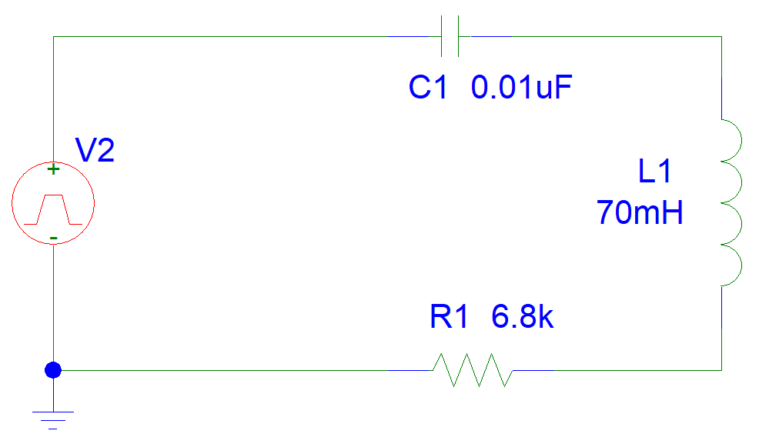



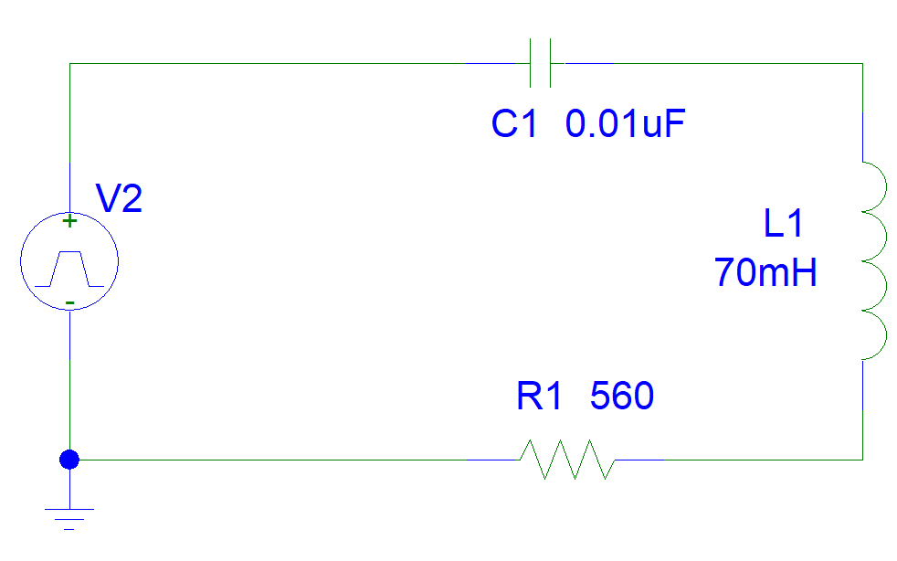



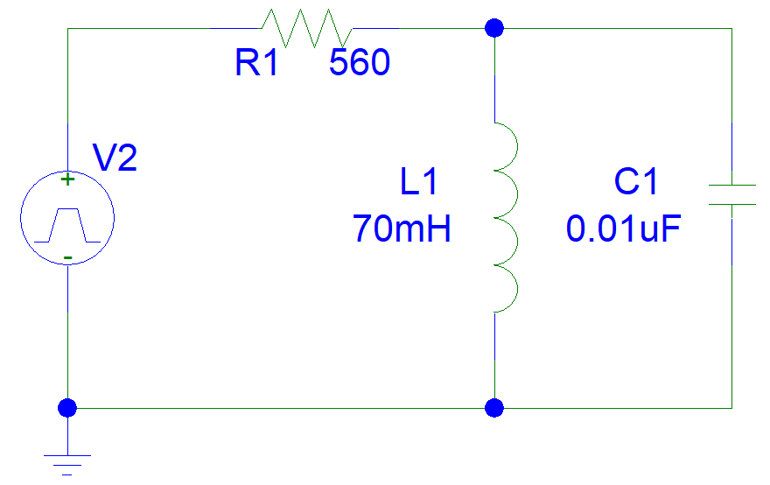



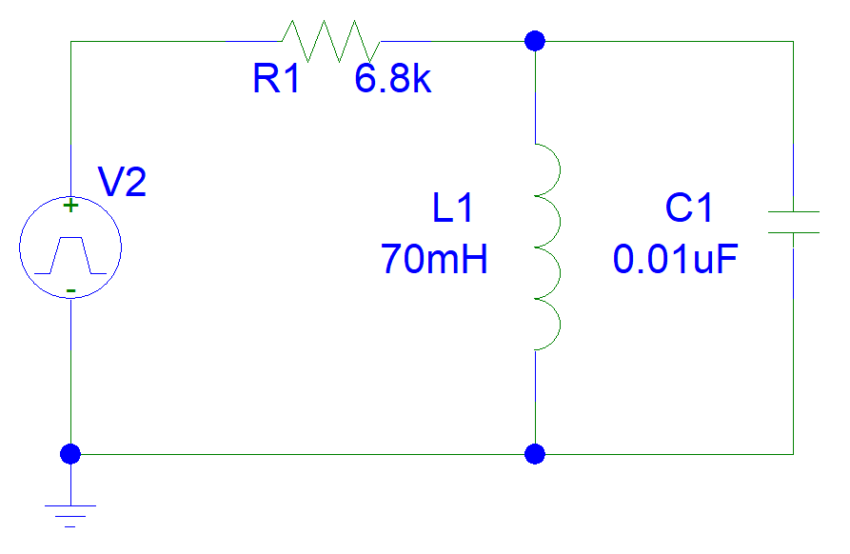

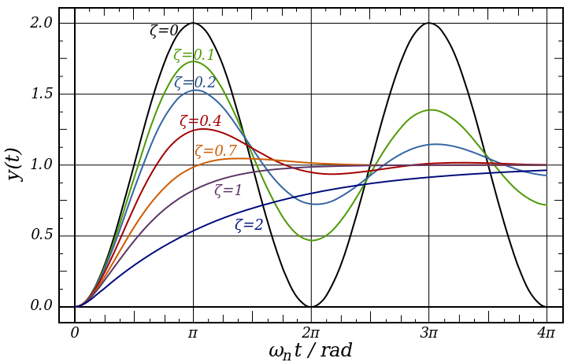

In engineering, the damping ratio is a dimensionless measure describing how oscillations in a system decay after a disturbance. Many systems exhibit oscillatory behavior when they are disturbed from their position of static equilibrium

The damping ratio is a system parameter, denoted by ζ (zeta, z), that can vary from undamped (z=0), underdamped (z<1) through critically damped (z=1) to overdamped (z>1).

Damping is caused by the resistance in the circuit. It determines whether or not the circuit will resonate naturally (that is, without a driving source). Circuits which will resonate in this way are described as underdamped and those that will not are overdamped.