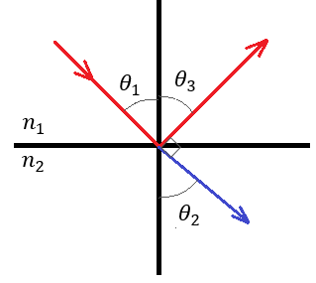Brewster’s Angle Derivation

$$Note: θ_{1}=θ_{3} by the law of reflection$$

$$θ_{2}+90°+θ_{1}=180°$$

$$θ_{2}=90°-θ_{1}$$

$$sinθ_{2}=\sin\left(90°-θ_{1}\right)=cosθ_{1}$$

$$Snell^{'}s Law:{ n}_{1}sinθ_{1}=n_{2}sinθ_{2}$$

$$\frac{n_{2}}{n_{1}}=n_{r}=\frac{sinθ_{1}}{sinθ_{2}}=\frac{sinθ_{1}}{cosθ_{1}}=tanθ_{1}$$

$$n_{r}=tanθ_{1}$$

Error Propagation

$$n=tanθ_{B}$$

$$\frac{∂θ}{∂n}=\sec^{2}{θ}=\frac{1}{\cos^{2}{θ}}$$

$$\frac{δn}{n}={\left\{{\left[\frac{\left(\frac{∂θ}{∂n}\right)δθ}{n}\right]}^{2}\right\}}^{\frac{1}{2}}$$

$$\frac{δn}{n}=\frac{δθ}{\cos^{2}{θ}tanθ}=\frac{δθ cosθ}{\cos^{2}{θ}sinθ}=\frac{δθ}{\cos{θ}sinθ}$$

$$Note: δθ=2°=\frac{2π}{180}=\frac{π}{90}$$

$$\frac{δn}{n}=\frac{π}{90\cos\left(60°\right)\sin\left(60°\right)}=0.081→9\% Uncertainty$$