|  |  |  |  |  |  |
| --- | --- | --- | --- | --- | --- |
| Name: |  | **Jared Fowler** | Lab Partners: |  | Chikheang Soeng |
| Date: |  | January 26, 2019 |  |  | David Awad |
| Class/Period: |  | Physics M20C Lab. Thursday 1pm-4pm. |  |  |  |
|  |  | Professor Meyer |  |  |  |

The Speed of Sound in Air

The speed of sound in air is experimentally found through two methods. First, the wavelength of sound is determined by measuring points of resonance along a variable length air column at fixed frequencies. The velocity is then calculated based upon the velocity-frequency-wavelength relation: . Second, the speed of sound in air is determined by sending a sound pulse to two receivers placed at various distances from the source and measuring the receive time difference. The velocity is then calculated based upon the velocity-distance-time relation: . Using an empirical formula, the theoretical speed of sound in air was calculated to be at 23.3 Celsius. The first method resulted in an experimental value of , and the second method resulted in an experimental value of . The percent discrepancies of these results are 3% and 2% respectively, which are both well-within the margin of error.

**Objective**

Determine the speed of sound in air through two methods: first, measuring the points of resonance along a variable length air column when a fixed frequency sound-source is projected into the containing tube apparatus and, second, sending a sound pulse to two receivers placed at various distances from the source and measuring the receive time difference.

**Theory**

**Note: Theories, concepts, and proofs heavily quoted from “Physics M20C Lab Manual” by Clint D Harper, “Physics for Scientists and Engineers” 9th edition by Serway and Jewett, and Wikipedia.**

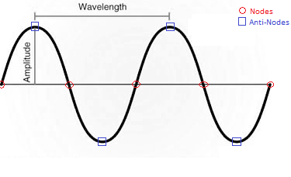

**Nodes and Anti-Nodes**

A node is a point along a standing wave where the wave has minimum amplitude. The opposite of a node is an anti-node, a point where the amplitude of the standing wave is a maximum. These occur midway between the nodes.

**Frequencies: Natural, Fundamental, and Harmonics**

Frequency is the number of occurrences of a repeating event per unit of time, generally seconds. Natural frequency is the frequency at which a system tends to oscillate in the absence of any driving or damping force. The fundamental frequency, often referred to as the fundamental, is defined as the lowest frequency of a periodic waveform. A harmonic is a wave with a frequency that is a positive integer multiple of the fundamental frequency (1st harmonic). The following harmonics are known as higher harmonics.

**Resonance**

A phenomenon that occurs when the frequency at which a force is periodically applied is equal or nearly equal to one of the natural frequencies of the system on which it acts. This causes the system to oscillate with larger amplitude than when the force is applied at other frequencies.

**Theoretical Speed of Sound**

As a theoretical basis, a reliable formula for the speed of sound in dry air at one atmosphere pressure is:

|  |  |  |
| --- | --- | --- |
|  |  | **Equation 0.1**  **(T is air temperature in** °**C)** |

**Open Resonance Air Column Apparatus**

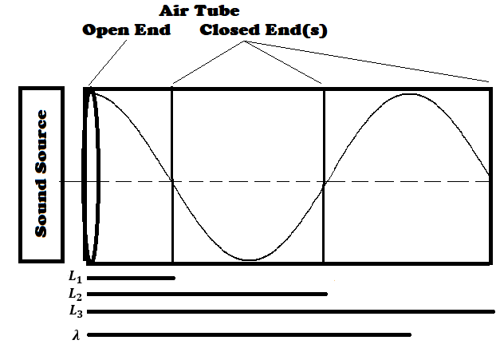A resonating air column in a tube with one end open and the other end closed will have a node at the closed end and an anti-node at the open end. If the air column is resonating in the fundamental mode it will have no other nodes or anti-nodes. On a sine wave, the distance from one of the maxima to the next point where it crosses zero is a quarter wavelength. Thus, for an air column in a tube with one open and one closed end, the length of the resonating column, L, and the wavelength λ, are related by:

|  |  |  |
| --- | --- | --- |
|  |  | **Equation 1.1A**  **(First Harmonic / Fundamental)** |

The second, third, and all following harmonics (N) can be found by increasing the distance between the open and closed ends of the tube by a factor of half a wavelength from the previous harmonic (N – 1). Thus, the wavelength at the second and third harmonic are defined as:

|  |  |  |
| --- | --- | --- |
|  |  | **Equation 1.1B**  **(Second Harmonic)** |
|  |  |  |
|  |  | **Equation 1.1C**  **(Third Harmonic)** |

For all types of waves, the relationship between frequency (f) and velocity (v) of the wave is:

|  |  |  |
| --- | --- | --- |
|  |  | **Equation 1.2** |

**Acoustic Delay Time**

The velocity (v) of a sound pulse between two points can be calculated by dividing the distance, d, by the difference in time, t.

|  |  |  |
| --- | --- | --- |
|  |  | **Equation 2.1** |

**Procedure**

**Open Resonance Air Column Apparatus with Variable Length**

The apparatus, as shown in **Figure 1.1**, was assembled. The piston was fully inserted into one end of the tube such that the resonance air column was very short. The speaker was situated at the other end. The frequency generator’s amplitude was pre-set to a low value. After power up, the generator’s frequency and amplitude were adjusted to output 600Hz at a barely audible amplitude. The piston was slowly pulled away from the speaker until the observable sound was the loudest. The length of the resonance air column was measured. The piston was again pulled away from the speaker until the next observable maximum was found. The total distance was recorded. Based upon theory, the total expected distance was around three times the first measured distance. The piston was then pulled for a third time until the observable sound was loudest. The total distance was recorded. The total expected distance was around five times the first measured distance. The entire procedure was then repeated for a frequency of 500Hz.

The measured values are displayed in **Table 1.1** in the analysis section. Note that the measured length uncertainty, +/- 2cm, is very generous due to the observational difficulties experienced during the procedure.

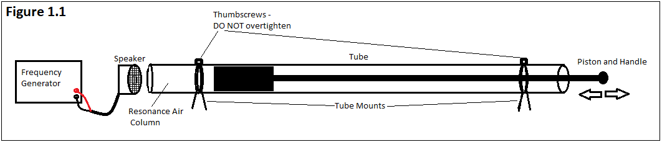

**Acoustic Delay Line**

(Note: This portion of the lab was assembled and performed by the professor.)

The apparatus, as shown in **Figure 2.1**, was assembled. Loudspeaker #1 was setup as the acoustic pulse source, and Loudspeaker #2 and #3 were setup as receivers. An oscilloscope was attached to the two receivers. A DC power supply was used to charge a capacitor, which was in-turn used to discharge energy into Loudspeaker #1, creating a pulse of acoustic energy. The distance between Loudspeakers #2 and #3 was measured, along with the difference in time when each received the acoustic pulse. This procedure was repeated twice more, each time adjusting the distance between the two receiving loudspeakers.

The air temperature at the time of experiment was recorded as 23.3 Celsius.

The measured values are displayed in **Table 2.1** in the analysis section. Note that the measured uncertainty for distance was determined to be +/- 0.5cm, and the uncertainty for time difference was determined to be the time duration of an entire pulse observed on the oscilloscope, which came out to 0.28ms.

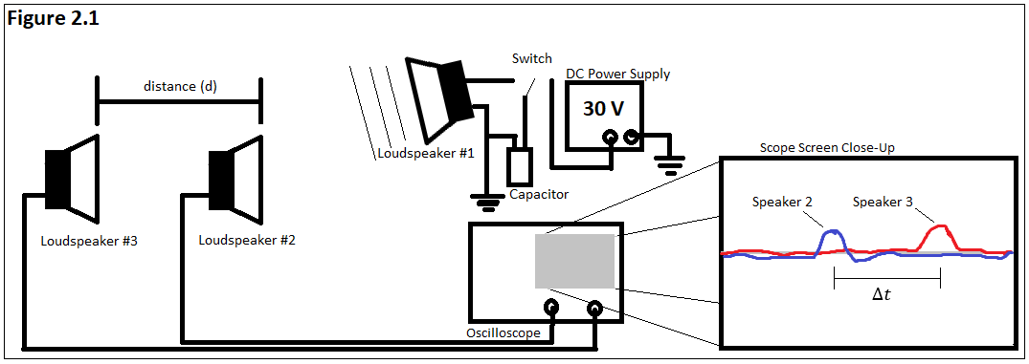

**Analysis / Discussion / Calculations**

**Theoretical Speed of Sound**

The theoretical speed of sound in air at 23.3 Celsius was calculated to be (see **Calculation 0.1**).

**Open Resonance Air Column Apparatus with Variable Length**

The speed of sound in air was found to be at 600Hz, and at 500Hz (see **Calculations 1.1**, **1.2**, and **1.3**). Hence, the average velocity for the two frequencies is . The large percent error results from the generous uncertainty in the air column length measurement, together with error propagation performed on the data values with the smallest length measurement. The uncertainty in length was measured as +/- 2cm, due to the several sources of error, including interference from neighboring experiments and physical sensitivities within the apparatus setup. In effect, 15% error is considered the maximum error for worst case scenario. Comparing the average experimental velocity to the theoretical value , there is only a 3% discrepancy (see **Calculation 1.4**), which is well within the experimental margin of error.

**Acoustic Delay Line**

The speed of sound in air was found to be (see **Calculations 2.1**, and **2.2**). This large percent error makes sense mathematically but is stunning none-the-less. The major source of error comes from the small difference in time measured in relation to its uncertainty. Note that the smallest sample time was 0.82ms, which is only three times greater than the uncertainty (+/- 0.28ms)! The uncertainty of distance between receivers (+/- 0.5cm) contributed very little error to the propagation. To reduce uncertainty, the distance between receivers should be significantly increased which in-turn will increase the time differences. Comparing the average experimental velocity to the theoretical value , there is only a 2% discrepancy (see **Calculation 2.3**), which is well within the experimental margin of error.

|  |  |  |  |
| --- | --- | --- | --- |
| **Table 1.1**  **Open Resonance Air Column Apparatus at Variable Length** | | | |
| **Frequency (Hertz)** | **(1/4) (meters)** | **(3/4) (meters)** | **(5/4) (meters)** |
| 600 | 0.135 | 0.420 | 0.720 |
| 500 | 0.170 | 0.506 | 0.850 |
| (Note: ) | | | |

|  |  |  |
| --- | --- | --- |
| **Table 2.1**  **Acoustic Delay Time** | | |
| **Test Number** | **Distance ‘d’ (meters)** | **Time Difference ‘t’ (Seconds)** |
| 1 | 0.400 | 0.00119 |
| 2 | 0.270 | 0.00082 |
| 3 | 0.435 | 0.00124 |
| (Note: ) | | |

|  |  |  |
| --- | --- | --- |
| **Calculation 0.1 -**  **Theoretical Speed of Sound in Dry Air** | | |
|  |  | Use **Equation 0.1** |
|  |  |  |
|  |  | Measured temperature at time of experiment was 23.3C. |

|  |  |  |
| --- | --- | --- |
| **Calculation 1.1 -**  **Speed of Sound from Average Wavelength and Frequency (600Hz)** | | |
|  |  | Use **Equation 1.1A**  1.1a |
|  |  | Use **Equation 1.1B**  1.1b |
|  |  | Use **Equation 1.1C**  1.1c |
|  |  |  |
|  |  | Average of 1.1a-1.1c |
|  |  |  |
|  |  |  |

|  |  |  |
| --- | --- | --- |
| **Calculation 1.2 -**  **Speed of Sound from Average Wavelength and Frequency (500Hz)** | | |
|  |  | Use **Equation 1.1A**  1.2a |
|  |  | Use **Equation 1.1B**  1.2b |
|  |  | Use **Equation 1.1C**  1.2c |
|  |  |  |
|  |  | Average of 1.2a-1.2c |
|  |  |  |
|  |  |  |

|  |  |  |
| --- | --- | --- |
| **Calculation 1.3 -**  **Error Propagation for Speed of Sound with Average Wavelength and Frequency** | | |
|  |  | **Use Equation 1.2** |
|  |  |  |
|  |  | Take partial derivatives in respect for wavelength and frequency. |
|  |  |  |
|  |  | Definition for absolute error. |
|  |  |  |
|  |  | Definition for relative error. |
|  |  |  |
|  |  | Substitute in partial derivatives and V. Simplify. Note: . |
|  |  |  |
|  |  | Use the smallest measured wavelength to estimate largest possible error. |

|  |  |  |
| --- | --- | --- |
| **Calculation 1.4 -**  **Percent Discrepancies for Speed of Sound with Average Wavelength and Frequency** | | |
|  |  | Definition of percent discrepancy. |
|  |  |  |
|  |  | Use theoretical value from **Calculation 0.1** and average velocity from 500Hz and 600Hz tests. |

|  |  |  |
| --- | --- | --- |
| **Calculation 2.1 -**  **Speed of Sound from Acoustic Delay Time** | | |
|  |  | Use **Equation 2.1**  2.1a |
|  |  | Use **Equation 2.1**  2.1b |
|  |  | Use **Equation 2.1**  2.1c |
|  |  |  |
|  |  | Average of 2.1a-2.1c |

|  |  |  |
| --- | --- | --- |
| **Calculation 2.2 -**  **Error Propagation for Speed of Sound from Acoustic Delay Time** | | |
|  |  | Use **Equation 2.1** |
|  |  |  |
|  |  | Take partial derivatives in respect for distance and time. |
|  |  |  |
|  |  | Definition for absolute error. |
|  |  |  |
|  |  | Definition for relative error. |
|  |  |  |
|  |  | Substitute in partial derivatives and V. Simplify. Note: . |
|  |  |  |
|  |  | Use the smallest measured distance and time to estimate largest possible error. |

|  |  |  |
| --- | --- | --- |
| **Calculation 2.3 -**  **Percent Discrepancy for Speed of Sound from Acoustic Delay Time** | | |
|  |  | Definition of percent discrepancy. |
|  |  |  |
|  |  | Use theoretical value from **Calculation 0.1** and experimental average from **Calculation 2.1**. |

**Conclusion**

The experiments yielded favorable results consistent with the theoretical speed of sound in air. The theoretical speed was calculated to be at 23.3 Celsius. The variable air column method resulted in an experimental value of , and the pulse to receiver method resulted in an experimental value of . The percent discrepancies of these results are 3% and 2% respectively, which are both well-within the margin of error.

Though the experiments gave decent results, there were many sources of error both accounted and unaccounted for. Ambient air temperature readings could have been taken more frequently, or better kept consistent within a temperature-controlled environment. The air column method heavily relied upon human observation. Better results could be yielded if audible interference, such as noise from simultaneous experiments and experimenters within close proximity, was mitigated. The pulse to receiver method has a much greater potential for accuracy since much of the human variable is removed. For better results, the distance between receiving loudspeakers could be increased, say, twenty meters or more, to significantly reduce the time uncertainty to value ratio. This, as with the first method, would ideally be done within a large, temperature controlled, quiet room.