|  |  |  |
| --- | --- | --- |
| NOTES: | Rod Material: | Brass |
|  | Rod Length: | (0.597 +/- 0.002) meters |
|  | Frequency Uncertainty: | +/- 10Hz. This means that for $Δf$, the uncertainty is +/- 20Hz. |
|  | Theoretical Velocity: | 3480 m/s |
|  |  |  |

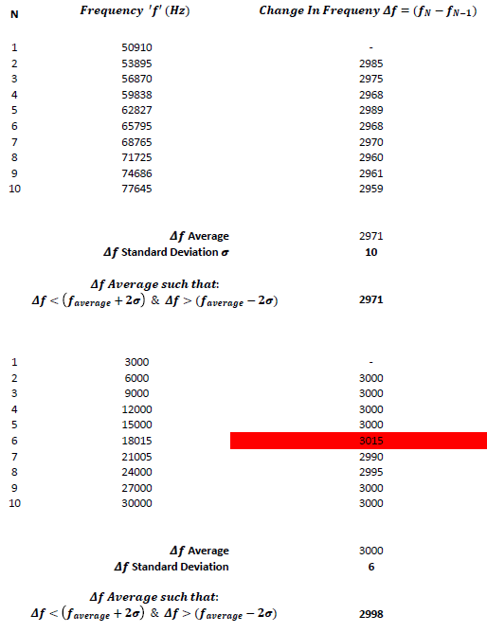**Calculation 1.1 – Speed of Sound in Brass Rod (High Frequency)**

$$v=2L(Δf)$$

$$v=2\left(0.597m\right)\left(2971Hz\right)$$

$$v=3547→3550 m/s$$

**Calculation 1.2 – Speed of Sound in Brass Rod (Low Frequency)**

$$v=2L(Δf)$$

$$v=2\left(0.597m\right)\left(2998Hz\right)$$

$$v=3580 m/s$$

**Calculation 1.3 – Percent Discrepancies**

$$\% Discrepancy=\left|\frac{V_{Theoretical}-V_{Experimental}}{V_{Theoretical}}\right|*100$$

High Frequency:

$$\% Discrepancy=\left|\frac{3480-3550}{3480}\right|*100=2\%$$

Low Frequency:

$$\% Discrepancy=\left|\frac{3480-3580}{3480}\right|*100=3\%$$

|  |  |  |
| --- | --- | --- |
| **Calculation 1.4 - Error Propagation** | | |
| $$V=2L(Δf)$$ |  | Starting Equation |
|  |  |  |
| $$\frac{∂V}{∂L}=2(Δf), \frac{∂V}{∂\left(Δf\right)}=2L$$ |  | Take partial derivatives in respect for length and delta frequency |
|  |  |  |
| $$δV={\left\{{\left[δL\left(\frac{∂V}{∂L}\right)\right]}^{2}+{\left[δ\left(Δf\right)\left(\frac{∂V}{∂\left(Δf\right)}\right)\right]}^{2}\right\}}^{\frac{1}{2}}$$ |  | Definition for absolute error. |
|  |  |  |
| $$\frac{δV}{V}={\left\{{\left[\frac{δL\left(\frac{∂V}{∂L}\right)}{V}\right]}^{2}+{\left[\frac{δ\left(Δf\right)\left(\frac{∂V}{∂\left(Δf\right)}\right)}{V}\right]}^{2}\right\}}^{\frac{1}{2}}$$ |  | Definition for relative error. |
|  |  |  |
| $$\frac{δV}{V}={\left\{{\left[\frac{δL(2\left(Δf\right))}{2L\left(Δf\right)}\right]}^{2}+{\left[\frac{δ\left(Δf\right)\left(2L\right)}{2L\left(Δf\right)}\right]}^{2}\right\}}^{\frac{1}{2}}={\left\{{\left[\frac{δL}{L}\right]}^{2}+{\left[\frac{δ\left(Δf\right)}{\left(Δf\right)}\right]}^{2}\right\}}^{\frac{1}{2}}$$ |  | Substitute in partial derivatives and V. Simplify. Note: $δL=±0.002m, δ\left(Δf\right)=± 20Hz$. |
|  |  |  |
| $$\frac{δV}{V}={\left\{{\left[\frac{0.002m}{0.597m}\right]}^{2}+{\left[\frac{20}{2959}\right]}^{2}\right\}}^{\frac{1}{2}}=0.007→1\% error$$ |  | Use the smallest calculated delta frequency to estimate largest possible error. |

**Conclusion**

The experimental speed of sound through a brass rod was $3550\frac{m}{s}±1\%$ for higher frequencies starting at 50KHz, and $3580\frac{m}{s}±1\%$ for lower frequencies starting at 3KHz. The percent discrepancies of these results were 2% and 3% respectively. Unfortunately, these percent differences are not within the margin of error. Perhaps as a general rule, experiments will typically have a greater margin of error with respect to the percent discrepancies. This experiment, however, seems to be an exception to that rule. Despite the sources of error, including the length measurement of the rod and human observational error while finding the correct frequencies, the measured values were still exceptionally accurate and consistent. The minimal variation of output mathematically contributed to a very low margin of error. It’s likely that the given theoretical value given for the speed of sound through brass wasn’t accurate for the brass rod used in the experiment. Consider the fact that brass is an alloy of copper and zinc. According to the *CRC Handbook of Chemistry and Physics 85th Edition*, the speed of sound through copper is 3750 m/s, and 3850 m/s through zinc. Brass rated at a copper-zinc ratio of 7:3 has a speed of sound measured at 3480 m/s. Without venturing into the complexities of how the copper-zinc ratios could affect the speed of sound, it’s a reasonable guess that the speed would vary based upon the associated changes of the material’s bulk modulus and density factors which share the following relationship with wave velocity: $v={\left(\frac{B}{p}\right)}^{\frac{1}{2}}$. The experiment could be improved by providing the exact copper-zinc ratio and a method to compute a more accurate value for the theoretical speed of sound through the brass.

The experimental values for both low and high frequency starting points yielded similar results as expected, however, the higher frequency data points were less consistent than the lower frequency data points. This could have been the result of observer uncertainty, other physical anomalies, or **perhaps** a need for greater frequency precision as the frequency to wavelength ratio grew. (Note: $v=λf$)