Jared Fowler

**Derivation – Index of Refraction and the Minimum Angle of Deviation Relationship**

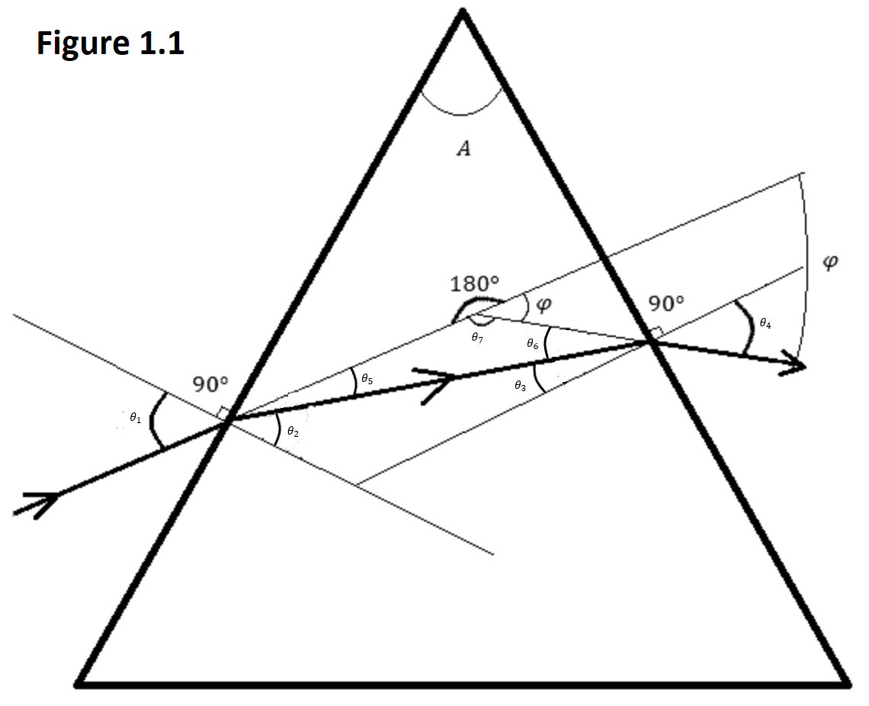

|  |  |  |
| --- | --- | --- |
| Use the sum of angles in a triangle is equal to 180 degrees rule to get the relationship between the apex and the two internal angles of refraction. |  |  |
|  |  |  |
| Notice the vertically opposite angles marked in red and blue. These indicates that:  Use the sum of angles in a triangle is equal to 180 degrees rule to find the relationship between the apex, external angles of refraction, and the angle of deviation. |  |  |
|  |  | Jared Fowler | |
|  |  | Snell’s law, where and are equal to 1. Also, and are equal. Simplify. | |
|  |  |  | |
|  |  | **(EQ 1.3)** and **(EQ 1.4)** | |
|  |  |  | |
|  |  | Minimum deviation definition | |
|  |  |  | |
|  |  | Solve for the derivative of with respect to . Use EQ 1.2 | |
|  |  |  | |
|  |  | **(EQ 1.5)** | |
|  |  |  | |
|  |  | Differentiate EQ 1.4 with respect to .  Then substitute in EQ 1.5. | |
|  |  |  | |
|  |  | **(EQ 1.6)** | |
|  |  |  | |
|  |  | Differentiate EQ 1.1 with respect to .  **(EQ 1.7)** | |
|  |  |  | |
|  |  | Substitute in EQ 1.7 and simplify.  Then multiply each side by | |
|  |  |  | |
|  |  | **(EQ 1.8)** | |
|  |  |  | |
|  |  | Differentiate EQ 1.3 with respect to .  Then multiply each side by | |
|  |  |  | |
|  |  | **(EQ 1.9)** | |
|  |  |  | |
|  |  | Subtract EQ 1.8 from EQ 1.9 | |
|  |  |  | |
|  |  | Simplify. Square the equation and use the trig-identity: | |
|  |  |  | |
|  |  | Substitute in EQ 1.3 and 1.4.  Simplify.  **(EQ 1.10)** | |
|  |  |  | |
|  |  | Solution needs to be valid for both EQ 1.1 and EQ 1.10. is a valid solution. Revisiting the vertically opposite angles rule indicates that | |
|  |  | Jared Fowler | |
|  |  | Substitute into EQ 1.2 and solve for .  **(EQ 1.11)** | |
|  |  |  | |
|  |  | Substitute into EQ 1.3 where  **(EQ 1.12)** | |
|  |  |  | |
|  |  | Combine EQ 1.12 with EQ 1.11 | |
|  |  |  | |
|  |  | **(EQ 1.13)** | |