Jared Fowler

Spherical Concave Mirrors and Lenses – Pre-lab Work

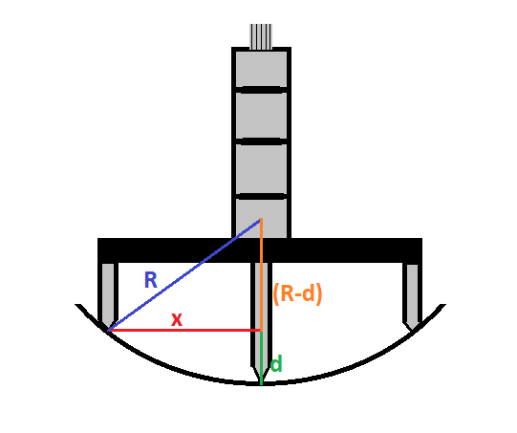Prove the focal length by spherometer formula: $R=\frac{x^{2}+d^{2}}{2d}=2f$

$$Use Pythagorean Theorem$$

$$R^{2}=x^{2}+{\left(R-d\right)}^{2}$$

$$R^{2}=x^{2}+R^{2}-2dR+d^{2}$$

$$2dR=x^{2}+d^{2}$$

$$R=\frac{x^{2}+d^{2}}{2d}$$

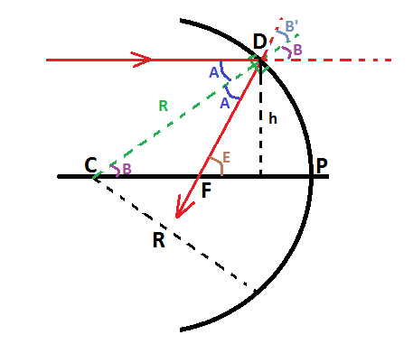

Consider a ray of light (red), parallel to the principle axis, incident on a spherical mirror. Based upon the law of reflection $A=A=B=B'$. By the law of corresponding angles angle PCD is equal to B and $E=2B$.

$$\frac{h}{R}=sinB$$

$$\frac{h}{f}=tanE=tan2B$$

**If the aperture of the mirror is small,** then

$$sinθ ≈tanθ ≈θ$$

$$\frac{h}{R}=\frac{h}{2F}→ R=2F$$