Jared Fowler

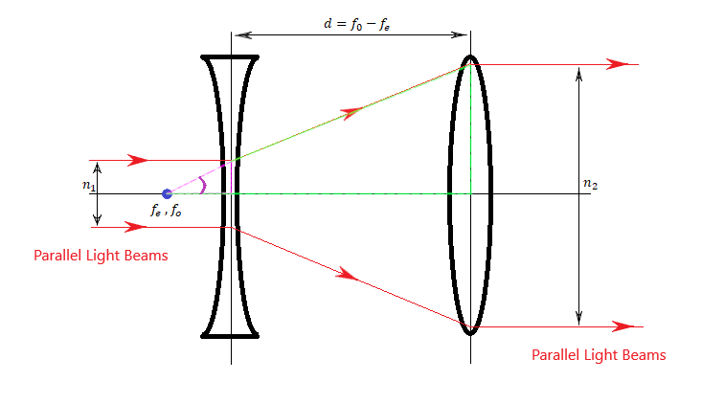

|  |  |  |
| --- | --- | --- |
| $$\frac{1}{f_{e}}=\frac{1}{P_{1}}+\frac{1}{Q_{1}}$$ |  | Thin lens formula |
|  |  |  |
| $$\frac{1}{f_{e}}=\frac{1}{∞}+\frac{1}{Q_{1}}$$ |  | Incoming parallel light beams indicate that the object is at infinite distance. |
|  |  |  |
| $$Q_{1}=f_{e}$$ |  | Solve. Note that the focal length of a diverging lens is negative. |
|  |  |  |
|  |  |  |
|  |  | Thin lens formula |
|  |  |  |
|  |  | Outgoing parallel light beams indicate that the image is at infinite distance. |
|  |  |  |
|  |  | Solve. |
|  |  |  |
| $$tanθ=\frac{n_{1}}{2f_{e}} and tanθ=\frac{n_{2}}{2f_{o}}$$ |  | (see Diagram – purple and green triangles) |
|  |  |  |
| $$\frac{n_{1}}{2f_{e}}=\frac{n_{2}}{2f_{o}}→\frac{n_{1}}{f_{e}}=\frac{n_{2}}{f_{o}}→\frac{n_{2}}{n_{1}}=\frac{f_{o}}{f_{e}}$$ |  |  |
|  |  |  |
| $$Note: Magnificaiton{{}_{}^{'}M}^{'}=\frac{h_{i}}{h_{o}}=\frac{n_{2}}{n_{1}}→ M=\frac{f_{o}}{f_{e}}$$ |  | Magnification is defined as image height over object height. Solve. |